Plenary Lectures

Structure and Lattice Dynamics of Ferroelectric Superlattices

Yu.I. Yuzyuk

Faculty of Physics, Southern Federal University, Zorge 5, Rostov-on-Don 344090, Russia

e-mail: yuzyuk@rambler.ru

Artificially fabricated superlattices (SLs) constructed by alternate layers of different polar and non-polar perovskites oxides exhibit superior properties, which make them attractive for thin-film device applications.
We report x-ray diffraction and micro-Raman scattering investigations of highly constrained epitaxial ferroelectric thin films (Ba,Sr)TiO₃ (BST) and series of superlattices BaTiO₃/(Ba,Sr)TiO₃ (BT/BST), BaTiO₃/BaZrO₃ (BT/BZ) and (Ba,Sr)TiO₃/BiFeO₃ (BST/BF). To clarify role played by epitaxial strains we have studied size effect in the set of single BST films deposited under similar condition onto MgO substrates.The two-dimensional (2D) stresses in epitaxial thin films change the entire phase transition sequence, creating new phases that are not present in bulk materials. The upward shift of the Curie temperature due to the 2D stress was systematically studied in several (Ba,Sr)TiO₃/(001)MgO thin films by means of x-ray diffraction and Raman spectroscopy as a function of film thickness. Significant transformation of the E(TO) soft mode was found in the thickness-dependent Raman spectra of (Ba,Sr)TiO₃/MgO films at the transition from c-domain tetragonal phase (thick films) to monoclinic phase when the film thickness was below 80 nm.
The in-plane and out-of-plane lattice parameters and polarized Raman spectra of BT/BST and BT/BZ superlattices were studied as a function of modulation period. The specific lattice parameters dependences on Sr content in BST layers for BT/BST-x SLs and on the modulation period for BT/ST SLs have been analyzed. It was found that when ☹ ≥ 76 Å the a and c parameters show no dependence on the stacking periodicity implying the appearance of the stress only near interfaces and the relaxation of the entire stress of layers. For BT/ST SLs the obtained results are in agreement with Raman data where soft mode depends slightly on the periodicity. Alternatively, for BT/BST-x SLs lattice parameters can be varied significantly even at larger modulation period (☹ = 110 Å). We found that the parameters of BST layer depend obviously on Sr concentration. The obtained results are in a good agreement with the Raman data obtained on the set of similar SLs where the soft mode frequency is shifted markedly when Sr content is varied from 0 to 1 in BST layers. Thus, the fabrication of the artificial SLs with variable composition of the constituting layers even with large modulation period allows strong variation of the ferroelectric properties comparing to the BT/ST SLs with variable layers thickness. Strain engineering in artificial superlattices allowed modifying their dielectric properties by varying either the Ba/Sr in BST layer concentration or the modulation periodicity in the SLs.
Thin films of multiferroic BiFeO₃/MgO revealed no significant transformation of their Raman spectra, while BST/BF SLs exhibited drastic changes of the Raman response as a function of layers thickness due significant epitaxial strains between alternating layers.

Acknowledgment. This work was supported by Russian Foundation for Basic Research (Grant № 12-02-91051 CNRS_а)

Polarons in Magnetoelectric Fluorides

C. Filipič, G. Tavčar, E. Goreshnik, B. Žemva, and A. Levstik

Jožef Stefan Institute, Jamova 39, 1000 Ljubljana, Slovenia

e-mail: cene.filipic@ijs.si

The vast majority of all known inorganic ferroelectrics and multiferroics are transitional metal oxides with perovskite structures. But some of the fluorides and oxyfluorides also show ferroelectric properties and are potential multiferroic systems. We studied several fluorides system, i. e., K₃Fe₅F₁₅, K₃Fe₂Cr₃F₁₅, (NH₄)₂FeF₆, and Pb₅Cr₃F₁₉, and all of them at higher temperatures undergo ferroelectric/antiferroelectric phase transition, and some of them also ferromagnetic transition at intermediate or at low temperatures. But the common characteristic of the studied fluorides systems is the appearance of small polarons which govern the charge transport at low temperatures.
In all studied fluoride systems the complex dielectric constant/ac electrical conductivity was investigated as a function of the frequency and temperature. In some substances at higher temperatures the charge transport is governed by a thermally activated process, while at lower temperatures, in all studied systems, the real part of the complex ac electric conductivity was found to follow the universal dielectric response σ′ ∝ ν ^{s}, being typical for hopping or tunneling of localized charge carriers. A detailed analysis of the temperature dependence of the UDR parameter s in terms of the theoretical model for tunneling of small polarons revealed that, at low temperatures, this mechanism governs the charge transport in all studied fluoride systems.

Evolution Of Nanodomain Structures In Uniaxial Ferroelectrics
And Achievements Of Nanodomain Engineering

V.Ya. Shur^{1,2}

¹Ferroelectric Laboratory, Ural Federal University, Ekaterinburg, 620000, Russia
²Labfer Ltd., Ekaterinburg, 620014, Russia
e-mail: vladimir.shur@usu.ru

Nanodomain engineering represents one of the most important targets of the ferroelectric science and technology nowadays. The periodical tailored domain structures are successively used for spatial modulation of the electro-optic and nonlinear optical properties for manufacturing various devices with upgraded performance. The further development of the poling process for fabrication of sub-micron-pitch gratings and precise engineered domain structures for the photonic applications needs the study of the domain evolution with submicron spatial resolution.
The application of the modern high-resolution experimental methods for studying the domain structure formation in nanoscale has allowed to reveal and to investigate the important role of the formation and evolution of the ensembles of isolated nanodomains. The reviewed resent achievements in research of the nanodomain kinetics in highly non-equilibrium switching conditions discovered the important role of the “earlier invisible” nanodomains and formation of self-assembled nanodomain structures.
The single crystals of lithium niobate (LN) and lithium tantalate (LT) family were chosen for investigation both as the model ferroelectrics and the most important for application nonlinear optical materials. These uniaxial crystals possess simple domain structure which can be studied by various experimental techniques, and ability to change in wide range the bulk screening rate by heating.
The nanodomain kinetics has been studied in the samples with the surface layer modified by proton exchange and during switching by pyroelectric field during cooling after fast pulse laser heating. Various types of the nanoscale domain structures and scenarios of their evolutions have been singled out. The analysis of nanodomain images at different depth in the bulk obtained using scanning laser confocal Raman microscopy allows us to obtain the unique information about formation of the nanodomain structures.
The obtained knowledge opens the new approach to development of nanodomain engineering. The high-efficient crystals with periodical domain structure for laser light frequency conversion in wide spectral range have been manufactured.

Acknowledgment. The equipment of the Ural Center for Shared Use “Modern Nanotechnology”, Institute of Natural Sciences, Ural Federal University has been used. The research was made possible in part by RFBR (Grants 10-02-96042-r-Ural-а, 10-02-00627-а, 11-02-91066-CNRS-а); by Ministry of Education and Science (Contracts P1262 and 16.552.11.7020), by OPTEC LLC and in terms of Ural Federal University development program with the financial support of young scientists.

References
1. V.Ya. Shur, Nano- and Micro-domain Engineering in Normal and Relaxor Ferroelectrics, in Handbook of Advanced Dielectric, Piezoelectric and Ferroelectric Materials, ed. by Z.-G. Ye (Woodhead Publishing Ltd., Cambridge 2008), pp. 622-669.
2. V.Ya. Shur, M.S. Nebogatikov, D.O. Alikin, et al. J. Appl. Phys. 110, 052013 (2011).
3. V.Ya. Shur, D.K. Kuznetsov, E.A. Mingaliev, et al. Appl. Phys. Lett. 99, 082901 (2011).

Magnetodielectric Effect and Magnetoelectricity in Multiferroics
and Heterogeneous Systems: Modeling and Experiment

A.V. Turik

Department of Physics, Southern Federal University, 344090 Rostov-on-Don, Russia
e-mail: turik@sfedu.ru

Quantitative measures of magnetodielectric effect (MDE) are magnetodielectric coefficient MD and magnetoelectric coefficient of dielectric losses ML (magnetodielectric and magnetolosses [1])
$\text{MD}(H)=\frac{ε'(H)−ε'(0)}{ε'(0)},$ $\text{ML}(H)=\frac{ε\text{ \backslash ( H \backslash ) - ε}(0)}{ε\text{ \backslash ( 0 \backslash ) \} \} ,\} \{}}$
where ε = ε′ - i ε′′ is complex dielectric permittivity of the material, ε(H) and ε(0) are dielectric permittivities measured at alternating electric field with strength Е and induction D in presence and in absence of the constant magnetic field H and induction B, respectively.
For explanation of MDE a number of models have been offered. It is possible to mention the models of antiferromagnetic spin fluctuations, spin-dependent polarization due to accumulation of a spatial charge [2], a combination of magnetoresistance effect and Maxwell-Wagner relaxation [1], magnetostriction and electrostriction [3], occurrence of the Hall effect on rough surfaces metal-dielectric, change of polarization of oxygen octahedrons owing to interaction of the magnetic field with magnetic moments of Fe ions. For lead ferroniobate PbFe_{1/2}Nb_{1/2}O₃ (PFN) ceramics the model not considered earlier, in which MDE connects with a shift ΔT_{C} in the magnetic field of ferro-paraelectric phase transition temperature, is of our main interest.
For research of influence of electric field E on magnetoelectric permittivity α = ∂D/∂ H the formulae [4] were used. For mutually perpendicular and parallel orientation of Е₃ and H₁

D₃ = ε₃₃⁰E₃ + α₃₁H₁, ∂D₃ / ∂ E₃ = ε₃₃^{H} = ε₃₃⁰ + H₁ ∂α ₃₁ / ∂ E₃, (1)
D₃ = ε₃₃⁰E₃ + α₃₃H₃, ∂D₃ / ∂ E₃ = ε₃₃^{H} = ε₃₃⁰ + H₃ ∂α ₃₃ / ∂ E₃. (2)

As is seen from (1) and (2), MDE is responsible for α₃₁ and α₃₃ dependence on E₃. As ∂α /∂ E = ∂²D/∂ E∂H = ∂ε /∂ H, a sign ∂α /∂ E is defined by a sign of MD, i.e. by a sign of ∂ε /∂ H. The value and a sign of ∂ε /∂ H close T_{C} strongly depend on temperature, and ∂ε /∂ H (T_{C}) ≅ 0.
For BaTiO₃ crystal ΔT_{C} = 0.1–0.3 °C at B = 10–20 T. In semiconductor ferroelectrics displacement of the Curie temperature in the magnetic field is by one or two order of magnitude greater than in BaTiO₃ (for example, in (PbGe)Te ΔT_{C} ≅ 1 °C at B = 3 T). Displacement ΔT_{C} is connected with the magnetoelectric contribution -1/2λ_{ij}P_{i}²M_{j}² [5] in the free energy (λ_{ij} = 2C_{kl}Q_{e,ki}Q_{m,lj} are connection factors, C are elasticity modules, Q_{e} and Q_{m} are magnetostriction and electrostriction coefficients, P_{i} and M_{j} are electric polarization and magnetization). This contribution in multiferroics can be much more, than in BaTiO₃. Strengthening MDE in PFN ceramics is connected with found out at T > 300 K spontaneous magnetization M_{s} due to presence of weak ferromagnetism, probably, owing to micro impurities PbFe₁₂O₁₉.
References
[1] G. Catalan. Appl. Phys. Lett. 88, 102902 (2006).
[2] Y. Chen, X-Y. Zhang, C. Vittoria, V.G. Harris. Appl. Phys. Lett. 94, 102906 (2009).
[3] H.Y. Hwang, S-W. Cheong, N. Ong, B. Batlogg. Phys. Rev. Lett. 77, 2041 (1996).
[4] A.V. Turik, A.V. Pavlenko, K.P. Andryshin et al. Phys. Sol. State 54, 947 (2012).

[5] A. Kumar, G.L. Sharma, R.S. Katiyar et al. J. Phys.: Condens. Matter 21, 382204 (2009).

Structural Instability in BaZrO₃ and BaSnO₃: Theory and Experiment

A.I. Lebedev, I.A. Sluchinskaya

Physics Dept., Moscow State University, Moscow, 119991, Russia
e-mail: swan@scon155.phys.msu.ru

It is believed that BaZrO₃ and BaSnO₃ crystals retain the perovskite cubic structure with the Pm3m space group down to the lowest temperatures. However, most of the phonon spectra calculations for BaZrO₃ [1–3] predict a structural instability of this phase with respect to the oxygen octahedra rotations. Since the discrepancy between the experiment and theory can be associated with some phenomena that destroy the long-range order in the crystal, in this work, the results of the first-principles calculations are compared with the results of the experimental EXAFS study of local distortions in BaZrO₃ and BaSnO₃.
The first-principles calculations were carried out within the density functional theory by analogy with [4]. In the phonon spectra of BaZrO₃ with the Pm3m structure, an instability of the R₂₅ mode was observed, which agrees with the previous results [1–3]. In the phonon spectra of cubic BaSnO₃, an instable M₃ mode was observed along with an instability at the R point. The calculations of the ground state showed that in barium zirconate the I4/mcm phase has the lowest energy, whereas in barium stannate the Imma phase has the lowest energy.
The barium zirconate and barium stannate samples were prepared by the solid-phase synthesis method. EXAFS spectra were recorded at the KMC-2 station of the BESSY synchrotron radiation source at the Ba L_{III}-edge (5.247 keV) at 300 K simultaneously in transmission and fluorescence modes. The choice of the Ba L_{III}-edge was dictated by the fact that the predicted structural instability accompanied by the octahedra rotations and the distortion of twelve Ba–O bond lengths should be most strongly manifested in the EXAFS spectra as an increase of the Debye-Waller factor in the first shell in the spectra recorded at the Ba edge.
The analysis of the EXAFS spectra of BaZrO₃ and BaSnO₃ revealed overestimated values (~0.015 Å²) of the Debye-Waller factor for the Ba–O bond length in both samples. These values ​​noticeably exceeded the Debye-Waller factors in the second shell (0.006–0.008 Å², Ba–Zr and Ba–Sn pairs) and in the third shell (~0.01 Å², Ba–Ba pairs). We associate the overestimated values of the Debye-Waller factor for the Ba–O bond length with the oxygen octahedra rotations described by the R₂₅ and M₃ modes. The estimated mean value of the rotation angle is about 4° in both crystals at 300 K.

Acknowledgment. The authors are grateful to the Russian-German laboratory for hospitality and financial support during their stay at BESSY.

References
[1] A. R. Akbarzadeh, I. Kornev, C. Malibert, L. Bellaiche, J. M. Kiat. Phys. Rev. B 72, 205104 (2005).
[2] J. W. Bennett, I. Grinberg, A. M. Rappe. Phys. Rev. B 73, 180102(R) (2006).
[3] A. Bilić, J. D. Gale. Phys. Rev. B 79, 174107 (2009).
[4] A. I. Lebedev. Phys. Solid State 51, 362 (2009) [Fizika Tverdogo Tela 51, 341 (2009)].

Природа Сегнетоэлектричества в Мультиферроиках RMnO₃ и BiFeO₃

О.Е. Квятковский

ФТИ им. А.Ф. Иоффе, 194021, Санкт-Петербург, Россия Адрес эл. почты: Kvyatkovskii@mail.ioffe.ru

Рассматривается микроскопическая природа сегнетоэлектричества в ромбических манганитах-мультиферроиках RMnO₃ (R=Tb, Dy) и в мультиферроике BiFeO₃. В соединениях RMnO₃ сегнетоэлектрический фазовый переход вызван магнитным упорядочением с неколлинеарной спиральной спиновой структурой [1]. Обсуждаются возможность чисто электронного механизма возникновения спонтанной поляризации без участия решетки, обусловленного спин-орбитальным взаимодействием, а также решеточные механизмы сегнетоэлектрического упорядочения, индуцированного спиральной магнитной структурой. Обсуждаются особенности сегнетоэлектрического упорядочения в парамагнитной, ферромагнитной и антиферромагнитной фазах классического мультферроика-перовскита BiFeO₃. На основе результатов расчетов из первых принципов для феррита висмута и родственных соединений со структурой перовскита (BiScO₃, YFeO₃, PbTiO₃, PbZrO₃ и CaTiO₃) рассматривается роль ионов Bi³⁺ и Fe³⁺ в формировании сегнетоэлектрической неустойчивости решетки в феррите висмута и влияние антиферродисторсионного (AFD) искажения, связанного с неустойчивостью фононных мод на границе зоны Бриллюэна, на переход в сегнетоэлектрическое состояние в родственных немультиферроиках BiScO₃ и YFeO₃.

Работа выполнена при поддержке Российского фонда фундаментальных исследований (Проект №12-02-00879).

Литература
[1] T. Kimura et al., 426, 56 (2003); T. Goto et al., Phys. Rev. B 92, 257201 (2004).

Strain-induced Ferroelastic Domains at Metal-Insulator
Phase Transitions in VO₂

A. Tselev¹, I. A. Luk’yanchuk^{2*}, I. N. Ivanov¹, J. D. Budai¹, J. Z. Tischler¹,
E. Strelcov³, A. Kolmakov³, and S. V. Kalinin¹

¹Oak Ridge National Laboratory, Oak Ridge, Tennessee 37831, USA
² University of Picardie, Amiens, France
³Southern Illinois University Carbondale, Illinois 6290, USA
*e-mail: lukyanc@ferroix.net

There is a growing interest in oxide materials with metal-insulator transition (MIT) for use in the ultra-fast electronics. The large majority of studies have focused on Vanadium dioxide with the objective to create a transistor in which the substrate-provided stress would significantly alter the state of an adjacent MIT oxide layer, thereby dramatically changing the conductivity between source and drain. VO₂ is a strongly correlated electron oxide, which exhibits an abrupt first-order MIT at 68 °C in with a few orders of magnitude change of electrical conductivity. The drop in conductivity is accompanied by a ferroelastic tetragonal-to-monoclinic lattice structure transformation that evidences the significant lattice contribution in the formation of the electronic band gap. This multifunctionality makes VO₂ an excellent candidate for applications in optical, electronic, and optoelectronic devices.
The ability to synthesize VO₂ in the form of nanocrystals uncovered a number of previously unknown aspects of MIT in this oxide. In particular, MIT can proceed through competition between two monoclinic (insulating) phases M1 and M2 and the tetragonal (metallic) R phase under influence of the strain. Here we show that the competition between M-phases is purely lattice-symmetry-driven. Within the symmetry approach, both M phases correspond to different directions of the same 4-component structural order parameter. We analyze the strain-controlled phase diagram of VO₂ in the vicinity of the R-M2-M1 triple point using the Ginzburg-Landau formalism, identify the pathways for strain-control of the transition and theoretically predict phases that have not been previously observed.
Existence of various degenerate low-temperature phases in VO₂ leads to formation of ferroelastic twin domains in strained single-crystalline nanobeams that are coupled to the strain-controlled metal-insulator transition. We report and theoretically explain the emergence of several possible families of ferroelastic domains in VO₂ thus allowing systematic studies of strain-controlled transitions in the presence of geometrical frustration.
These insights open the door toward more systematic approaches to synthesis of VO₂ nanostructures in desired phase states and to use of external fields in the control of the domains of VO₂ phase states.
.
References
1. A. Tselev, E. Strelcov, I. A. Luk'yanchuk, J. D. Budai, J. Z. Tischler, I. N. Ivanov, K. Jones, R. Proksch, S. V. Kalinin, and A. Kolmakov, Nano Letters 10, 2734-2734 (2010)
2. A. Tselev, V. Meunier, E. Strelcov, W.A. Shelton , I.A. Luk’yanchuk, K. Jones, R. Proksch, A. Kolmakov, and S.V. Kalinin ACS NANO 4 4412 (2010)
3. A. Tselev, I. A. Luk’yanchuk, I. N. Ivanov, J. D. Budai, J. Z. Tischler, E. Strelcov, A. Kolmakov, and S. V. Kalinin: Nano Lett 10, 4409 (2010).

Thermodynamic, Dielectric and Piezoelectric Properties of K_{1−x}(NH₄)_{x}H₂PO₄ Type Mixed Crystals

S. Sorokov ¹, L. Korotkov ², R. Levitskii ¹, Z. Trybula ³, A. Vdovych ¹

¹Institute for Condensed Matter Physics, National Academy of Sciences of Ukraine.
1 Svientsitskii Street, 79011 Lviv, Ukraine.
² Voronezh State Technical University, Moskosky Pr. 14, 394026 Voronezh, Russia.
³Institute of Molecular Physics, Polish Academy of Sciences, Smoluchowskiego 17, 60-179 Poznan, Poland

e-mail: sorok@mail.lviv.ua

We propose a pseudospin model for the () type mixed crystals, which takes into account the energy levels of protons (deuterons) around a group with random parameters, random long-range interaction, random local deformational field.
Within the framework of a cluster approximation we explore the temperature dependences of heat capacity, local polarization of hydrogen bonds, Edwards-Anderson parameter, as well as of the real and imaginary parts of longitudinal and transverse dielectric permittivities in a wide range of sample compositions for the and mixed systems. It is shown, that results of calculation of physical characteristics of these materials within proposed theory satisfactorily agree with experimental data, with the exception of phase transition regions and intermediate composition regions.
For pure crystal of type and type we calculated the permittivity of mechanically free and clamped crystals, piezoelectric coefficients, and elastic constants. The calculations of the temperature dependences of these characteristics confirm the experimentally obtained significant difference between the values of and in the type crystals and the very small difference between these quantities for type ones.
For mixed crystal of type we discuss the manifestation of piezoelectric coupling in temperature and frequency dependence of the dielectric permittivities in ferroelectric and antiferroelectric composition regions. Possible further improvement of the theory requires additional experimental data for the temperature dependences of all the calculated characteristics of these crystals in a wide composition range.

References
1. Levitskii R. R., Sorokov S. I., Stankowski J., Trybula Z., Vdovych A. S. // Condensed Matter Physics, 2008, 11, 3(35) p.523-542.
2. Sorokov S. I., Levitsky R.R., Vdovych A.S. // Condens. Matter Phys. 2010. Vol. 13, No 1. P. 13706: 1.26
3. Sorokov S. I., Levitsky R.R., Vdovych A.S., Korotkov L.N. // Ferroelectrics. 2010. Vol. 397, Issue 1. P. 43

ACKNOWLEDGMENTS. This work was supported by State Fund Fundamental Researches of Ukraine (Grant № Ф40.2/099)

Domain Types – Phase Contents Interrelations in Perovskite-Type Ferroelectric Solid Solutions

V. Yu. Topolov

Department of Physics, Southern Federal University, 344090 Rostov-on-Don, Russia
e-mail: vutopolov@sfedu.ru

In the ferroelectric solid solutions (FESS) with the perovskite-type structure, various heterophase states are observed in certain molar-concentration, temperature and electric-field ranges [1]. In the FESS of Pb(Zr_{1–x}Ti_{x})O₃, (1 – x)Pb(Mg_{1/3}Nb_{2/3})O₃ – xPbTiO₃, (1 – x)Pb(Zn_{1/3}Nb_{2/3})TiO₃ – xPbTiO₃, etc., heterophase states are concerned with the presence of intermediate phases close to the morphotropic phase boundary (MPB). The present study develops concepts [1] on the role of non-180° domain types (twin components) in the stress relief at the phase coexistence. Examples of elastic matching of the adjacent phases in the FESS are discussed to show the active role of specific domain types in forming the phase content near the MPB.
The role of elastic matching of the P4mm and Cm phases is considered in (1 – x)Pb(Fe_{1/2}Nb_{1/2})O₃ – xPbTiO₃ (0.05 ≤ x ≤ 0.08) to interpret volume fractions of the coexisting phases. The studied phase coexistence under conditions for the complete stress relief is related to elastic matching of the single-domain Cm phase and the P4mm phase split into two types of the 90° domains [2].
Conditions for the complete stress relief are examined in the heterophase states P4mm – P4mm and P4mm – Cc of (1 – x)BiFeO₃ – xPbTiO₃ to interpret variations of the phase content near the MPB (0.27 ≤ x ≤ 0.31). The key role of the 90° domains of the low-temperature P4mm phase in the stress relief is emphasised. Hereby different variants of the single-domain Cc phase can be present and influence the phase content [3].
The role of the non-180° domain types of the P4mm and R3m phases in heterophase structures of (1 – x)BiScO₃ – xPbTiO₃ (0.60 ≤ x ≤ 0.64) is studied in the context of the phase content. The bridging Cm phase coexists with the adjacent phase, and different variants of elastic matching ‘single-domain Cm phase – polydomain P4mm phase’, ‘single-domain Cm phase – polydomain R3m phase’ and ‘single-domain Cm phase – near single-domain R3m phase’ promote the complete stress relief. Based on these concepts and considering a minimum number of the non-180° domain types in each coexisting phase, we find a molar-concentration dependence of the volume fraction of the Cm phase in the heterophase states. This volume fraction does not exceed 2 / 3 at room temperature. A correlation between the predicted volume fraction of the Cm phase and ratios of its unit-cell parameters is first revealed. The role of the intermediate R3m phase in the phase sequence R3c – R3m – Pm$\overline{3}$m at x = 0.60 is discussed. Good agreement between the predicted and experimental [4] data on the phase content is reached.

References
[1] V.Yu. Topolov, Heterogeneous Ferroelectric Solid Solutions. Phases and Domain States. Springer, Berlin, Heidelberg (2012).
[2] V.Yu. Topolov, Mater. Lett. 66, 57 (2012).
[3] V.Yu. Topolov, J. Appl. Phys. 111, 094109 (2012).
[4] K. Datta, D. Walker, and P. A. Thomas, Phys. Rev. B 82, 144108 (2010).

Session 1.
Phase transitions, lattice dynamics
and soft modes.

Oral Presentation
Analytical Expressions for the Landau Coefficients in the Four-Particle Cluster Approximation, Critical Electric Field and Tricritical Point in KDP

V.A. Abalmassov

Institute of Automation and Electrometry, Novosibirsk, 630090, Russia
e-mail: abalmassov@iae.nsk.su

Landau phenomenological theory has been used extensively to account for experimental data on the KDP ferroelectric phase transition. In a recent paper [1] we have presented numerical values for the Landau coefficients that follow from the four-particle cluster approximation in frame of the proton ordering model of the crystal. Now we show that analytical expressions for these coefficients (in a case of DKDP, when a proton tunneling is neglected) can be obtained as well. For example, $A=T{{\left(K−1+2L\right)}/2}/{\left(1+L\right)}−γ$, where $L=e^{−\text{βω}}$, $K=e^{−\text{βε}}+e^{−β\left(4ω−2ε\right)}$ and $\left(ε,ω,γ\right)$ - parameters of the cluster approximation.
We consider the Landau expansion up to sixth order in polarization and calculate the critical field value, at which the phase transition becomes of second order, for DKDP to be about $E_{\text{cr}}=1\text{.}\text{20}⋅{\text{10}}^{6}$V/m while the experimental value is $E_{\text{cr}}=0\text{.}\text{71}⋅{\text{10}}^{6}$V/m. The discrepancy can be attributed to the approximate values of the cluster approximation parameters $\left(\text{85},\text{719}\text{.}8,\text{39}\text{.}7\right)$K obtained from the fit of dielectric susceptibility data [2] and approximate nature of the Landau expansion. As to the later, indeed, a smaller value of about $E_{\text{cr}}=1⋅{\text{10}}^{6}$V/m can be obtained directly from microscopic theory.
Substitution of deuterons with protons results in decrease of the proton intersite distance (and effective dipole moments) by factor $d$ and thus in the scaling of the cluster approximation parameters as $d^{2}\left(ε,ω,γ\right)$. This implies the scaling of the electric field by the factor $d$ (geometric effect) which is not enough however to account for the large difference in the critical field values between KDP and DKDP. Also the scaling does not explain the difference in the polarization value at the critical temperature in these crystals. A possible way is to consider proton tunnelling. On the basis of the phenomenological theory with coefficients calculated numerically in the cluster approximation we find $d=0\text{.}\text{7996}$ and the tunnelling constant $Γ=\text{84}\text{.}\text{75}$K from the correspondence to the experimental value of the critical field in KDP $E_{\text{cr}}=\text{18}\text{.}3⋅{\text{10}}^{3}$V/m. The above value of $d$ accords with that obtained from the geometric and saturation polarization data [3].
Finally we consider the pressure dependence of the KDP parameters $d$ and $Γ$similar to [3] and for the pressure value $p=2\text{.}3$kbar find that the Landau coefficients $A$ and $B$ become zero at the temperature $T_{\text{cr}}=\text{115}$K which is close to experimental data [4].
Sets of parameters with negative $γ$ [2, 3] do not provide the experimental value of the critical field and the triple point.

Acknowledgment. This work was supported by Program for Basic Research, Physical Sciences Department, Russian Academy of Sciences (Project II.5.3).

References
1. V.A. Abalmasov and A.S. Yurkov. Physics of the Solid State 54, 984 (2012).
2. V.A. Abalmassov, A.M. Pugachev, N.V. Surovtsev. Physics of the Solid State 53, 1371 (2011).
3. S. Torstveit, Phys. Rev. B 20, 4431 (1979).
4. V.H. Schmidt, A.B. Western, and A.G. Baker, Phys. Rev. Lett. 37, 839 (1976).

First-Principles Based Study of Temperature Effects in Perovskite Ferroelectrics
_______________
N.L. Matsko , ⎪E.G. Maksimov⎪

Lebedev Physical Institute of the Russian Academy of Sciences. Russia, Moscow, Leninsky av., 53. 119991
e-mail; matsko@lpi.ru. ; Tel: +7(495)135-75-11

DFT based calculations allow to determine ground state properties of the system with high accuracy. In order to consider temperature effects in the system, one has to include atomic vibrations. The free energy of the system is given by the equation:
where T is temperature and {R₀} are equilibrium atomic positions. E_{tot}{ρ(R₀),(R₀)} – system energy with ions in equilibrium positions. Because k_{B}T<<E_{F}, temperature dependence of electron subsystem may be ignored. The main temperature dependence goes from the lattice dynamics contribution, thus phonon part of crystal energy contains all temperature effects in the considered approach. However phonon calculations based on DFT require significant computational time. Even more time is required when performing calculations of anharmonic effects which are of great importance at high temperatures.
The study of ferroelectric transition in perovskites requires description of changes in their crystal structure with temperature. To perform this research we derived a hybrid computational scheme (first-principles and phenomenological), which provides a good accuracy and greatly accelerates numerical calculations.
Using the pseudopotential method phonon dispersion curves in five symmetric directions were calculated for cubic phase of BaTiO₃ at zero temperature. Parameters of BaTiO₃ shell model were found to fit the phonon dispersion curves to first-principles ones. In such quasi-harmonic lattice dynamic approach temperature dependence and anisotropy/isotropy (BaTiO₃, KNbO₃ /PbTiO₃) of soft ferroelectric mode was reproduced.
Atomic motions in perovskites become essential anharmonic in the vicinity of the phase transition. Molecular dynamics (MD) simulation is an appropriate method to calculate such effects. Calculations of the dynamical structure factor (DSF) and phonon frequencies in MD model give good agreement with lattice dynamic case when anharmonicity is weak. DSF calculations allow the phonons features near phase transition point to be explored. In our MD model we reproduced anisotropy and temperature dependence of the central peak of inelastic neutron scattering in BaTiO₃. We have showed that this peak associated with overdamped phonons has the same symmetry with soft phonon mode.
The form of atomic displacement correlation functions in BaTiO₃ indicates that Ti atom oscillates around center of the unit cell, while O atoms perform quasi-one-dimensional oscillations in the direction of titan atoms. Thus peculiarities in X-ray scattering and specificity in EXAFS spectroscopy in perovskite ferroelectrics can be explained as a consequence of the soft mode anisotropy. Ferroelectric phase transition in such systems is of displacive type.

Acknowledgment. This work was supported by Russian Foundation for Basic Research (Grant N 10-02-00694, 11-02-00615). Numerical calculations were performed using Joint Supercomputer Center of the RAS.

References
1 E.G. Maksimov, N.L. Matsko, JETP. 108(3),435-446 (2009)
2 N.L. Matsko, E.G. Maksimov and S.V. Lepeshkin, Bulletin of the Lebedev Physics Institute. 38(3),80-84 (2011)
3 N.L. Matsko, E.G. Maksimov and S.V. Lepeshkin, JETP. 141(7) (2012)

Interband Theory of Ferro-Elastic Phase Transitions

E.N. Myasnikov, Z.P. Mastropas

Southern Federal University, Rostov-on-Don, 344082, Russia
e-mail: mastrozin@mail.ru

The method of quasiparticles, which allows one to relate crystal properties with those of charge carriers and phonons in the crystal, is used successfully in a theory of phase transitions in crystals. In such representation, the system of elementary excitations of a crystal has to be considered as a system of quantized fields, each with its own ground (vacuum) state. Vacuum states can differ by crystal deformation along the normal coordinate of some oscillation mode. The state with deformation is called a quantum coherent state. Structural transformations of a crystal are transitions from one quantum coherent state to another. The energy of a quantum coherent state is larger than the ground energy, which explains its instability. The state can become stable if the electron density distribution in the crystal’s elementary cell will be adjusted to the new arrangement of atoms or ions which corresponds to the quantum coherent state of a crystal lattice. Such adjustment is possible only in the presence of a strong enough electron-phonon interaction.
To prove this statement, we built the interaction Hamiltonian between electrons and branch of transverse acoustic oscillations whose displacement vectors are in the plane of contiguity of two adjacent cells. The vertex part of the interaction between electrons and transverse acoustic phonons is calculated. Transverse oscillations were chosen due to the fact that for any superposition of transverse oscillations the displacement divergence is zero. This means that any of these superpositions do not break translational symmetry of a crystal, and the study of structural changes of crystals under the influence of electron-phonon interaction simplifies significantly [1].
We considered the most complicated case of a crystal with a large forbidden zone width exceeding the energy of a quantum of acoustic oscillation by orders of magnitude. Structural changes in such crystals happen as a result of mixing between wave functions of carriers in the valence zone with wave functions of carriers in the conductivity zone under the influence of virtual interband transitions of carriers [2].
The calculated dependence under the wave vector of the interband interaction turned to be directly proportional. We varied the strength constant of this interaction while describing the ferro-elastic phase transition [3]. It is shown that the wave vector of a “soft” mode is of the order of the inverse lattice constant. Based on our calculations, the dispersion of acoustic branch at different temperatures from both sides of the phase transition temperature is presented schematically.

References
1. A.A Abrikosov, L.P Gor'kov, I.E Dzyaloshinskii. Methods of quantum field theory in statistical physics. Science, GRFML, Moscow (1962)
2. E.N.Myasnikov, Z.P. Mastropas. Physics of the Solid State. 52,(3), 599 (2010)
3.A.E. Myasnikova, E.N.Myasnikov, Z.P. Mastropas. Theoretical and Mathematical Physics. 157(2), 273 (2008)

The Number of Possible Orientation States in Ferroelastics and Multiaxial Ferroelectrics at Polymorphic Phase Transitions

V.A. Nepochatenko¹, V.G. Pozdeev²

¹Belotserkovsky National Agrarian University, 09111, Ukraine
²Dnepropetrovsk National University, 49010, Ukraine

e-mail: vnepochatenko@gmail.com

The issue of the number of possible orientation states in polymorphic phase transitions is contraversive nowadays. Most authors consider that the multiplicity of the orientation states system equals the ratio order of point group symmetry of the paraphase and the ferroelectric phase. However, there are experiments in which the number of orientation states does not match the ratio orders of point groups.
The paper deals with the analysis of the formation of the orientation states at structural phase transitions based on the experimental results of studing domain structure and phase boundaries in Pb₃ (PO₄)₂, BiVO₄, BaTiO₃ and models of phase boundaries [1,2]. It is shown that every possible orientation state is formed by a plain phase boundary of one, certain orientation and the number of possible orientations of the phase boundaries depends on the symmetry of the paraphase. And there are the phase boundaries among them, which form similar (suborientation) states, which differ in the direction of spontaneous rotation crystallographic axes of ferrophase relative to paraphase. It has been determined that the suborientation states superpose to symmetry operations that are not lost in the phase transition. It has been concluded that all the elements of symmetry, not only the lost at the phase transition ones, are the elements of the twinning domains.
Considering the presence of suborientation states changes significantly the morphology of domain structures in ferroelastics and multiaxial ferroelectrics, in particular, it explains the existence of non-equilibrium domain walls, whose orientation depends on the temperature of the ferroelectric phase. [3]
The paper suggests the method for determining the number of possible orientation states at structural phase transitions. A comparative analysis of the calculated values ​​with experimental results has been made.

References
1. V.A. Nepochatenko and I.A. Nepochatenko. Ukraine Phys. Journ. 50, 64 (2005).
2. V.A. Nepochatenko, V.M Duda, I.A. Nepochatenko. Nano - and Microsystem Technology. N5. 32 (2010)
3. Nepochatenko V. A. Ferroelectrics. 359, 242 (2007).

Temperature Dependence of Raman Scattering
in Rb₂KHoF₆ and Rb₂KDyF₆ Crystals

A.S. Krylov, S.N. Krylova, A.N. Vtyurin, V.N. Voronov

¹ Kirensky Institute of Physics SB RAS, Krasnoyarsk, 660036, Russia
e-mail: slanky@iph.krasn.ru

The perovskite-like Rb₂KHoF₆ and Rb₂KDyF₆ crystals belong to the family of A₂B⁽¹⁾B⁽²⁾X₆ elpasolites, where A and B are metal cations or more complex molecular ions and X are oxygen or halogen anions (high symmetry phase G₀, space group Fm3m, Z = 4). The structural properties and phase transitions of Rb₂KHoF₆ and Rb₂KDyF₆ crystals were studied by optical microscopy and calorimetry [1]. These crystals demonstrate phase transition under cooling: T_{c} = 400 K (into G₁ phase, space group P12₁/n1, Z = 2) for Rb₂KНоF₆ and T_{c} = 390 K (into G₁ phase, space group P12₁/n1, Z = 2) for Rb₂KDyF₆. Small rotations of B⁽²⁾X₆ octahedra and displacements of Rb ions may be considered as an origin of these transitions, as well as their combination, that can occur by small displacements or by ordering processes. These changes manifest themselves experimentally in the lattice dynamics anomalies, including the condensation of soft phonon modes during displacive transitions. Phonon spectra investigations of Rb₂KHoF₆ cubic phase have been performed by inelastic scattering [2]; no soft modes were found, while diffuse peak of neutron scattering was observed. To investigate mechanisms of these transitions we have studied Raman scattering spectra of Rb₂KHoF₆ and Rb₂KDyF₆ in a wide temperature range including transition points.
Raman spectra were collected in a backscattering geometry, using a triple Raman spectrometer operating Horiba – Jobin Yvon T64000 in double subtractive mode, with CCD cooled at 140 K. Because of the small sample size we could not receive polarized Raman spectra. The spectral resolution for the recorded Stokes side Raman spectra was set to 1 cm⁻¹ (this resolution was achieved by using gratings with 1800 grooves mm⁻¹ and 100 μm slits). The microscope system based on Olympus BX41 microscope with a 50× objective lens f = 10.6 mm of NA 0.5 provides a focal spot diameter of about 5 μm on a sample. Single-mode argon 514.5 nm of Spectra-Physics Stabilite 2017 Ar⁺ laser of 100 mW power (15 mW on a sample) was used as excitation light source. The correlation between the Raman active modes in the monoclinic phase and the modes in the cubic phase is shown in Fig. 1. Raman scattering spectra of Rb₂KHoF₆ and Rb₂KDyF₆ crystals have been studied in temperature range from 20 K to 399 K and from 7 K to 500 K correspondingly. Parameters of Raman lines have been quantitatively analyzed. The small values of the line half-widths and their temperature dependences indicate that the vibration damping in the high-symmetry phase is determined by the decay of phonons due to their anharmonicity and is not related to structure disordering.
Figure 1. Correlation diagram
for Raman active modes.

Acknowledgment. This work was partly supported by Russian Foundation for Basic Research project № 11-02-98002-r, № 12-02-00056, integration project SB RAS № 28, SS-4828.2012.2.

References
1. M.V. Gorev, I.N. Flerov, V.N. Voronov, S.V. Misyul'. PSS 35, 4, 524 (1993)
2. M.V. Gorev, K.S. Aleksandrov, A. Tressaud, J. Grannec, M. Couzi. Mat. Sc. Eng.: Reports, 24, 3, 81 (1998)

The Phase Diagram and the Origin of Ferroelectricity
in PbTiO₃ at High Pressure

A.I. Lebedev

Physics Dept., Moscow State University, Moscow, 119991, Russia
e-mail: swan@scon155.phys.msu.ru

The strain engineering has already become an important technological approach which enables to enhance the properties of many electronic materials. In ferroelectrics, due to the large strain–polarization coupling, the strain effects are especially important. For example, in ferroelectric thin films and superlattices, the biaxial strain can be used to finely tune the ferroelectric, dielectric, and piezoelectric properties of these materials.
The influence of hydrostatic pressure on displacive phase transitions was analyzed by Samara et al. [1], who explained why an increase in pressure usually decreases the temperature of the ferroelectric phase transitions and increases the temperature of structural phase transitions associated with soft phonons at the boundary of the Brillouin zone. Recently, a very different behavior of the ferroelectric properties was discovered in the first-principles studies of PbTiO₃ at high pressures; the observed enhancement of the ferroelectric instability with increasing pressure was explained by an original electronic mechanism of ferroelectricity [2]. Later, the enhancement of ferroelectricity at high pressures was predicted for a number of perovskite oxides with a cubic Pm3m structure [3]. Recently, a similar behavior was predicted for HgTiO₃ with the R-3c structure of the paraelectric phase [4].
In previous first-principles studies of lead titanate [2,3,5], several possible lattice distortions and phonon mode instabilities were not taken into account. These problems are solved in the present calculations performed within the density functional theory. It turned out that the tetragonal P4mm phase of PbTiO₃ is stable up to 4.5 GPa. At this pressure, the crystal undergoes a first-order phase transition to the rhombohedral R3c phase (P_{s} is parallel to the <111> direction, the octahedra rotations correspond to the a–a–a– Glazer tilt system). At 20.3 GPa, the symmetry of the crystal abruptly changes to Ima2; in this phase P_{s} is parallel to the <110> direction and the octahedra rotations correspond to the (a–a–c⁰) Glazer tilt system. At about 24.5 GPa, the ferroelectricity is suppressed and PbTiO₃ transforms to the Imma phase with the octahedra rotations corresponding to the (a–a–c⁰) Glazer tilt system. At last, at about 55 GPa, the crystal undergoes a first-order phase transition to the polar R3c phase which remains stable at least up to 130 GPa.
An interesting feature of the phonon spectrum of the paraelectric Pm3m phase of lead titanate is the appearance of unstable X₅ phonon mode at the boundary of the Brillouin zone at pressures above 19 GPa. Above 120 GPa, this mode and the ferroelectric T_{1u} mode become the most unstable modes in the phonon spectrum of cubic PbTiO₃. The appearance of these two unstable modes at high pressures are analyzed in the model of geometrically-driven ferroelectricity in PbTiO₃.

References
[1] G.A. Samara, T. Sakudo, K. Yoshimitsu. Phys. Rev. Lett. 35, 1767 (1975).
[2] I.A. Kornev, L. Bellaiche, P. Bouvier, P.E. Janolin, B. Dkhil, J. Kreisel. Phys. Rev. Lett. 95, 196804 (2005).
[3] I.A. Kornev, L. Bellaiche. Phase Transitions 80, 385 (2007).
[4] A.I. Lebedev. Phase Transitions (2012); http://dx.doi.org/10.1080/01411594.2012.693181
[5] Z. Wu, R.E. Cohen. Phys. Rev. Lett. 95, 037601 (2005).

Structural Changes in the Trigger Transition, Critical and Noncritical Order Parameters in the Rb₂KHoF₆ Elpasolite

S.V. Misyul¹, M.S. Molokeev², I.N. Safonov¹

¹Siberian Federal University, Krasnoyarsk, 660041, Russia
²The Kirensky Institute of Physics of SB RAS, Krasnoyarsk, 660036, Russia
e-mail: misjul@akadem.ru

A Rb₂KHoF₆ compound in high-temperature phase has cubic symmetry with space group Fm3m (Z = 4) and belongs to the family of elpasolite. Structural phase transition (PT) in the Rb₂KHoF₆ crystal was investigated earlier in [1, 2] using polarization-optical, calorimetric, and X-ray methods. In [1, 2] it was found that in the lowered temperature conditions Rb₂KHoF₆ undergoes one trigger ferroelastic phase transition at the temperature of 400 K. This paper determines the crystal structures of two phases of Rb₂KHoF₆ crystals, highly symmetric initial G₀ – Fm3m and dissymmetric G₁ – P2₁/n, according to the data from the X-ray experiment on a powder sample. Refinement of profile and structural parameters was carried out according to the method implemented in the program [3].
The analysis of the structural distortions and the relation of the distortions to the of critical and noncritical parameters of PT were carried out using a group-theoretical analysis of the structural PT in crystals with the space group Fm3m [4]. The analysis and the refined structure of the low-temperature distorted phase prove conclusively that the critical distortion of the initial cubic elpasolite structure of Rb₂KHoF₆ are φ and ψ type rotations of octahedral groups HoF₆, which are transformed by irreducible representations (IR) of the Fm3m group 11-9 (Γ₄⁺) and 10-3 (X₃⁺). Noncritical 5-11 (Γ₃⁺) and 7-11 (Γ₅⁺), leading to distortions of the HoF₆ octahedra and displacements of Rb ions are associated with these critical IR.
The temperature dependence of the crystal cell parameters and intensities of X-ray reflections allowing to define the temperature behavior of the moduli components of the strain tensor was defined during the research. The discussion of the results given in the framework of thermodynamic Landau theory.

Acknowledgment. This work was supported by the Council on Grants from the President of the Russian Federation (Grant NSh-4828.2012.2)

References
1. V.N. Voronov, M.V. Gorev, S.V. Mel’nikova, S.V. Misyul, I.N. Flerov. Sov. Phys. Sol. State. 34, 168 (1992)
2. M.V. Gorev, I.N. Flerov, V.N. Voronov, S.V. Misyul . Phys. Sol. State. 35, 524 (1993)
3. Bruker-AXS. TOPAS User’s Manual (2007)
4. K.S. Aleksandrov, S.V. Misyul and E.E. Baturinets. Ferroelectrics. 354, 60 (2007).

Session 1.
Phase transitions, lattice dynamics
and soft modes.

Poster Presentation

Pretransition and Molecular Relaxation in Potassium Perchlorate

A.R. Aliev, I.R. Akhmedov, M.G. Kakagasanov

Amirkhanov Institute of Physics of the Dagestan Scientific Center of the Russian Academy of Sciences, Makhachkala, 367003, Russia
E-mail: amilaliev@rambler.ru

The present work is a spectroscopic study of the processes of molecular relaxation in crystalline potassium perchlorate (KClO₄). In previous work we studies the Raman spectra and molecular relaxation in sodium perchlorate [1].
At room temperature KClO₄ is a rhombic crystal (low-temperature phase II). At 574 К a phase transition occurs. The high-temperature phase I has a cubic structure; at T=855 К the crystal melts [2].
Vibrational spectra of perchlorates studies in many works [3]. The molecular anion ClO₄– is characterized by the following vibrations: ν₁(A) is the stretching totally symmetrical vibration (935 cm^{–1}); ν₂(E) (462 cm^{–1}) is the twice degenerate vibration; ν₃(F) is the thrice degenerate vibration (1102 cm^{–1}); ν₃(F) is the thrice degenerate vibration (628 cm^{–1}).
Investigations were carried out by the Raman spectroscopic method using a DFS-24 spectrometer [4]. Raman spectra were excited by an argon laser (λ=488 nm). On passing through a filter (488 nm) the radiation was scattered by the sample and directed to the inlet slot (100–150 μm) of the spectrometer. As a dispersion element, a diffraction grating was used. The scattered radiation was recorded by a photoelectric receiver connected via an amplifier to a recorder. The discharge current force of a gas tube of the laser was 24–30 A. The sample was crushed in a mortar and placed into a quartz cuvette in a furnace. The temperature of the sample was maintained with an accuracy of ±1 К by a VRT-2 high-current regulator and measured by a calibrated chromel-alumel thermocouple. Raman spectra were recorded in the field of the totally symmetrical oscillation ν₁(A). The parameters of reorientation with respect to polarized Raman lines were evaluated based on the temperature dependences of their widths.
The processes of vibrational dephasing and orientational relaxation make the basic contribution to the width of the spectral band. This requirement is entirely satisfied with the ν₁(A) lines of the tetrahedral ion of potassium perchlorate.
We have investigated the temperature dependence of the position of the maximum and the width of the spectral contour corresponding to the vibration ν₁(A) of the anion ClO₄– in crystalline potassium perchlorate in the temperature range 298 – 583 K. It was noted that at temperatures up to 500 K the temperature dependence of the width is exponential; then its slope becomes smoother, which can be associated with saturation of the rotation mobility of the anion. A further increase in the temperature causes the instability of the low-temperature crystalline phase and the transition to a new high-temperature crystalline phase. In the temperature range 500 – 570 K there is a pretransition state. In the region of the phase transition one observes bending of the temperature dependences of the frequency and the width.

References
1. A.R.Aliev, A.I.Akaeva, A.Z.Gadzhiev, Russian Physics Journal, 43, 1023 (2000).
2. A.R.Aliev, A.I.Akaeva, A.Z.Gadzhiev, Journal of Applied Spectroscopy, 65, 979 (1998).
3. A.R.Aliev, A.I.Akaeva, A.Z.Gadzhiev, Rasplavy, 4, 59 (2002).
4. A.R.Aliev, M.M.Gafurov, Russian Journal of Electrochemistry, 37, 536 (2001).

PZT System: the Real State Diagram

I.N. Andrushina, L.A. Shilkina, K.P. Andrushin, L.A. Reznichenko

Research Institute of Physics of Southern Federal University
e-mail: futur6@mail.ru

Taking into account that to this day the РbZr_{1-x}Ti_{x}О₃ PZT system remains unique and important, it appears essential to conduct studies aimed at establishment of the principles of the crystal structure formation and electrical properties.
The aim of the present work is the determination of state diagram of PZT system and features of electrophysical properties of its solid solutions (SS), prepared by ceramic method.
It is established that to PZT system state diagram, in additional to the previously known , are peculiar features due to the real structure (defective situation which is in many respects related to the variable valence of Ti ions and, as a result, to formation, accumulation, and ordering of point defects (oxygen vacancies) and their elimination by crystallographic shifts):
- irregularity line of phase transitions in paraelectric state to a greater extent in the rhombohedral - tetragonal transformation
- occurrence at 0.20≤x≤1.00 of intermediate “area of fuzzy symmetry” that proceed transition in non-polar cubic phase with increasing temperature;
- the formation of morphotropic two areas: narrowing (rhombic - rhombohedral) and expanding (rhombohedral - tetragonal) with increasing temperature;
- Saturation monosymmetry fragments of the phase diagram of the phase coexistence region of the state
The fields of homogeneity of real SS of PZT system contains line interpose boundaries of the new type, indicating prevailing in the rhombohedral region inner phase transformations manifested in the presence of two or more parameters of the cell (while maintaining the global symmetry of the crystal lattice) and causing smearing of the ferroelectric - paraelectric transitions, with increasing content of lead titanate, the dielectric dispersion and relaxation, as well as non-monotonic concentration dependence of electrical parameters. The figure shows full phase x-T- diagram of real SS of PZT system.

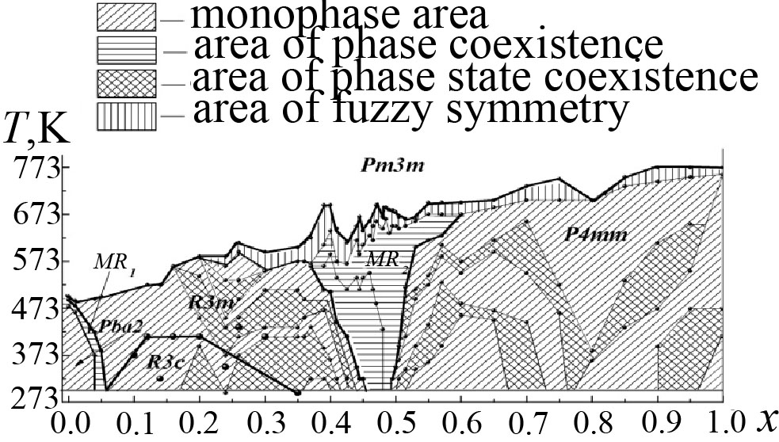
Fig. Full phase x-T- diagram of real SS of PZT system.

This work was financially supported by the Ministry of Education and Science of Russian Federation, state contract № 16.513.11.3032.

Structure Phase Transition in SbO₄C₂₉H₃₁

E.V. Dmitricheva, A.V. Gushcin, V.A. Ivanov, N.V. Somov

Nizhny Novgorod State University, Nizhny Novgorod, 603950, Russia

This work is a descriptive survey of investigation of the phase transitions of the second kind in the crystal of triphenylantimony dimethacrylate Ph₃Sb(O₂CCH=CH₂)₂.
The sample of Ph₃Sb(O₂CCMe = CH₂)₂ was obtained by the oxidative addition of hydrogen peroxide to triphenylantimony in the presence of methacrylic acid [1]. Heat capacities of triphenylantimony dimethacrylate were measured by precision adiabatic vacuum calorimetry over the temperature range from T = (6 to 335) K. Over the range from T = (150 to 167) K, phase transitions are seen [2].
We have decided to investigate the change of the structural features of this crystal in the process of the phase transition. The intensity of independent reflections have been measured on the automatic X-ray diffractometer Oxford Diffraction Gemini S with κ–goniometer and CCD detector SAPPHIRE III. The X-ray experiment was performed at Т = 100(2) К, Т= 140(2) К, Т = 160(2) К, Т = 170(2) К и Т = 293(2) К temperature. Diffraction data collection, data reduction, determination of unit cell parameters, the identification of possible space group symmetry and absorption correction were carried out in the CrysAlisPro program [3]. Solution and refinement of the atomic structure of the crystal have been carried out in the software complex SHELX97 [4].
As a result of the analysis of reciprocal space and atomic structure of triphenylantimony dimethacrylate, we have established the presence of the structural phase transitions of the second kind at Т = 160 K. We have established that crystals of triphenylantimony dimethacrylate with benzene, C₂₉H₂₈O₄Sb, are triclinic space group symmetry $Р\bar{1}$, at all temperatures. Unit cell parameters are given in Table 1. We have observed unit cell parameters variation (V = 3765(1) Å³ at T = 140К and V = 1259(1) Å³ at T = 170К) as a result of the structural phase transitions.

Table 1. Unit cell parameters of the crystals Ph₃Sb(O₂CCH = CH₂)₂
Т, К | Cell |  |  |  |  |  | V, Å³
Т, К | a, Å | b, Å | c, Å | α, ˚ | β, ˚ | γ, ˚ | V, Å³
293(2) | 9.3837(4) | 9.4289(5) | 15.0493(6) | 77.150(4) | 89.358(4) | 88.614(4) | 1297.78(10)
170(2) | 9.2805(2) | 9.3283(3) | 14.9084(3) | 77.356(2) | 89.814(2) | 88.916(2) | 1259.11(5)
160(2) | 9.2747(2) | 9.3384(2) | 14.9056(2) | 77.332(1) | 89.799(1) | 88.949(1) | 1259.35(4)
140(2) | 9.2697(4) | 19.2071(5) | 21.1733(6) | 92.478(2) | 90.789(3) | 9.2697(4) | 3765.7(2)
100(2) | 9.2484(2) | 19.1504(3) | 21.1441(3) | 92.489(1) | 90.772(1) | 9.2484(2) | 3740.79(11)

References
- Gushcin, A. V.; Shashkin, D. V.; Prytkova, L. K.; Somov, N. V.; Baranov, E. V.; Shavyrin, A. S.; Rykalin, V. I. Synthesis and structure of triphenylantimony dimethacrylate. Russ. J. Gen. Chem. 2011, 81, 493–496.
- Alexey V. Markin, Irina A. Letyanina, Vitaly A. Ruchenin, Natalia N. Smirnova, Alexey V. Gushchin, and Dmitry V. Shashkin // J. Chem. Eng. Data 2011, 56, 3657–3662.
- CrysAlisPro, Agilent Technologies, Version 1.171.35.11 (release 16-05-2011 CrysAlis171.NET) (compiled May 16 2011, 17:55:39)
- Sheldrick, G. M. (1997). SHELX97. Programs for Crystal Structure Analysis (Release 97-2). University of Göttingen, Germany.

Temperature Raman Scattering Investigations of Rb₂KHoF₆ and Rb₂KDyF₆ Crystals

A.S. Krylov¹, S.N. Krylova¹ , A.N. Vtyurin¹, V.N. Voronov¹

¹ Kirensky Institute of Physics SB RAS, Krasnoyarsk, 660036, Russia
e-mail: slanky@iph.krasn.ru

The perovskite-like Rb₂KHoF₆ and Rb₂KDyF₆ crystals belong to the family of A₂B⁽¹⁾B⁽²⁾X₆ elpasolites, where A and B are metal cations or more complex molecular ions and X are oxygen or halogen anions (high symmetry phase G₀, space group Fm3m, Z = 4). The structural properties and phase transitions of Rb₂KHoF₆ and Rb₂KDyF₆ crystals were studied by optical microscopy and calorimetry [1]. These crystals demonstrate phase transition under cooling: T = 400 K (into G₁ phase, space group P12₁/n1, Z = 2) for Rb₂KНоF₆ and T = 390 K (into G₁ phase, space group P12₁/n1, Z = 2) for Rb₂KDyF₆. The cause a number of structural phase transitions, which are generally related to changes in the lattice of octahedral groups, such as small pivoting of B⁽²⁾X₆ octahedra and displacement Rb atoms. These changes manifest themselves experimentally in the anomalies lattice dynamics, including the condensation of soft phonon modes during displacive transitions. Phonon spectra investigations Rb₂KHoF₆ cubic phase have performed by neutron scattering method [2]. Soft modes condensations did not find. In the cubic phase Rb₂KHoF₆ have observed diffuse scattering peak. To investigate phase transition mechanism Raman scattering spectra of Rb₂KHoF₆ and Rb₂KDyF₆ crystals have been studied in the wide temperature.
Because of the small sample size we could not
receive polarized Raman spectra. Raman spectra were collected in a backscattering geometry, using a triple monochromator Jobin Yvon T64000 Raman spectrometer operating in double subtractive mode then detected by a CCD cooled at 140 K. The spectral resolution for the recorded Stokes side Raman spectra was set to 1 cm⁻¹ (this resolution was achieved by using gratings with 1800 grooves mm⁻¹ and 100 μm slits). The microscope system based on Olympus BX41 microscope with a 50× objective lens f = 10.6 mm of NA 0.5 provides a focal spot diameter of about 5 μm on sample. Single-mode argon 514.5 nm of Spectra-Physics Stabilite 2017 Ar⁺ laser of 100 mW power (15 mW on the sample) was used as excitation light source. The correlation between the Raman active modes in the monoclinic phase and the modes in the cubic phase is shown in Fig.1. Raman scattering spectra of Rb₂KHoF₆ and Rb₂KDyF₆ crystals have been studied in temperature range from 20 K to 399 K and from 7 K to 500 K correspondingly. Parameters of Raman lines have been quantitatively analyzed. The small values of the line half-widths and their temperature dependences indicate that the vibration damping in the high-symmetry phase is determined by the decay of phonons due to their anharmonicity and is not related to structure disordering.
Figure 1. Raman-active modes correlation diagram.

Acknowledgment. This work was partly supported by Russian Foundation for Basic Research project № 11-02-98002-r, № 12-02-00056, integration project SB RAS № 28, SS-4828.2012.2.

References
1. M.V. Gorev, I.N. Flerov, V.N. Voronov, S.V. Misyul'. PSS 35, 4, 524 (1993)
2. M.V. Gorev, K.S. Aleksandrov, A. Tressaud, J. Grannec, M. Couzi. Mat. Sc. Eng.: Reports, 24, 3, 81 (1998)

Order Parameter of Phase Transition, Fluctuations and Nanoclasters in Benzil Crystals

Yu.F. Markov, E.M. Roginskii

A.F. Ioffe Physical-Technical Institute RAS, 194021 Saint-Petersburg, Russia

e-mail: Yu.Markov@mail.ioffe. ru

The single crystals of benzil (C₆H₅CO)₂ at room temperature occurs in space group $D_{3}^{4}$ (P3₁21). This fascinating organic crystal has been aptly labeled as "organic" quartz, as it being isomorphous with α-quartz. At the T_{c}=83.5K in benzil crystals the triggering (usually strongly first order) phase transition (PT) $D_{3}^{4}→C_{2}^{3}$ from trigonal phase to monoclinic are realized. In the Brillouin and Raman spectra the softening of acoustical and optical phonons were observed respectively [1, 2]. The PT are accompanied by doubling of the unit cell, M→Г folding, arising of spontaneous strain and domain structure. It was assumed that PT occurs at the centre (Г-point) of the Brillouin zone (BZ) which induces the transition at the BZ boundary (M-points) [3]. The benzil crystals are the model objects for investigation of general problems of structural phase transitions (PT).
In present work investigations of this triggering PT have been carried out. The temperature behavior of the PT order parameter and its fluctuations both static and dynamic were obtained. High-frequency fluctuations are connected with soft mode vibrations in para- and ferrophases, which behavior and influence of PT on them were studied. At the cooling (T→T_{c}) the softening of the most low-frequency phonons and appearance in spectra of new lines, associated with the doubling of the unit cell and M-Г folding in BZ were observed [4]. The appropriate critical exponents were determined.
Appearance of the diffuse X-ray maxima at the M-points of BZ (T>T_{c}), connected with nucleus of low-temperature phase have been detected and their behavior (already as fundamental reflections) at T<T_{c} have been studied. The temperature dependence of order parameter in the low-temperature phase and the corresponding critical exponents were obtained. The temperature behavior of diffuse reflexes was studied too. The amplitudes, correlation radiuses (practically sizes of nucleus of low-temperature phase) and critical exponents in high-temperature phase were obtained. The nature of this triggering PT are discussed.

The work was supported in part by programs of the Presidium (P-20) and Division of Physical Sciences of Russian Academy of Sciences.

References
[1] R. Vacher, M. Boissier, J. Sapriel. Phys. Rev. B, v.23, p.215 (1981)
[2] J. Sapriel, A. Boudou and A. Perigaud. Phys. Rev. B, v.19, p.1484 (1979)
[3] J.C. Toledano. Phys. Rev. B, v.20, p.1147 (1979)
[4] M.A.Ivanov, V.A.Kimasov, Yu.F.Markov. Izv. Akad. Nauk Russia, Ser.Fiz.,v. 67, p.1093 (2003)

Isomorphous Phase Transitions on the Phase Diagrams of Ferroelastics

S.V. Pavlov

Lomonosov Moscow State University, Moscow, 119991, Russia
e-mail: swcusp@mail.ru

Lines of isomorphic phase transitions with a liquid-gas critical point are present on phase diagrams of many substances which behavior are described by phenomenological models with two interacting order parameters.
In the improper ferroelastics spontaneous polarization and spontaneous deformation are order parameters. These parameters, as a rule, are conjugated on symmetry owing to a piezoelectric effect or electrostriction in ferroelastics.
Hence, in thermodynamic potential expansion there should be a term dPε or QP²ε, where d and Q are piezoelectric and electrostriction coefficient accordingly. It is common knowledge [1] that presence of such terms in phenomenological models causes occurrence of the liquid-gas critical point and areas of isomorphic phase transitions on the phase diagram. As a simple example it is possible to consider phenomenological model, in which order parameters symmetry is defined by L-group С₂. The full rational basis of invariants of this L-group consists of three invariants: I₁=η², I₂=ξ², I₃=ηξ, where η and ξ are order parameters, and for a ferroelastic η ∼P, ξ ∼ε. The model constructed by methods of the catastrophe theory [2] is that:

Φ=a₁η²+a₂ξ²+a₃ηξ+a₄η⁴+a₅η²ξ²+a₆η⁴ , (1)

where a₁=a′₁(T-T₁), a₂=a′₂(T-T₂), a₄> 0 and a₆> 0. Coefficient a₅ can be both positive and negative.
Phenomenological models with a bilinear member well describe phase transitions in such ferroelastics, as a molybdate of terbium Tb₂(MoO₄)₃ and calomel Hg₂Cl₂. Temperature dependences of spontaneous polarization in these ferroelastics show small anomalies in the low-temperature phase. The crystal symmetry does not change near these anomalies. Ferroelectric-ferroelastic K₃WO₃F₃ is of particular interest. This crystal has cubic high-symmetry phase and undergo sequence of phase transitions: the first from a paraelectric phase to the ferroelectric phase and the second from ferroelectric to the ferroelastic phase. The small anomaly is observed in the latter phase and is theoretically interpreted as transition from incommensurate to a commensurate phase. In this work it is supposed that it is isomorphic phase transition which is described by potential with multicomponent interacting order parameters. Presence in the potential of the electrostriction interactions term of electric and elastic order parameters causes occurrence on the phase diagram of model isomorphic phase transitions points and lines.

References
1. E.I. Kut’in, V.L. Lorman and S.V. Pavlov. Soviet Physics - USPEKHI. 34, 497 (1991)
2. Strukov B.A., R.Poprawski, S.A.Taraskin et.al. Ferroelectrics, 168, 61 (1995)

Dispersion of Phonons and Their Pressure Behaviour
in Model Ferroelastics Hg₂I₂

E.M. Roginskii¹, A.A.Kvasov², Yu.F. Markov¹ and M.B.Smirnov²

¹ A.F. Ioffe Physical-Technical Institute, 194021 Saint-Petersburg, Russia
² Saint-Petersburg State University, 199034 St.-Petersburg, Russia
e-mail: e.roginskii@mail.ioffe.ru

Univalent mercury halide crystals (Hg₂Hal₂, Hal=Cl, Br, I) are isomorphic at room temperature and form body-centered tetragonal lattice ($D_{4h}^{\text{17}}$) with two linear Hal-Hg-Hg-Hal molecules in the unit cell, weakly bonded to each other. The chain structure of these crystals gives rise to a very strong anisotropy in the elastic and optical properties. The crystals Hg₂Hal₂ exhibit unique physical properties, as a record-high birefringence (Δn = +1.48 for Hg₂I₂ crystals) a record low transverse acoustic (TA) velocity (V=253m/sec Hg₂I₂), and a high acousto-optical interaction (M₂ = 4284∙10⁻¹⁸ CGS units for a TA wave). These crystals find application in technology as basic components of acousto-optical filters, acoustic delay lines, polarizers, modulators, deflectors etc.
These crystals are model samples at phase transitions problems studying. When cooled to T_{c} = 186 K (Hg₂Cl₂) and Т_{с} = 144K, (Hg₂Br₂) crystals undergo improper ferroelastic phase transitions from the tetragonal to orthorhombic phase ($D_{4h}^{\text{17}}→D_{2h}^{\text{17}}$), but in the isomorphic Hg₂I₂ PT does not occur even by cooling down to very low temperature (~1.5K) (incipient PT, T_{c} ≈-20K). The PT in Hg₂I₂ crystals was realized at P_{c}=9Kbar (T=300K) only. These PT were induced by the soft TA-mode at the X-point of the Brillouin zone (BZ) boundary of the tetragonal paraphase, accompanied by doubling of the unit cell and the X→Γ folding in BZ.
In the recent work the dispersion of optical and acoustical phonons and density of phonon states of Hg₂I₂ crystals were got. The calculations was performed with “LADY” package. The analysis of various potential models was made and shown that the most primitive model of the potential (the model of rigid ions - RIM) are not fruitful in description of the Hg₂I₂ physical properties.
The best results ware obtained with VFF model (the valence-force field approach). The model gives a very good agreement with experimentally obtained frequencies of phonons in center (Г-point) and boundary (X-point) of Brillouin zone BZ. The dispersion curves in the Г→X ([110]), Г→Z ([001]) and others high symmetry directions, potential parameters and density of phonon states was got.
In the present work theoretical analysis of the hydrostatic pressure influence on lattice dynamics and on acoustical and optical branches dispersion in particular was performed. Dispersion branches was plotted in wide pressure range (0-10Kbar). It was shown that in Г-X direction all branches except soft mode merely sensitive to hydrostatic pressure. It was revealed that the frequency of the soft mode at the BZ boundary ω_{sm} decreases dramatically at increasing of pressure. The pressure behavior of soft mode frequency at X-point was plotted and compared with the soft mode overtone experimentally observed by Raman spectra analysis. The pressure dependence of soft mode at X-point was approximated by line. The same linear approximation was plotted with experimental data. The critical pressure, which corresponds to the soft mode condensation (ω_{sm}=0) was got and compared with the one experimentally obtained.

Acknowledgment. This work was supported in part by Program of Presidium of RAS (P-20).

Изучение Сегнетоэластического Фазового Перехода в Кристаллах SB₅O₇I.

Р.М. Магомадов, Х.С-Х. Ахматов

Чеченский Государственный Университет. Грозный, ул. Киевская 33.
E-mail: Rukman20031@yandex.ru

Иодид окиси сурьмы, Sb₅O₇I существует в пяти политипных модификациях, о физических свойствах и методах выращивания этих кристаллов сообщалось в работах [1,2]. В зависимости от принадлежности к одной из этих модификаций кристаллы являются сегнетоэластиками или сегнетоэлектриками - сегентоэластиками. Кристаллы – модификации относятся к сегнетоластикам, при температуре Т =481 К они испытывают сегнетоэластический фазовый переход. В центросимметричной низкотемпературной фазе кристалл является сегнетоэластиком. Симметрия кристалла допускает в плоскости а-с три возможных напрвления спонтанной деформации, расположенных под углом 120⁰. Механическое переключение кристалла достигается путем приложения в плоскости а-с механического напряжения.
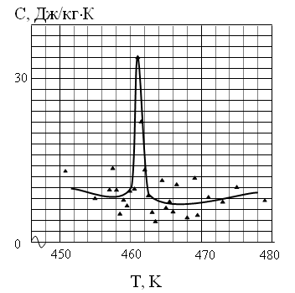
Приложение одноосного
механического напряжения
в этой плоскости, параллельно оси спонтанной деформации, приводит к сдвигу температуры фазового перехода
вверх [3]. Изоморфное замещение Sb на As приводит к понижению температуры фазового перехода кристаллов Sb₅O₇I [4].
20
Нами исследовано влияние примеси As на температуру сегнетоэластического фазового перехода SB₅O₇I.
10
Температура сегнетоэластического фазового перехода кристаллов определялась
методом дифференциально–термического и термогравиметрического анализа на установке «Termoskan – 2». Рис. 1
На рисунке №1 приведена температурная
зависимость удельной теплоемкости кристаллов Sb₅O₇I с примесью As. Как видно из температурной зависимости удельной теплоемкости, сегнетоэластический фазовый переход в кристаллах Sb₅O₇I происходит с поглощением тепла, то есть это фазовый переход первого рода, а примесь As смещает этот фазовый переход на на 20 К вниз.

References
1. Nitsche R., Kramer V., Schumacher M. and Bussman // J. Crystal Growt.1977, v.42, p.549.
2.Nitche R., Kramer V., Schumacher M., and Russman A. // J. Cristal Growt. 1977, v.42, p.549.
3.Магомадов Р.М., Матиев А.Х., Ахматов Х.С-Х. Влияние механических напряжений на физические свойства сегнетоэластиков. // Известия Высших учебных заведений. Северо-Кавказский регион. Естественные науки. 2007, №6, с.38.

О Влиянии Механических Напряжений на Фазовый Переход в Тонкой Сегнетоэластической Плёнке

В.Н. Нечаев, А.В. Шуба

Воронежский государственный технический университет, Воронеж, 394026, Россия

e-mail: vmfmm@mail.ru

В настоящей работе теоретически исследуется фазовый переход в тонкой сегнетоэластической плёнке при приложении вдоль её плоскости механических напряжений с учётом различного контакта плёнки и окружающих её слоев, не испытывающих фазового перехода.
На основании [1] свободная энергия сегнетоэластической плёнки, расположенной в плоскости имеет вид
(1)
где коэффициенты в разложении Ландау свободной энергии, корреляционная постоянная, внешние напряжения, коэффициенты Ламэ, пластическая деформация, являющаяся параметром порядка, описывающим сегнетоэластический фазовый переход, параметр, обратно пропорциональный степени взаимодействия плёнки с окружением. Варьируя функционал (1) получим нелинейное дифференциальное уравнение:
(2)
с граничными условиями общего типа:
(3)
где L – толщина плёнки.
Численное решение (2), (3) позволило определить температуру фазового перехода как функцию внешних напряжений и типа контакта с окружающими слоями.

Литература
1. А.С. Сигов, А.П. Леванюк. Изв. АН СССР. Сер. физич. 43, 8 (1979).

Features of Phase Transitions in Ferroelastic Thin Plates

V.N. Nechaev and A.V. Viskovatyh

Voronezh State Technical University, Voronezh, 394026, Russia
e-mail: ostrogvisk@mail.ru

In addition to the features of nanoscale ferroelastics phase transitions such as the inhomogeneous distribution of the order parameter, the importance of long-range fields, conjugate to the order parameter, etc., of decisive importance to take into account changes in the shape of the sample during the phase transition. Problems of this type are called in continuum mechanics problems with free boundary. In these problems, the boundary region (or part thereof), in which the solution is sought, is unknown and determined in the solution. The purpose of this study is to examine the effect of geometric dimensions and shape of the plate at the ferroelastic phase transition temperature.
In the framework of thermodynamic theory, the dependence of the phase transition temperature of ferroelastic plates on its thickness, taking into account nonlinear effects, and gradient terms in the free energy.
The thermodynamic potential ferroelastic plate is the sum of three terms: the elastic potential , contribution to the thermodynamic potential , associated with the order parameter η, and a term taking into account the interaction of the order parameter with elastic strain .
In addition, take into account that part of the border will be located in such a way that each point on the border turned to zero configuration force (equilibrium condition of the border) [1]:
.

We analyzed the dependence of the angle of φ formed by the top or bottom edge of the plate and lateral faces, in the direction of which is a shift, the thickness of the plates at a temperature of phase transition. Significant contribution to the change of the form of the sample at the phase transition and the value of the configuration force exert stress and deformation in surface areas of the plate.

References
1. A.T. Kosilov, A.M. Perevoznikov, A.M. Roshchupkin. Surface. Physics, chemistry and mechanics. 10, 36 (1983)

Session 2.
Multiferroics

Oral Presentation

Magnetodielectric and Magnetolosses Effects in Statistical Mixtures

A.I. Chernobabov¹ and A.V. Turik²

¹Pyatigorsk State Humanitarian and Technological University, 357500 Pyatigorsk, Russia

²Department of Physics, Southern Federal University, 344090 Rostov-on-Don, Russia
e-mail: kaffiz_pgtu@yandex.ru

Magnetodielectric MD=(ε′(В)-ε′(0))/ε′(0) and magnetolosses ML=(ε′′(В)-ε′′(0))/ε′′(0) effects are a measure of relative change of complex dielectric permittivity ε* = ε′ - i ε′′ under the influence of a magnetic induction В [1,2]. Here ε(0) and ε(В) are dielectric permittivities in absence and in presence of the magnetic induction В, respectively. From the models offered for explanation of magnetodielectric effect, in the present work the combination of magnetoresistance (MR) with Maxwell-Wagner (MW) relaxation [2] is studied. Object of research are two-phase statistical mixtures from equally oriented isotropic components of the spheroidal form.
Following [2] we assume, that conductivities γ₁ and γ₂ of material components are much different from each other and γ₂ exponentially depends on the induction of the applied magnetic field, i.e. we consider, that γ₁ = 10⁻⁶, γ₂ = 10⁻⁴ exp(|B/B_{s}|) (Ω⋅m)⁻¹, where B_{s} = 2 T. Relative dielectric permittivities ε′ of both components are identical and equal 3000. Calculations of tensor components of the composite ε* were performed under the modified Bruggeman-Odelevsky formula [3], in which the depolarization factor of spheres 1/3 was replaced by depolarization factors of spheroid 0 < n_{ii}(ζ) < 1, depending on aspect relations ζ = a/c. For statistical mixtures ε * calculating formula looks like

(1)
-10
-5
0
5
10
-0,8
-0,4
0,0
0,4
0,8
1,2

B
(T )

1
2
3
4
MD ML
Here ε⁽¹⁾, ε⁽²⁾, θ₁ and θ₂ are dielectric permittivities and volume concentrations of both components of the statistical mixture, respectively.
Fig. 1 shows results of our calculation for ε₃₃ of the magnetoresistive statistical mixture from spherical (ζ =1, curves 1, 2) and oblate spheroidal (ζ =10, curves 3, 4) components at equal volume concentrations θ₁ = θ₂ = 0.5. MD (curves 1, 3) and ML (curves 2, 4) have been calculated. In spite of [2], the curve 4 representing ML for the oblate spheroid and similar curve for tgδ, absent in Fig. 1, have two maxima.

Fig. 1. Dependences MD and ML on induction B.
Values ML at a curve (2) are reduced in 100 times.

References
1. A.V. Turik, A.V. Pavlenko, K.P. Andryushin at al. Phys. Sol. State 54, 947 (2012).
2. G. Catalan. Appl. Phys. Lett. 98, 102 902 (2006).
3. J.A. Reynolds and J.M. Hough. Proc. Phys. Soc. 70, part 8, No 452B, 769 (1957).

Magnetodielectric Effect in Laminated Dielectric-Semiconductor Structures

A.V. Turik

Department of Physics, Southern Federal University, 344090 Rostov-on-Don, Russia

e-mail: turik@sfedu.ru

Quantitative measures of magnetodielectric effect (MDE) are magnetodielectric (MD) and magnetolosses (ML, MT) defined as
$\text{MD}(B)=\frac{ε'(B)−ε'(0)}{ε'(0)}$,$\text{ML}(B)=\frac{ε\text{ \backslash ( B \backslash ) - ε}(0)}{ε\text{ \backslash ( 0 \backslash ) \} \} \} \{}}$,$\text{MT}(B)=\frac{\text{tg}δ(B)−\text{tg}δ(0)}{\text{tg}δ(0)}$(1)

(ε′(B) and ε′(0) are real, ε″(B) and ε″(0) are imaginary parts of effective material dielectric permittivity ε =ε′ - iε″ measured at alternating electric field with strength Е in presence and in absence of the constant magnetic induction B, respectively, tg δ = ε″/ε′).
According to model [1], strengthening MDE occurs due to a combination of magnetoresistance (MR) with Maxwell-Wagner (MW) polarization. In model [1] it is supposed, that boundary layers and/or near-electrode layers can possess specific conductivities γ₁, essentially differing from conductivities γ₂ of the grains of ceramics. Generated spin-dependent tunneling of electrons dependence of these conductivities on a magnetic induction B, shows as changes ε′ and ε″ of composite owing to MW polarization.
The magnetic field suppresses local fluctuations of magnetization, weakens the effective potential of defects, enhances return time of a relaxation and a number of the localized carriers on a tail of electronic or hole zone below mobility edge [2]. It is also a mechanism of occurrence huge isotropic negative MR which is well described by the formula γ₂(B)/γ₂(0) ∼ exp(|B/B_{s}|) [1]. The negative MR is mainly due to spin-dependent tunneling where the electrons flow through insulating barriers [3].
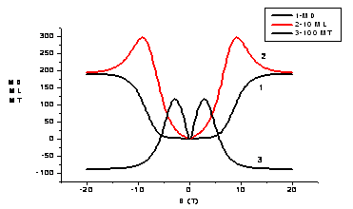
We have shown that in
the Catalan dielectric- semi-
conductor structures appear
a magnetoelectric permittivi-
ty (α ≠ 0; MD∼ B⋅∂α/∂E)
and nonmonotonic depende-
nce (maximum) of ML and
MT values on the magnetic
induction B. This circum-
stance, which has over-
looked by Catalan [1], leads
to change of the MT sign.
Figure shows the results of the calculation of characteristics for magneto-resistive composite with specific conductivities γ₁ = 10⁻¹² (Ω⋅m)⁻¹, γ₂(0) = 10⁻¹¹ (Ω⋅m)⁻¹, permittivities ε′₁(0) = ε′₂(0) = 3000 and volume concentrations of the components θ₁ = 0.005, θ₂ = 1 - θ₁.

References
1. G. Catalan. Appl. Phys. Lett. 88, 102902 (2006).
2. E.L.Nagaev. Uspekhi Fizicheskikh Nauk 166, 833 (1996).
3. C.Y. Chou, P.C. Kuo, Y.D. Yao, A.C. Sun, S.C. Chen, I.J. Chang, J.W. Chen.
IEEE Ttrans. on magnetics 41, 906 (2005).

Direct Magnetoelectric Effect in Layered Composites TDF – PZT

S.A. Gridnev, Yu.E. Kalinin, A.V. Kalgin, E.S. Grigorjev

Voronezh State Technical University, Moskovsky Prospect, 14, Voronezh, 394026, Russia
e-mail: grigoryev_eu@mail.ru

The direct magnetoelectric (ME) effect in two-layered composites Tb_{0.12}Dy_{0.2}Fe_{0.68} – PbZr_{0.53}Ti_{0.47}O₃ (further TDF – PZT) has been studied.
Composites, used for ME studies, have contained stuck together with the epoxy compound plane-parallel plates of the ferromagnetic TDF with thicknesses of 0.3 mm,
0.6 mm, 0.9 mm, 1.2 mm, 1.5 mm, 1.6 mm, 1.7 mm, 1.8 mm, and 2.1 mm and the piezoelectric ceramics PZT with the thickness of 0.3 mm. A length to width ratio for TDF plates is 6 mm : 6 mm and that for PZT plates is 8 mm : 6 mm.
Main results, obtained in this work, are following:
1. The largest value of the ME voltage coefficient α is observed as the angle between directions of the polarization in the PZT plate and the magnetization in the TDF plate is 90º, i.e. in case of the transverse ME effect.
2. The transverse magnetoelectric voltage coefficient α₃₁ vs. the frequency of alternating magnetic field passes through three peaks which maximum values correspond to frequencies of the electromechanical resonance of a composite sample as a whole in three directions. For the longitudinal resonance frequency a value of α₃₁ is maximal and with the thickness of the TDF plate from 0.3 mm to 2.1 mm passes through a peak reaching its maximal value of 125.1 mV/(cm·Oe) at 293 K for a composite with thicknesses
of the ferromagnetic plate and the piezoelectric plate of 1.5 mm and 0.3 mm, respectively (1.5 TDF – 0.3 PZT).
3. Measurement of the ME response of composite samples TDF – PZT over the temperature range of 77 – 488 К shows a peak in the dependence α₃₁(T), which is determined by behavior of the magnetostriction coefficient of TDF with temperature. Cyclic heating-cooling treatment of composites TDF – PZT confirms a relationship of the observed
peak to composite features. For studied composites the maximal ME response is observed at 253 K with the largest value of α₃₁ equal to 149.8 mV/(cm·Oe) for the composite 1.6 TDF – 0.3 PZT. Above 253 K magnetoelectric properties of composites TDF – PZT are weakly decreased with temperature that is due to the depolarization of the piezoelectric component of composites.
4. Field dependences of the transverse ME voltage coefficient have a maximum
which corresponds to the static magnetic field strength Н₌ equal to 720 Oe. The curves α₃₁(Н₌), which were measured as Н₌ was increased from zero to the maximum
value and then was decreased, do not coincide to each other testifying to their hysteresis behavior.
5. Experimental data are discussed in terms of the method of efficient parameters for heterogeneous medium.

Session 2.

Multiferroics

Poster presentation
Structural Phase Transitions and Burns Temperature in PbFe_{0.5}Nb_{0.5}O₃ Multiferroic Probed by Second Harmonic Generation

A. M. Pugachev¹, V.I. Kovalevskii¹, I.P. Raevski², S.A. Prosandeev²,
M.A. Malitskaya², S.I. Raevskaya², V.V. Titov² and I.N. Zakharchenko²

¹ Institute of Automation and Electrometry, Russian Academy of Sciences, Novosibirsk, 630090, Russia
² Research Institute of Physics and Physics Department, Southern Federal University, Rostov on Don, 344090, Russia
e-mail: igorraevsky@gmail.com

A study of second harmonic generation (SHG) in the ternary perovskite multiferroic PbFe_{0.5}Nb_{0.5}O₃ (PFN) single crystals, ceramics, and powders has been carried out in a temperature range 300-800 K. SHG intensity exhibits well-observed anomalies corresponding to rhombohedral-tetragonal and tetragonal-cubic ferroelectric phase transitions. A finite SHG signal was experimentally detected also in the paraelectric phase of PFN. In contrast to BaTiO₃ [1] the normalized SHG intensity in the paraelectric phase is higher in PFN single crystal than in the powder and ceramics. This may be attributed to a higher concentration of intrinsic defects, presumably oxygen vacancies. Such supposition correlates well with much higher n-type conductivity of PFN single crystals as compared to ceramics. Though PFN does not exhibit frequency shift of the permittivity maximum typical of relaxors, SHG intensity shows a distinct change in its temperature dependence at 570-600 K. This anomaly may be attributed to the Burns temperature below which the polar nanoregions appear. Similar SHG anomaly corresponding to the Burns temperature was observed in BaTiO₃ single crystal [1].
Fig. 1. Temperature dependences of the normalized SHG intensity I_{2ω} for the PbFe_{0.5}Nb_{0.5}O₃ single crystal and powder. Rh- rhombohedral, T-tetragonal, C-cubic phases.

Acknowledgment. This work was supported by Russian Foundation for Basic Research (Grants No. 11-02-90428 Ucr_f_a and No. 12-08-00887_a)

References
1. A.M. Pugachev, V.I. Kovalevskii, N.V. Surovtsev, S. Kojima, S.A. Prosandeev, I.P. Raevski, and S.I. Raevskaya. Phys. Rev. Lett., 108, 247601 (2012).

The Effect of Deviations From Stoichiometry on Magnetic Phase Transition Temperature in PbFe_{0.5}Nb_{0.5}O₃ Multiferroic

N.P Vyshatko^{1,2}, A.N.Salak³, A.V. Poushkarev¹, N.M. Olekhnovich¹, I.P. Raevski⁴,
S.P. Kubrin⁴, M.A. Malitskaya⁴, S.I. Raevskaya⁴, A.V. Blazhevich⁴ and I.N. Zakharchenko⁴

¹ Scientific-Practical Materials Research Centre of NAS of Belarus, Minsk, 220072, Belarus
² Bruker AXS, Karlsruhe, 76187, Germany
³ University of Aveiro, Department of Ceramics and Glass Engineering/CICECO,
Aveiro, 3810-193, Portugal
⁴ Research Institute of Physics and Physics Department, Southern Federal University, Rostov on Don, 344090, Russia
e-mail: sveta.raevskaya@mail.ru

Dielectric, X-ray and Mössbauer studies of nonstoichiometric PbFe_{0.5}Nb_{0.5}O₃ (PFN) - based ceramics obtained by solid-state reaction of the appropriate mixtures of PbO, Fe₂O₃ and Nb₂O₅ have been carried out. Temperature T_{N} of the antiferromagnetic phase transition was determined from the temperature evolution of ⁵⁷Fe Mössbauer spectrum. For compositions prepared at ambient pressure deviation from stoichiometric PbFe_{0.5}Nb_{0.5}O₃ composition by changing either Fe/Nb or PbO/(Fe_{0.5}Nb_{0.5}) ratio leads to formation of heterogeneous mixtures containing a limited PFN-based perovskite solid solution and Fe₂O₃, PbO or pyrochlore Pb₃Nb₄O₁₃ –type phases. Similar to the A-site doping of PFN [1], PbO-deficiency leads to decrease of T_{N}. Increasing or decreasing the Fe-content in the starting mixture of oxides as compared to stoichiometric PFN composition, leads to increase or decrease of T_{N} respectively. However T_{N} changes in nonstoichiometric PFN ceramics prepared at ambient pressure are rather modest and usually do not exceed 10-20 K. The only exception are compositions with the ratio Fe/Nb <1, exhibiting lowering of T_{N} by 80-100 K. To study this large effect the high pressure synthesis of the (1-x)PbFe_{0.5}Nb_{0.5}O₃-xPbNb_{0.8}O₃ solid solution system was carried out. It was found that the solubility limit in this system at high pressures increases 4-5 times as compared to synthesis at ambient pressure and reaches x ≈ 0.2. The parameter of the quasi-cubic unit cell increases linearly with x in the 0<x<0.2 range. The values of T_{N} decrease monotonically as x grows. However above a certain compositional threshold the fast decrease of T_{N} stops and a new magnetic state with comparatively high
(~50 K) transition temperature becomes stable in a rather wide compositional range. Similar character of T_{N}(x) dependence was observed previously in the (1-x)PbFe_{0.5}Nb_{0.5}O₃-xPbTiO₃ solid solutions [3]. Besides lowering of T_{N} in the major part of the sample, for some compositions an increase of T_{N} up to 180-200 K was observed in a part of a sample’s volume.

Acknowledgment. This work was supported by Russian Foundation for Basic Research (Project No.
12-02-90019 Bel_a) and Belarusian Republican Foundation for Basic Research (Project No. Т12R-077)

References
1. I.P. Raevski, S.P. Kubrin, S.I. Raevskaya, V.V. Stashenko, D.A. Sarychev, M.A. Malitskaya, M.A. Seredkina, V.G. Smotrakov, I.N. Zakharchenko, and V.V. Eremkin. Ferroelectrics. 373, 121 (2008).
2. I. P. Raevski, S. P. Kubrin, S. I. Raevskaya, V. V. Titov, D. A. Sarychev, M. A. Malitskaya, I. N. Zakharchenko, and S. A. Prosandeev. Phys. Rev. B. 80, 024108 ( 2009).
3. I.P. Raevski, S.P. Kubrin, S.I. Raevskaya, S.A. Prosandeev, M.A. Malitskaya, Yu.N.Zakharov, A.G. Lutokhin, V.V. Titov, D. A. Sarychev, E.I.Sitalo, A.V. Blazhevich, and I.N. Zakharchenko. Proc. Intern. Sympos. Applications of Ferroelectrics (ISAF/PFM),1(2011).

Studies of Magnetic Phase Transitions in PFW-PT Multiferroic Solid Solutions by Neutron Diffraction and Mössbauer Spectroscopy

I.P. Raevski¹ , S.P. Kubrin¹, S.I. Raevskaya¹, A.V. Blazhevich¹, A. A. Naberezhnov², E.A. Dyadkina³, M.S. Seregin², J.-U. Hoffman⁴

¹ Research Institute of Physics and Physics Department, Southern Federal University, Rostov on Don, 344090, Russia
² Ioffe Physical technical Institute, RAS, St.Petersburg, 194021, Russia
³ Petersburg Nuclear Physics Institute, Gatchina, St.Petersburg, 188300, Russia
⁴ Helmholtz Zentrum Berlin, Berlin, D-14109, Germany
e-mail: igorraevsky@gmail.com

Detecting the temperature T_{N} of the antiferromagnetic phase transition in multiferroic solid solutions is often a hard task. This is due to the fact that above a certain content of the second component a weak anomaly in the magnetic susceptibility or magnetization corresponding to T_{N} becomes practically invisible [1,2]. In the present work T_{N} values for
(1-x)PbFe_{2/3}W_{1/3}O₃ –xPbTiO₃ (PFW-xPT) compositions with x=0; 0.2; 0.3 have been determined from the temperature evolution of either the low-angle elastic neutron scattering (Fig.1) or the Mössbauer spectrum of ⁵⁷Fe [3] (Fig.2). For PFW-0.2PT composition the anomaly in the temperature dependence of the unit cell volume was found at T_{N}.

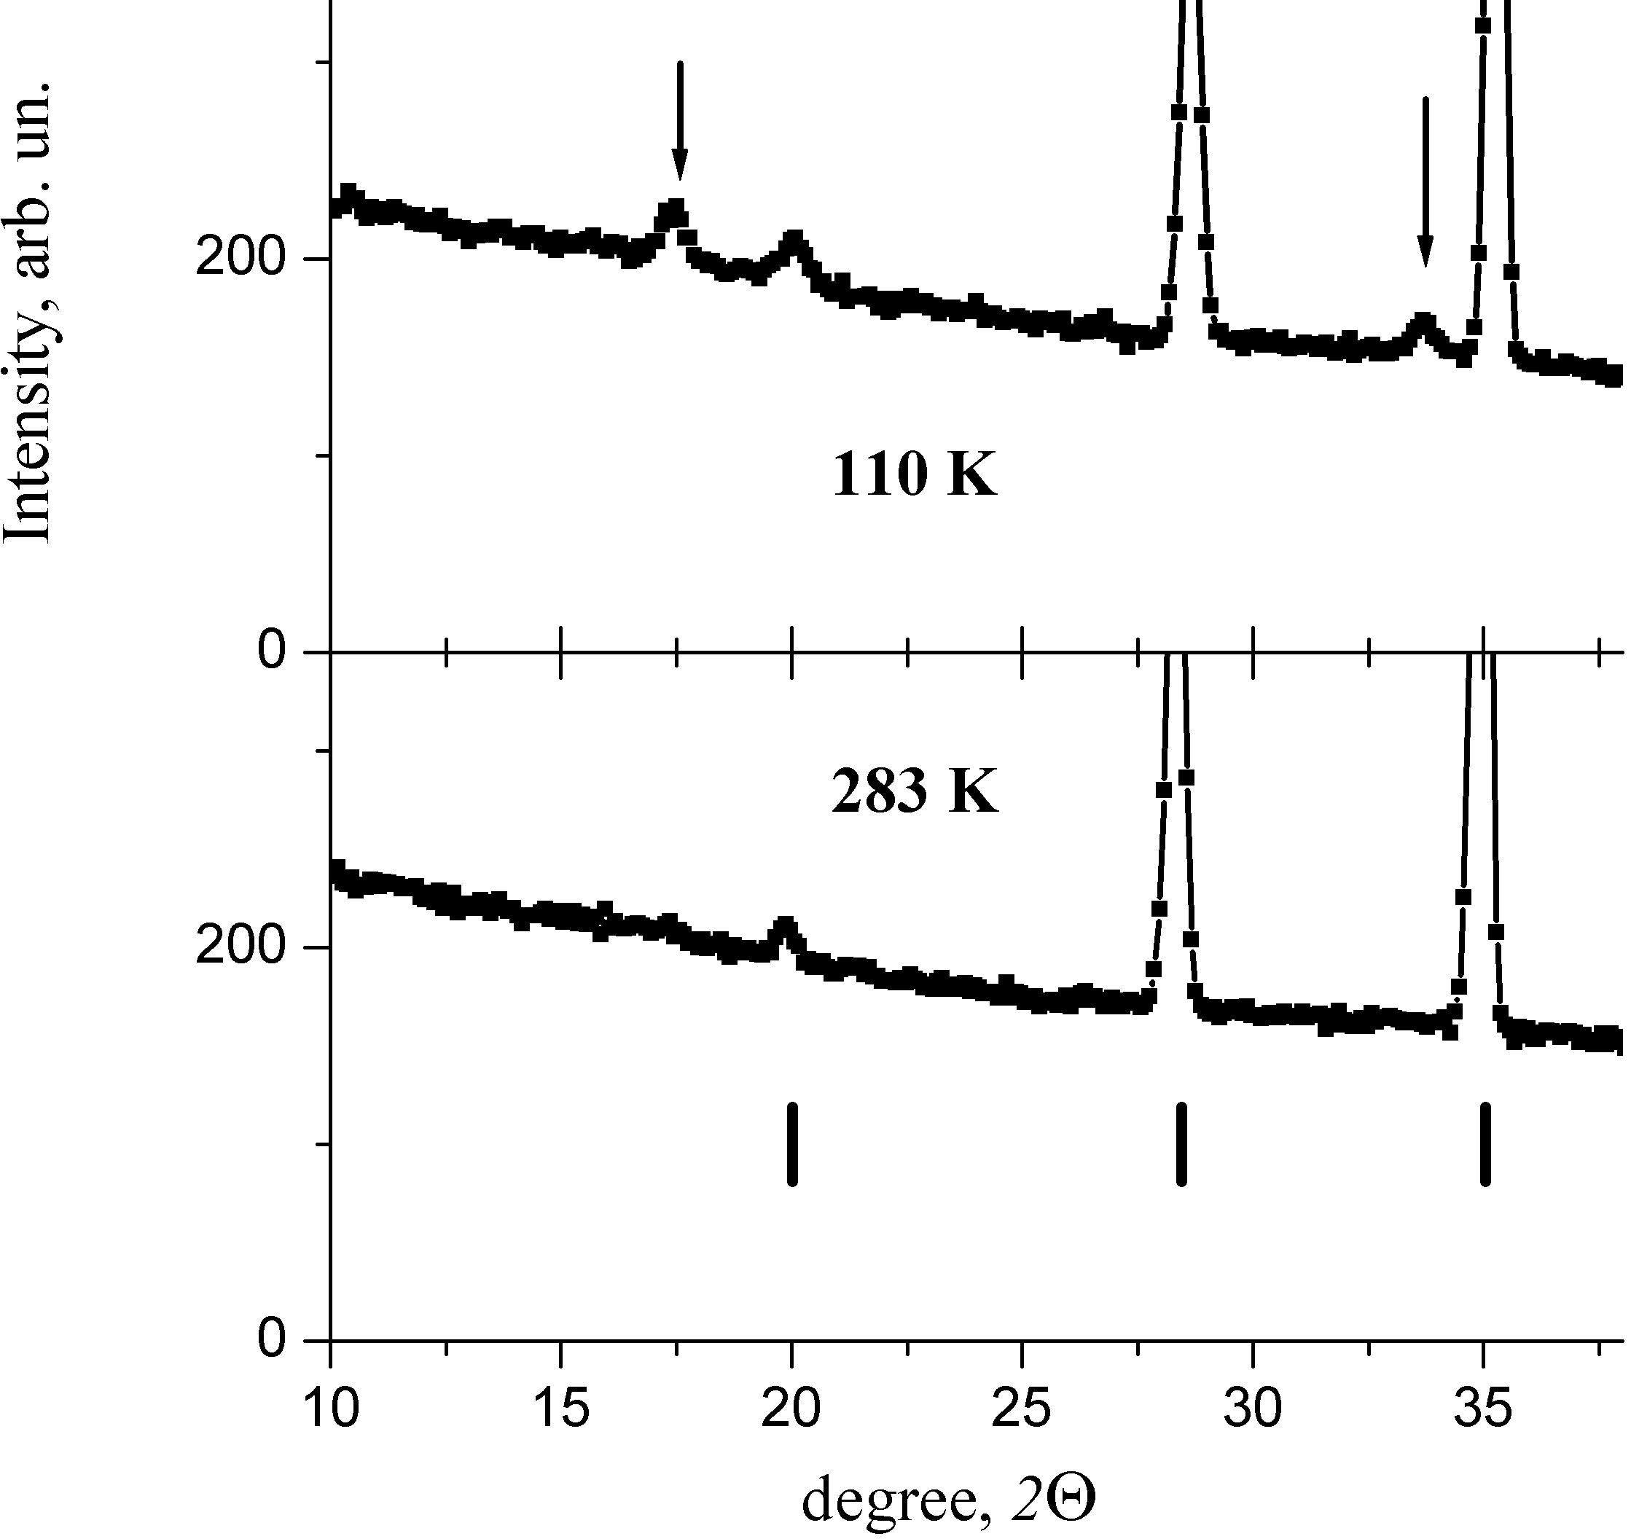
Fig.1 Temperature evolution of low-angle elastic neutron scattering for PFW-0.2PT. Arrows mark the magnetic superstructure peaks (1/2 1/2 1/2 ) and (1/2 1/2 3/2). | Fig.2 Temperature evolution of the relative intensity of resonance absorption in Mössbauer spectrum for PFW-xPT compositions with x=0 and x=0.3.

Acknowledgment. This work was supported by Russian Foundation for Basic Research (Grant No.
11-02-90428 Ucr_f_a)

References
1. L.Mitoseriu, D. Marre, A. S. Siri, and P. Nanni. Appl. Phys. Lett., 83, 5509 (2003).
2. S. P. Singh, S.M. Yusuf, S. Yoon, S. Baik, N. Shin, and D. Pandey. Acta Mater. 58, 5381 (2010).
3. I.P. Raevski, S.P. Kubrin, S.I. Raevskaya, V.V. Stashenko, D.A. Sarychev, M.A. Malitskaya, M.A. Seredkina, V.G. Smotrakov, I.N. Zakharchenko, and V.V. Eremkin. Ferroelectrics. 373, 121 (2008).
Магнитодиэлектрический Эффект в Сегнетокерамике Pb(In_{1/2}Nb_{1/2})O₃

С.А.Гриднев, М.Ю. Воскобойник

Воронежский государственный технический университет, Воронеж, 394026, Россия
e-mail: mukluyd@gmail.com

С фундаментальной точки зрения сосуществование сегнетоэлектрического и магнитного порядков вызывал пристальный интерес исследователей ещё с 80-х годов прошлого века. Механизм сегнетоэлектричества в перовскитовых сегнетоэлектриках АВО₃, требует, чтобы катионы в позиции B имели незаполненную d орбиталь, что несовместимо с магнитным упорядочением. Чтобы обойти эту несовместимость, в одном из направлений исследований предлагалось создавать материалы с нетрадиционными механизмами сегнетоэлектричества и/или магнитного упорядочения.
В данной работе проводилось исследование магнитодиэлектрического эффекта (МДЭ) в релаксорной сегнетокерамике PbIn_{0.5}Nb_{0.5}O₃. Образцы были получены из НИИ физики Южного федерального университета.
Диэлектрические свойства измерялись в приложенном постоянном магнитном поле Н напряженностью до 2 кЭ при комнатной температуре (т.е. в сегнетоэлектрической фазе) на частотах в диапазоне 25 Гц – 5 кГц. В результате было обнаружено, что с увеличением Н действительная и мнимая компоненты диэлектрической проницаемости (ε’и ε”) образца уменьшаются, причем отклик этих величин на магнитное поле (МС,%) уменьшается при увеличении частоты измерительного поля (рис.1), на основании чего был сделан вывод, что магнитное поле влияет на доменную структуру релаксора.
а) б)

Рис.1 Зависимости величины магнитоёмкости от магнитного поля для неотожженного (а) и отожженного (б) образца PIN при разных частотах: 1 –25; 2 – 110; 3 - 210; 4 - 510; 5 - 1000; 6 - 2000; 7 – 5000 Гц.

Возникновение МДЭ эффекта в сегнетоэлектриках во внешнем магнитном поле, может быть объяснено на основе модели возникновения магнитного момента, создаваемого током переполяризации при боковом смещении доменной границы [1].

Литература
1. Флерова С.А., Чупис И.Е. // Известия РАН. Сер. физ., 1993. Т. 57, №3, стр. 20-22.

Two-Layered Magnetoelectric Composites TDF – PZT:
New Approach to Preparation and Properties

S.A. Gridnev, Z.H. Gribe, and A.V. Kalgin,

Voronezh State Technical University, Moskovskii prospect, 14, 394026, Voronezh, Russia
e-mail: kalgin_alexandr@mail.ru

Layered magnetoelectric (ME) composites, thanks to the absence in them of the mutual doping of phases, have mainly better ME properties in comparison with particulate composites. Most of layered ME composites are alternating layers of magnetostriction and piezoelectric materials stuck together with the epoxy compound. However, the stuck layer makes worse the elastic energy transfer between magnetostriction and piezoelectric layers leading to the decrease in a ME response of composites. Therefore, in the present work a new approach to the preparation of layered ME composites by the example of two-layered ferromagnetic-piezoelectric composites Tb_{0.12}Dy_{0.2}Fe_{0.68} – PbZr_{0.53}Ti_{0.47}O₃ (further TDF – PZT) was proposed. According to this approach, using carefully mixed the micron-sized TDF powder with mass of 1.66 g. and the epoxy compound with mass of 0.36 g., we created a stiff consistency of the mixture that was applied to pre-polarized in industrial conditions piezoelectric PZT plates. For 24 h the magnetic layer was curing. In fact, the magnetic layer was a particulate composite consisting of an organic matrix with the filler in the form of TDF particles randomly distributed in the matrix. Thus, one could assume that the mechanical contact between the magnetostriction layer on the basis of TDF and the PZT layer would be better than in a usual two-layer composite.
Composites, used for ME studies, have contained plane-parallel layers of the ferromagnetic TDF with thicknesses of 0.6 mm, 0.9 mm, and 1.2 mm and the piezoelectric ceramics PZT with the thickness of 0.3 mm. A length to width ratio for TDF plates has been 6 mm : 6 mm and that for PZT plates has been 8 mm : 6 mm.
It is established that the largest value of the ME voltage coefficient has been in case of the transverse ME effect. Maximal values of the transverse ME voltage coefficient α₃₁ have been achieved at the longitudinal electromechanical resonance frequency of composites TDF – PZT as a whole and have been of 18.7 mV/(cm·Oe), 28.7 mV/(cm·Oe), and 30.7 mV/(cm·Oe) for composites with thicknesses of the magnetic layer of 0.6 mm, 0.9 mm, and 1.2 mm, respectively. Obtained values of α₃₁ proved to be much smaller than values α₃₁ for two-layered composites TDF – PZT prepared by the traditional technology [1]. The results are discussed.

Acknowledgment.The work has been executed at financial support of RFBR (grant no. 10-02-00336).

References
[1] Gridnev S.A., Kalinin Yu.E., Kalgin A.V., and Grigoryev E.S. Direct magnetoelectric effect in two-layered composites TDF – PZT over a temperature interval of 77 – 500 K // Abstracts of the 52nd scientific and technical conference of the faculty, staff, post-graduate students, and students. Voronezh: VGTU. 2012. P. 6.

Magnetic Properties and Magnetoelectric Interaction of
Bi_{1-x}A_{x}FeO₃ (A=La, Nd) Multiferroics

A.A. Amirov ¹, I.K. Kamilov¹, L.A. Reznichenko ², O.N. Razumovskaya ², I.A. Verbenko ²

¹ Institute of Physics, Dagestan Scientific Center of Russian Academy of Sciences, 94 Yaragskogo Street, Makhachkala, Russia
² Institutes of Physics, South Federal University, 194 Stachki Street, Russia
e-mail: amiroff_a@mail.ru

Compounds on base of BiFeO₃ are very perspective multiferroic materials due to high temperature of magnetic and ferroelectric phase transitions, bad conductivity and simple chemical structure [1-2].
High quality ceramics were synthesized on the basic of Bi_{1-x}A_{x}FeO₃ (A=La, Nd; x=0-0.2) solid solutions. Their crystal and grain structure, Mossbauer spectra, dielectric, magnetic, thermal characteristics were studied. The ac-susceptibility vs. temperature curve of BiFeO₃ has a sharp peak at 646 K which corresponds to the antiferromagnetic phase transition and it is confirmed by literature data [3].
The anomalies of dielectric permeability, spacing parameter and heat capacity near temperature of antiferromagnetic order T_{N} were observed in all samples which is typical for multiferroics. The magnetization curves also have been studied at the room temperature for the samples. The magnetization of pure BiFeO₃ is small and grows linearly with magnetic field. Such type of magnetization curve is typical for antiferromagnetic materials. La and Nd substitutions lead to increase magnetic properties of BiFeO₃. The substitution Bi by La or Nd changes the temperature of the antiferromagnetic order and increases the magnetization of pure BiFeO₃. The magnetic properties change occurs not only on account of magnetic moment and ionic radiuses (lanthanum atom has no its magnetic moment), but also because of La and Nd ions magnetic moments anisotropy. A rare-earth substituent can change the anisotropy constant, so that the presence of SMSS would be energy-wise disadvantageous [4].

References
- J. Wang et al., Science 299, 1719 (2003)
- A.K. Zvezdin and A.P. Pyatakov, Sov. Phys. Usp. 47, 8 (2004).
- Sosnowska and A. K. Zvezdin, J. Magn. Magn. Mater 140–44, 167 (1995)
- M. Kadomtseva, A. K. Zvezdin et. al., Sov. Phys. JETP 79, 705 (2004)

Session 3.
Structure, Crystal Growth and Optical Properties

Oral Presentation
Crystals Chemistry Consideration of Acousto-Optical Ferroic Crystals.

E.F. Dudnik, S.V. Akimov

«Technologies Science & Development Center “Ecospectrum” Ltd. Dnepropetrovsk 49038, Ukraine

e-mail: akimov.serge@mail.ru ; akimov@a-teleport.com

Proposed crystal-chemical classification of acousto-optical crystals, based on the concept of structural type. Name of a structural type, as a rule, to the name of a known material according to established marks. This approach has allowed to unite the acousto-optic crystals in the family, having similar crystal-chemical properties. Allocated 18 of the families of the acousto-optic crystals related to the different structural types. In the framework of the proposed classification scheme are considered the most numerous representatives of acousto-optic materials crystals, mainly, oxygenated inorganic compounds, to which also belong to the acousto-optic crystals and which in particular have been investigated by the authors and described in the works [1-7]. Most of the families acousto-optical crystals on the type of insertion complexes in space were divided into the following crystal-chemical classes.

Table 1. Crystal-chemical classes acousto-optical crystals
Class | Family
I. Acousto-optical crystals with isolated anion complexes:
a) simple (island) complexes - the tetrahedral anionic groups in crystals are isolated from each other; | Scheelite, Fergusonite,  Palmierite, Apatite
b) isolated anionic groups, when combined, form a polyhedron metal atom, resulting in the creation of a laminated structure. | Double lead molybdate  Bismuth molybdate
II. Acousto-optical crystals with anionic or cationic complexes connected through the vertices (ribs or planes) in the endless line fragments (chains, tapes; sub-chains;, sub-tapes;) or two-dimensional layers structures | Rutile, Aluminium oxide. Lithium Niobate
III. Acousto-optical crystals with anionic or cationic complexes united through the vertices and (or) planes, forming a three-dimensional frame or three-dimensional ligature. To this class should include acousto-optic crystals, having the frame substructure. | Quartz, Cristobalite,  Paratellurite, Perovskite  Potassium-tungsten bronze, Pyrochlore
IV. Acousto-optic crystals with anionic complexes, related hydrogen bonds. | KDP
V. Ion (molecular) crystals. | Calomel
VI. Covalent crystals. | Diamond
It is found that most of the acousto-optic crystals are ferroic and belong or to ferroic of the first order (ferroelectrics, ferroelastics), or to ferroic of higher order (for example, to ferroelastoelectrics), or possess a combination of the ferroic’s properties of the first and higher orders at the same time.
The proposed crystal-chemical classification makes it possible to produce further effective search for the acousto-optic materials on the basis of the ferroic crystals, necessary for the development of new directions of modern technics on the basis of Photonics

References
1. E.V. Sinyakov, S.V. Akimov, V.G. Pozdeev, V.G. Savchenko. Phys. Solid State. 18, №10, 3164 (1976)
2. S.V. Akimov T.M. Stolpakova, E.F. Dudnik, E.V. Sinyakov. Phys. Solid State. 19, №8, 1832 (1977).
3. S.V. Akimov., E.F. Dudnik, T.M. Stolpakova, G.V. Dovchenko. Phys. Solid State. 20, №3, 944 (1978).
4. S.V. Akimov, I.Ye. Mnushkina, E.F. Dudnik. Technical Physics. 51, №11, 784 (1981).
5. E.F. Dudnik, S.V. Akimov. Phys. Solid State.1978, 20, №9, 2815 (1978).
6. S.V. Akimov M.D. Volnyaskii V.G. Monya, E.F. Dudnik. Technical Physics. 49, №11, 2490 (1979).
7. S.V. Akimov, V.G. Monya. Phys. Solid State. 21, №8, 2533 (1979).

Structure and Properties of the Ceramic SrTiO₃-BiScO₃ System

O.N. Ivanov, E.P. Danshina

Joint Research Centre “Diagnostics of structure and properties of nanomaterials”,
Belgorod State University, Belgorod, 308015, Russia
e-mail: ivanov.oleg@bsu.edu.ru

Perovskite-type SrTiO₃-BiScO₃ system is a new system interesting to study the possibility of ferroelectric state formation in multicomponent systems consisting of nonferroelectric components. In this system strontium titanate, SrTiO₃, is known to be an incipient ferroelectric lying near the limit of its paraelectric phase stability. Pure SrTiO₃ retains a nonpolar centrosymmetric crystal on cooling down to the lowest temperature at T → 0 K. Weak external influences including various impurities substituted for the host ions in crystal structure can destroy a paraelectric state and induce a ferroelectric phase transition in incipient ferroelectrics.
BiScO₃ is an interesting end member for fabrication of new ceramic solid solutions. Despite its utility in solid solutions, there is little knowledge about BiScO₃ member itself. Although it has been speculated that it may be ferroelectric, no experimental confirmations were reported.
Ceramic solid solutions of (1-x)SrTiO₃-xBiScO₃ system with x=0, 0.05, 0.1, 0.2, 0.25, 0.3, 0.35, 0.4, 0.45 and 0.5 were synthesized via solid-state processing techniques.
X-ray diffraction analysis revealed that at room temperature the ceramic (1-x)SrTiO₃-xBiScO₃ samples with x > 0 consist of mixture of cubic centrosymmetric Pm3m phase and tetragonal polar P4mm phase. Lattice parameters for these phases arise as x increases. In addition, it was found by EBSD method that at room temperature fraction of the cubic phase decreases and fraction of the tetragonal phase increases as the mole fraction of BiScO₃ increases. Phase coexisting is assumed to be one of reasons of relaxor properties for the system under study.
Dielectric measurements of the compositions with x > 0 demonstrated anomalies associated with diffuse ferroelectric phase transition. The degree of diffuseness of a phase transition, σ, was estimated within the framework of the Smolenskii-Isupov model developed for two-component systems A(B’_{1-x}B’’_{x})O₃ or (A’_{1-x}A’’_{x})BO₃. It was also found that a greater percentage of BiScO₃ resulted in a higher degree of diffuseness and stronger relaxor behaviour. This can be explained by the increased cation disorder due to the substitution on the A-site by Bi and on the B-site by Sc in the SrTiO₃ structure.
It should be noted that temperature dependence of dielectric permittivity for relaxors can be analyzed in the spherical ‘random field-random bond’ model. The SRFRB model predicts a transition to the ferroelectric phase, the dipolar glass state or mixed ferroelectric-dipolar glass state at various values of model parameters. The SRFRB model parameters extracted from the best dielectric data fitting for all compositions under study allows us to conclude the samples of the (1-x)SrTiO₃-xBiScO₃ system with x > 0 should undergo a transition to the spherical glass state.
Acknowledgment. This work was financially supported by Ministry of Education and Science of Russian Federation under Contract No 16.552.11.7004.

Growth of Piezoelectric Potassium Bromate Crystals from
Electrolyte Solutions

B.I. Kidyarov
A.V. Rzhanov Institute of Semiconductor Physics SB RAS, Novosibirsk, 630090, Russia
e-mail: kidyarov@isp.nsc.ru

The crystals of potassium bromate (KBrO₃) have high piezoelectric, electrooptic and nonlinear optical properties [1]. In pure water solution one could observed the unstable formation perfect pyramidal-prismatic, rhombohedral, plate and imperfect crystals having solution inclusions and incorrect growth form: twinned, dendritic, pine-tree, fernlike, skeleton and other non-completed crystals [2]. The maximum supercooling of KBrO₃ solution is dependent essentially on solution overheating and one is achieved to 50-60°С. According to our phenomenological classification KBrO₃ is related to the second group-AII of salts, solutions of which have essential memory crystallization effect. At the crystal growth of these salts, it is necessary without fail to search of suitable poly-component solution. In this connection, given work is devoted to study of crystallization and crystal growth of KBrO₃ from multi-component aquosystem: 1-Са(NO₃)₂ - Ba(NO₃)₂ - H₂O, 2 -Са(NO₃)₂ - Pb(NO₃)₂ - H₂O, 3 -Са(NO₃)₂ - ZnSO₄ -H₂O, 4 -Са(NO₃)₂ - Zn(NO₃)₂ - ZnSO₄ -H₂O, 5- Са(NO₃)₂ - Pb(NO₃)₂ - ZnSO₄-H₂O, 6-Zn(NO₃)₂- ZnSO₄- Pb(NO₃)₂ - H₂O. The 10x10x10 mm crystals were grown from optimal solutions on prismatic seed by a cooling method with a rate of ~ 03 ÷0.5°С a day in the 5-litres crystallizer. The crystal of KBrO₃ is trigonal C_{3v}, space groupe R3m [1-2]. The next faces are observed on this crystal: pyramids {1‾11} and {‾11‾1}, prisms {110}, pyramids {102} and {‾10‾2}, pedion (001). Pedion is not observed in work [2]. The main growth forms of this crystals are: a- holohedral prisms with top and bottom pyramids, b-, c- prismatic skeleton crystals, d- dendritic, pine-tree, fernlike crystals, e- holohedral rhombohedrons, f- hollow rhombohedrons, g- thick hollow plates, h- hollow prisms or separate lateral plate of prism, i- growth twins, plate polytwins, four-fold crystals, j- asymmetric rhombohedrons. In case of initial KBrO₃ salt with a mark “chemical purity”, it is observed as rule formation of imperfect crystals, which have often numerous solution inclusions: b- d, f- h. In binary aquosystem Са(NO₃)₂ - H₂O, contained Са(NO₃)₂ ⋅ 4H₂O with a mark of “high purity”, grow uncompleted imperfect and dendritic crystals, while in case of reagent with a mark of “pure for analysis” it is also observed a formation perfect prismatic-pyramidal crystals and then an imperfect rhombohedrons. An addition of “chemical purity” Ba(NO₃)₂ into water (~0.02-0.3 g/litre) is influenced to crystallize prismatic-pyramidal crystals and then (~0.5-0.8 g/litre) perfect and imperfect rhombohedrons. In aquosystem Са(NO₃)₂ - Ba(NO₃)₂ -H₂O, contained 5-20 g/litre “high purity” Са(NO₃)₂ ⋅ 4H₂O and ~0.02-0.3 g/litre Ba(NO₃)₂, can be formed perfect prismatic-pyramidal and some rhombohedral crystals and also the same imperfect crystals. The most perfect prismatic-pyramidal crystals grow at concentration of ~0.04 and ~0.18 g/litre Ba(NO₃)₂. In binary aquosystem Pb(NO₃)₂ - H₂O, contained 0.005-0.03 g/litre Pb(NO₃)₂, the perfect rhombohedral crystals are also formed. At small concentration of Са(NO₃)₂⋅4H₂O (~1-4 g/litre) and content of ZnSO₄ – 0.2-0.4 g/litre it is formed more isometric perfect KBrO₃ crystals. So, the KBrO₃ perfect crystal growth is reproducible only from some optimal multi-component aqueous solution.

References
- О.А.Doil’nitsina, B.I.Kidyarov, Yu.N. Polivanov Кratkie soobtsheniya po fizike.
Eksperimental’naya i teoreticheskaya fizika. М.: FIAN, №6, p.21 (1985). (In Russian).
- B.I.Kidyarov, R.R.Nevyantseva, Dandaron N.D., L.F. Zaitseva. Izvestiya SO AN SSSR,
ser. khim. nauk, 1984. в.5, №15, p.51. (In Russian).

Optical Studies of Antiferroelectric Cs₂Nb₄O₁₁ Single Crystal

Hsiang-Lin Liu¹

¹Department of Physics, National Taiwan Normal University, Taipei 11677, Taiwan
e-mail: hliu@ntnu.edu.tw

We report a joint experimental and theoretical investigation of the optical properties of Cs₂Nb₄O₁₁ single crystal. In room-temperature optical absorption spectra, we found a direct gap about 3.55 ± 0.05 eV and charge transfer excitations at about 4.96 and 6.08 eV, which are in good agreement with the first-principles calculations. Upon passing through the 165 ºC antiferroelectric to paraelectric phase transition, the peak energies of two charge transfer bands display almost no temperature dependence, yet they become even broader and exhibit enhanced oscillator strength. We infer this intriguing behavior as the manifestation of Nb cation distortions due to the charge-lattice interaction.

Acknowledgment. This work was supported by National Science Council of Republic of China under Grant No. NSC 98-2112-M-003-004-MY3

References
1. H. L. Liu et al. J. Appl. Phys. 110, 103515 (2011)

Interrelationship «Structure – Property» for Crystals of
Non-centrosymmetric Wolframates

B.I. Kidyarov, and V.V. Atuchin

A.V. Rzhanov Institute of Semiconductor Physics SB RAS, Novosibirsk, 630090, Russia
e-mail: kidyarov@isp.nsc.ru

Structure and physical properties are tabulated for ~ 100 non-centrosymmetrical (NCS) crystals of simple and binary tungstates and tungsten-bearing oxides. A simple empirical way to classify the known acentric wolframates M_{m}E_{n}W_{p}O_{t} is presented. As a basic criterion the shortest chemical bond length L(E, M-O) between cation and oxygen in crystal lattice is taken [1]. Here the cations E and M are defined by the relation 124 ≤L(E-O)≤202 pm<L(M-O). In the plane L(M-O) - L(E-O) the acentric wolframate crystals are positioned inside of three intersected ellipses of «acentricity», Fig.1. The wolframate crystals with high non-linear optical (NLO) and others acentric physical parameters are concentrated near axis lines into the ellipses or positioned near the boundary of the rosette revealing non-monotonic dependency of the properties on their shortest chemical bond lengths, having two maxima at L(E-O) = 173 and 187 pm, Fig.2.
The crystal of в-LiWNbO₃ (C_{3v}) has the most NLO susceptibility among all oxide crystals. The distribution of all NCS wolframate crystals on point symmetry is also sharply non-monotonic with maximum for C_{2v} and D₂, T_{d}. This methodology allows to clбssifỷ more reliable acentric wolframates and it is useful to predict their NLO properties.

Fig.1. Ellipses of «acentricity» for the simple and binary wolframate crystals. Dark symbols are designated the crystals having high NLO properties. | Fig.2. The dependence of NLO- susceptibility (ч⁽²⁾) on the shortest bond length L(W-O) for wolframate crystals.
References
1. V.V.Atuchin, B.I. Kidyarov and N.V. Pervukhina // Computational Materials Science, 30, 411 (2004).

Orientational Order and Birefringence in Nano-Layers in Casted Polymer Films

A. V. Maksimov, T. A. Val’kova, O.G. Maksimova and E.V. Proutorov

Cherepovets State University, Lunacharskii Pr. 5, Cherepovets,
Vologda region, 162600 Russian Federation, e-mail: a_v_maximov@mail.ru

In the “planar-chain model” [1] the value of quadrupole orientational order parameter S₀= - 0.5 independently on the chain bending rigidity. Therefore, this model does not explain experimental dependence of S₀ on the chain bending rigidity. Spontaneous ordering of fragments of chain molecules near the surface in casted polymer films must be described in terms of the multichain model with local intra- and interchain orientational interactions of chain kinetic units and transversal fluctuations of their orientation in the approximation of strong planar orientation order in the layers. Chain packing in the plane-ordered state is impossible unless the interchain interaction parameter b = 2K₂/k_{B}T > b_{c}. The value of b_{c} decreases with chain bending rigidity (parameter a = 2K₁/k_{B}T). The calculated dependences [2] of the limiting values of the quadrupole orientation order parameter S₀ on the reduced length of the Kuhn statistical segment A = 2a describe reasonably well the experimental data obtained in a study of the orientational order parameter on the chain bending rigidity of polymer films for polymer-homologue polysaccharides [3], sulphonated phenyl-containing polymers [4], and poly-tri-methil-silyl-propynes [5] at mean values of interchain interactions parameter b = 1.75, b = 1.1 and b = 6.0 correspondingly. The monolayer thickness in films of some polysaccharides and sulphonated phenyl-containing polymers has been calculated from the fitting of the theoretical to the experimental dependences of the birefringence on the width of the polymer films.

References
1. A. V. Maksimov and Yu. Ya. Gotlib, Vysokomol. Soedin., Ser. A 30, 1411 (1988). 2. A. V. Maximov, G. M. Pavlov, Polymer Science A 49, Vysokomol. Soedin.,Ser. A. 49, 1239 (2007).
3. G. M. Pavlov, А.S. Gubarev, I.I. Zaytseva, U.А. Fedotov. Polymer Science A 49, Vysokomol. Soedin.,
Ser. A 49,1476 (2007).
4. G.M. Pavlov and A.E. Grishchenko, Polymer Science B 47, Vysokomol. Soedin., Ser.B 47, 1882 (2005).
5. L.V. Naumova, A.E. Grishchenko, Polymer Science B 47, Vysokomol. Soedin., Ser. A 47, 2056 (2005).

This work was supported by the Federal Target Program “Scientific and Scientifically-Pedagogical Manpower of Innovational Russia on 2009 – 2013”

Session 3.
Structure, Crystal Growth and Optical Properties

Poster Presentation

The Growth KDP with KMnO₄ and K(SbO)C₄H₄O₆∙1/2 H₂O

A.E. Egorova, V.N. Portnov

N.I. Lobachevsky State University of Nizhny Novgorod, Nizhny Novgorod, 603950, Russia
e-mail: ae-egorova@yandex.ru

Crystals of potassium dihydrogen phosphate are widely applied in science and techniques, medicine and food industry.
In this work we grew crystals of potassium dihydrogen phosphate with potassium permanganate.
It was established KMnO₄ influence on the growth of KDP. Crystals got brown coloring, and it was visible that in sector of growth of a side of a prism concentration of manganese more than in sector of growth of a bipyramid. Potassium permanganate (КMnO4) addition to the KDP (KН₂PO₄) solution increases the growth rate of the {100} faces and decreases that of the {101} ones. The complex ion MnНPO⁴⁺ is an impurity affecting {101} face growth rate. The Mn³⁺ ion replaces the K⁺ ion in the KDP structure and causes the change of hydrogen positions. The increase of the {100} face growth rate is connected with the capture of MnO₂ partiсles. The doping of KDP crystals by Mn decreases the effective quadratic nonlinear sensitivity of crystals.
The analysis of element structure of crystals was carried out on a Wavelength Dispersive X-Ray Fluorescence Spectrometer of Shimadzu Lab Center XRF-1800 on intensity К-line of characteristic x-ray radiation (HRI) of potassium and manganese. Measurements were carried out in three points of each crystal with use previously the constructed calibration curves. Concentration of atoms Mn calculated .
It was established K(SbO)C₄H₄O₆•1/2 H₂O influence on the growth of KDP too.
Crystals of KDP + K(SbO)C₄H₄O₆•1/2 H₂O were grown at a room temperature. The summits of the bipyramid are rounded. The natural pyramidal faces develop only partly from the edges of the adjacent prismatic faces, and the area of the (Oil) faces is very much diminished.

References
1. Vorontcov D.A., Egorova A.E., Kim E.L., Marychev M.O., Petrova A.A, Portnov V.N., Somov N.V//Vestnik. N.I. Lobachevsky State University of Nizhny Novgorod №5 (2), 2010. P.210-213

The Growth Copper and Zinc Tartrate Crystals

M.L. Labutina, M.O. Marychev, N.V. Somov

Nizhny Novgorod State University after N.I. Lobachevsky, Nizhny Novgorod, 603950, Russia
e-mail: marychev@yandex.ru

One of the important problems of condensed matter physics is the synthesis, growth, study nonlinear optical crystals properties, and setting relation structure-dependent properties of the composition, symmetry and atomic structure. The ability to double the frequency of the laser radiation is one of the structural-dependent nonlinear properties of crystals. In this paper, we investigated tartrates, because of their nonlinear optical properties are poorly studied. The growing of copper, calcium, manganese, strontium, cobalt, barium, tin, zinc and iron tartrate crystals in gel [1] has been caused by search of new nonlinear optical materials for second harmonic generation. Gel was prepared on the basis of sodium metasilicate and tartaric acid. The water solutions of CuCl₂∙2H₂O, Ca(NO₃)₂∙4H₂O, MnCl₂∙4H₂O, Sr(NO₃)₂, CoSO₄∙7H₂O, BaCl₂, SnCl₂∙2H₂O, ZnSO₄∙7H₂O and FeCl₃∙6H₂O were used as a feeding substances. Obtained crystals were transparent, visually homogeneous, and have the linear dimensions 1-4 mm. These crystals haven’t the center of inversion. The SHG experiment on the powder samples [2] of grown crystals has been carried out. Effective values of a second-order nonlinear susceptibility of the copper, calcium, manganese, strontium, cobalt, barium, tin, zinc and iron tartrate crystals relatively to the powder sample of KDP crystal was measured. Received values for copper, calcium, manganese, strontium, cobalt, barium, tin, zinc and iron tartrate crystals are 0.32 ± 0.02, 0.29 ± 0.01, 0.65 ± 0.01, 0.52 ± 0.01, 0.12 ± 0.03, 0.35 ± 0.01, 1.38 ± 0.02, 0.48 ± 0.03 and 0.06 ± 0.02 respectively. For the first time in our laboratory the mixed tartrate copper and zinc crystals was grown. Gel was prepared on the basis of sodium metasilicate and tartaric acid. The water solutions of CuCl₂∙2H₂O and ZnSO₄∙7H₂O were used as a feeding substances. Obtained crystals were transparent, visually homogeneous, and have the linear dimensions 1-3 mm.
The degree of small deviations from center-symmetric condition of the crystal structures influences on intensity of second-harmonic generation (SHG). Therefore the value of pseudosymmetry was calculated on the basis of X-ray data for each crystal structure. Structures of clear and mixed crystals were defined by single crystal X-ray diffraction. X-ray diffraction data were obtained by Oxford Diffraction (Gemini S) diffractometer with graphite monochromated Mo-K_{α} radiation (λ=0.71073 Ǻ) and CCD Sapphire III detector in the ω-scan mode at a room temperature. The crystal structure was solved by direct methods (Shelx97) [3] and refined by full matrix method (Shelx97) [3]. The reflection data were processed by analytical absorption correction algorithm [4]. All non-hydrogen atoms were refined with anisotropic correction.

Acknowledgment. This work was supported by leading scientific schools grant 2883.2012.5.

References
1. H. Henish The growth crystals in gel. M.: Mir, 112 (1973)
2. S.K. Kurtz and T.T. Perry, J. App. Phys. 39. No.8. July. 3798 (1968)
3. G.M. Sheldrick, Acta Cryst. A64, 112 (2008)
4. C. Katayama, Acta Cryst. A42. 19 (1986)
Investigation of the Structural Conditionality for Changes in Physical Properties of K₉H₇(SO₄)₈·Н₂О Crystals

I.P. Makarova, V.V. Grebenev, T.S. Chernaya, I.A. Verin and V.V. Dolbinina

Shubnikov Institute of Crystallography of Russian Academy of Sciences, Moscow, Russia
e-mail: secr@ns.crys.ras.ru

Currently, K₉H₇(SO₄)₈∙Н₂О crystals are the only representative of the M₉H₇(XO₄)₈∙xН₂О family. They were obtained for the first time at the IC RAS, and measurements of conductivity showed that crystals undergoes a superprotonic phase transition at T ≈ 398 K.
The interest in compounds of M_{m}H_{n}(XO₄)_{(m+n)/2} (М = K, Rb, Cs, NH₄; X = S, Se, P, As) is related to the solution of the fundamental problem of physics of condensed state: phase transitions and stabilization of phases with high proton conductivity in order to design new functional materials. In most H-containing crystals, H atoms completely occupy crystallographic positions and form a regular network of H-bonds. Superprotonic crystals form a peculiar class in which changes occur in the network of H-bonds at phase transitions, which lead to radical changes in properties, in particular, to the conductivity of ≈10^{–2} Ω^{–1}cm^{–1}. These crystals are unique in a class of proton conductors, since superprotonic conductivity is related to structural features of these compounds, instead of consequence of impurity doping process.
X-ray data allow to draw a conclusion on the distinction of structural mechanisms of conductivity in M_{m}H_{n}(XO₄)_{(m+n)/2}·xН₂О. In M₃H(XO₄)₂ the proton conductivity is caused by the formation of dynamically disordered network of H-bonds in which both positions of the centers and orientations of H-bonds are disordered, that enables protons to move over vacant crystallographically equivalent positions [1], [2]. The occurrence of high conductivity in K₉H₇(SO₄)₈∙Н₂О [3] is related to diffusion of crystallization water and motion of K ions, as well as to the transformation of the system of H-bonds and protonic motion. The stabilization of the high-temperature superprotonic phase and its supercooling to low temperatures are due to the presence of channels for K ions (Fig. 1.) and slow backward diffusion of water in the crystals.

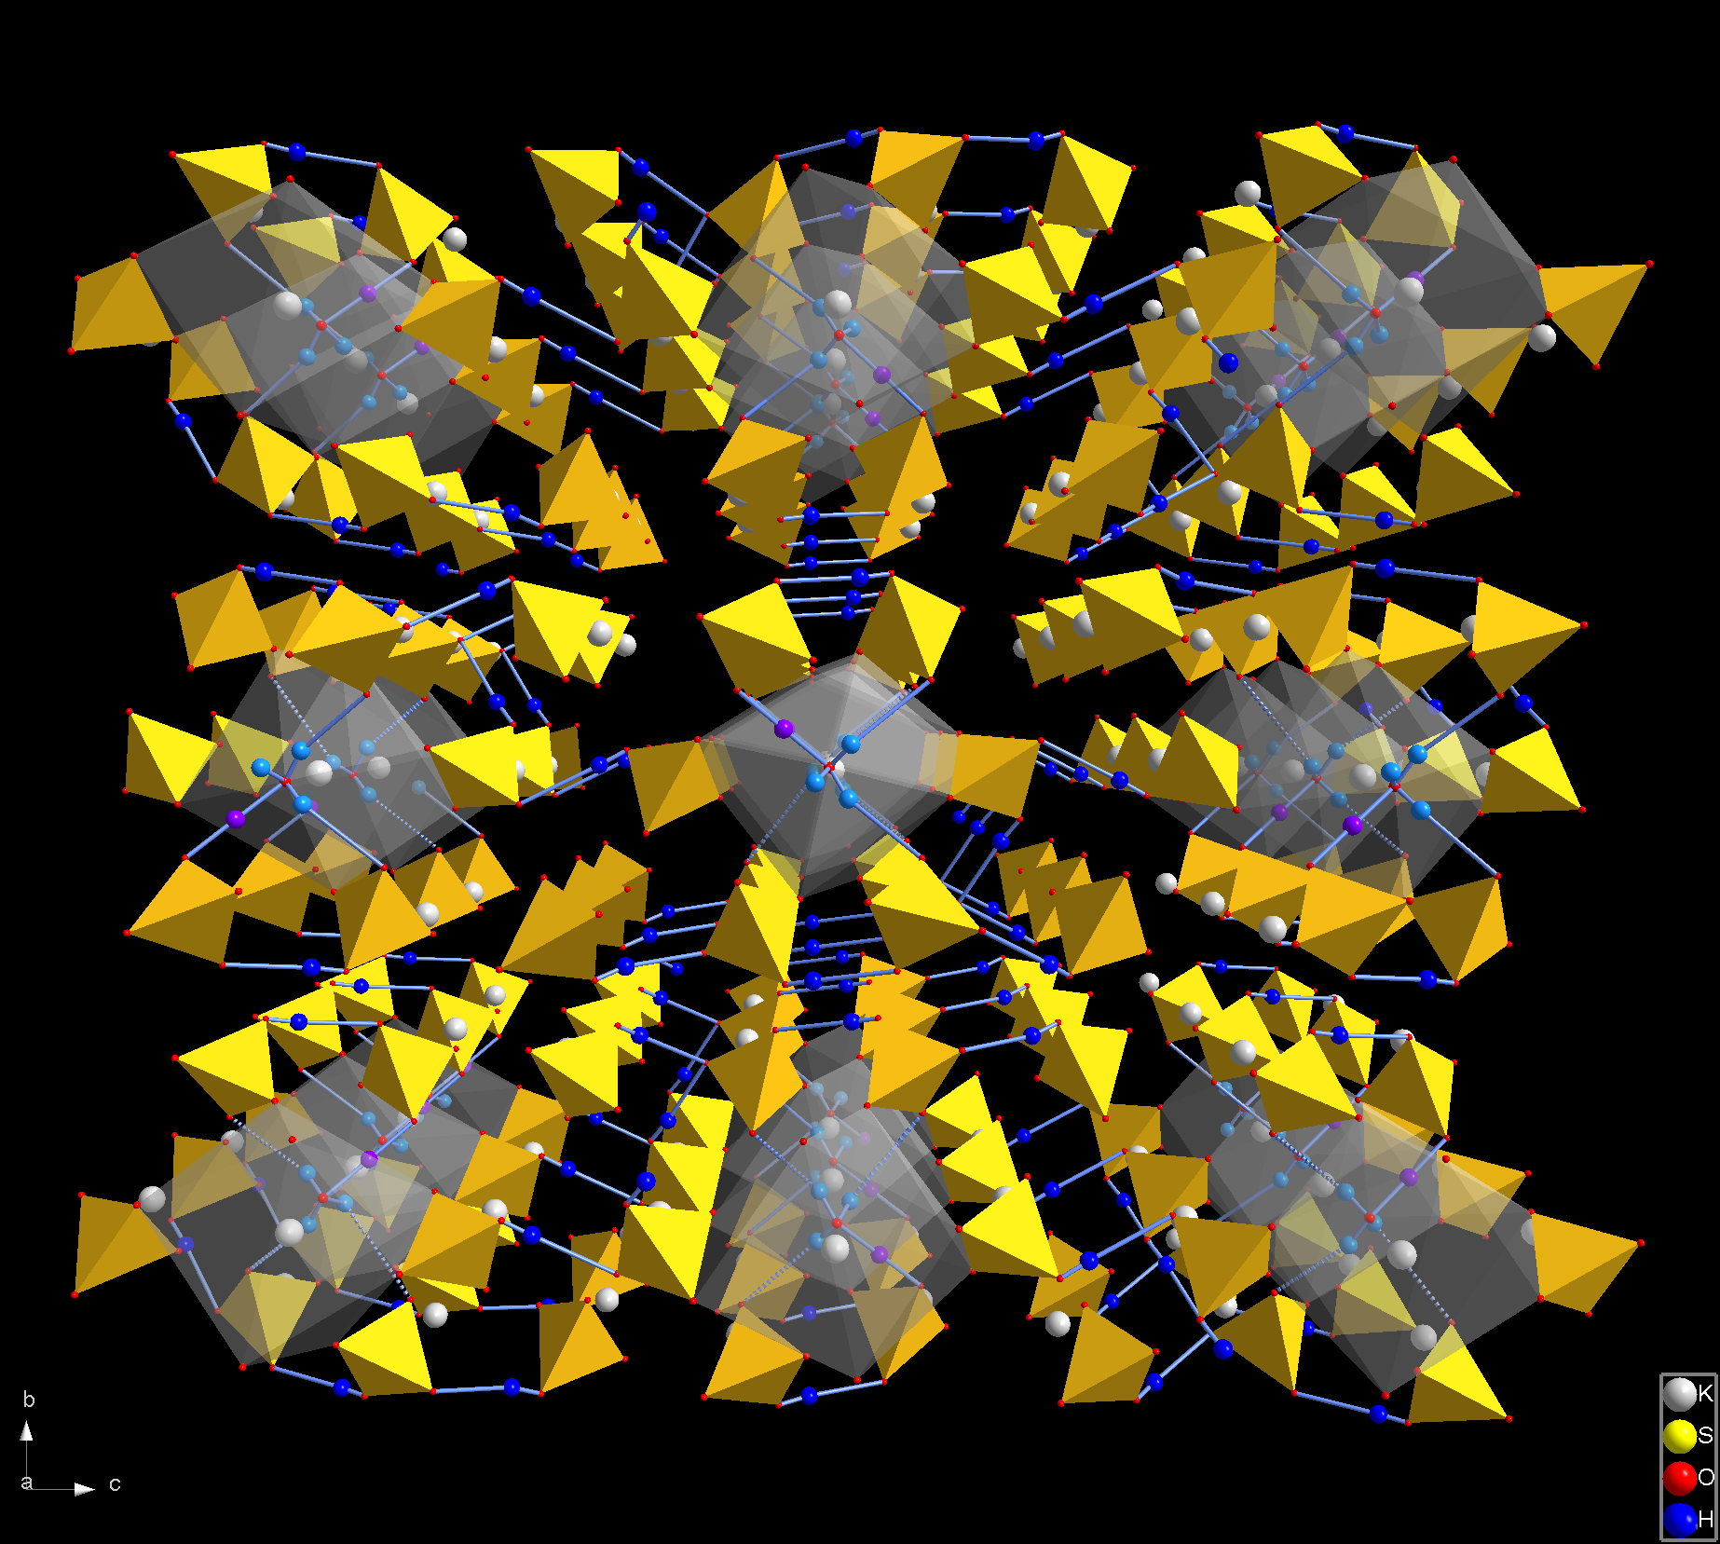

Fig. 1. Atomic structure of K₉H₇(SO₄)₈∙Н₂О crystals. Coordination polyhedra of K9 atoms and SO₄ tetrahedra are shown.

Acknowledgment. The work was supported in the frame of the program “Physics of new materials and structures” of the Department of Physical Sciences of RAS and by the RFBR grants №11-02-01145.

References
1. I.P. Makarova, T.S. Chernaya, A.A. Filaretov, et al. Crystallography Report 55 (3), 393-403 (2010).
2. A.I. Baranov, I.P. Makarova, L.A. Muradyan, et al. Sov. Phys. Crystallogr. 32 (3), 400-406 (1987).
3. I.P. Makarova, T.S. Chernaya, V.V. Grebenev, et al. Crystallography Report 56 (6), 994-1003 (2011).
Effect of MnO₂ and Li₂CO₃ on the Structural, Microstructural and Electrophysical Properties of PbFe_{0.5}Nb_{0.5}O₃ Ceramics

A.V. Pavlenko, S.I. Shevtsova, L.A. Shilkina, A.A. Pavelko, L.A. Reznichenko.

Research Institute of Physics, Southern Federal University,
Rostov-on-Don, 344090, Russia
e-mail: tolik_260686@mail.ru

Despite the fact that ferroelectromagnet PbFe_{1/2}Nb_{1/2}O₃ (PFN) perovskite ceramics as well studied to date, there are contradictions in the literature regarding its properties that are usually associated with sensitivity of those to technology of ceramic production. The stabilization of PFN properties in some cases is achieved by introducing the elements that generate the liquid phase during the ceramic manufacture process. This phase have a significant impact on the "elementary" stage of mass transfer during the synthesis, sintering, recrystallization of the object. Oxide of manganese (IV) and lithium carbonate (I) are among the modifiers. In this regard, it seems urgent to study the influence of these substances on the regularities of formation of structural and dielectric properties of PFN ceramics, together with a detailed analysis of the microstructure.
The pure PFN ceramics and ceramics modified over the stoichiometry of 1 mol. % MnO₂ (PFNM) and 1 mol. % Li₂CO₃ (PFNL) obtained by the usual ceramic technology from solid state sintered powders. The lack of impurities in the objects was established by X-ray method. The samples have rhombohedral structure with slightly different cell parameters at room temperature. The introduction of MnO₂ and Li₂CO₃ led to a decrease in the sintering temperature of ceramics from 1100 °C (PFN) to 1060 °C (PFNM) and 1080 °C (PFNL).
Studying the microstructure fragments of etched and cleaved objects it is revealed that the PFN and PFNM average grain size is 4 ÷ 6 μm, and in RFNL - 8 ÷ 12 μm. The essential difference in the effect of modifiers revealed in the analysis of the cleavages, which are held both along the grains and grain boundaries in the case of PFN, in the case of RFNL destruction is carried out through the grain boundaries only, and the presence of "liquid phase" located between the grains in the form of "layers" of thickness ~ 0,3 μm is noted. In PFNM destruction is carried out mostly through the grains. The modification has led to an increase in resistivity at room temperature with 2,9·10⁷ Ω·m, in the case of PFN, up to 7,2·10⁹ Ω·m and 2,6·10¹⁰ Ω·m, and in cases of PFNM and PFNL, respectively. Ferroelectric (FE) properties of the materials were manifested in the study of dielectric hysteresis loops at temperatures of (30 ÷ 120) °C. In PFN saturated FE loops could only get up to a temperature ~ 75 °C, and in PFNM and PFNL up to (110 ÷ 120) °C, because of the increase of ceramics conductivity. Curie temperature of PFN, PFNM and PFNL determined from dielectric measurements are 98 °C, 97 °C and 96 °C, respectively. This fact allows us to suggest that PFNL and PFNM refer to FE with a diffuse phase transition, and the diffuseness increases in line PFN → PFNL → PFNM.
We believe the observed effects to indicate the localization of modifiers at the grain boundaries, and their partial embedding in B-positions, which in the case of Li is attributed to the proximity of its ionic radius with radius of Nb. The most effective is the modification with Li (the largest reduction in electrical conductivity, higher values of piezoproperties and their reproducibility).

This work was financially supported by the Ministry of Education and Science of the Russian Federation, state contract № 16.513.11.3032
Growth, X-Ray and Dilatometric Studies of PbFe_{0.5}Nb_{0.5}O₃-PbTiO₃ Crystals

V.G. Smotrakov, V.V. Eremkin, A. F. Semenchev, S.I. Raevskaya, S.I. Shevtsova,
I.P. Raevski, M.A. Malitskaya and I.N. Zakharchenko

Research Institute of Physics and Physics Department, Southern Federal University, Rostov on Don, 344090, Russia
e-mail: igorraevsky@gmail.com

Solid solutions (1-x)PbFe_{0.5}Nb_{0.5}O₃ – xPbTiO₃ (PFN-xPT) exhibit very high piezoelectric properties [1] and promising multiferroic behaviour [2]. In the present study PFN-xPT single crystals (0≤x ≤0.22) in the form of cubes up to 3-4 mm on edge were grown by spontaneous crystallization using PbO - B₂O₃ as a flux. The crystals of all compositions obtained have a black colour and rather high (> 10⁻⁵ Ohm⁻¹·cm⁻¹ ) dc conductivity at room temperature. X-ray diffraction studies have shown that pure PFN has a rhombohedral symmetry, in crystals with x≈0,07 both rhombohedral and tetragonal phases are present while crystals with higher Ti content are tetragonal. Results of dilatometric studies (Fig.1) correlate well with the x-ray data. Temperature dependences of relative thermal expansion are sharply different for single crystals of rhombohedral and tetragonal compositions. Phase transition temperatures determined from dilatometric data agree well with the x,T-phase diagram of PFN-xPT solid solutions plotted using the results of dielectric, pyroelectric and piezoelectric studies of highly-resistive PFN-xPT ceramics [1].
Fig. 1. Temperature dependences of relative thermal expansion ΔL/L for some compositions of
(1-x)PFN-xPT solid solution single crystals: 1 – x=0; 2 – x=0,07; 3 – x=0,12; 4 – x=0,22; 5- x=1.
The insert highlights the ferroelectric phase transition region for x=0 composition.

Acknowledgment. This work was supported by Russian Foundation for Basic Research (Grants No.
11-02-90428 Ucr_f_a and No. 12-08-00887_a)

References
1. E.I.Sitalo, I.P. Raevski, A.G. Lutokhin, S.P. Kubrin, S.I. Raevskaya, Yu.N. Zakharov, M.A. Malitskaya, A.V. Blazhevich, I.N. Zakharchenko. Ferroelectrics, 419, 76 (2011).
2. I.P. Raevski, S.P. Kubrin, S.I. Raevskaya, S.A. Prosandeev, M.A. Malitskaya, Yu.N.Zakharov, A.G. Lutokhin, V.V. Titov, D. A. Sarychev, E.I.Sitalo, A.V. Blazhevich, and I.N. Zakharchenko. Proc. ISAF-PFM-2011. Vancouver, Canada. 6014097 (2011).

XAFS Study of Structural Position and Oxidation State
of Mn Impurity in CaTiO₃

A.I. Lebedev¹, I.A. Sluchinskaya¹, D.A. Zadorin¹, A. Erko²

¹ Physics Dept., Moscow State University, Moscow, 119991, Russia
² Helmholtz-Zentrum Berlin, 12489 Berlin, Germany
e-mail: swan@scon155.phys.msu.ru

The search for new off-center magnetic impurities, which can result in simultaneous ferroelectric and magnetic ordering and magnetoelectric interaction in crystals, attract much attention. Materials with such properties are referred to as multiferroics. Recently, in SrTiO₃ doped with magnetic Mn impurity, whose off-centering has been proven by direct EXAFS measurements [1], a new type of magnetoelectric interaction was discovered [2]. In this work, the structural position and the oxidation state of the Mn impurity in CaTiO₃ samples prepared under different conditions were studied using XAFS spectroscopy methods. The dielectric and electron spin resonance (ESR) measurements of the samples were also performed.
Samples with the impurity concentration of 2–5% and different deviation from stoichiometry were prepared by the solid-phase synthesis method and annealed at 1100–1500 °C. The EXAFS and XANES spectra were recorded at the KMC-2 station of the BESSY synchrotron radiation source in fluorescence mode at the Mn K-edge at 300 K.
To determine the oxidation state of the Mn impurity, the position of the absorption edge in XANES spectra were analyzed. The analysis showed that the Mn ions in CaTiO₃ can be in two oxidation states, 2+ and 4+, depending on the preparation conditions. According to the EXAFS data, the Mn⁴⁺ ions are located at the B sites and are on-center (R_{Mn-O} = 1.90 Å). Although the EXAFS spectra of (Ca_{1-x}Mn_{x})TiO₃ were contaminated by small signal from Mn at the B sites, it was concluded that in these samples the Mn ions are predominantly in the 2+ oxidation state, occupy the A sites, and are on-center.
From the analysis of ESR spectra of CaTiO₃(Mn) samples, the g-factor and the isotropic hyperfine coupling constant A were evaluated. The obtained parameters are: g = 2.00 and A = 86·10⁻⁴ cm⁻¹ for the sample with predominant substitution at the A site, and g = 2.00 and A = 81·10⁻⁴ cm⁻¹ for the sample with the impurity at the B site.
Dielectric measurements in the 77–300 K temperature range of CaTiO₃(Mn) samples prepared under different conditions showed shifts of the extrapolated Curie temperature to more negative values, indicating the weakening of the ferroelectric instability in CaTiO₃ when doping it with manganese at both the A and B sites.

Acknowledgment. I.A.S. and A.I.L. are grateful to the Russian-German laboratory for hospitality and financial support during their stay at BESSY.

References
1. A.I. Lebedev, I.A. Sluchinskaya, A. Erko, V.F. Kozlovskii. JETP Lett. 89, 457 (2009) [Pis’ma v ZhETF 89, 545 (2009)].
2. V.V. Shvartsman, S. Bedanta, P. Borisov, W. Kleemann, A. Tkach, P. M. Vilarinho. Phys. Rev. Lett. 101, 165704 (2008).

XAFS Study of Structural Position and Oxidation State
of the Ni Impurity in SrTiO₃

I.A. Sluchinskaya¹, A.I. Lebedev¹, A. Erko²

¹ Physics Dept., Moscow State University, Moscow, 119991, Russia
² Helmholtz-Zentrum Berlin, 12489 Berlin, Germany
e-mail: irinasluch@nm.ru

SrTiO₃ is a perovskite-type crystal widely used in microelectronics. The nickel impurity acts as an acceptor and significantly increases the resistivity of strontium titanate. Nickel creates the energy levels in the forbidden gap of SrTiO₃ and strongly modifies its optical properties. This results in a strong absorption in the visible light region, which enables to consider SrTiO₃(Ni) as a promising material for new generation of photocatalysts and solar energy converters.
On the other hand, there is a need to search for new magnetic off-center impurities, which can produce simultaneous ferroelectric and magnetic ordering and so, can result in interesting magnetoelectric properties. Materials with these properties belong to multiferroics. Recently, in the SrTiO₃ incipient ferroelectrics with the Mn off-center magnetic impurity, a new type of magnetoelectric interaction has been discovered [1].
In this work, a possibility of off-centering of the Ni magnetic impurity in SrTiO₃ is checked. To determine the structural position and the oxidation state of Ni in SrTiO₃, XAFS-spectroscopy techniques were used.
Samples with the impurity concentration of 2–3% and different deviation from stoichiometry were prepared by the solid-phase synthesis method and annealed at 1100–1500 °C. The EXAFS and XANES spectra were recorded in fluorescence mode at the KMC-2 station of the BESSY synchrotron radiation source (the beam energy 1.7 GeV, the electron beam current up to 290 mA) at the K-edge of Ni at 300 K. The EXAFS spectra were processed in the conventional way.
X-ray diffraction study showed that only the SrTi_{0.97}Ni_{0.03}O₃ sample annealed at 1500 °C was single-phase. Other samples contained traces of the second phase, but the correct identification of the composition of the second phase using X-ray diffraction was difficult.
To determine the oxidation state of the Ni impurity, the position of the absorption edge in XANES spectra was analyzed. It was shown that in the single-phase SrTi_{0.97}Ni_{0.03}O₃ sample annealed at 1500 °C, Ni ions are in the oxidation state close to 4+. In SrTi_{0.97}Ni_{0.03}O₃ and Sr_{0.98}Ni_{0.02}TiO₃ samples annealed at 1100 °C, its oxidation state is close to 3+, whereas in the Sr_{0.98}Ni_{0.02}TiO₃ sample annealed at 1500 °C, the oxidation state of Ni is 2+. The changes of the oxidation state were consistent with the color of the samples, which varied from pale brown for Sr_{0.98}Ni_{0.02}TiO₃ (1100 °C) to almost black for SrTi_{0.97}Ni_{0.03}O₃ (1500 °C).
According to the EXAFS data analysis, in the single-phase SrTi_{0.97}Ni_{0.03}O₃ sample annealed at 1500 °C the Ni ions are located at B sites and are on-center (R_{Ni-O} = 1.92 Å, R_{Ni-Sr} = 3.36 Å, R_{Ni-Ti} = 3.88 Å). The study of the EXAFS structure in two-phase samples showed that between two possibilities (NiTiO₃ and NiO second phases) the precipitated phase is NiTiO₃.

Acknowledgment. I.A.S. and A.I.L. are grateful to Russian-German laboratory for hospitality and financial support during their stay at BESSY.

References
1. V.V. Shvartsman, S. Bedanta, P. Borisov, W. Kleemann, A. Tkach, P. M. Vilarinho. Phys. Rev. Lett. 101, 165704 (2008).
Новая Бессвинцовая Керамика BiKScNbO₆

С.А. Гриднев, Н.А. Толстых, В.В. Макарова, М.С. Калиенко

Воронежский государственный технический университет, Воронеж, 394026, Россия

e-mail: mad_nik@bk.ru

В последнее время бессвинцовые пьезоэлектрические соединения вызывают все больший интерес среди исследователей. Это связано с тем, что такие материалы являются более экологически чистыми по сравнению с обширным рядом свинецсодержащих соединений с общей формулой Pb₂B'B"O₆. В данной работе приводятся результаты исследования новой бессвинцовой керамики со структурой сложного перовскита BiKScNbO₆, в которой было предсказано возможное возникновение сегнетоэлектрического состояния [1].
Образцы бессвинцовой керамики были получены по стандартной двухстадийной керамической технологии путём синтеза соединения при температуре 900ºС в течение 6 часов из компонентов Bi₂O₃, K₂CO₃ Sc₂O₃ и Nb₂O₅ и последующего спекания в течение 18 часов при температуре 1100ºC.
В результате рентгенографического структурного анализа полученной керамики было определено, что материал является двухфазным с равными долями фаз со структурой перовскита и со структурой пирохлора.
Были проведены измерения диэлектрических свойств данного материала в широком интервале температур при различных частотах. Результаты исследования приведены на рисунке 1. В области температур 40 – 350ºC на частотах 10 kHz – 1 MHz обнаружен процесс диэлектрической релаксации (рисунок 1). Полученные результаты обсуждаются.

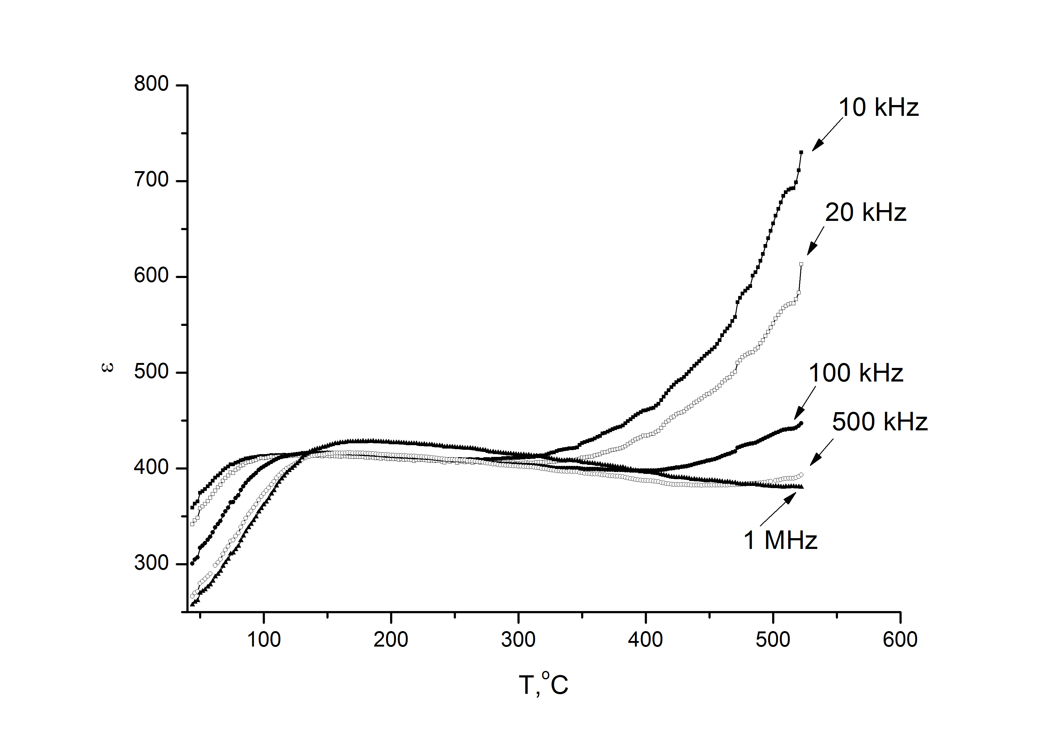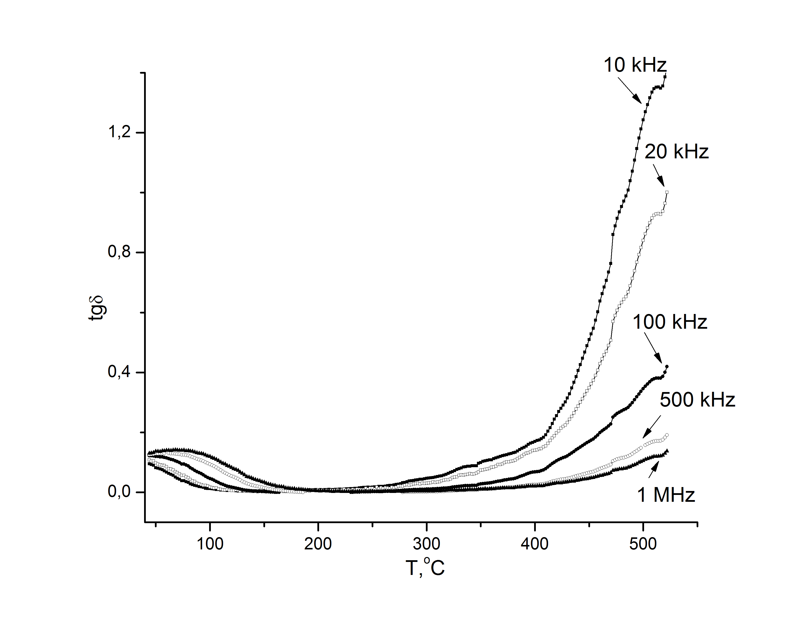
a) b)
Рисунок 1. Температурные зависимости диэлектрической проницаемости (a) и тангенса угла диэлектрических потерь (b) для материала BiKScNbO₆.

Благодарность. Работа выполнена при поддержке Российского фонда фундаментальных исследований (грант РФФИ № 10-02-00336)

Список литературы
1. I.V. Zinenko. 19 Всероссийская конференция по физике сегнетоэлектриков. Тезисы докладов, 1 (2011)
Optimization of technology for lead-free niobate piezoceramics
K.P. Andryushin, I.A. Verbenko, A.I. Miller, H.A. Sadykov, I.N. Andryushina,
A.G. Abubakarov, L.A. Reznitchenko

¹Scientific Research Institute of Physics, The Southern Federal University, Rostov-on-Don, Russia
Practically the only alternative to toxic Pb-containing ferropiezoelectrics are niobates alkali metals and solid solutions (SS) based on them. To overcome some technological obstacles to widespread practical use of niobate ceramics, possibly constructing multicomponent systems, that have several advantages compared with the components of the binary; modification when by the introduction of small amounts of complex and simple compounds significantly alter the electrical characteristics of ceramics; stepwise optimization of the regulations; and the introduction of new methods to control the kinetics of synthesis and sintering objects at the expense of high external influence on the precursors.
The objects of the present study were selected multicomponent SS on the basis of binary systems (Na,Li)NbO₃, (Na,K)NbO₃ and SS of ternary system (1-x-y)NaNbO₃ – xKNbO₃ – yCd_{0.5}NbO₃, that research by the seven sections. Synthesis of SS was carried out by solid-state method, including the high-energy milling of precursors selected compositions. Sintering was carried out by the common ceramic technology: T_{sint}. = (1130 ÷ 1240) ºC (depending on composition) for (1 ÷ 2.5) hour.
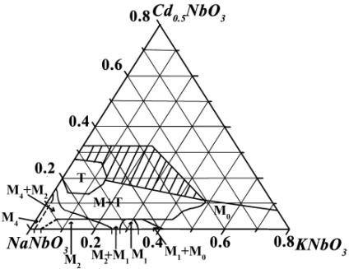
It is established that the introduction of modifiers leads to an increase in density, the mechanical quality factor and dielectric constant. At the same influence on the piezoelectric characteristics modifiers can be divided into three groups: CuO and MnO₂ promote to increase pezoanisotropy (decrease of piezoelectric coefficients of the planar vibration mode, and the rapid growth of the thickness piezoelectric activity); with NiO a sharp increasing of a planar piezoelectric activity, and the thickness modes of vibration is associated. Investigation of the electrophysical characteristics of the system (1-x-y)NaNbO₃ – xKNbO₃ – yCd_{0.5}NbO₃ detected nonmonotonic behavior of all the dependencies with extremes near the symmetry transitions, which corresponds to the logic of the changes in the electrical parameters of the systems with morphotropic phase boundaries. Irregularity of all dependencies is a consequence of the extreme complexity of the phase diagram of the system with a lot of different character of the sequence of phase transformations (Fig) (M- monoclinic phase, T- tetragonal phase, index indicates the multiplication of perovskite cell along b-axis, heterogeneous area is shaded). During the optimization technology of ceramic materials has also been found that the use of crushing activation reduces the temperature of synthesis and sintering of ceramics at 100-300 ºC, while increasing the density of the ceramics and improving their electrical characteristics.
Fig. Phase diagram of the system
(1-x-y)NaNbO₃-xKNbO₃-yCd_{0.5}NbO₃

Effects of Anion Ordering on Structural and Optical Properties of K₃WO₃F₃ Elpasolite
B.I. Kidyarov¹, V.V. Atuchin², L.I. Isaenko³, M.S. Molokeev⁴, A.P. Yelisseyev³ and
S.A. Zhurkov³

¹Laboratory of Nonlinear Resonant Processes and Laser Diagnostics, Institute of Semiconductor Physics, SB RAS, Novosibirsk, 630090, Russia
e-mail: kidyarov@isp.nsc.ru
²Laboratory of Optical Materials and Structures, Institute of Semiconductor Physics, SB RAS, Novosibirsk, 630090, Russia
³Laboratory of Crystal Growth, Institute of Geology and Mineralogy, SB RAS, Novosibirsk, 630090, Russia
⁴Laboratory of Crystal Physics, Institute of Physics, SB RAS, Krasnoyarsk, 660036, Russia

The structures of three phases of the K₃WO₃F₃ crystal have been determined from X-ray diffraction data. The profile and structural parameters have been refined using the DDM program. The results have been discussed using the group theoretical analysis of the complete order parameter condensate that accounts the critical and noncritical atomic displacements, which allows the interpretation of the experimental data. The sequence of structural transformations on the temperature decrease from 473 to 300 K is found to be as follows: Fm3m→I4mm→Cm. Room-temperature modification of potassium oxyfluorotungstate, G2-K₃WO₃F₃, has been prepared by low-temperature chemical route and single crystal growth. The crystal structure of G2-K₃WO₃F₃ is illustrated in Fig. 1. Wide optical transparency range of 0.3–9.4 μm and band gap E_{g} = 4.32 eV have been obtained for G2-K₃WO₃F₃ (space group Cm) crystal. The transparency window of G2-K₃WO₃F₃ is shown in Fig. 2.

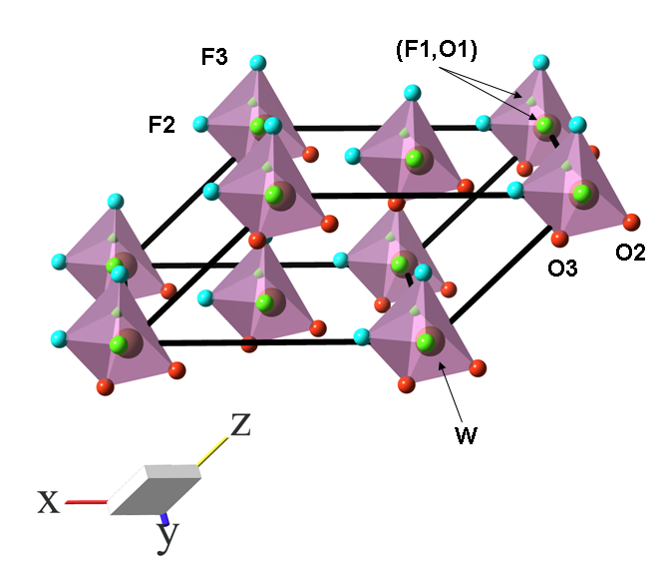 | 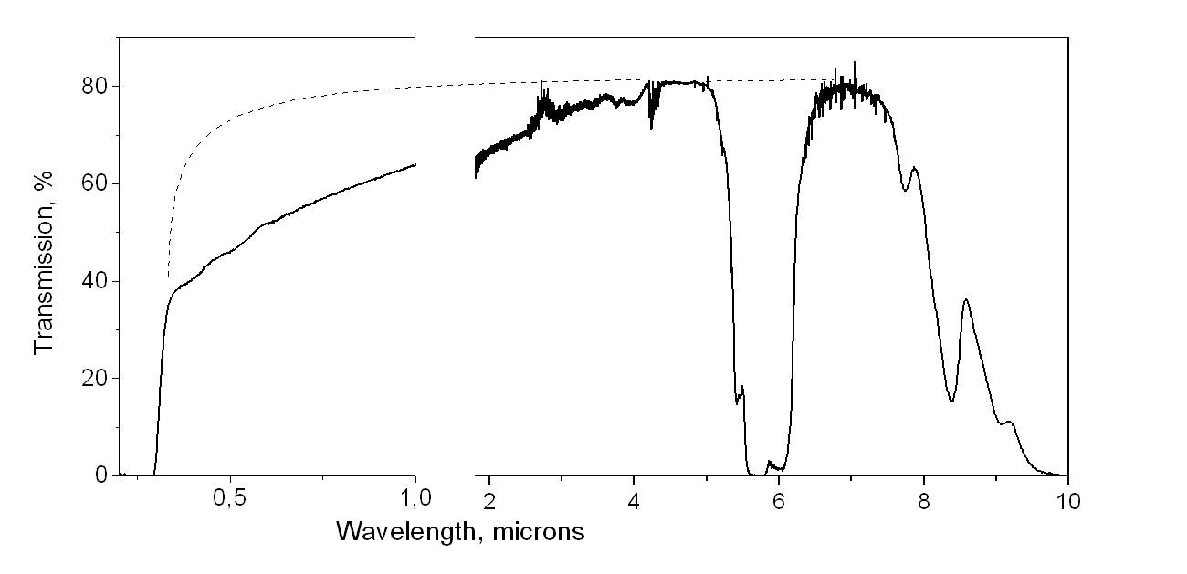
Fig. 1. Fragment of the crystal structure of room-temperature polymorph G2-K₃WO₃F₃. Oxygen, fluorine and mixed oxygen/fluorine positions are shown by red, blue and green colors, respectively. | Fig. 2. Transmission spectrum of 1.8 mm thick G2-K₃WO₃F₃ single crystal, at T = 300 K. Dotted curve shows an expected transmission spectrum in inclusions and water-free K₃WO₃F₃.

Interrelationship of Micro- and Macro-Structure with Physical Properties of Binary and Ternary Non-centrosymmetric Germanate Crystals

V.V. Atuchin, B.I. Kidyarov, and I.B. Troitskaia

A.V. Rzhanov Institute of Semiconductor Physics, Novosibirsk, 630090, Russia
e-mail: kidyarov@isp.nsc.ru

Noncentrosymmetric (NCS) germanate crystals are almost unavailable in nature but many of synthetic compounds are used in acoustoelectronics, optoelectronics and laser optics. As a rule, the NCS crystals possess nonlinear optical (NLO), piezoelectric and electrooptical properties. In this work, the systematization of published data on the structure (point symmetry group), oxide bond lengths and NLO properties for ~100 various NCS germanates has been produced. The sharp nonmonotonic distribution of the NCS germanate crystals over the point symmetry groups has been obtained. An approach to see the empirical “composition − structure – property” interrelationships is proposed. As it is shown in Figure, NCS germanate crystals are positioned into the three partly intersected ellipses of «acentricity» I-III on the plane of oxide bond lengths. The nonmonotonic dependency of NLO susceptibility (ч²) on the shortest chemical bond length L(Ge-O) has been obtained. It is shown that the crystals with the high values of ч² are positioned into the regions 2-3 and 9. On this basis, it is predicted that the combination with niobates, tantalates, iodates and titanates is useful to achieve the generation of new germanates with high values of ч². Now only the crystal of Ba₂TiGeO₈ (C_{4v}) with ч² = 22 pm/V is obtained.
In addition, the NLO properties of GeO₂ crystals with α-quartz structure (P3₂21) have been estimated experimentally for the first time. The GeO₂ nanocrystals where precipitated

from aqua ammonium germanate solution with nitric acid at T=100°C [1]. The XRD, SEM, DSC and UV-VIS absorption methods have been used for the evaluation of the crystals. Direct bandgap of 5.72 eV was estimated from the plot of optical density vs. energy [1]. The NLO properties of this crystals where measured by Kurtz-Perry method to be 0.6-0.8 pm/V in reference to LiB₃O₅ crystals (1.2 pm/V). The value 0.6-0.8 pm/V is comparable with that estimated theoretically as 1.4 pm/V [2]. The piezoelectric module of α-quartz GeO₂ is above 20 K/N.
Fig. The NCS germanate crystals in different regions 1-9 of I-III ellipses of «acentricity» : dark points – potential ferroelasic crystals.

References
1. C.V. Ramana, G. Carbajal-Franco, I.B. Troitskaia, et al, Mat. Sci. Eng. B, 174 279 (2010).
2. P. Hermet, G. Fraysse, A. Lignie, et al, J. Phys. Chem. C, 116 8692 (2012).

Electronic Structure And Nonlinear Optical Properties Of Monoclinic
G2-K₃WO₃F₃
B.I. Kidyarov¹, V.V. Atuchin², L.I. Isaenko³, V.G. Kesler⁴, Z.S. Lin⁵, M.S. Molokeev⁶,
A.P. Yelisseyev³ and S.A. Zhurkov³

¹Laboratory of Nonlinear Resonant Processes and Laser Diagnostics, Institute of Semiconductor Physics, SB RAS, Novosibirsk, 630090, Russia
e-mail: kidyarov@isp.nsc.ru
²Laboratory of Optical Materials and Structures, Institute of Semiconductor Physics, SB RAS, Novosibirsk, 630090, Russia
³Laboratory of Crystal Growth, Institute of Geology and Mineralogy, SB RAS, Novosibirsk, 630090, Russia
⁴Laboratory of Physical Principles for Integrated Microelectronics, Institute of Semiconductor Physics, Novosibirsk, 630090, Russia
⁵Technical Institute of Physics and Chemistry, Chinese Academy of Sciences, P.O. Box 2711, Beijing 100190, China
⁶Laboratory of Crystal Physics, Institute of Physics, SB RAS, Krasnoyarsk, 660036, Russia

Complex metal oxyfluorides are attractive compounds for creation new noncentrosymmetric crystals because the strong distortion of metal-(O,F) polyhedra in crystal lattice is achieved due to different ionicity of metal-O and metal-F bonds. Room-temperature modification of potassium oxyfluorotungstate, G2-K₃WO₃F₃, space group Cm, has been prepared by low-temperature chemical synthesis. Phase composition of the final product was evaluated with XRD analysis. Presence of pure monoclinic G2-K₂WO₃F₃, space group Cm, modification was found with structural parameters a = 8.7459(2)Å, b = 8.6930(4)Å, c = 6.1650(3)Å, в = 135.178(2)°.
The electronic band structure has been calculated with the first-principles theory and measured with X-ray photoelectron spectroscopy (XPS). The valence band spectrum is shown in Fig. 1. The calculated energy band gap is 4.2 eV, in good agreement with the experimental value of 4.413 eV. The PDOS analysis clearly shows that the O 2p orbitals are located at the valence band maximum, while the W 5d orbitals located at the conduction band minimum. They directly determine the band gap. The calculated nonlinear optical coefficients are as high as d₃₃ ~ -2.91 pm/V.
Fig.1. Valence band structure as measured by XPS

Pseudosymmetry Characteristics and Nonlinear Optical Properties of Crystals of KTP Family

A.P. Gazhulina, M.O. Marychev

Nizhny Novgorod State University, Nizhny Novgorod, 603950, Russia
e-mail: asyagazhulina@yandex.ru

Research of the interrelation between structural, symmetry features of crystals and its nonlinear optical properties are continued here [1]. Systematization of information about the structural data, the data of nonlinear optical properties of crystals of the KTP family, research of its pseudosymmetry features, comparison of pseudosymmetry features with second-order nonlinear optical properties are the key points of present work. The family of crystals with KTP (potassium titanyl phosphate) type of structure consists of more than 100 compounds with general formula MM’OXO₄, where M = K, Rb, Na, Cs, Tl, NH₄; M’ = Ti, Sn, Sb, Zr, Ge, Al, Cr, Fe, V, Nb, Ta, Ga; X = P, As, Si, Ge [2].
The review of the structural data and the data of nonlinear optical properties of crystals of family KTP was carried out. The structural information for 29 pure crystals, and also for 89 doped crystals was found. Information of nonlinear optical properties for 108 structures was found.
Calculation of pseudosymmetry [3] concerning the operation of inversion for the found crystals of KTP family was carried out. Spatial maps of distribution of a degree of invariance concerning the operation of inversion for various positions of points of inversion were received within the limits of their cells. Positions of the centers of the pseudoinversion appropriate to the maximal values of a degree of invariance of structures of crystals for inversion were determined; the analysis of its arrangement concerning elements of symmetry of space groups of symmetry of the investigated crystals was carried out. Histograms of distribution of value of a degree of pseudo-inversion on pure crystals and doped crystals were received. These calculated values were compared to known nonlinear optical characteristics. It was established, that the pure crystals with the greatest value of a degree of invariance concerning the operation of inversion, had the least values of nonlinear optical characteristics.

References
1. V.A. Ivanov et al. // Crystallography Reports. 2008. v. 53. p. 678.
2. G.D. Stucky, M.L.F. Phillips, T.E. Gier // Chem. Mater. 1989. v. 1. p. 492.
3. E.V.Chuprunov // Crystallography Reports. 2007. v. 52.p. 1.

Session 4.
Disordered Ferroelastics and Related Materials

Oral Presentation
Нелинейный диэлектрический отклик в смешанном кристалле K_{0,91}(NH₄)_{0,09}H₂PO₄

Л.Н. Коротков¹, Т.Н. Короткова²

¹Воронежский государственный технический университет, 394026, Воронеж, Россия
²Воронежский институт МВД России, 394065, Воронеж, Россия

l_korotkov@mail.ru

Известно [1], что в cмешанных кристаллах сегнето-антисегнетоэлектрика дигидрофосфата калия – аммония K_{1-x}(NH₄)_{x}H₂PO₄ (KADP-x%) с концентрацией аммония, лежащей в интервале 0 ≤ x ≤ x_{F} ≈  0.2, реализуется сегнетоэлектрический (СЭ) фазовый переход. Смешанные кристаллы промежуточных концентраций 0.20  x  0.70, демонстрируют стеклоподобное поведение при низких температурах. В составах с концентрацией x близкой к граничной x_{F} в пределах определенного интервала температур имеет место сосуществование СЭ и стеклоподобной фаз [2]. Причины, вызывающие такое сосуществование, в настоящее время обсуждаются [3-5]. Предполагается, в частности, что оно может возникнуть вследствие действия случайных электрических и упругих полей, которые случайным образом ориентирует полярные области в СЭ кристалле [3].
Цель данной работы – изучить особенности нелинейного диэлектрического отклика в монокристалле K_{0,91}(NH₄)_{0,09}H₂PO₄ в окрестностях СЭ фазового перехода.
В ходе эксперимента было исследовано влияние постоянного смещающего и переменного электрических полей на диэлектрический отклик монокристалла K_{0,91}(NH₄)_{0,09}H₂PO₄ в окрестностях температуры сегнетоэлектрического фазового перехода T_{C}.≈95 K. Ниже T_{C} нелинейный отклик преимущественно обусловлен доменным механизмом. Это, в частности, подтверждается наблюдением хаотических колебаний в содержащей исследуемый образец в качестве конденсатора С последовательной RLC цепи, возбуждаемой синусоидальным напряжением. Вблизи температуры Кюри обнаружены особенности поведения диэлектрической нелинейности, объясняемые возникновением промежуточного гетерофазного состояния. Полученные результаты объясняются в рамках модели «случайных полей» [3 - 4].

Работа выполнена при поддержке Российского фонда фундаментальных исследований (проект N 11-02-90435_укр.-ф-а)

1. S.A. Gridnev, L.N. Korotkov, S.P. Rogova, L.A. Shuvalov, R.M. Fedosyuk. Ferroelectrcis Letters. 13, 67 (1991).
2. Л.Н. Коротков, Л.А. Шувалов. Кристаллография. 49, 920 (2004).
3. M.D. Glinchuk, R. Fari. J. Phys. Condens. Matter. 8, 6985 (1996)
4. M.D. Glinchuk, V.A. Stephanovich. J. Phys. Condens. Matter. 10, 11081 (1998).
5. R. Blinc, R. Pirc, B. Tadic, J Dolinesek. Ferroelectrics. 78, 27 (1988).

Mean-Field Method for Analysis Surface Effects in Flexible-Chain
Polymer Layers

A. V. Maksimov and O.G. Maksimova

Cherepovets State University, Lunacharskii Pr. 5, Cherepovets,
Vologda region, 162600 Russian Federation,
e-mail: a_v_maximov@mail.ru

The possibility of an exact analytical description of surface effects in polymer layers is demonstrated using a specific microscopic model. The model employed is an adsorbed flexible macromolecule with an arbitrary contour length placed in a mean-field created by other polymer chains. On the basis of the mean-field method [1, 2] (single-chain approximation [3]), the variation of the partition function and the free energy of the chain with the absorption interaction parameter and the magnitude of the mean-field is calculated. It’s shown that the system has unusual phase transition of the chain from the elongated to an absorbed state. This transition has simultaneously the properties of first- and second-order transitions. The critical meaning of the magnitude of the mean-field is found as a function of the absorption interaction parameter. The type and characteristics of transition in the proposed model are compared with those based on the Landau [4] and scaling theory [5] and also with the model of an adsorbed individual polymer chain with an arbitrary number of links and an external force applied [6].

References

1. P. G. De Gennes and J. Prost, The Physics of Liquid Crystals, Oxford: Clarendon Press (1974).
2. S. Chandrasekhar, Liquid Crystals , London: Cambridge Univ. Press (1977).
3. P. G. De Gennes, Scaling Concepts in Polymer Physics. Ithaca&London: Cornell Univer. Press (1979).
4. L. D. Landau and E. M. Lifshits, Statistical Physics , New York: Pergamon (1980).
5. M. Doi and S.F. Edwards, The Theory of Polymer Dynamics, Oxford: Claredon Press (1986).
6. L.I. Klushin, A.M. Skvortsov and A.A. Gorbunov, Phys. Rev. 56, 1511(1997).

Simulation of Polarization Switching Processes
in Ferro- and Liquid Crystal Polymers

O. G. Maksimova, T. O. Petrova and A. V. Maksimov

Cherepovets State University, Lunacharskii Pr. 5, Cherepovets,
Vologda region, 162600 Russian Federation, e-mail: og62@mail.ru

Using the method of Monte Carlo ferroelectric and liquid crystal polymer systems have been simulated within the three-dimensional lattice model with interaction potentials of the dipole and quadrupole types. The developed software has been tested in comparison with analytical calculations and the data of natural experiments [1]. Polymer films where the molecules are in $α$- and $β$- phases, placed in an alternating electric field are considered in the paper. The model has the potential with continuous symmetry group; therefore the dependence of the polarization vector on electric field intensity in quasistatic process is reversible (without hysteresis). While simulating the real samples it is necessary to consider the relaxation time that was introduced by varying the number of Monte Carlo steps. Absorption amplitudes of polarized radiation have been calculated, those were considered to be proportional to the square-mean-square value of the cosine of the angle between the dipole moment and the axis of director [2], depending on the temperature, dimensionless parameters of intra- and intermolecular interactions, and also characteristics of the external field. Obtained curves have a "Butterfly" form and agree with the experimental data given in [3]. Dependences of the area of curves on the frequency of the external field have been calculated.

Acknowledgment. This work was supported by the Federal Target Program “Scientific and Scientifically-Pedagogical Manpower of Innovational Russia on 2009 – 2013”

References
- T. O. Petrova, O. G. Maksimova, R.A. Gerasimov, A. V. Maksimov. // Physics of the Solid State, 2012, Vol. 54, No. 5, pp. 937–939.
- V.V. Kochervinskiy. // Vysokomol. Soedin., Ser. C. 50, № 7.
- Buchtemann A., Stark W., Kunster W.// Vibrat.Spectrosc.1993.V.4.P.231.

Properties and Phase Diagram of Lead-Free
Tetragonal Tungsten Bronze Ceramics

D. Mezzane^{1,2*}, Y. Amira^{1,2}, E. Taifi^{1,2}, Y. Gagou¹ , E. Choukri²,
M. E. Marssi¹,Y.Elamraoui², I. Lukyanchuk¹

¹ LPMC, University of Picardie, Amiens, France
² LMCN, FSTG, University of Marrakech, Morocco
e-mail : daoudmezzane@gmail.com

We report the synthesis, X-ray structural characterization and frequency-dependent dielectric and ac-conductivity measurements for two promising lead-free ferroelectric TTB–type ceramics: K3Li2Nb₅O₁₅ (KLN), GdK₂Nb5O₁₅ (GKN).
1. KLN Potassium Lithium Niobate K3Li2Nb5O15 has the TTB - type structure with 4 formula per primitive unit cell and demonstrate the Paraelectric-Ferroelectric transition with symmetry change P4/mbm- P4bm at Tc ≈ 430°C. Structural and dielectric properties of KLN were studied in the temperature interval of 50-550°C. Space charge polarization, relaxation phenomena and free charge conductivity have been elucidated using impedance spectroscopy technique. Cole-Cole plots have revealed a non Debye and polydispersive type relaxation. In paraelectric phase the Arrhenius activation energy Eτ=0.533 eV was determined. Santos-Eiras model d was applied to treat the impedance spectroscopy experiments [1-3].
2. GKN. Temperature-controlled X-ray diffraction, dielectric susceptibility, DSC and Raman scattering methods were used to study phase transitions in Gadolinium Potassium Niobate GdK₂Nb5O₁₅ at Tc₁ = 238°C and Tc₂ =375°C that are attributed to ferroelectric-antiferroelectric-paraelectric (FE-AFE-PE) trasformations. The FE and PE phases adopt the polar P4bm and centrosymmetric P4/mbm space groups, respectively. For the intermediate AFE phase, the structure is refined in the non-polar space group P4nc with doubling of the c unit cell parameter, which is compatible with an AFE phase. This result was confirmed by Raman spectroscopy. The presence of the AFE phase between the FE and PE phases and the complex nature of TTB crystal structure can explain the large thermal hysteresis observed at the FE-AFE transition between heating and cooling cycle and the extremely large depression of Curie-Weiss temperature T₀. [4-5].
References
[1] E.Choukri, Y. Gagou, E., A. Belboukhari, G. Erramo, M.-A. Frémy, A. Zegzouti,
D. Mezzane, I. Luk’yanchuk, and P. Saint-Grégoire; Phase diagram and dielectric properties of ferroelectrics ceramics Pb2-xK1+xLixNb5O15; Superlattices and Microstructures, 49, 300 (2011)
[2] D. Mezzane1, M. El Marssi2, I. Luk’yanchuk2, Dielectric and structural properties of diffuse ferroelectric phase transition in K3Li2Nb5O15 ceramic, Eur. Phys. J B 2012, accepted,
[3] E.Choukri, Y. Gagou, D. Mezzane, Z.Abkhar, El Moznine, I. Luk’yanchuk and P. Saint-Grégoire; Dielectric and structural properties of diffuse ferroelectric phase transition in Pb1.85K1.15Li0.15Nb5O15 ceramic; European Phys. Journ.-Appl. Phys. 53, 20901 (2011)
[4] M. El Marssi and P. Saint-Gregoire, Pulsed Laser Deposition of TTB-type Materials Thin Films Examples of Pb2KNb5O15 (PKN) and GdK2Nb5O15 (GKN), Research Journal of Nanoscience and Nanotechnology, 2, 24-30 (2012)

Session 4.
Disordered Ferroelastics and Related Materials

Poster Presentation
Particularity of the Dielectric and Elastic Properties of the Ceramic System SrTiO₃-BiScO₃

E.P. Danshina, O.N. Ivanov

Joint Research Centre “Diagnostics of structure and properties of nanomaterials”,
Belgorod State University, Belgorod, 308015, Russia
e-mail: danshina@bsu.edu.ru

The perovskite-type SrTiO₃-BiScO₃ system is a new, interesting system for studying the possibility of ferroelectric state formation in multicomponent systems consisting of nonferroelectric components. In this system, strontium titanate, SrTiO₃, is known to be an incipient ferroelectric lying near the limit of its paraelectric phase stability [1]. Various ions substituted for the host ions both in the A- and B-positions in ABO₃ perovskite structure can induce a ferroelectric phase transition in SrTiO₃. BiScO₃ is an interesting end member for fabrication of new ceramic solid solutions [2].
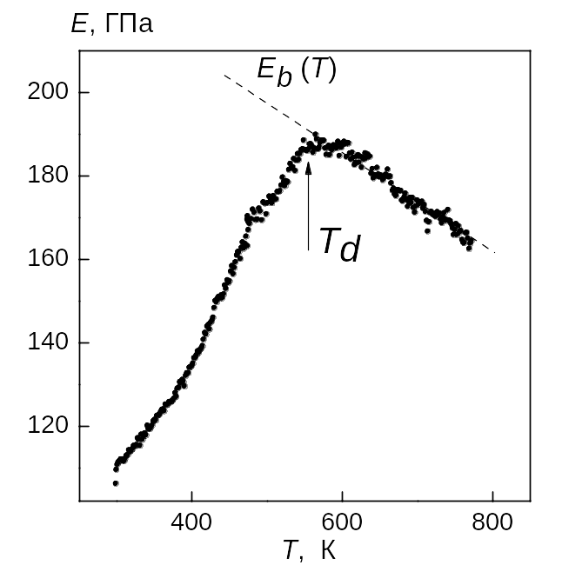
Ceramic solid solutions of (1-x)SrTiO₃-xBiScO₃ system with x=0, 0.05, 0.1, 0.2, 0.25, 0.3, 0.35, 0.4, 0.45 and 0.5 were synthesized via solid-state processing techniques. End members in this system are not ferroelectrics. XRD analysis revealed that at room temperature all compositions under study (excepting pure SrTiO₃) consist of mixture of nonpolar cubic Pm3m phase and polar tetragonal P4mm phase. EBSD mapping was applied to image a two-phase structure.
Figure 1. Temperature dependences Young modulus for the x = 0,30 (E_{b}(T) – background)
Dielectric anomalies associated with a diffuse ferroelectric phase transition were found and analyzed for these compositions. The relaxor ferroelectric behavior was likely due to complex processes of cation substitution and ordering on the A-site and on the B-site.
The experimental evidence of the presence of diffuse ferroelectric phase transition in SrTiO₃ - BiScO₃ are the results of a study of the elastic properties of the samples. It is known that the temperature dependence of the elastic modulus C in the ferroelectric phase transition in the crystal without the piezoelectric effect in the paraelectric phase is given by
, (1)
где С^{p} – modulus of elasticity in the paraelectric phase, g – electrostriction constant, P_{S} – spontaneous polarization, χ – dielectric susceptibility.
Due to electrostriction relationship between polarization and strain in the relaxor ferroelectrics below the Burns T_{d} should be observed elastic softening, which manifests itself as an anomalous decrease in elastic modulus with decreasing temperature. Such behavior was indeed observed experimentally (Fig. 1).

Acknowledgements. This work was financially supported by the Ministry of Education and Science of the Russian Federation under Contracts No 16.552.11.7004 and No P415.

References
[1] K.A. Muller and H. Burkard. “SrTiO₃: an intrinsic quantum paraelectric below 4 K”. Phys. Rev. B., Vol. 9, No. 7, pp. 3593 – 3602, 1979.
[2] R.E. Eitel, C.A. Randall, T.S. Shrout and S.-E. Park. “Preparation and characterization of high temperature perovskite ferroelectrics in the solid-solution (1-x)BiScO₃-xPbTiO₃”. Jpn. J. Appl. Phys., Vol. 41, pp. 2099-2104, 2002.
Dielectric Relaxation in Ferroelectrics PbFe_{0.5}Nb_{0.5}O₃

A. A. Kamynin, S. A. Gridnev, and N. V. Gerashchenko

Voronezh State Technical University, Voronezh, 394026, Russia

The study of disordered systems is an actual issue in solid state physics. One of these systems is ferroelectric relaxors. An important feature of relaxor materials is that they have glassy properties. Therefore, the aim of this study was to determine whether a ceramic material PbFe_{0.5}Nb_{0.5}O₃ (PFN) is in the glass state. Temperature dependences of the imaginary part of permittivity (ε'')
Fig.2. Dependence of ln τ on 1/T
Fig.1. Temperature dependences of imaginary part of dielectric permittivity: 1- 25; 2-100; 3-500 Hz; 4-1 kHz;
Fig. 3 - Distribution function of relaxation times on frequencies and temperatures for PbFe1/2Nb1/2O3

are shown in Fig. 1. The peaks in the curves ε'' (T) occupy an interval of temperatures about 90 ° C, i.e., the phase transition is diffused, moreover there is a significant dispersion of ε*. For describing dependence of ε*(T) is well-suited model of composition fluctuations. In the diffuse area the ε*(T) are fine described by a quadratic Curie-Weiss low [1] with the Gauss diffuse factor σ = 28,14 ⁰C. Away from the blur field a linear Curie-Weiss law is performed with parameters C_{w} = 23,3 10⁵ ⁰C, T₀ = 80 ⁰C. These features make the PFN is relaxor-like. A plotted dependence of lnτ on 1 / T (Fig. 2) does not obey the Arrhenius law. To study the evolution of the relaxation times spectrum with temperature, the distribution function of relaxation times as function of frequency and temperature g (f, T) (Fig. 3) was plotted using the approximate formula, valid for the case of a wide relaxation spectrum times: $g\left(τ,T\right)≈\frac{2ε^{''}\left(1/2\text{πτ},T\right)}{π\left[ε_{0}\left(T\right)+ε_{∞}\right]}$. The obtained results give us a possibility to conclude that the PFN is not a dipole glass above the Fogel-Fulcher temperature T_{FH} ≈ 35 ⁰C.

References
[1] S. A. Gridnev, A. A. Kamynin, // Physics of solid state, 2012. V. 54, N2, P. 956.

Harmonic Analysis of the Time Evolution of the Polarization Components on the Electric Field Intensity in Rb₂ZnCl₄ Crystal Near the Curie Point

V.V.Gorbatenko, V.I.Kudrjash, B.N.Prasolov and S.A.Gorbatenko

Federal State Public Educational Establishment of Higher Professional Training «Voronezh Institute of the Interior of the Russian Federation», Voronezh, 394065, Russia
E-mail: vlgorbatenko@rambler.ru

Based on dielectric and polarization investigations of the Rb₂ZnCL₄ crystal specimens, it was demonstrated in [1, 2] that relaxation of nonequilibrium permittivity ($ε_{x}$) higher than the temperature of the ferroelectric phase transition (T_{c} ≈ 199.4 K) is associated with the unfastening of ferroelectric domain boundaries (DBs) from stoppers, followed by disappearance of the domain structure in the inadequate phase (IP). Take note of the fact that the temperature-independent behavior of the coercive field (E_{coer}) obtained after processing of the dielectric hysteresis loops measured at the frequency of 0.3 Hz is observed in equilibrium conditions near of T_{c} in the ferroelectric phase (FP). As the Curie point is approached in the FP, the coercive field thus does not tend to zero, as would follow from thermodynamic representations.
It was shown that if an alternating electric field (E~) with a frequency on the order of 20 kHz and an amplitude higher than the coercive field E_{coer} in the FP upon isothermal exposure is applied to the Rb₂ZnCl₄ crystal specimens, the relaxation of $ε_{x}$ and E_{coer} are observed after E~ is switched off. The effect of the field E~ on the specimen yields a decrease in E_{coer} that confirms the process of DB liberation from defects. After E~ is switched off, the reverse process takes place: DBs are fixed by the defects, which manifests itself in an increase in E_{coer}. In this work, the time evolution of the dielectric hysteresis loops was studied in detail by means of harmonic analysis after E~ acted on the specimen.
Analysis of the time evolution of the dielectric hysteresis loops showed that relaxation of the field intensity $E_{c}=E_{m}\text{sin}ϕ_{o}$ is observed so long as the intensity of the switching field E_{o}= E_{coer} – E_{c} remains almost constant. The time dependence of E_{c} is well approximated by the equation

$E_{c}(t)=E_{∞}−E_{\text{co}}\text{exp}(−\sqrt{t/τ}),$ (1)

where E∞ is the equilibrium value of E_{c}, E_{co} is the non-equilibrium value of E_{c}, and $τ$ is the relaxation time of this process, $ϕ_{o}$is the phase shift angle for the first harmonic.
It should be noted that the temperature-independent behavior of E_{coer} = E_{c} + E_{o} is observed under equilibrium conditions near T_{c} in FP, though E_{o} in turn tends to zero as T_{c} is approached, while E_{c} increases. We may assume that in ultra-pure crystals, the value of E_{c} associated with losses does not contribute noticeably to E_{coer}, and E_{coer} is determined by E_{o}; i.e., E_{coer} will tend to zero as T_{c} is approached, as follows from thermodynamic considerations.

References
1. Gridnev, S.A., Gorbatenko, V.V., and Prasolov, B.N., Ferroelectrics, 1993, vol. 143, nos. 1—4, p. 85.
2. Gridnev, S.A., Gorbatenko, V.V., and Prasolov, B.N., Izv. Akad. Nauk, Ser. Fiz., 1993, vol. 57, no. 3, p. 97.

Electromechanical Properties of K_{1−x}(NH₄)_{x}H₂PO₄ Single Crystals

¹D. Likhovaya, ¹A. Bocharov, ¹L. Korotkov
²V. Zakhvalinskii, ²E. Pilyuk, ²A. Khmara, ³S. Sorokov and ⁴E. Sitalo,

¹Voronezh State Technical University, Voronezh, Russia
²Belgorod State University, Belgorod, 308015, Russia
³Institute for Condensed Matter Physics, Lviv, 79011, Ukraine
⁴Southern Federal University, Rostov on Don, Russia

e-mail: l_korotkov@mail.ru

Ammonium dihydrogen phosphate (NH₄)H₂PO₄ and potassium dihydrogen phosphate KH₂PO₄ are well known crystals having a tetragonal structure (I$\overline{4}$2d) at a room temperature. These crystals form solid solutions of K_{1-z}(NH₄)_{x}H₂PO₄ within concentration range 0.0 ≤ x ≤ 1.0. Their physical properties, in particular, electromechanical properties are slightly investigated up to now. Therefore the purpose of the present work is study of elastic and piezoelectric properties of K_{1-x}(NH₄)_{x}H₂PO₄ solid solutions.
The experiments were performed using the samples with ammonium concentrations x ≈ 0.0, 0.05; 0.12; 0.19, 0.24, 0.32, 0.67, 0.75 and 0.94 of 45º z - cut rectangular plates ≈2x6x0.7 mm³. Silver electrodes were evaporated on the main surfaces which are normal to the tetragonal c (z) axis. The measurements of dielectric permittivity at room temperature were carried out using a capacitance bridge at the frequency of 10 kHz. The magnitude of ac measuring field was not more than 10 V/cm. Elastic compliance (S_{45-z} = 0.5(S₁₁ + S₁₂) + 0.25S₆₆), piezo - coefficient d₃₆ and electromechanical coupling coefficient k₃₆ were measured using resonance - antiresonance method.
Analysis of experimental results revealed piezoactivity of the crystals under study within temperature ranges which available under experimental conditions (15-300 K). It was found a weak dependence of elastic compliance S_{45-x} on ammonium concentration x at room temperature. At the same time approximately linear increase of d₃₆ and k₃₆ coefficients with concentration x have been found (figure).

Figure. Concentration dependences of k₃₆ and d₃₆ at 300 K

ACKNOWLEDGMENTS. This work was supported by Russian Foundation for Basic Research (Grant N 11-02-90435-укр.-ф-а)
Dielectric, Elastic and Electromechanical Responses in K_{0.25}(NH₄)_{0.75}H₂PO₄ Mixed Crystal

¹D. Likhovaya, ²V. Zakhvalinskii, ²E. Pilyuk, ²A. Khmara, ³S. Sorokov
and ¹L. Korotkov

¹Voronezh State Technical University, Voronezh, Russia
²Belgorod State University, Belgorod, 308015, Russia
³Institute for Condensed Matter Physics, Lviv, 79011, Ukraine

e-mail: l_korotkov@mail.ru

Ammonium dihydrogen phosphate NH₄H₂PO₄ is a canonical antiferroelectric (AFE) crystal. Its physical properties are well studied at temperatures above AFE transition temperature (T_{N}). Below T_{N} ≈148 K a NH₄H₂PO₄ samples are cracked out owing to strong mechanical stresses due to appearance of spontaneous deformations at AFE first order phase transition. Therefore physical properties of AFE crystals of KDP family are poorly investigated at low temperatures up to now. In AFE compounds of K_{1-x}(NH₄)_{x}H₂PO₄ solid solutions mechanical stresses at T_{N} are decreased and sample is not cracked out. It permits us to study the dielectric, mechanical and electromechanical properties of NH₄H₂PO₄ type crystal.
The experiments were performed using the sample of K_{0.25}(NH₄)_{0.75}H₂PO₄ single crystal of 45º z - cut rectangular plates ≈2x6x0.9 mm³. Silver electrodes were evaporated on the main surfaces which are normal to the tetragonal c (z) axe. The sample was placed in a cryostat where a temperature was changed from 10 to 300 K and was measured with an error not more than 0.5 K. The measurements of dielectric permittivity (ε₃₃) were carried out using a capacitance bridge at the frequency of 10 kHz. Elastic compliance (S_{45-z} = 0.5(S₁₁ + S₁₂) + 0.25S₆₆), piezo - coefficient d₃₆ and electromechanical coupling coefficient k₃₆ were measured using resonance - antiresonance method.
The experiment results revealed the decrease of phase transition temperature (T_{N} ≈ 53 K) and its diffuseness in K_{0.25}(NH₄)_{0.75}H₂PO₄ crystal in comparison with NH₄H₂PO₄. Above T_{N} the ε₃₃, S_{45-x}, k₃₆ and d₃₆ temperature dependences are obeyed to Curie – Weiss law within broad temperature range.
Near T_{N} these dependences show anomalous behavior. It was found, in particular, that positions of their maximums does not coincide (Figure).
Obtained results are discussed in the framework of cluster model of K_{1-x}(NH₄)_{x}H₂PO₄ mixed crystals.

ACKNOWLEDGMENTS. This work was supported by Russian Foundation for Basic Research (Grant N 11-02-90435-укр.-ф-а)

Kinetics of Order Local Parameter in the Ferroelectric PLZT

S. A. Gridnev, A.A. Kamynin and V.A. Leonov

Voronezh State Technical University, Voronezh, 394026, Russia

Many materials can be considered more or less disordered, so the study of disordered systems is an actual issue in solid state physics. One of these systems is relaxor ferroelectrics. The aim of this study is determination of the temperature dependence of the local polarization in the ceramics of PLZT in the region of diffuse phase transition. The peak in the curve of ε'(T) (Fig. 1) has a temperature range of about 200 ⁰C, i.e. the phase transition is diffused. To describe the dependence of the dielectric permittivity on temperature in present study we used the model of composition fluctuations [1] according to which the ε′ in the diffuse phase transition area can be written as
$ε'≈\frac{ε_{m}}{1+(T−T_{m}{)^{2}}/2σ^{2}}$ (1)
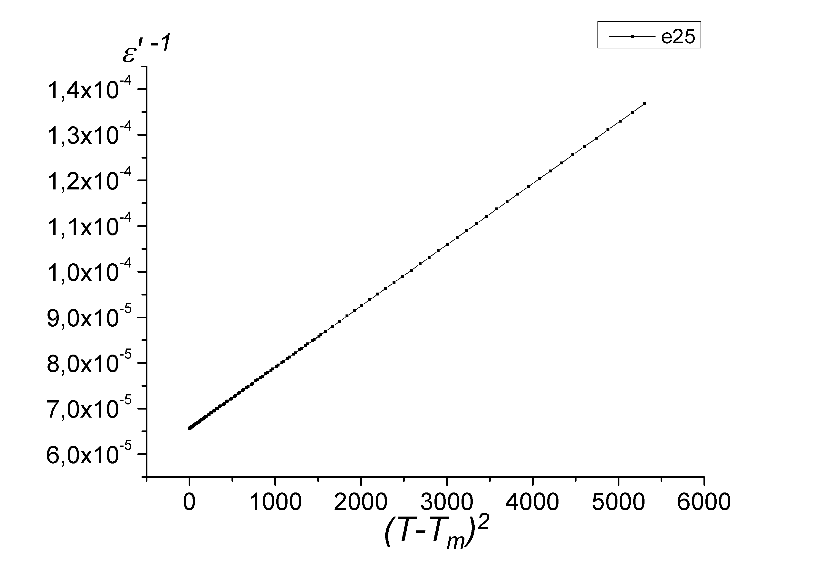
Fig. 2. Dependence of (ε′)⁻¹ on the ${\left(T−T_{m}\right)}^{2}$at 25 Hz.
where ε_{m} - maximum value of the dielectric permittivity, T_{m} - the temperature corresponding to ε_{m}; σ ≈ 50 ⁰C - Gaussian diffuse factor. Figure 2 shows that (1) is a good approximation for experimental data. It is seen in Fig. 1 that far from the diffuse region (higher than Burns temperature T_{d}) a linear Curie-Weiss law is performed with parameters of C_{W} = 2,56·10⁵ ⁰C and T₀ ≈ 215 ⁰C. The obtained value of the Curie-Weiss constant C_{W} is typically for the first order phase transition. It should be noted that T₀ > T_{m} ≈ 164 ⁰C. To reveal where the polarization starts to arise, we plotted the local order parameter q(T). For obtaining the dependence q(T) in the region of diffuse phase transition we used the approach [2], whereby the deviation from the Curie-Weiss law due to the existence of a nonzero local order parameter q

Fig. 1. Temperature dependence of the local order parameter compared to the temperature dependences of ε′ and (ε′)⁻¹ at the frequency of 25Hz.
ε′
(ε′)⁻¹
q
$ε^{−1}(T)=(T−T_{0})/{C_{W}}+f(T)$, (2)
where f(T)= ε₀γq(T), γ – the thermodynamic factor, ε₀ – dielectric constant. Constructed in this way the temperature dependence of the local order parameter is shown in Fig. 1 in comparison with the temperature dependence of (ε ')⁻¹. It is seen that the root mean square polarization begins to occur not at the temperature of maximum value of permittivity ε_{m} but at Burns temperature T_{d} ≈ 284 ⁰C.

References
[1] G.A. Smolenskii, V.A. Bokov, V.A. Isupov, N.N.Krainik, R.E. Pasynkov and A.I. Sokolov. Ferroelectrics and Related Materials. – New York: Gordon and Breach, 1984. 396 p.
[2] L. Mitoseriu, A. Stancu, C. Fedor, P.M. Vilarinho // J. Appl. Phys. 2003. V. 94. P. 1918.

Dielectric response in AB'_{1/2}B''_{1/2}O₃ and AB'_{1/3}B''_{2/3}O₃-type complex oxides
A. Pavlenko, AA Pavelko, M. Talanov, LA Shilkina, LA Reznichenko
Research Institute of Physics, Southern Federal University, Rostov-on-Don, Russia

email: dipoleglass@gmail.com

Complex perovskite oxides with the general formula AB'_{1/2}B''_{1/2}O₃ and AB'_{1/3}B''_{2/3}O₃ is characterized by the unique dielectric properties in the vicinity of the ferroelectric (FE) transition temperature at T = T_{m}. This feature is often associated with fluctuations in the chemical composition of the object in the B-position. One of the most intensively studied materials of this type are PbFe_{1/2}Nb_{1/2}O₃ (PFN) and PbMg_{1/3}Nb_{2/3}O₃ (PMN), which were discovered and first studied by a group of Soviet scientists led by G.A. Smolenskii in the late of 50-th of XX century. Both of these compounds and solid solutions (SS) based on them are not only scientific but also practical interest. However, due to the lack of definitive data about the nature of phase transitions in the PFN and PMN-PbTiO₃(PT) -based SS (near the morphotropic phase boundary), a study of the dielectric characteristics of the spectra give valuable information on the temperature-frequency dynamics of the processes occurring in these compounds still seems relevant. Thus, the goal of this work was to establish the regularities of formation of the dielectric properties of ceramics based on PFN and PMN-PT.
The PFN samples obtained by conventional ceramic technology. Ceramic system PMN-PbNi_{1/3}Nb_{2/3}O₃ (PNN) - PbZn_{1/3}Nb_{2/3}O₃ (PZN)-xPT with x = 0,25 ÷ 0,40 obtained by solid-phase synthesis with elements of columbite method. X-ray diffraction studies were performed on a DRON-3. Measurements of complex permittivity ε* = ε' - iε'' (ε' and ε'' - the real and imaginary parts of ε*, respectively) produced using the impedance-meter Novocontrol ALPHA A High-Resolution Dielectric Analyzer.
X-ray analysis showed that the ceramic samples were obtained without a trace of impurity phases. PFN has a rhombohedral, and PMN-PNN-PZN-PT - heterophase (coexisted pseudocubic and tetragonal) structures at room temperature. In both sites there are no superstructure reflections in the diffraction patterns, which indicate the disorder in the B-position to be existed. However, there is a significant difference in the dynamics of the behavior of ε* in the vicinity of T_{m} (see figure).
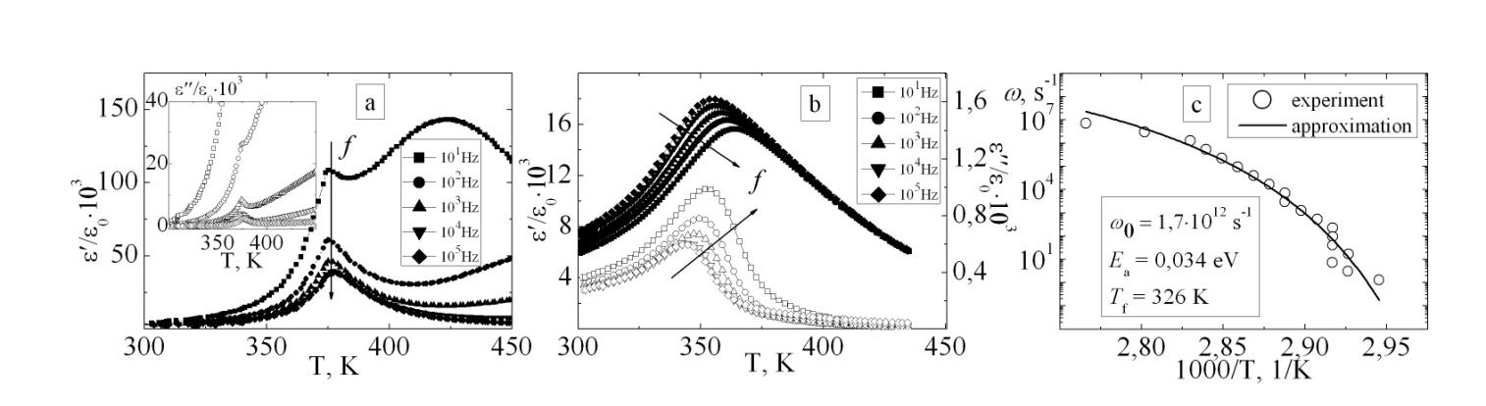
Fig. ε'/ε₀ (T) and ε''/ε₀ (T) dependences (ε₀ is the dielectric constant) of PFN (a), PMN-PNN-PZN-PT (b) ceramics and the dependence of ω = 2·π·f on 1/T (c), which show the fulfillment of the Vogel-Fulcher law.

In the scope of this work the analysis and approximation of the experimental data are carrying out. Possible reasons for the observed differences in the ε'/ε₀ and ε''/ε₀ behavior of studied compounds in the vicinity of T_{m}, which may indicate a fundamentally different mechanisms responsible for phase transitions in complex oxides such as AB'_{1/2}B''_{1/2}O₃ and AB'_{1/3}B''_{2/3}O₃ is discussed.

Dielectric Studies of Lead-Free Relaxor Ceramics and Single Crystals with Tetragonal Tungsten Bronze Structure

S.I. Raevskaya², D.V. Suzdalev¹, E.M. Panchenko¹, A. M. Pugachev², I.P. Raevski¹,
M.A. Malitskaya¹, V.V. Titov¹ , O.A. Bunina¹, and J-L. Dellis ³

¹ Research Institute of Physics and Physics Department, Southern Federal University, Rostov on Don, 344090, Russia
² Institute of Automation and Electrometry, Russian Academy of Sciences, Novosibirsk, 630090, Russia
³ LPMC, Universite de Picardie Jules Verne, F-80039 Amiens, France.
e-mail: sveta.raevskaya@mail.ru

Dielectric properties of KSr₂(Nb_{1-x}Ta_{x})₅O₁₅ and Sr_{0.6}Ba_{0.4}Nb₂O₆ ceramics and Sr_{0.75}Ba_{0.25}Nb₂O₆ single crystals have been studied in a wide frequency and temperature range. Some features characteristic of relaxors were observed, namely fulfilment of quadratic and linear Curie-Weiss laws for ε' just above and well above the temperature T_{m} of ε'(T) peak respectively, the Vogel-Fulcher scaling of both ε'(T) and ε''(T) peaks. However, similar to lead-free perovskite relaxors e.g. (Na,Sr,Li)NbO₃ [1], the dielectric response of both KSr₂(Nb_{1-x}Ta_{x})₅O₁₅ and Sr_{x}Ba_{1-x}Nb₂O₆ has some peculiarities as compared to canonical lead-containing perovskite relaxors, e.g. PbMg_{1/3}Nb_{2/3}O₃. In particular, the large difference between Vogel-Fulcher temperature Т₀ values for real and imaginary parts of permittivity implies that in lead-free materials Т₀ has no relation with the temperature of freezing of the relaxation spectrum. The results obtained show that additional studies of different lead-free relaxors are necessary to make a deeper insight into the origin of their peculiar properties.
Fig. 1. Dependences of 1/(lnf0-lnf) on Т_{m} (f₀ is an attempt frequency in the Vogel-Fulcher law ) for ε' (а) and ε'' (b) of the KSr₂(Nb_{1-x}Ta_{x})₅O₁₅ ceramics. Numbers correspond to x values.

References
1. S.I. Raevskaya, L. A. Reznitchenko, V. V. Titov, I. P. Raevski, M. A. Malitskaya, I. N. Zakharchenko, J-L. Dellis. Ferroelectrics. 371, 63 (2008).

Cтеклоподобное Поведение Слоистых Кристаллов
CuCr_{x}In_{1-x}P₂S₆ при Высоких Давлениях

О.В.Шуста, А.Г.Сливка, В.С. Шуста

Физический факультет, Ужгородский национальный университет,
ул. Пидгирна,46, Ужгород 88000, Украина

Кристаллы твердых растворов на основе соединений CuInP₂S₆, CuCrP₂S₆, со слоистой структурой в настоящее время представляют собой модельные объекты для исследования эффектов замораживания релаксационной динамики, обусловленной дипольным разупорядочением. При изменении химического состава твердых растворов наблюдается трансформация от дипольного упорядочения с дальным порядком (сегнетиэлектрическая или антисегнетиэлектрическая фаза) через состояние с близким дипольным порядком (релаксорный стан) к дипольному стеклу с характерной релаксационной динамикой, обусловленной индивидуальным “замораживанием” сегнетоактивных ионов в кристаллической ячейке.
В настоящей работе приведены результаты экспериментальных исследований влияния высокого гидростатического давления на фазовые переходы и релаксационное поведение диэлектрической проницаемости в слоистых соединениях CuCr_{x}In_{1- x}P₂S₆.
Установлено, что увеличение гидростатического давления в исследованных кристаллах приводит к увеличению действительной и мнимой частей диэлектрической проницаемости в области дипольного стекла, увеличивает час релаксации при уменьшении энергии активации. Также установлено, что температура перехода в стеклоподобное состояния уменьшается при увеличении гидростатического давления.

The Distribution Function of Local Fields for Simple Model of K_{1−x}(NH₄)_{x}H₂PO₄ Type Mixed Crystal

S. Sorokov

Institute for Condensed Matter Physics, National Academy of Sciences of Ukraine,
1 Svientsitskii Street, 79011 Lviv, Ukraine

e-mail: sorok@mail.lviv.ua;

The spin-glass model on regular random graphs (Bethe lattice), which takes into account the four random energy levels of structure element of graphs, is explored. Within the frame of replica symmetry approach the integral equation for distribution function of local fields is derived. The numerical and analytical (at T=0) solutions for some relations between energy levels are obtained. The presented model can be used for the () type mixed crystals, which takes into account the random energy levels of protons (deuterons) around a group.

References
1. Matsuda Y., Nishimori H., Zdeborová L. Krzakala F. // J. Phys. A: Math. Theor., 2011, 44 185002.
2. Sorokov S. I., Levitsky R.R., Vdovych A.S. // Condens. Matter Phys. – 2010. – Vol. 13, No 1. – P. 13706: 1.26

ACKNOWLEDGMENTS. This work was supported by State Fund Fundamental Researches of Ukraine (Grant № Ф40.2/099)

Electromechanical Properties of Relaxor Ferroelectrics Ceramics in Different Regimes Supply of the Electric Field

M.V. Talanov

Research Institute of Physics, Southern Federal University, Rostov-on-Don, 344090 Russia
e-mail: tmikle-man@mail.ru

To create an energy-efficient actuators required materials with high electromechanical coupling constants and piezoelectric coefficients. To date, the most promising basis for the creation of such devices are solid solutions (SS) based on relaxor ferroelectrics (Pb(Mg_{1/3}Nb_{2/3})O₃ (PMN) and Pb(Zn_{1/3}Nb_{2/3})O₃ (PZN)) and PbTiO₃ (PT), located near the morphotropic phase boundary [1]. It is known [2] that these materials under the influence of high electric field (E) undergo an irreversible phase transition, which affects the character of the manifestations of electromechanical properties. Thus, in some studies [3,4] reported the fundamental differences between the curves of dependencies of deformation (ξ) crystals of PMN-30PT, PZN-8PT on the electric field applied in the monopolar and bipolar regime. The aim of this study is to identify characteristics of the formation of electromechanical properties of multicomponent ceramic systems based on PMN, PZN, Pb(Ni_{1/3}Nb_{2/3})O₃ and PT with different regimes of application of an electric field.
The object of the study are multicomponent system ceramics PMN-PNN-PZN-xPT (x ÷ 0.25-0.40), doped Ba. To measure the elastic deformation induced by the piezoelectric element attached to the continually changing electric field E, we used a specially designed stand. Stand included: precision micrometer stand for fixing the piezoelectric element and the sensor, a stabilized voltage source; galvanomagnetic dilatometer with digital display readings. The measurements were performed in quasi-static mode in the range of E ÷ ± 12kV/cm.
Established that in ceramics containing x <0.30 the curves ξ (E), obtained as in bipolar and unipolar regime with, characterized almost no hysteresis, and close values of the maximum ξ. Heterophase SS (with 0.30 ≤ x <0.375) peculiar to a pronounced hysteresis, and ξ is much larger (up to 30%) of the maximum value of ξ in the bipolar regime (compared to monopolar). These features are associated with the evolution of the dominant contributions to ξ (E) from electrostrictive to piezoelectric with increasing content of the PT.

This work was financially supported by the Ministry of Education and Science of Russian Federation, state contract № 16.513.11.3032.

Acknowledgment. This work was supported by government contract (Grant N 16.513.11.3032)

References
1. S.-E. Park, T.R. Shrout. J. Appl. Phys. 82, 804 (1997).
2. F. Bai, N. Wang, J. Li at all. J. Appl. Phys. 96, 1620 (2004).
3. D. Viehland, J. Li. J. Appl. Phys. 92, 7690 (2002).
4. D. Viehland. J. Appl. Phys. 88, 4794 (2000).

Процессы Релаксации Поляризации при Освещении Монокристалла SBN-75+Cr

А.И. Бурханов¹, К.П. Гужаковская¹ и Л.И. Ивлева²

¹Волгоградский государственный архитектурно-строительный университет, Волгорад, 400074, Россия
²Институт общей физики РАН им. А.М. Прохорова, Москва, Россия
e-mail: burkhanov@inbox.ru

В настоящей работе исследована температурно-полевая эволюция петель поляризации монокристалла ниобата бария-стронция SBN-75 с примесью 0,01 at.% Cr в области размытого фазового перехода до и после воздействия освещения малой мощности.
Образец для исследований был приготовлен в виде прозрачного параллелепипеда (размером 4.5×5×3 мм³) с отполированными до оптического качества большими поверхностями, на которые падал свет от светодиода (0,15 мВт/см²). Измерительное синусоидальное поле E от 200 до 1860 В/см подавалось по направлению полярной оси кристалла и было перпендикулярно направлению луча света. Значения эффективной диэлектрической проницаемости ε'_{эфф} = P/(ε₀E), где P – поляризация, ε₀ – электрическая постоянная, определялось с использованием модифицированной схемы Сойера-Тауэра на частоте 1 Гц в квазистатическом режиме нагрева.
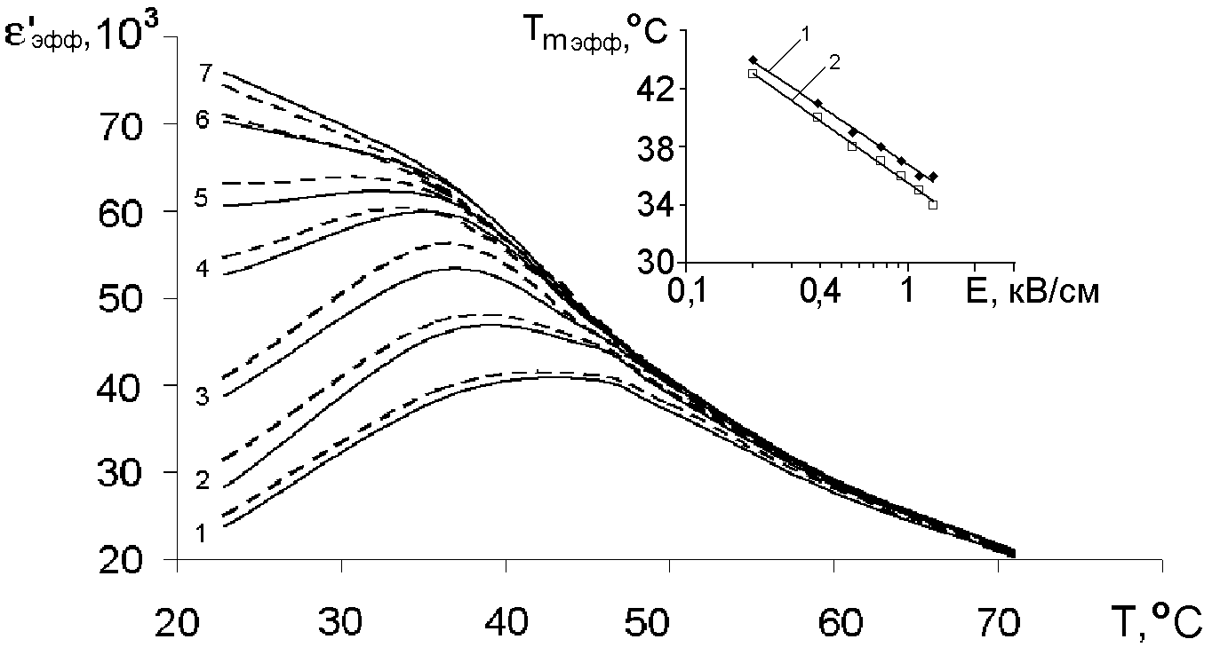
Рисунок иллюстрирует поведение температурных зависимостей ε'_{эфф} как без освещения (сплошные кривые), так и при освещении (пунктирные) для различных амплитуд поля E: 1 – 0,2 кВ/см, 2 – 0,56 кВ/см, 3 – 0,93 кВ/см, 4 – 1,3 кВ/см, 5 – 1,48 кВ/см, 6 – 1,68 кВ/см, 7 – 1,86 кВ/см. На врезке показана зависимость температуры максимума ε'_{эфф} от приложенного поля T_{m_эфф}(E): 1 – без освещения; 2 – при освещении.
Установлено, что при полях E < E_{i} (при E_{i} максимум ε'_{эфф}(Т) превращается в излом, кривая 5) имеет место рост значений ε'_{эфф} с увеличением Е как без, так и при освещении образца. Однако при освещении ε'_{эфф} оказываются выше, чем без освещения. При этом в обоих случаях происходит сдвиг T_{m_эфф} в сторону более низких температур: T_{m_эфф} ~ ln(E). По сравнению со случаем без освещения, при освещении T_{m_эфф} оказываются ниже (врезка: кривые 1 и 2, соответственно).
Таким образом в работе показано, что освещение не меняет общего характера амплитудной зависимости T_{m_эфф}(E), который имеет место в релаксорах [1], но при этом от амплитуды E зависит влияние освещения на значения ε'_{эфф}.
Результаты обсуждаются в рамках представлений о существовании различных вкладов в релаксацию поляризации, определяемых, с одной стороны, полярными кластерами и их границами (при E < E_{i}), а с другой (при E > E_{i}) – особым поведением доменной структуры в релаксорах типа SBN [2].

Литература
- A.E. Glazounov, A.K. Tagantsev, A.J. Bell. Phys. Rev. B. 53, 11281 (1996)
- Т.Р. Волк, Н.Р. Иванов, Д.В. Исаков, Л.И. Ивлева, П.А. Лыков. ФТТ. 47, 293 (2005).

Влияние Освещения на Процессы Низко - и Инфранизкочастотной
Релаксации Поляризации в Сегнетокерамике SBN

Лыу Тхи Ньян ¹, С.В. Медников ¹, А.И.Бурханов², K. Bormanis³, M. Antonova³

¹ Волгоградский государственный технический университет
² Волгоградский государственный архитектурно – строительный университет
³ Institute of Solid State Physics, University of Latvia, Riga, Latvia

В работе исследовано влияние освещения белого цвета, излучаемого светодиодом мощностью 0.15 мВт на характер диэлектрического отклика керамики SBN-75 в сильных переменных полях в диапазоне частот от 0.1Гц до 10Гц.
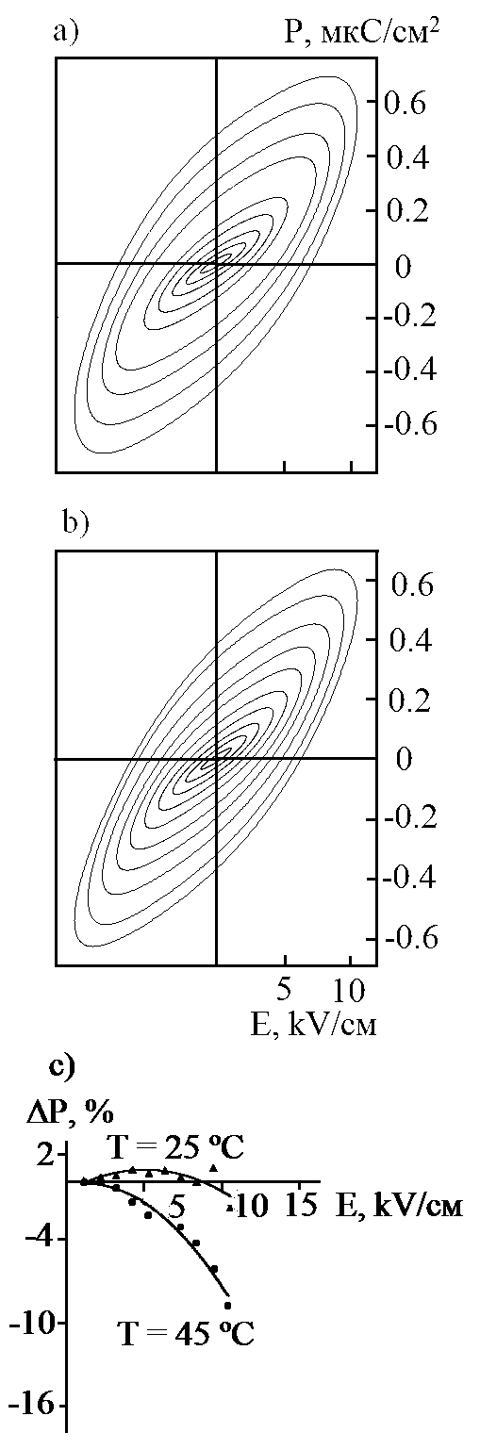
Рисунок иллюстрирует, достаточно типичное, для керамических образцов поведение петель поляризации (ПП) на частоте 1 Гц при Т=45 ^{о}С (T_{m} ≈ 110^{о}С , [1]), где на таких низких частотах выражено проявление релаксации объемного заряда. В тоже время из сравнения ПП, полученных на неосвещенном (а) и освещенном (б) образце керамики ниобата бария стронция Sr_{0.75}Ba_{0.25}Nb₂O₆, обладающей размытым фазовым переходом [1] выявляется, что освещение заметным образом уменьшило площадь петли. Таким образом, можно предполагать, что освещение существенно уменьшает вклад в поляризацию процессов, связанных с образованием объемного заряда.
В работе также показано, что параметр, характеризующий относительное изменение поляризации ΔP = (P_{освеще} – P_{неосве})/P_{мах} при более низких температурах Т=+25ºС (рисунок с) имеет максимум при некотором значении амплитуды Е . То есть, освещение приводит в начале к увеличению значений поляризации до определенных величин Е, а затем, с увеличением прикладываемого поля Е, к умещению ΔP. Наиболее вероятной причиной такого поведения ΔP(Е) является различие вкладов в релаксацию поляризации объектов, характерных для области размытого фазового перехода, когда появление неравновесных носителей при освещении может существенно изменять степень воздействия внутренних полей на данные объекты. При более высоких температурах (Т=+45ºС) ∆P идет в отрицательную область, так как в данном случае освещение заметно уменьшает поляризацию, обусловленную при повышенных температурах и полях релаксацией объемного заряда.

Рисунок

1) K. Bormanis, A.I. Burkhanov, S.V. Mednikov, Luu Thi Nhan, A. Kalvane, and M. Antonova. Relaxor Properties of Barium-Strontium Niobate Ceramics. Ferroelectrics, 2011, 417, 01, 58 - 62.

Процессы Релаксации Поляризации в Сегнетокерамике PMN+2%Li₂O в Области Размытого Фазового Перехода

А.И.Бурханов¹, И.Е. Туманов¹ , К.Борманис², А.Калване²

¹Волгоградский государственный архитектурно-строительный университет, Волгоград, Россия
²Институт Физики твердого тела Латвийского университета, Рига, Латвия
e-mail: f1z1c@yandex.ru

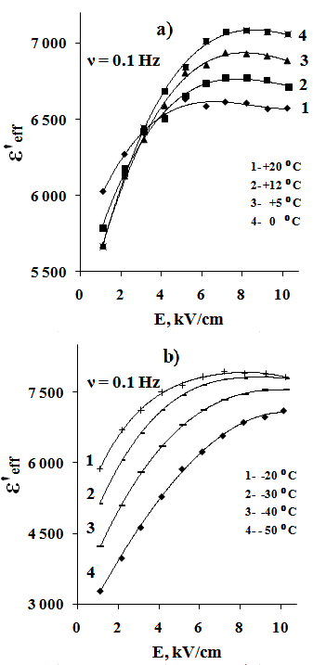
В настоящей работе исследовался характер диэлектрической нелинейности в керамике магногиобата свинца с добавкой лития в области размытого фазового перехода.
Диэлектрический отклик изучался методом Сойера-Тауэра при частоте измерительного поля от 0.1 до 10 Гц. Исследуемая керамика Pb(Mg_{1/3}Nb_{2/3})O₃ + 2wt.% Li₂O была приготовлена по обычной керамической технологии.
Выявлены особенности в поведении эффективных значений диэлектрической проницаемости, рассчитываемых из петель поляризации как ε΄_{эфф}=P/(ε_{o}·E).
Рисунок иллюстрирует амплитудные зависимости ε΄_{эфф}(Е) в области температур как выше температуры максимума диэлектрической проницаемости T_{m} , так и ниже T_{m} (для слабых измерительных полей для 1 Гц T_{m} ≈ -16^{о}C, для 1000 Гц T_{m} ≈ -3^{о}C [1]).Установлено, что в области Т>T_{m} при некотором Е_{i} значения ε΄_{эфф} становятся температурно-независимыми. При этом величина Е_{i} существенно зависит от частоты измерительного поля: чем ниже частота, тем ниже значения Е_{i}. Данная особенность является следствием большого вклада в релаксацию поляризации процессов проводимости при Т>T_{m}, а при приближении к T_{m} и росте Е постепенно увеличивающимся вкладом в поляризацию таких объектов как полярные кластеры и фазовые (доменные) границы с существенным разбросом по временам релаксации. При Т<T_{m} вклад в релаксацию поляризации в основном определяется поведением доменной структуры данного материала. Однако существенный температурный сдвиг амплитудных зависимостей указывает на значительное распределение критических (коэрцитивных) полей переключения доменов, что характерно для сегнетоэлектриков с размытым фазовым переходом.

1. А.И.Бурханов, И.Е. Туманов, К.Борманис, А.Калване . Низко- и инфранизкочастотные диэлектрические свойства керамики Pb(Mg1/3Nb2/3)O3 + 2wt.%Li2O // Физика твердого тела, 2012, том 54, вып. 5
A New Description Method of Oxygen-Octahedral Systems’ Deformations in the Crystal Structures of Functional Materials

A.V. Nazarenko, A.G. Razumnaya and M.F. Kupriyanov

Southern Federal University, Rostov-on-Don, 344090, Russia
e-mail: razumnaya1@gmail.com

A lot of functional materials have crystalline structures, which could be considered as «distorted» structures with respect to some «ideal nondistorted» ones. If such deformations are small, then distorted structures could become ideal, for example, at heating. Distorted structures are considered as pseudosymmetric ones with respect to ideal structures. The reasons of the distortion could be different. The most striking examples of distorted structures are structures of ferroics (ferroelectrics, ferroelastics etc.).
Mutilation phase transitions and spontaneous deformations, caused by spontaneous polarization, were considered as main reasons of distortions of perovskite structures. The crystals of perovskite family undergo numerous phase transitions caused by the octahedra rotations around various directions with respect to parent ideal cubic cell.
Possible reasons of structural distortions listed in [1] are: distortions caused by the bond network, distortions caused by structural incommensurations, distortions caused by cation-cation repulsion, distortions caused by electronic effects.
To characterize the distortions of BO₆ octahedra in perovskite structure we introduced interatomic l_{B-O} bonds. The set of topologically homogeneous matrix elements were constructed as scalar products ${\bar{l}}_{i}{\bar{l}}_{j}$ (i, j = 1…6) of B-O bond lengths. For ideal nondistorted octahedra with the cubic symmetry the corresponding matrix has the following form:

$$L_{\text{ij}}=\left|\begin{matrix}l^{2} & 0 & 0 & −l^{2} & 0 & 0 \\ 0 & l^{2} & 0 & 0 & −l^{2} & 0 \\ 0 & 0 & l^{2} & 0 & 0 & −l^{2} \\ −l^{2} & 0 & 0 & l^{2} & 0 & 0 \\ 0 & −l^{2} & 0 & 0 & l^{2} & 0 \\ 0 & 0 & −l^{2} & 0 & 0 & l^{2}\end{matrix}\right|$$

The nonzero values of the nondiagonal elements of this matrix imply that the angle between the corresponding bonds is different from 90^{о}. A negative value indicates that the angle exceeds 90^{о}, while a positive value corresponds to the angle less than 90^{о}. Relationships between the matrix elements depend on the symmetry of the distorted octahedra.
The results of x-ray diffraction data treatment for Y_{1-x}Ca_{x}MnO₃ [2] and BiFeO₃–YMnO₃ [3] solid solutions are presented.

Acknowledgment. This work was supported by Russian Foundation for Basic Research (Grant N 10-03-00189а)

References
1. M. Kunz, I.D. Brawn, J. Solid State Chem. 115, 395-406 (1995).
2. A.G. Razumnaya, A.G. Rudskaya, M.F. Kupriyanov et al. Solid State Physics. 51, 2171-2174 (2009).
3. A.V. Nazarenko, A.G. Razumnaya, M.F. Kupriyanov et al. Solid State Physics. 53, 1523-1525 (2011).

Session 5.
Heterogenous Systems and Thin Films

Oral presentation

Structural and Dielectric Properties of Glycine Phosphite Thin Films

E.V. Balashova¹, B.B. Krichevtsov¹, G.A. Pankova², V.V. Lemanov¹

¹ Ioffe Physico-technical Institute of RAS, 194021 Saint-Petersburg, Russia
² Institute of macromolecular compounds of RAS, 199004 Saint-Petersburg, Russia
e-mail: balashova@mail.ioffe.ru

Active progress in the investigation of ferroelectric films revealed their considerable potential for application in various areas of modern technology such as information storage systems, sensors of different fields, elements of microelectronics and so on [1,2]. Recently it was shown that thin polycrystalline films of betaine phosphite (BPI),(CH₃)₃NCH₂COO⋅H₃PO₃, can be grown on different substrates by evaporation method [3]. BPI films consist of large, about several millimeters in size, single crystal blocks, and exhibit pronounced dielectric anomaly at ferroelectric phase transition. The review of small- and strong signal dielectric response in BPI and deuterated BPI films can be found in [3]. In this report, we present first results on preparation, characterization of block and crystal structure, and study of dielectric properties of glycine phosphite films.
Thin polycrystalline films of amino acid ferroelectrics glycine phosphite (GPI) and deuterated GPI have been prepared by evaporation method on NdGaO₃(001) substrate with interdigital structure of electrodes deposited on the surface. Optical images of films obtained by means of polarized microscope in reflection mode have shown that the films consist of small single crystal blocks of several tens of microns in size. X-ray diffraction analysis proves that the non-polar c* axis in blocks coincides with the normal to the surface, and the polar axis b is oriented in the film plane. Temperature dependences of capacitance of GPI/NdGaO₃ structures measured using interdigital structure of electrodes exhibit strong anomaly at ferroelectric phase transition temperature similar to that of glycine phosphite single crystals along polar b axis. Dielectric hysteresis loops in glycine phosphite films were found and measured below Curie temperature by Sawyer-Tower method. The difference in frequency dependence of coercive field and remnant polarization in structures with GPI films and previously studied betaine phosphite films is analyzed and attributed to considerable difference in dimensions of blocks in these structures. It was found that the DC electric field applied to DGPI films below Curie temperature induces considerable unipolarity of hysteresis loops which can be easily controlled by electric voltage and temperature.

Acknowledgment. This work was supported by Russian Foundation for Basic Research (Grant N 10-02-00557a)

References
1. M. Dawber, K.M. Rabe, J.F. Scott. Rev. Modern Phys. 77, N4, 1083 (2005).
2. J.F. Scott. Ferroelectric Memories (Springer, Berline), 2000.
3. E.V. Balashova, B. B. Krichevtsov (2011) Amino-acid ferroelectric thin films, Ferroelectrics – Material Aspects, Mickaël Lallart (Ed.), ISBN: 978-953-307-332-3, InTech, Available from: http://www.intechopen.com/articles/show/title/amino-acid-ferroelectric-thin-films

Пироэлектрический Эффект в Слоистых Магнитоэлектрических Композитах Связности 2-2

А.А. Богомолов¹, А.В. Солнышкин^{1,2}, Д.Ю. Карпенков¹, И.Л. Кислова³

¹Тверской государственный университет, Тверь, 170002, Россия
²Национальный исследовательский университет «МИЭТ», Москва, Зеленоград, 124498, Россия
³Тверской государственный технический университет, Тверь, 170009, Россия
e-mail: alexey_bogomolov@mail.ru

Магнитоэлектрические (МЭ) композиционные структуры на основе керамических сегнетоэлектриков и магнитострикционных материалов являются альтернативой однофазных кристаллических мультиферроиков, которые обладают незначительным по величине магнитоэлектрическим эффектом. Несмотря на достаточно большое число экспериментальных и теоретических исследований МЭ композитов, многие важные вопросы не решены до сих пор. В частности, мало изучены пироэлектрические свойства магнитоэлектрических материалов. Исследование пироэлектрического эффекта в этих объектах позволяет определять степень механической связи и контролировать степень поляризованности сегнетоэлектрических слоев.
В настоящей работе приводятся результаты экспериментальных исследований пироэлектрических откликов, полученных динамическим методом, слоистых магнитоэлектрических композитов связности 2-2. Объектом исследования служили плоскопараллельные пластинки керамики системы цирконата титаната свинца (ЦТС), на противоположные стороны которых методом вжигания серебряной пасты нанесены проводящие электроды. На одну из поверхностей приклеивалась пластинка никель-цинкового (NiZn) феррита. Образцы керамики ЦТС были предварительно поляризованы в электрическом поле по стандартной методике.
Анализ электрического отклика композитных образцов на воздействие теплового потока, модулированного импульсами прямоугольной формы, показал, что в начальный момент воздействия возникает упругая волна, которая инициирует пьезоотклик. Частотная зависимость начального выброса тока также свидетельствует о его пьезоэлектрической природе – с понижением частоты модуляции он уменьшается вплоть до полного исчезновения на низких частотах. Дальнейший нагрев образца композита PZT-никель-цинковый феррит тепловым потоком приводит к возникновению тока, являющегося комбинацией пироэлектрического и пьезоэлектрического откликов, последний обусловлен механическим взаимодействием слоев, составляющих композит.
Выполнен расчет временной зависимости пироэлектрического тока композита PZT-никель-цинковый феррит. Показано, что согласие расчета и эксперимента наблюдается при учете механического взаимодействия пироэлектрического и непироэлектрического слоев, связанного с тепловыми деформациями несегнетоэлектрического слоя, в электрический отклик исследуемых образцов. Таким образом, в неоднородных средах пироэлектрический коэффициент нельзя определять без учета пьезоэлектрического вклада, обусловленного различием коэффициентов теплового расширения, отвечающих различным материалам, составляющим композит.
Аналогичная картина может иметь место и для пироэлектрических откликов сегнетоэлектриков при наличии приповерхностных слоев, не обладающих спонтанной поляризацией.

Диэлектрические Свойства Пористых Оксидов Алюминия и Кремния с Сегнетоэлектрическими Включениями

О.М.Голицына, С.Н.Дрождин, А.Е.Гриднев, В.М.Кашкаров

Воронеж, Воронежский государственный университет

Исследованы диэлектрические свойства композиционных материалов, полученных путем внедрения сегнетоэлектрика ТГС и его аналогов (АТГС, ТГС+Сr³⁺) в матрицы пористых оксидов алюминия и кремния.
Пористые пленки Al₂O₃ с регулярной системой пор в виде цилиндрических ячеек глубиной 5 мкм и диаметром пор 110 нм были получены при 30 минутном анодировании Al фольги в фосфорной кислоте. Подложка из пористого SiO₂ формировалась в процессе электрохимического травления Si в смеси плавиковой кислоты и изопропилового спирта с добавлением перекиси водорода. Образуется случайная система пор в виде цилиндрических ячеек глубиной 10 мкм с диаметром пор 500, 1000 нм. Свежеприготовленные образцы выдерживались в вакууме 10⁻⁴ мм рт.ст. в течение 24 ч при комнатной температуре.
Сегнетоэлектрический материал внедрялся в поры путем его осаждения из пересыщенного раствора ТГС, АТГС ( 10 вес. % в растворе L,α аланина ), ТГС+Cr³⁺ ( Cr³⁺ не более 10 вес.% в растворе ) при понижении температуры от 55^{о} С до 20^{о} С. Образцы пористых Al₂O₃ и SiO₂ с сегнетоэлектрическими включениями отжигались на воздухе при температуре 100-105 ^{о}С в течение 3 ч. Электроды наносились путем распыления серебра в вакууме на обе поверхности образца. Емкость С и проводимость G образцов измерялись в интервале температур от комнатной до 100^{о} С с помощью моста ВМ- 484 Tesla на частоте 1,592 кГц в поле с амплитудой 0,3 В. Точность стабилизации температуры составляла ±0,1 ^{о}С. Экспериментальные результаты выявили влияние «ограниченной геометрии» на фазовые превращения ТГС и его аналогов в пористых матрицах Al₂O₃ и SiO₂ . Обнаружено расширение сегнетоэлектрической фазы в сторону более высоких температур. Для этих композитов по зависимостям G(T) были рассчитаны значения энергии активации W, которые коррелируют со значениями W для объемного ТГС. Показано, что перенос заряда в изучаемых композитах осуществляется преимущественно через внедренный сегнетоэлектрик.

Transition Temperatures of Oriented Rochelle Salt Nanorods,
Confined in Porous Alumina Films

A.P. Moina

Institute for Condensed Matter Physics, 1 Svientsitskii Street, Lviv, 79011, Ukraine
e-mail: alla@icmp.lviv.ua

We consider the phase transitions in oriented Rochelle salt nanorods confined in a porous alumina matrix. The spontaneous polarization is assumed to be directed along the rod axis. Neglecting in the first approximation the correlational (gradient) and depolarization field effects, we use the model of bulk Rochelle salt crystal. We employ the recently developed [1] modification of the two-sublattice deformable Mitsui model that includes the shear strain ε₄ and the diagonal strains ε₁, ε₂, ε₃, and take into account the interface stresses, thermal mismatch between the inclusions and the matrix, and the size variation of the elastic constants. The size dependences of the Curie temperatures are calculated within the mean field approximation.
The elastic constants are assumed to have contributions, inversely proportional to the rod diameter. The interface stress components σ₁, σ ₂, σ₃ were considered as temperature independent and also inversely proportional to the diameter, in the spirit of the generalized Young-Laplace equation. The free parameters were determined by fitting the calculated T_{C1} in 80 nm nanorods to the experimental value [2]. It is shown that the best agreement with experiment is obtained if the interface stress is hydrostatic, rather than radial.
We also adapt the bulk deformable Mitsui model to the case of a finite cylindrical system. Within the mean field approximation we derive the expression for the thermodynamic potential and obtain equations for the order parameters and lattice strains with taking into account the deformational effects, such as the thermal mismatch and the interface stresses, and determine the transition temperatures of such a system. The obtained results are compared to those for the bulk model. The role of the intrinsic size effects in Rochelle salt nanorods embedded in the alumina matrix is explored.

References
1. A.P. Moina, R.R. Levitskii, I.R. Zachek, Condens. Matter Phys. 14, 43602 (2011)
2. S.V. Baryshnikov, E.V. Charnaya, E.V. Stukova, A.Yu. Milinskiy, Cheng Tien, Ferroelectrics 396, 3 (2010)

Пироэлектрические Свойства Пленочных Композитных Материалов на Основе Сополимера P(VDF-TrFE)

А.В. Солнышкин^{1,2}, А.А. Богомолов¹, И.М. Морсаков¹

¹Тверской государственный университет, Тверь, 170002, Россия
²Национальный исследовательский университет «МИЭТ», Москва, Зеленоград, 124498, Россия
e-mail: a.solnyshkin@mail.ru

Полярные полимеры и композиты на их основе являются перспективными материалами для создания дешевых функциональных элементов современной сенсорной техники, обладающих повышенной чувствительностью за счет управляемых свойств, связанных с дипольным упорядочением полимерной матрицы. Эти материалы относятся к неоднородным системам, свойства которых зависят от концентрации фаз в материале и электрофизических характеристик каждой из фаз. Отклик на внешнее воздействие (электрическое поле, механическое напряжение, изменение температуры и т.д.) является суммарным, определяемым откликами отдельных компонент системы, или определятся некоторым свойством, не присущим ни одной из составляющих фаз.
В настоящей работе динамическим методом выполнены исследования пироэлектрических свойств пленочных образцов композитного материала на основе сополимера винилиденфторида с трифтроэтиленом P(VDF-TrFE) с различным уровнем содержания включений сегнетоэлектрической керамики системы цирконата титаната свинца (ЦТС) в широком интервале температур, включающем точку фазового перехода полимерной матрицы. Исследуемые образцы композита поляризованы электрическим полем коронного разряда.
Результаты исследований показали, что распределение поляризации является достаточно однородным в образцах чистого сополимера P(VDF-TrFE) за исключением приповерхностного слоя с выходом «+»P_{S}, где наблюдается незначительная неоднородность, обусловленная инжекцией электронов из катода в полимер. Для пленочных образцов композита P(VDF-TrFE)+ЦТС экспериментально обнаружено существование аномального пироэлектрического отклика: передний фронт импульса характеризуется значительным выбросом тока (нестационарная компонента) с последующим достаточно быстрым релаксационным спадом до некоторого установившегося значения (квазистационарная компонента). Нестационарная компонента электрического отклика имеет пьезоэлектрическую природу.
Установлено, что концентрационная зависимость величины пироэлектрического коэффициента композита P(VDF-TrFE)+ЦТС носит экстремальный характер с максимумом, соответствующим 20% содержанию керамики.
Температурная зависимость нестационарной компоненты отклика (начального импульса тока) в целом соответствует ходу спонтанной поляризации, тогда как аналогичная зависимость, определенная для квазистационарной компоненты, имеет максимум в области фазового перехода полимерной матрицы. Сравнительный анализ результатов пироэлектрических измерений для образцов сополимера P(VDF-TrFE) и композитов P(VDF-TrFE) с включениями керамики системы ЦТС показывает, что наблюдаемые различия пироэлектрического отклика связаны с внедрением включений сегнетоэлектрической керамики в полимерную матрицу, образующими приповерхностный слой.

Session 5.
Heterogenous Systems and Thin Films

Poster presentation

Сильные и Слабые Релаксационные Поляризации в Гетерогенных Диэлектриках

А.С.Богатин, А.В.Турик, Ю.А.Игнатова, Е.В.Андреев, С.А.Ковригина, В.Н.Богатина

Южный федеральный университет, Ростов-на-Дону, 344090, Россия
e-mail: asbbogatin@sfedu.ru

Рассмотрение релаксационной поляризации, связанной с накоплением зарядов на неоднородностях, началось с Д.К.Максвелла. К.Вагнер показал, что распоряжаясь надлежащим образом характером гетерогенности модели диэлектрика, можно получать все формулы формальной теории, описывающей релаксационную поляризацию. Двухслойный конденсатор, описание свойств которого начато Максвеллом, подробно изучен Сканави. В виде двухслойного конденсатора может быть представлена многослойная структура, свойства диэлектрика которой постоянны в пределах слоя и изменяются скачком при переходе от слоя к слою, причем компоненты в слоях чередуются. Рассмотрение комплексной диэлектрической проницаемости двухслойной структуры проведено А.Р.Хиппелем. Авторы целого ряда статей и монографий описывают диэлектрические свойства и релаксацию в гетерогенных структурах. Принято все гетерогенные системы делить на две большие и различные по физическим свойствам группы – матричные системы, один из компонентов которых составляет связную матрицу, и статистические смеси.
В матричных системах компоненты геометрически неравноправны, перестановка индексов в уравнениях, описывающих эффективные свойства таких систем, приводит к изменению рассчитываемых свойств. Статистические смеси состоят из беспорядочно распределенных или произвольно ориентированных частиц, чаще всего одинаковых по форме и размерам.
Начиная с [1], нами показано, что релаксационные поляризации можно делить на сильные и слабые. При развитии сильных в частотных зависимостях мнимых частей комплексной проводимости имеются экстремумы, при развитии слабых они отсутствуют. При развитии сильных поляризаций, в отличие от слабых, увеличение сквозной электропроводности не может подавить экстремумы в частотных зависимостях тангенса угла диэлектрических потерь. Переход от слабых поляризаций к сильным обусловлен ростом отношения Δε/ε∞, где Δε=ε_{s}-ε∞ - разность значений высокочастотной и низкочастотной диэлектрических проницаемостей. Таким образом, развитие сильных релаксационных поляризаций связано с усилением в диэлектрике роли релаксационных поляризаций по сравнению с ролью быстрых поляризационных процессов. В рамках модели двухслойного конденсатора релаксационные поляризации являются только дебаевскими, и переход от слабых поляризаций к сильным зависит только от отношения сопротивлений и емкостей слоев. Переход к другим моделям гетерогенности, например использование уравнения Бруггермана или формулы Клаузиуса-Мосотти-Лорентц-Лоренца приводит к переходу к распределению релаксаторов Коула – Коула. В этих случаях отношение Δε/ε∞ зависит не только от отношений емкостей и электропроводностей компонентов, но и от их концентрации, причем находятся концентрации компонентов, которым соответствуют большие отношения Δε/ε∞. Именно при этих концентрациях компонентов и развиваются сильные релаксации в гетерогенных диэлектриках.

Литература
1. А.С.Богатин, И.В.Лисица, С.А.Богатина. Письма в ЖТФ, 28, 18, 61 (2002).

Метод Экстраполяции для Определения Вида Распределения Релаксаторов в Диэлектриках

Е.В.Андреев, А.С.Богатин, А.В.Турик, Ю.А.Игнатова, С.А.Ковригина, В.Н.Богатина

Южный федеральный университет, Ростов-на-Дону, 344090, Россия
e-mail: asbbogatin@sfedu.ru

Экспериментально наблюдаемые диэлектрические спектры многообразны. И если первых исследователей могло полностью удовлетворить распределение Дебая, то в дальнейшем для описания конкретных экспериментальных данных были сформулированы распределения Коула-Коула, Дэвидсона- Коула, Гавриляка-Негами и некоторые другие. Проблема аппроксимации экспериментально наблюдаемых диэлектрических спектров спектрами, соответствующими тому или иному распределению релаксаторов , решается обычно методом интерполяции за счет эмпирического подбора параметров распределения. Как правило, при этом вид распределения выбирается исследователем интуитивно. Между тем аппроксимация экспериментальных диэлектрических спектров может быть проведена количественно путем экстраполяции спектров диэлектриков.
Для идентификации распределения релаксаторов и определения его параметров методом экстраполяции необходимо совместное изучение частотных зависимостей действительной ε′ и мнимой ε" частей комплексной диэлектрической проницаемости и действительной σ′ и мнимой σ" комплексной электропроводности релаксационного процесса в исследуемом диэлектрике. В двойном логарифмическом масштабе эти функции при стремлении частоты ω как к нулю, так и к бесконечности являются линейными. Наклоны асимптот этих функций к осям частот различны. Сопоставление экспериментальных диэлектрических спектров диэлектриков с данными теоретического рассмотрения позволяет определять вид и параметры распределения. Характерным для дебаевского распределения является наклон высокочастотной асимптоты lg(ε′(lgω)). Модуль тангенса угла наклона этой асимптоты равен 2. Аналогичные асимптоты для других распределений проходят более полого. Модуль тангеса наклона соответствующих асимптот равен параметру распределения (Коула-Коула, Дэвидсона-Коула) или произведению этих параметров (Гавриляка - Негами), т.е. он заведомо меньше двух. Наиболее характерными для для распределения Коула-Коула является наклон низкочастотной асимптоты lg(σ′(lgω)). Тангенс угла наклона в этом случае равен (1+α). Для распределения Дэвисона – Коула тангенс угла наклона этой асимптоты , как и для распределения Дебая, равен 2, но но модуль тагенса угла наклона высокочастотной асимптоты lg(ε′(lgω)) равен параметру распределения. Определиться с распределением Гавриляка – Негами можно следующим образом. Параметр α этого находится из низкочастотной асимптоты lg(σ′(lgω)), но если это распределение Гавриляка – Негами, а не Коула – Коула, то модуль тангенса угла наклона высокочастотной асимптоты lg(ε′(lgω)) равен произведению параметров α·β , откуда по предыдущей информации о величине α может быть определен параметр β. После определения вида распределения релаксаторов характеристическое время релаксации определяется по точке пересечения высокочастотной и низкочастотной асимптот.
Разработанный метод позволил определить вид и параметры распределения релаксаторов в керамическом Pb_{0,9}La_{0,1}TiO₃, керамических твердых растворах Sr TiO₃-SrMg_{1/3}Nb_{2/3}O₃ и в ряде других диэлектрических материалов.

Electric Properties of Heterogeneous Со_{x}(PZT)_{100-x} Nanocomposites

A.G. Gorshkov¹, S.A. Gridnev²

¹Voronezh Institute of State Fire Service of EMERCOM of Russia, Voronezh 394052, Russia, e-mail: gorasic@mail.ru
²Voronezh State Technical University, Voronezh, 394026, Russia

Last years the composite materials, which are nanosized granules of magnetic metal, distributed in nonmagnetic matrix are actively studied. Such composites possess a number of unusual magnetic, electric, optical and magnetoelectrical properties. Their studying stimulates by applications of composites in electronic engineering. The most significant changes of properties of heterogeneous nanostructures occur near a percolation threshold. Some interval of compositions corresponds to a percolation threshold, in which coagulation of separate granules and formation of percolation of electroconduction clusters occurs. At the same time, the analysis of experimental and theoretical works shows that dielectric and electric characteristics of nanocomposites in the region of low temperatures are unsufficiently studied.
The purpose of the present work is a study of conductivity mechanisms at low temperatures for nanocomposite samples Со_{x}(PZT)_{100-x} in a wide concentration range of a metal phase, as well as electric and dielectric properties vs. a composite composition.
Samples of Со_{x}(PZT)_{100-x} have been prepared by ionic-beam sputtering of a target in mixed atmosphere (argon + oxygen) at partial pressure of oxygen 5,2⋅10⁻³ N/m² in order to provide full oxidation of the dielectric phase. For sputtering a combined target consisting of a cast cobalt plate and several PZT ceramic plates on its surface was used. The non-uniform arrangement of PZT plates on a target surface enabled us to prepare samples during a single deposition process and, accordingly, under the same preparation conditions. Besides, in this case a ratio of metal and dielectric phases in samples was varied from 0 up to 75 at.% Co.
Frequency dependences of conductivity for composites below a percolation threshold in weak fields were investigated at room temperature and showed the Mott’s type hopping mechanism of conductivity.
For compositions below a threshold of percolation a change of the conductivity mechanism from the Mott’s law ln(σ)∼(1/T)^{1/4} to the dependence ln(σ)∼(1/T)^{1/2} is observed at a temperature 190 K. From temperature dependences of conductivity for the interval 90 – 190 K Mott’s law is hold, the density of electronic states at the Fermi level for a metal phase for different compositions and the hopping length of charge carriers have been calculated. For description of temperature dependences of conductivity in an temperature interval 190-293 K the model of inelastic resonant tunneling of electrons [1,2] has been used. In frames of this model we estimated an average number of the localized states in a dielectric matrix between the metal granules, participating in electronic transport. It was established, that the more a concentration of a metal phase is the lesser an average number of the localized states in a dielectric matrix is.

References
[1] Glazman L I and Matveev K A 1988 Zh. Eksp. Tekhn. Fiz. 94 332
[2] Glazman L I and Shekhter R I 1988 Zh. Eksp. Tekhn. Fiz. 94 292

Conductivity and Barrier Effects in PZT-Based Thin Film Heterostructures According to Synthesis Conditions

M.V. Kamenshchikov¹, A.V. Solnyshkin^{1,2}, A.A. Bogomolov¹, and I.P. Pronin³

¹Tver State University, 170002, Tver, Russia
²National Research University of Electronic Technology “MIET”, Moscow, Zelenograd, 124498, Russia
³A.F.Ioffe Physico-Technical Institute, RAS, 194021, St. Petersburg, Russia
e-mail: Mikhailkamenshchikov@yandex.ru

Nowadays, PZT-based thin film Pb(Zr,Ti)O₃, is widely used in creating devices of optoelectronics and microelectronics. The properties of these structures are substantially dependent on the method of their formation, the choice of material of substrate, electrodes, etc. Therefore, the aim of this work was to investigate of electrophysical properties of PZT thin films according to synthesis conditions.
Research was performed on thin-film Pt/PZT/Pt capacitor structures formed on silicon substrates by rf magnetron sputtering method at temperatures of 540 – 570°C. The thickness of the PZT layer is about 500 nm. Data about electrical conduction and barrier effects were obtained from analyses of current-voltage (I-V) and capacitance-voltage (C-V) characteristics.
Fig. 1 shows the dependence of current experimentally received on applied voltage in semi-logarithm scale for the PZT capacitors synthesized at 545°C. I-V characteristics generally possess nonlinear type in the electric fields exceeding 10 kV/cm. Moreover, I-V characteristics show asymmetry that indicates to the differences between the potential barriers sizes on the interfaces of thin film structure Pt/PZT/Pt. For the films with the synthesis temperature ≥545°С under electric field exceeding 35 kV/cm, there is an abrupt increase in current by several orders. At the same time the biggest jump (∼10⁵ times) was detected in samples with the synthesis temperature 550°C.
The temperature dependence of conductivity is also discussed in the work. From I-V characteristics are carried out at the range of temperature from 20 to 150°C and the electric field range less than 70 kV/cm, we can stress two main conductivity mechanisms: Ohmic (before 10 kV/cm) and the Poole-Frenkel emission (10 - 70 kV/cm).
Fig.1. I-V characteristics of PZT thin film | Fig.2. C-V characteristic at measured U = 1 V and f = 25 Hz. | Fig.3. Plot 1/С² vs bias from the C-V measurements

C-V characteristics (fig.2) also are asymmetry. From analysis of C-V characteristics were obtained potential barriers values on the Pt/PZT interfaces according to synthesis conditions. On the fig.3 is shown the dependence of 1/C² on the bias field for the film with a synthesis temperature 545°C. On the basis of the presented diagram were estimated the sizes of potential barriers for top and bottom interfaces (1.2 and 0.5 eV).
Ba_{0.8}Sr_{0.2}TiO₃ Films Crystallized at Room Temperature by Laser Assisted Annealing

J. P. B. Silva¹, A. Khodorov¹, M. Pereira¹ and M. J. M Gomes¹

Physics Centre, University of Minho, 4710-057, Campus de Gualtar, Braga, Portugal.

e-mail anatoli@fisica.uminho.pt

The integration of ferroelectric thin films (FETF) into silicon based technology meets problems of interfacial chemical reactions and atoms interdiffusion when deposited in strongly oxidizing conditions at elevated temperatures. The use of laser assisted annealing (LAA)¹ may help to avoid many of the technological problems. Adjusting laser fluency and frequency, a temperature profile could be created in such a way that the crystallization of film would be accompanied by minimal heating of substrate. Moreover, the laser crystallization is super-fast with the total exposure time up to few ms that allows eliminating the interfacial diffusion. These make LAA to be an attractive and versatile crystallization method and the crystallization of FETF on substrates like platinized silicon and polyethylene terephthalate was demonstrated²⁻⁴.
In this work the Ba_{0.8}Sr_{0.2}TiO₃ films were grown by PLD on platinized silicon, glass and ITO-coated glass substrates. The crystallization has been performed with help of LAL (KrF laser) at RT. The previous study showed that Pt/Si substrate acts as a heat sink that makes the temperature profile to be well non-uniform and the use of high energy density and repetition rate was necessary to crystallize the BST films which caused cracking and damaging of surface layer². The dielectric substrates like glass can help to avoid this problem. Adjusting annealing conditions we were able to grow the well crystalline crack-free BST films with pure perovskite phase on bare glass substrate with help of LAL. For the electrical and electro-optical characterization the BST films were grown on ITO-coated glass substrate. In order to improve adhesion and the surface of BST films a seed and capping layers of La_{0.5}Sr_{0.5}CoO₃ have been used. The optimization of the growth process as well as the comparison of physical properties of LAL processed films will be presented.

References
¹J.M. Poate and J.W. Mayer, editors, Laser Annealing of Semiconductors (Academic, New York, 1992).
²O. Baldus and R. Waser, Appl. Phys. A 80 1553 (2005)
³E.D. Tsagarakis C. Lew, M.O. Thompson and E.P. Giannelis, Appl. Phys. Lett. 89 202910 (2006).
⁴S.S.N. Bharadwaja, F. Griggio, J. Kulik and S. Trolier-McKinstry, Appl. Phys. Lett. 99 042903 (2011).
Диэлектрические Характеристики Композитных Структур на Основе Сополимера P(VDF-TrFE) с Включениями Сегнетоэлектрической Керамики

И.М. Морсаков¹, А.В. Солнышкин^{1,2}, А.А. Богомолов¹, И.Л. Кислова³

¹Тверской государственный университет, Тверь, 170002, Россия
²Национальный исследовательский университет «МИЭТ», Москва, Зеленоград, 124498, Россия
³Тверской государственный технический университет, Тверь, 170009, Россия
e-mail: i.morsakov@gmail.com

Целью данной работы являлось изготовление пленочных образцов композитного материала на основе сополимера поли(винилиденфторид-трифтроэтилена) P(VDF-TrFE) с различным уровнем содержания включений керамики системы цирконата титаната свинца (ЦТС) и исследование дисперсии диэлектрических характеристик.
Для приготовления образцов пленок сополимера и композитов на его основе использован метод кристаллизации из раствора. Получены образцы, содержащие 10 ÷ 50 объемных процентов керамики, толщина которых варьировалась в пределах 20 ÷ 100 мкм.
Изучение диэлектрических свойств композитных пленок в частотном интервале 10^{–1}÷10⁶ Гц были выполнены с помощью универсального измерительного моста Novocontrol ALPHA High-Resolution Dielectric Analyzer, оборудованного системой Novocontrol QUATRO cryosystem для низкотемпературных измерений. Для определения диэлектрических параметров в интервале 10⁶÷10⁹ Гц использовался измеритель импеданса HP-4191B RF. Дисперсия комплексной диэлектрической проницаемости ε∗ = ε′ – iε′′ (где ε′ – действительная часть комплексной проницаемости ε∗, а ε′′ – ее мнимая часть) была исследована в области температур от –50° до 140°С.
В ходе проведенных исследований установлено, что наличие включений сегнетоэлектрической керамики в полимерной матрице P(VDF-TrFE) оказывает значительное влияние на диэлектрические свойства композита, в частности, увеличение содержания керамического наполнителя приводит к росту ε. Наиболее хорошо экспериментальные данные в этом случае описывает модель, предложенная в работе [1], в которой композитный материал рассматривается как бинарная система, состоящая из сплошной среды и эллипсоидальных включений в сплошной матрице.
Дисперсионные зависимости диэлектрических параметров композитных пленок зависят от процентного содержания включений керамики ЦТС. В области низких частот (f<10³ Гц) влияние включений сегнетоэлектрических зерен на диэлектрическое поведение композитных пленок более существенное, чем для высокочастотного диапазона. Это связано с увеличением проводимости исследуемых образцов с ростом содержания включений керамики ЦТС.
Температурное поведение диэлектрических характеристик композитных пленок P(VDF-TrFE) + ЦТС определяется в основном откликом полимерной матрицы. Наличие включений керамики ЦТС в композитных пленках приводит к смещению температуры фазового перехода в высокотемпературную область, как в процессе нагрева, так и при охлаждении исследуемых объектов.

References
1. T. Yamada, T. Ueda, T. Kitayama. J. Appl. Phys. 53, 4328 (1982)

The Mutual inFluence of Components in Ferroelectric Composites

E.V. Stukova

Amur State University, Blagoveschensk, 675027, Russia
e-mail: lenast@bk.ru

Problem solution, connected with the understanding the mechanisms of ordering dipole particles in ferroelectrics, has a long history. It dates back to the work of Debye and Langevin, and it is still topical. Without taking into account the ordering and interaction of dipole particles it is not possible to describe any phenomena in ferroelectric solid solutions, nor in dipole glasses, nor influence of dipole impurities on ferroelectrics properties. The nature of cooperative phenomena in disordered systems raises great interest. The mutual influence of ferroelectric particles in different composites (see [1] and references) deserves special interest.
As ferroelectrics possess spontaneous polarization, and small particles typically are typically single-domain, they can be regarded as dipoles with a significant dipole moment, and interaction between them can not be neglected. So in [2] it is shown that collective effects are observed for ferroelectric powders KNO₃ when all isolated powder particles experience a phase transition at the same time.
Composites based on ferroelectric materials may have a very different structure. These may be polar particles in weakly and strongly polarized matrices, polar particles in the polar matrix, etc. Physical properties of small particles in such composites are connected with the size and their geometry. Besides, the volume ratio of the components and the interaction of particles with a matrix and among themselves plays a significant role. All these factors, taken together, lead to the fact that the characteristics of structures obtained in this way may differ significantly from the characteristics of initial materials.
The results can be explained within the framework of Landau-Ginzburg theory, taking into account the dipole-dipole interaction. It is shown that there is an interaction between individual components in ferroelectric composites, which can lead to changes in the properties of the composite components.

References
1. S.V. Baryshnikov, C. Tien, et al. Ferroelectrics. 363, 177 (2008).
2. M.J. Westphal. J. Appl. Phys., 74, 3131(1993).

Electrical Conductivity of NaNO₂ –SiO₂ Matrix Composites

L. Korotkov¹, V. Dvornikov¹, M. Vlasenko¹, T. Korotkova², A. Naberezhnov³
and
E. Rysiakiewicz-Pasek⁴

¹Voronezh State Technical University, Voronezh, Russia.
²Voronezh Institute of the Ministry of Internal Affairs of Russia, Voronezh, Russia
³Ioffe Phys.-Tech. Institute, St.-Petersburg, Russia
⁴Institute of Physics, Wroclaw University of Technology, Wroclaw, Poland

The DC and AC electrical conductivity (σ) of polycrystalline NaNO₂ and SiO₂-NaNO₂ composites, prepared by embedding of sodium nitrite into porous glasses with 7; 46 and 320 nm average pore diameter, have been studied at frequencies of 0.1 Hz – 1 MHz within temperature range 300 - 520 К.
The experiment shows two temperature regions in σ(T) dependences corresponding to two different thermoactivated mechanisms, and further we use the following relation for the approximation of σ(T) dependence:
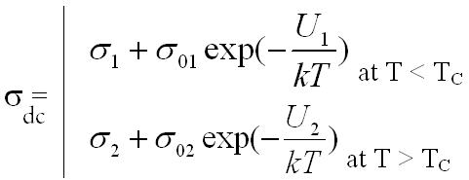
,

where k is Boltzmann constant, σ₀₁ and σ₀₂ are the constants, σ₁ and σ₂ are components of conductivity caused by other mechanisms of charge transfer, U₁ and U₂ are the activation energies below and above T_{C} correspondingly. It was found the trend to decrease of activation energy of conductivity at decrease of matrix pore diameter (see table). Study of frequencies dependences of σ shows strong contribution of hopping mechanism to total electrical conductivity.

Table
Material | U₁, eV  (T<T_{C}) | U₂, eV  (T>T_{C})
Crystalline NaNO₂ | 1.7 | 1.0
Composite SN320 | 1.65 | 1.55
Composite SN46 | 0.67 | 0.42
Composite SN7 | 0.79 | 0.79

Механические, Диэлектрические и Магнитные Свойства Гранулированных Нанокомпозитов Co_{x}(PZT)_{100-x}

Д.П. Тарасов², Р.В. Хаустов², Л. Н. Коротков¹, А.В.Ситников¹, Ю.Е. Калинин¹

¹Воронежский Государственный Технический Университет, Моск. пр-т 14, Россия
²Военный Авиационный Инженерный Университет, ул. Ст. Большевиков 54А, Россия
e-mail: demetriys@mail.ru

Целью работы явилось экспериментальное изучение механических, диэлектрических и магнитных свойств пленок нанокомпозиционного материала Co_{x}(PZT)_{100-x} в широком интервале температур и концентраций х.
Композиционные материалы были получены методом ионно-лучевого распыления составной мишени на подложку из ситалла. Структурный анализ показал, что полученные пленки представляет собой композит, состоящий из аморфной матрицы PZT и металлических включений (Co) в виде гранул с размерами ~10 нм. В результате термической обработки при температуре ≈ 670 ^{о}С аморфная матрица кристаллизуется с образованием кристаллитов, имеющих структуру перовскита.
Процессы намагничивания изучали при комнатной температуре с помощью вибрационного магнетометра. Для измерений диэлектрических свойств использовали стандартный ёмкостной мост, работающий на частоте 1 кГц. Исследования температурных зависимостей упругого модуля и внутреннего трения (Q⁻¹) проводились с использованием обратного маятника с возбуждением в образце изгибных колебаний на частоте f ≈ 20 Гц.
Анализ экспериментальных результатов показал:
(I). Для всех исследованных композитов с частицами Со в интервале температур 225 – 245 К обнаружены релаксационные максимумы внутреннего трения, высота которых возрастает с увеличением концентрации металлической фазы. Предполагается, что данные максимумы Q⁻¹ связанны с перескоками атомов внутри металлических гранул.
(II). Экспоненциальный рост внутреннего трения (высокотемпературный фон Q⁻¹), обусловленный затуханием упругих колебаний в металлических включениях. Установлено, что наблюдаемое в эксперименте двукратное увеличение энергии активации высокотемпературного фона Q⁻¹ при температурах выше ≈ 700 К связано с ограничением диффузионного движения точечных дефектов границами частиц металлической фазы.
(III). Обнаруженные в эксперименте максимумы Q⁻¹ в окрестностях 570 К в термически отожженных образцах композитов системы Co_{x}(PZT)_{100-x} обусловлены зародышеобразованием и движением межфазных границ в диэлектрической матрице в окрестностях сегнетоэлектрического фазового перехода первого рода.
(IV). На основании результатов диэлектрических измерений установлено, что в подвергшихся термической обработке (10 минут при температуре 875 К) образцах композиционных материалов системы Co_{x}(PZT)_{100-x} с концентрацией х < 50 aт. % реализуется сегнетоэлектрическое состояние ниже ≈ 570 К.

(V). Анализ петель магнитного гистерезиса выявил существенное возрастание спонтанной намагниченности в узкой области концентраций х, расположенной выше порога перколяции (х ≈ 60 ат. %), сопровождающееся немонотонной концентрационной зависимостью коэрцитивной силы. Показано, что немонотонное поведение коэрцитивной силы связано со сменой доминирующего механизма перемагничивания металлических ферромагнитных гранул.
(VI). Экспериментально установлено, что термический отжиг образцов Co_{x}(PZT)_{100-x} с х > 50 ат. % в вакууме при температуре 875 К в течение 10 минут приводит к появлению петель магнитного гистерезиса сложного вида. Сложный вид петель (появление перетяжек), по-видимому, связан с образованием двухфазной системы магнитных частиц, характеризующихся различной величиной коэрцитивной силы.

Особенности Инфранизкочастотных Процессов Релаксации Поляризации в Монокристаллах LiNbO₃

Фам Май Ан¹, Нгуен Хоай Тхыонг¹, С. В. Медников¹, А. И. Бурханов²

¹Волгоградский государственный технический университет
²Волгоградский государственный архитектурно-строительный университет
e-mail: vl28_pa@yahoo.com

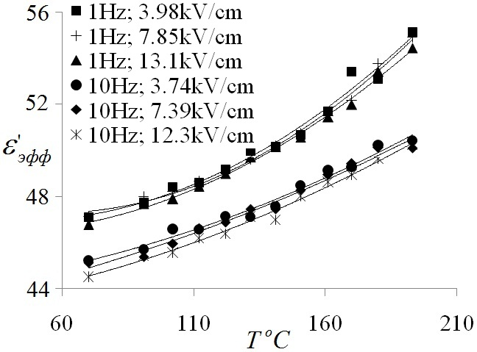
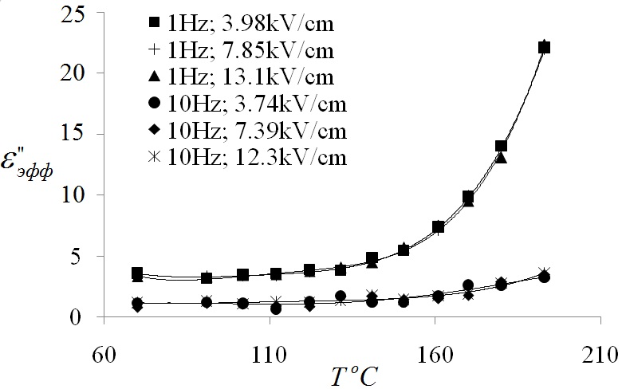
В работе методом Сойера - Тауэра исследованы процессы релаксации поляризации монокристала ниобата лития LiNbO₃ в переменных синусоидальных полях Е в интервале амплитуд от 3.74 до 13.1 кВ.см⁻¹ на частотах 1 Гц и 10 Гц в области температур от 70°C до 200°C. Установлено, что на частоте 1 Гц в отличие от 10 Гц при Т>130˚C наблюдается существенное увеличение эффективных диэлектрических потерь при одновременном увеличении эффективной диэлектрической проницаемости . При этом в диапазоне использованных амплитуд Е сохраняется линейный характер диэлектрического отклика в поведении амплитудных зависимостей . Наиболее вероятной причиной роста и является вклад в релаксацию поляризации объемного заряда, который обусловлен возникновением новых носителей таких как поляроны малого радиуса (, ) [1]. Их появление возможно при относительно большом электрон – фононном взаимодействии, которое возникает при температуре больше некоторой критической (в нашем случае Т ~ 130˚С). Кроме того, увеличение объемного заряда может связано с влиянием диффузии ионов при высоких температурах.
Температурные зависимости
(Т) (а) и
(Т) (б) при различных значениях амплитуды поля на частотах 1 Гц и 10 Гц
(б)
(а)
Таким образом, полученные экспериментальные результаты позволяют сделать вывод о том, что особенности релаксации поляризации в температурном диапазоне до 200˚С связаны с образованием поляронов малого радиуса в области температуры Т>130˚C и их вкладом в диэлектрическую релаксацию кристалла LiNbO₃.

Список литературы
- Евдокимов, С. В. Особенности темновой проводимости кристаллов ниобата лития конгруэнтного состава / С. В. Евдокимов, А. В. Яценко // ФТТ. – 2006. – Т. 48. – № 2. – С. 317–320.

Щелочно-Боросиликатные Стекла с Магнитной Фазой

Н. Поречная ¹, С. Плясцов¹, Е. Королева^{1,2}, И. Голосовский³, Ю.Кибалин³,
Т. Антропова⁴, О. Пшенко⁴

¹СПбГПУ, ул. Политехническая 29, Санкт-Петербург, 195251 Россия
² ФТИ им. А.Ф. Иоффе РАН, ул. Политехническая 26, С.-Петербург, 194021 Россия
³ ПИЯФ , Гатчина, С.-Петербург, 188300 Россия
⁴ ИХС РАН, наб. адм. Макарова 2, С.-Петербург, 199034 Россия

Щелочно-боросиликатные стекла, допированные оксидом железа (III) обладают магнитными свойствами и могут быть использованы для создания, так называемых, активных (магнитных) пористых матриц. Дальнейшее введение в такие матрицы сегнетоэлектрика (NaNO₂, KNO₃) позволит создать новый тип материала с пространственно разделенными магнитной и сегнетоэлектрической фазами. Благодаря разветвленной системе пор, в подобных матрицах можно получить большую площадь интерфейса между подсистемами (магнитной и сегнетоэлектрической), что увеличивает обменное взаимодействие между ними и приводит к новым эффектам (возможность управлять поляризацией с помощью магнитного поля).
Были исследованы три образца двухфазных стекол с разным процентным содержанием гематита (Fe₂O₃): 15 % - Fe15, 20 % - Fe₂0 и 25 % - Fe25. Для всех образцов характерно образование магнитных агломератов по всему объему, что подтверждается данными атомно-силовой (см. рис.) и просвечивающей электронной микроскопии. При этом наблюдается зависимость их размеров от концентрации оксида железа: 320 нм – Fe20, 360 нм – Fe15, 940 нм – Fe25. Такая же зависимость наблюдается для дифракционного размера частиц всех образцов, кроме того обработка данных порошковой рентгеновской дифракции показала, что все стекла содержать в основном кристаллиты магнетита, а в одном случае (Fe15) преобладает кристаллическая фаза β-Fe₂O₃.
Для визуализации распределения намагниченности применялась методика магнитно-силовой микроскопии (МСМ). По данным МСМ для разных значений внешнего магнитного поля была произведена оценка коэрцитивного поля поверхностных агломератов (80 – 100 мТ). Дальнейшие магнитометрические измерения подтвердили правильность этой оценки.
Кроме структуры и магнитных свойств был исследован диэлектрический отклик образцов в диапазоне температур 115 К – 600 К и частотном интервале 3 мГц – 30 МГц, а также в температурном диапазоне 4 К до 300 К во внешнем магнитном поле.
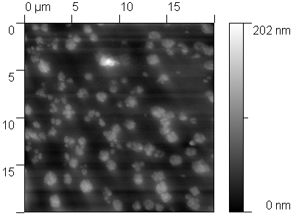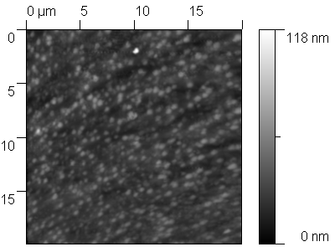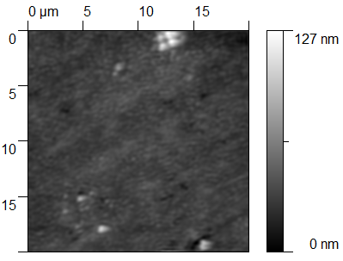

а также в температурном диапазоне 4 К до 300 К во внешнем магнитном поле.
Увеличение концентрации оксида железа (III) в двухфазных щелочно-боросиликатных стеклах

Session 6.
Domains and domain boundaries
and their dynamics

Oral Presentation

Переключение Доменов в Доменных Границах Сегнетоэлектриков

Б.М.Даринский¹, А.П.Лазарев², А.С.Сигов³

¹ВГУ, Воронеж, Россия, E-mail: me144@phys.vsu.ru
²Rosbiokvant Ltd., Voronezh, Russia, E-mail: main@rosbiokvant.ru
³MИРЭА, Mocква, Россия, E-mail: rector@mirea.ru

В настоящее время активно ведутся поиски с целью создания запоминающих устройств на основе переключения доменов в сегнетоэлектриках. Одновременно ставится задача о радикальном улучшении таких характеристик вычислительной техники как увеличение плотности записи информации, снижение электрических затрат на процессы запоминания, хранения, считывания информации, увеличение быстродействия и эксплуатационного ресурса. Для решения этих задач естественно воспользоваться идеями и подходами, развиваемыми в нанофизике.
В работе в качестве управляемого объекта предлагается использовать в качестве компьютерной ячейки памяти домен, который при стечении ряда обстоятельств образуется в доменной границе сегнетоэлектрического кристалла.
Для исследования условий возникновения таких доменов и их характеристик применяется метод клеточных экспериментов, разработанный в [1], в основе которого лежит теория Морса об индексах особых точек отображения. Процесс переключения направления поворота вектора поляризации $P_{i}$ в доменной границе может происходить как при воздействии температуры (фазовый переход первого или второго рода), так и при воздействии электрического поля. В работе рассматривается модельный пример поворота $P_{i}$ в доменной границе под действием электрического поля.
Проведено определение равновесных значений компонент вектора спонтанной поляризации $P_{1}$, $P_{2}$, коэрцитивного поля E. Состояние с $P_{1}≠0,P_{2}=0$ соответствует основному, состояние $P_{1}=0,P_{2}≠0$ соответствует метастабильному. Сравнение поля переключения Е с аналогичным полем для переключения компоненты поляризации $P_{1}$ показывает, что Е значительно меньше Р.
Таким образом, прилагая электрическое поле перпендикулярно плоскости пластины, можно переключать вектор поляризации в доменной границе. То есть, для специально подобранного материала и нанотехнологии возможна разработка элементов памяти на доменных границах нелинейных диэлектриков. Из-за относительно малой величины эксплуатационных полей предложенный механизм памяти должен иметь преимущество по сравнению с аналогичным устройством на доменах.

Работа выполнена при финансовой поддержке по ГК 16.513.11.3014

Литература
1. Даринский Б.М., Дьяченко А.А., Лазарев А.П., Топологические методы исследования в термодинамике сегнетоэлектриков, Изв. РАН, 71, №10, с. 1388-1341, 2007 г.

Температурная Зависимость и Релаксация Доменного Вклада
в Диэлектрическую Проницаемость Сегнетовой Соли

С.Н. Дрождин, О.М.Голицына

Воронежский государственный университет, Воронеж, Россия

По температурным зависимостям диэлектрической проницаемости ε и тангенса угла диэлектрических потерь tgδ, измеренным при нагревании и охлаждении, можно выделить величину доменного вклада в значения этих величин [1,2]. Ранее подобные исследования были проведены для кристаллов группы TGS [3], а в настоящей работе – для кристаллов сегнетовой соли (RS). Получены следующие результаты:
1. для кристаллов сегнетовой соли зависимости ε(Т) и tgδ(Т), полученные с переводом кристалла из обеих неполярных фаз RS в сегнетоэлектрическую, лежат выше зависимостей, измеренных при обратных переводах, что связано с большей величиной доменного вклада в величины ε и tgδ в первом случае;
2. по разности зависимостей ε(Т) и tgδ(Т), измеренных в обоих режимах, выделены доменные составляющие ε_{dom} и tgδ_{dom} , которые могут быть увеличены воздействием на кристалл постоянного электрического поля в сегнетофазе и переменного в парафазе;
3. в окрестности нижней точке Кюри доменный вклад в диэлектрическую проницаемость выражен меньше, чем вблизи верхней, но присутствует в большем температурном интервале;
4. временные релаксационные зависимости диэлектрической проницаемости, стимулированные переводом кристалла RS, как через верхнюю, так и через нижнюю точку Кюри, подчиняются экспоненциальному закону с близкими по величине временами релаксации, но с отличающимися значениями энергии активации;
5. большая величина доменного вклада в величину ε после перевода кристалла в сегнетоэлектрическую фазу не вызывает нарушения закона Кюри-Вейсса, но ведёт к значительному отклонению от закона «двойки».

Литература
1. Новик. В. К., Лотонов А. М., Гаврилова Н. Д. О временной зависимости диэлектрической дисперсии триглицинсульфата вблизи точки Кюри / Новик. В. К., Лотонов А. М., Гаврилова Н. Д. - Физика твердого тела, 2007, том 49, вып. 7.
2. Новик. В. К., Лотонов А. М., Гаврилова Н. Д. Диэлектрические потери как индикатор кинетики сегнетоэлектрического фазового перехода / Новик. В. К., Лотонов А. М., Гаврилова Н. Д. - Физика твердого тела, 2009, том 51, вып. 7.
3. С.Н.Дрождин, О.М.Голицына, Физика твердого тела, 2012, Т. , №5, стр.853

Усталостные явления в тонких сегнетоэлектрических пленках, стимулированные многократным переключением поляризации

А.С. Сидоркин, Л.П. Нестеренко

Воронежский государственный университет, Университетская пл.1, Воронеж, 394006, Россия
e-mail: sidorkin@phys.vsu.ru

Закономерности процесса усталости в виде зависимости от амплитуды поля, стимулирующего переключение, его частоты и температуры, показывают, что, по крайней мере, в случае пленок титаната свинца и цирконата – титаната свинца, наблюдаемые процессы усталости имеют доменную природу [1]. При этом доменная структура может играть как активную, так и пассивную роль, когда в первом случае меняются основные параметры переключательного процесса, а в другом он просто блокируется посторонними факторами. В связи с этим целью настоящей работы было экспериментальное изучение процессов усталости в сегнетоэлектрических пленках на примере тонких пленок титаната свинца и цирконата-титаната свинца и выяснение конкретной роли доменной структуры в рассматриваемых явлениях.
Для определения переполяризационных свойств и характеристик пленок были использованы модифицированная схема Сойера-Тауэра с компенсацией проводимости и методика Мерца. Полученные экспериментальные результаты показывают, что увеличение амплитуды переменного электрического поля в интервале значений выше коэрцитивного приводит к ускорению процессов усталости (т.е., к уменьшению порогового значения циклов переключения, при котором наблюдаются усталостные изменения в переключаемой поляризации и коэрцитивном поле). Одновременно пороговое значение циклов переключения растет с увеличением частоты
Наблюдаемая в эксперименте зависимость усталости от амплитуды может быть связана с дрейфом заряженных носителей в приложенном электрическом поле, рост амплитуды которого ускоряет движение носителей, что приводит к закреплению обратных доменов, возникающих вблизи поверхности сегнетоэлектрика. Это в свою очередь приводит к резкому уменьшению поляризации и блокированию процессов переключения.
Предполагается, что роль дефектов, способствующих накоплению связанной с переключением усталости, играют заряженные дислокации, которые меняют знак вместе с изменением полярности домена, в котором они находятся, и испытывающие вследствие этого в отличие от точечных заряженных дефектов постоянное воздействие силы определенного направления. Численные оценки позволяют в рамках данной модели позволяют получить разумные значения числа критических циклов переключения и соответствующее эксперименту время релаксации.

Работа выполнена при поддержке Федеральной целевой программы «Научные и научно-педагогические кадры инновационной России» на 2009-2013 годы.

Литература
1. А.С. Сидоркин, Л.П. Нестеренко, А.Ю. Пахомов. Изв.РАН. Серия Физическая.75, № 10,1385 (2011)

Session 6.
Domains, Domain Boundaries
and Their Dynamics

Poster Presentation

Investigation of the Single-Domain State Disintegration in Ferroelectrics

V.V. Ivanov, S.A. Borisenko

Tver State University, Tver, 170100, Russia
e-mail: Socrat15@yandex.ru

Ferroelectrics are perspective as materials for memory storage devices in present time. One of the important properties of memory cell is information storage time. Thereby, the aim of this work is research single-domain stability of ferroelectric sample.
The special part in switching processes researching presents Barkhausen pulses analysis, which usually concerned with polarization centres nucleation and single domains intergrowth. The examination of this effect makes a contribution in under-standing of physical processes, occurred ferroelectric switching. Having high sensitivity, the Barkhausen effect allows to trace the domain structure transformation in ferroelectric crystals [1]. The Barkhausen effect studying is especially reasonable in cases of absence or complication of domain structure and it dynamic direct observation methods. The question about relationship between intermittent switching processes and whole crystal switching is fundamentally important [2, 3].
The Barkhausen pulses appearance is indicating the beginning of single domain state fracture, i.e. the antiparallel domains nucleation. So this method is suitable to detect single-domain state disintegration and estimate disintegration value.
As objects under research are taken the available for IR converters monoaxial ferroelectric triglycine sulphate (TGS) (NH₂CH₂COOH)₃H₂SO₄ and perspective in various cases barium titanate BaTiO₃. The experiment was conducted with step-by-step variation of external electric field by polarization curve method.
Single-domain stability had been researched for each sample in shorting rate and in generic field with disintegration volume estimation.

References
1. V. Ya. Shur, A. L. Gruverman, V. P. Kuminov, N. Tonkachyova Dynamics of Plane Domain Walls in Lead Germanate and Gadolinium Molybdate // Ferroelectrics, Vol. 111, pp. 197-206 (1990)
2. V.M. Rudyak The Barkhausen effect as ferroelectric crystals researching method // Izv. AN USSR, phys., 1967, v.31, №7, p.1171-1174. (in russian)
3. M.B. Belonenko, A.S. Sasov Investigation into the domain structure dynamics in ferroelecrics with incommensurate phase // Rus. Phys. J,, 2006, v: 49, № 8, p. 864-868.)
Formation of Dendrite Domain Structures by Switching at Elevated Temperatures in Stoichiometric Lithium Niobate

D.S. Chezganov, M.M. Neradovskiy, M.S. Nebogatikov, V.Ya. Shur

Ferroelectric Laboratory, Ural Federal University, Ekaterinburg, 620000, Russia
e-mail: dmit.chezganov@gmail.com

The formation of the stable dendrite domain structures during polarization reversal in uniform electric field at elevated temperatures (above 250ºC) in single crystals of stoichiometric lithium niobate LiNbO₃ was revealed and investigated.
The dendrite domain structures consisting of the stable non-through domains were appeared on Z+ polar surface as a result of application of triangular electric field pulses (field increasing rate 500 V/s) using uniform solid state electrodes. The static domain structures obtained at the surface were visualized with high spatial resolution after selective chemical etching by piezoresponse force microscopy (PFM) and scanning electron microscopy (SEM). Application of Raman confocal microscopy (RCM) allowed to visualize the domain structure in the bulk [1].
The analysis of the set of RCM images (Fig. 1) obtained by scanning at different depth allowed to reveal the main stages of the dendrite structure evolution. It was shown that the process of the domain structure formation for application of the single pulse was composed of five successive stages. The first stage represents the appearance of the single isolated nanodomain – the center of the dendrite. The second stage represents the formation of the three isolated nanodomains at the equal distance from the first one at the vertices of an equilateral triangle oriented along Y directions thus suppressing the growth of the first domain. The third stage represents the oriented growth of the nanodomain chains with sub-micron period in six Y directions. During the fourth stage the six-ray domain star with rays oriented strictly along Y directions formed as a result of domain merging. At the fifth stage the rays were broadened by sideways wall motion thus forming the star-like domain structure.
Application of the second electric field pulse leaded to appearance of the new isolated domains according to the similar scenario at given distance from the ray ends of the six-ray domain star and further growth in five Y directions. The main stages of the formation of five-ray stars have been similar to domain structure evolution at the first pulse.
The obtained formation of the dendrite structures has been attributed to correlated nucleation caused by field distribution in the vicinity of the isolated needle-like domains with charged domain walls. It is necessary to point out that at the used elevated temperatures the mechanism of electrical conductivity has changed from electronic to ionic. This fact leads to isotropic domain growth by stochastic nucleation instead of anisotropic determined nucleation obtained at low temperatures [2].

Acknowledgment. The equipment of the Ural Center for Shared Use “Modern Nanotechnology”, Institute of Natural Sciences, Ural Federal University has been used. The research was made possible in part by RFBR (Grants 10-02-96042-r-Ural-а, 10-02-00627-а, 11-02-91066-CNRS-а); by Ministry of Education and Science (Contracts 16.740.11.0585, P1262 and 16.552.11.7020), by OPTEC LLC and in terms of Ural Federal University development program with the financial support of young scientists.

References
1. V.Y. Shur, P.S. Zelenovskiy, M.S. Nebogatikov, et al., J. Appl. Phys. 110, 052013 (2011).
2. V.Ya. Shur, Nano- and Micro-domain Engineering in Normal and Relaxor Ferroelectrics, in Handbook of Advanced Dielectric, Piezoelectric and Ferroelectric Materials, ed. by Z.-G. Ye (Woodhead Publishing Ltd., Cambridge 2008), pp. 622-669.

Nanoscale Dendrite Domain Structures In LiNbO₃ And LiTaO₃
Induced By Pulsed Laser Heating

D.K. Kuznetsov, E.A. Mingaliev, V.Ya. Shur, M.S. Kosobokov, and A.I. Lobov

Ferroelectric Laboratory, Ural Federal University, Ekaterinburg, 620000, Russia

e-mail: dimak@labfer.usu.ru

The stable snowflake-type dendrite nanodomain structures appeared as a result of pulse laser heating have been revealed and investigated in single crystals of congruent lithium niobate (CLN) and congruent lithium tantalate (CLT).
The polar surfaces of investigated single crystalline wafers have been irradiated by pulse infrared CO₂ laser with 10.6 μm wavelength. The static domain structures obtained at the surface were visualized with high spatial resolution after selective chemical etching by piezoresponse force microscopy (PFM) and scanning electron microscopy (SEM). Application of Raman confocal microscopy (RCM) allowed to visualize the domain structure in the bulk [1]
The dendrite nanodomain structures in CLN were formed after irradiation of Z+ polar surface by series of laser pulses. In CLT the structures were obtained near the edges of the central part of the irradiated zone heated above the phase transition temperature. The variation of the domain structures appeared in the wafer heated up to 30 – 250^{O}C before laser irradiation has been studied.
It was shown that the nanoscale dendrite structures represented isolated snowflake domains. The sizes of snowflake domains ranged from 500 nm to few microns. The width of individual rays is about 20 nm.
The domains appeared under the action of pyroelectric field during cooling after fast heating under the action of the pulse laser irradiation [3]. The formation of isolated dendrite nanodomains during cooling can be divided into two successive stages: (1) usual growth of isolated convex domains with hexagonal shape and sizes about few microns,
(2) backswitching of arisen domains under the action of pyroelectric field which change the sign for large enough domain.
During the second stage the reversal motion of the domain walls through propagation of the highly organized quasi-periodical structure of nanodomain arrays from the edge to the domain center occurred. The growth of isolated nanodomains led to their merging in each array and formation of the finger-like structure. The electrostatic interaction between approaching domain walls hampered the merging of neighbouring fingers thus resulted in formation of narrow residual rays of the snowflake dendrite nanodomain structure.

Acknowledgment. The equipment of the Ural Center for Shared Use “Modern Nanotechnology”, Institute of Natural Sciences, Ural Federal University has been used. The research was made possible in part by RFBR (Grants 10-02-96042-r-Ural-а, 10-02-00627-а, 11-02-91066-CNRS-а); by Ministry of Education and Science (Contracts 16.740.11.0585, P1262 and 16.552.11.7020), by OPTEC LLC and in terms of Ural Federal University development program with the financial support of young scientists.

References
1. V.Y. Shur, P.S. Zelenovskiy, M.S. Nebogatikov, et al., J. Appl. Phys. 110, 052013 (2011).
2. V.Ya. Shur, D.K. Kuznetsov, E.A. Mingaliev, et al. Appl. Phys. Lett. 99, 082901 (2011).

Kinetics of Domain Structure in SBN Single Crystals Using Electrodes Based on Stable Suspension of Silver Nanoparticles

A.E. Tyurnina¹, R.V. Kozin¹, V.Ya. Shur¹, V.A. Shikhova¹, D.K. Kuznetsov¹, E.A. Mingaliev¹, D.V. Pelegov¹, A.V. Ievlev¹, L.I. Ivleva², J. Dec³

¹Ferroelectric Laboratory, Ural Federal University, Ekaterinburg, 620000, Russia
²General Physics Institute of the Russian Academy of Sciences, Moscow, 119991, Russia
³Institute of Materials Science, University of Silesia, Katowice, 40-407, Poland
e-mail: anastasiya.uniim@mail.ru

The evolution of the ferroelectric domain structure and switching current have been measured during cyclic switching using stable suspension of silver nanoparticles as an electrode in single crystals of relaxor ferroelectric strontium barium niobate Sr_{x}Ba_{1-x}Nb₂O₆ (SBN, x=0,61).
It is well-known that domain kinetics during cyclic switching strongly depends on the electrodes types. Particularly, the fatigue effect (decreasing of the switching charge during cycling) is essentially more pronounced for metal electrodes as compare with the solid state ones [1]. The explanation of this experimental fact has been the reason to study the cyclic switching process using the electrodes representing suspension of metal nanoparticles in liquid.
The used stable suspension of the silver nanoparticles has been produced by laser ablation of silver target in the deionized water without addition of surfactants. The polarization reversal has been in situ studied in various fields by simultaneous recording of the sequence of instantaneous domain images and switching current [2]. All measurements were performed below freezing temperature. The experimental results have been compared with the data obtained during switching in the same conditions at the same place of the sample using usual liquid electrodes.
The domain structure kinetics and the switching current shape have been studied for polarization reversal using suspension of various concentrations and different sizes of nanoparticles. “The optical current” obtained by image processing of the set of instantaneous domain patterns and the switching current data have been fitted by Kolmogorov - Avrami formula modified for finite size media [3]. The spatial heterogeneity of the domain kinetics in SBN crystals has been revealed and quantitatively characterized in terms of local bias field value.
The obtained difference between domain kinetics for cyclic switching with various liquid electrodes has been explained taking into account the additional series resistance of used electrode.

Acknowledgment. The equipment of the Ural Center for Shared Use “Modern Nanotechnology”, Institute of Natural Sciences, Ural Federal University has been used. The research was made possible in part by RFBR (Grants 10-02-96042-r-Ural-а, 10-02-00627-а, 11-02-91066-CNRS-а); by Ministry of Education and Science (Contracts 16.740.11.0585, P1262 and 16.552.11.7020), by OPTEC LLC and in terms of Ural Federal University development program with the financial support of young scientists.

References
1. V.Ya. Shur, A.R. Akhmatkhanov, and I.S. Baturin, J. Appl. Phys., 111, 124111 (2012).
2. V.Ya. Shur, D.V. Pelegov, V.A. Shikhova et al., Phys. Solid State, 52, 323 (2010).
3. V.Ya. Shur, E.L. Rumyantsev, and S.D. Makarov, J. Appl. Phys., 84, 445 (1998).

On the Nuclear Magnetoelectric Resonance in Potassium Niobate

A.S. Yurkov

Omsk, 644076, Russia
e-mail: fitec@mail.ru

It has been known for a long time that nuclear spins with quadrupole moment, which are located in a noncentrosymmetric position in a dielectric crystal, can be excited by an alternating electric field. This is why, apart from conventional nuclear magnetic resonance (NMR) and nuclear quadrupole resonance (NQR) a nuclear electric resonance (NER), and nuclear magnetoelectric resonance (NMER) become possible.
Experimental observations of NER and NMER which occur through the quadrupole mechanism have usually been hampered by the fact that in ordinal dielectric crystals the interaction with an electric field is several orders of magnitude weaker than their interaction with a magnetic field. At the same time in ferroelectrics such an interaction should be much stronger [1].
It was shown in [1] that the resonance contribution to permittivity from nuclear spins of niobium in the single-domain tetragonal potassium niobate is comparable in magnitude to the contribution from the same spins to magnetic permeability. Description in terms of permittivity is adequate for experiments with continual irradiations of a sample. In more recent paper [2] the nuclear electric resonance was considered under the conditions of pulsed excitation of nuclear subsystem of the same crystal. In [1,2] actually only NER has been considered and did not concern the possibility of NMER in the same crystals. The aim of this work is to fill this gap.
The solution of the problem shows that at least for the tetragonal potassium niobate, the NQR, NER and NMER signals are comparable in magnitude but the NMER signals can be observed only if the sample is single-domain or at least if it has nonzero polarization averaged over the domain structure. This finding which is confirmed by direct calculation has a clear symmetry origin and is associated with the fact that the magnetic and electric vectors have different spatial parities. At the same time, the different parities of those vectors with respect to the time reversal do not lead to the prohibition for magnetoelectric effect because of fundamentally dynamic situation where differentiation with respect to time changes time parity to opposite value.

References
- A.S. Yurkov, Phys. Solid State 50, 1510 (2008).
- A.S. Yurkov, Bull. Russ. Acad. Sci.: Phys. 74, 1206 (2010).

Role of Domain Orientations in Forming the Hydrostatic Performance
of Novel 2–2 Single Crystal / Polymer Composites

V. Yu. Topolov¹, C. R. Bowen² and A. V. Krivoruchko³

¹Department of Physics, Southern Federal University, 344090 Rostov-on-Don, Russia
²Materials Research Centre, Department of Mechanical Engineering, University of Bath,
BA2 7AY Bath, United Kingdom
³Don State Technical University, 344000 Rostov-on-Don, Russia
e-mail: vutopolov@sfedu.ru; c.r.bowen@bath.ac.uk; kolandr@yandex.ru

We report results on the effect of the orientation of the main crystallographic axes on the piezoelectric hydrostatic parameters performance of the 2–2 parallel-connected composites based on relaxor-ferroelectric single crystals (SCs) of 0.72Pb(Mg_{1/3}Nb_{2/3})O₃–0.28PbTiO₃ (PMN–0.28PT). Layers of this SC are poled along one of the following directions in the perovskite unit cell: [111] (single-domain state, 3m symmetry), [001] (four domain types in the domain-engineered state, 4mm symmetry) and [011] (two domain types in the domain-engineered state, mm2 symmetry). The full set of electromechanical constants of the composite at the fixed orientation of the main crystallographic axes in the SC layers is determined within the framework of the matrix method [1]. It is shown how the orientation of the non-180° domains in the SC component influences the hydrostatic piezoelectric coefficients $d_{h}^{}$, $e_{h}^{}$ and $g_{h}^{}$, squared hydrostatic figure of merit ($Q_{h}^{}$)² = $d_{h}^{}$$g_{h}^{}$ and hydrostatic electromechanical coupling factor $k_{h}^{}$ of the 2–2 composite in a wide volume-fraction range. Large values of the hydrostatic parameters (table) are achieved at specific orientations of the main crystallographic axes of the SC component and are due to a specific anisotropy of its elastic and piezoelectric properties, especially in composites based on the [111]- and [011]-poled SCs. The results of the present study highlight the important advantages of 2–2 PMN–0.28PT-based composites over conventional 2–2 composites [2] mainly due to the much larger values of the hydrostatic parameters that are achieved in the presence of SCs with a high piezoelectric activity.

Table. Absolute maxima of hydrostatic parameters Π_{h}* of 2–2 PMN–0.28PT / polyvinylidene fluoride composites
 | With [111]-poled SC | With [001]-poled SC | With [011]-poled SC
Π_{h}* | Value of absolute maxΠ_{h}* (optimal volume fraction of SC) | Value of absolute maxΠ_{h}* (optimal volume fraction of SC) | Value of absolute maxΠ_{h}* (optimal volume fraction of SC)
$$d_{h}^{}$$ | 133 pC / N (0.238) | 228 pC / N (0.253) | 372 pC / N (0.337)
$$g_{h}^{}$$ | 242 mV.m / N (0.007) | 230 mV.m / N (0.007) | 284 mV.m / N (0.012)
$$e_{h}^{}$$ | 45.1 C / m² (0.868) | 24.3 C / m² (0.811) | 25.7 C / m² (0,876)
($Q_{h}^{}$)² | 12.3.10⁻¹² Pa⁻¹ (0.021) | 15.3.10⁻¹² Pa⁻¹ (0.038) | 33.8.10⁻¹² Pa⁻¹ (0.068)
$$k_{h}^{}$$ | 0.217 (0.027) | 0.235 (0.048) | 0.361 (0.095)

References
1. V.Yu. Topolov, A.V. Krivoruchko. J. Appl. Phys. 105, 074105 (2009)

Session 7
Miscellaneous

Oral Presentation
Elastic Properties of (NH₄)₃H(SO₄)₂ Crystal in the Ferroelastic Phase

S.G. Lushnikov¹, A.I. Fedoseev¹, V.V. Dolbinina²

¹Ioffe Physical Technical Institute, St. Petersburg, 194021, Russia
²Institute of Crystallography RAS, Moscow, 117333, Russia
e-mail: fedoseev@mail.ioffe.ru

Triammonium hydrogen disulphate (TAHS) is a member of M₃H(S0₄)₂ family of hydrogen sulphates (M = Rb, Cs, NH₄). TAHS exhibits five successive phase transitions: superionic () => ferroelastic (A2/a) phase transition at T_{(I-II)}=T_{s}=413K, ferroelastic (A2/a) => ferroelastic (P2/n) transition at T_{(II-III)}=265K, phase transitions at T_{(III-IV)}=139 К, T_{(IV-V)}=133 K and T_{(V-VII)}=63K [1]. Investigations of the behavior of sound velocity and damping in TAHS were carried out in the vicinity of a superionic-ferroelastic phase transition [2, 3]. A contribution of the acousto-ionic interaction has been determined [3], but no detailed analysis of TAHS elastic properties in the ferroelastic phase A2/a was performed.
This report is concerned with calculations of elastic constants of the TAHS crystal from the data obtained from Brillouin light scattering experiments in the 180º scattering geometry at room temperature. The monoclinic phase (II) of TAHS is characterized by the presence of the second-order axis and symmetry plane perpendicular to it. It is known that the as-grown crystal has a well developed plane normal to the axis of the high-temperature trigonal phase (I), and the axis lies in this well developed plane. If the axis Y||b is oriented along the axis (directions of axes X||a and Z||c is arbitrary), a tensor of elastic constants for the monoclinic phase consists of 13 nonzero parameters (С₁₁, С₁₂, С₁₃, С₁₅, С₂₂, С₂₃, С₂₅, С₃₃, С₃₅, С₄₄, С₄₆, С₅₅, С₆₆). It can easily be shown that at room temperature a purely longitudinal and two purely transverse elastic waves propagate along the Y||b||axis. If the X´ axis is oriented along the displacement vector in one of these purely transverse waves, and Z´ is along the displacement vector of the second purely transverse wave, then (С₄₆)´=0. Thus, the velocity of an elastic wave propagated in an arbitrary direction of the TAHS crystal is determined by a linear combination of 12 nonzero elastic constants in this rational coordinate system (X´Y´Z´).
We carried out measurements of hypersound phonon velocity for a rectangular sample with sizes 5.8х5х2.78 mm³, where the plane of the largest face was normal to the axis, and the axis was lying in this plane at an angle of 51º to the 5.8х2.78 mm² face. As a result, three orthogonal cross sections of the surface of phase velocities were obtained. At first, for the coordinate system where Y||b|| and Z||c||, 13 elastic constants were calculated from the measured elastic waves velocities. In the calculations, the average refractive index was taken to be n=1.5, the sample density was ρ = 1832 kg/m³, and the wavelength was λ = 488 nm. Secondly, using expression tg2φ=2C₄₆/(C₆₆-C₄₄), the angle of rotation (φ) of the X and Z axes around Y||b|| towards X´ and Z´ was found and 12 nonzero elastic constants sought were calculated in the rational coordinate system.

References
1. K. Gesi. Phys. Status Solidi (A) 33, 479 (1976).
2. B.V. Shchepetilnikov et. al. Fizika tverdogo Tela 32, 2885 (1990);
3. S.G. Lushnikov, A.I. Fedoseev, L.A. Shuvalov, H. Schmidt. Jetp. Lett 78, 84 (2003).

Field and Deformational Effects in Quasi-one-Dimensional
CsH₂PO₄ Type Ferroelectrics

R.R. Levitskii¹, I.R. Zachek², A.S. Vdovych¹, P.P. Guranych³ and A.G. Slivka³

¹Lviv Polytechnic National University, Lviv, 79013, Ukraine
²Institute for Condensed Matter Physics of the National Academy of Sciences of Ukraine, Lviv, 79011, Ukraine
³Uzhhorod National University, Uzhhorod, 88000, Ukraine,
e-mail: levyt@icmp.lviv.ua

Within the framework of the proposed modified proton ordering model for quasi-one-dimensional CsH₂PO₄ type ferroelectrics, that takes into account linear over strains ε_{i} and ε₅ contributions to the proton subsystem energy, using the two-particle cluster approximation, with taking into account short-range and long-range interactions, longitudinal electric field, and hydrostatic pressure p=-σ_{i} we calculate the thermodynamic potential. From the condition of the thermodynamic potential minimum, we obtain a system of equations for the strains ε_{i} and for the order parameter. Using these equations we calculate the longitudinal static dielectric permittivity of mechanically free and clamped crystals, coefficients of piezoelectric strain and stress, and the elastic constants at constant field. Molar heat capacity of proton subsystem is calculated by direct differentiation of the thermodynamic potential over temperature.
The longitudinal dynamic dielectric permittivity of mechanically free and clamped crystals are explored within the D.N.Zubarev nonequilibrium statistical operator method, with taking into account the dynamics of strains via Newtonian equations of motion.
Experimental study of field and pressure dependences of dielectric characteristics and of phase transition temperature is performed. A thorough numerical analysis within the proposed theory of previously available and obtained by us experimental data for the CsH₂PO₄ type ferroelectrics is performed. A proper description of the experimental data for the studied crystals is obtained.

Additional Terahertz Light Waves in SrTiO₃ Crystal

Z.P. Mastropas, E.N. Myasnikov

Southern Federal University, Rostov-on-Don, 344082, Russia
e-mail: mastrozin@mail.ru

The most detailed information about the movement of crystals lattices under their structural reformation and excitations can be obtained by studying their reflection and absorption spectra. But the procedure of processing these spectra in order to get the required information is rather complicated, so that results of such processing coming from different research groups are often completely different. It is obvious that this procedure has to be improved to eliminate existing controversy.
For example, for StTiO₃ crystal it is necessary to take into account the strong dependence of its own oscillation frequencies on their wave vector. In these cases the processing of spectra has to be done using crystal optics formulae, taking into consideration temporal and spatial dispersion of dielectric permittivity. In such media, a light wave incident on the crystal surface gives rise to two refracted waves with different refraction coefficients. It is then necessary to find a relation between the characteristics of transverse and longitudinal modes and dielectric permittivity with complete consideration of electromagnetic interaction.
Dielectric permittivity, characterizing crystal receptivity to electromagnetic field exposure, is ideologically close to the Green’s function which describes, by definition, the transition of microparticles between states under the interaction [1]. In this work, we derived crystal optics formulae taking into account both temporal and spacial dispersion of dielectric permittivity. This was done by calculating quantum Green’s functions of phonons and photons in the media using methods of quantum field theory. As a result, it is shown that true eigen-oscillation modes in the media, by their properties, are the flow of polaritons [2] which are superpositions of photons and phonons.
The formula for the dielectric permittivity was derived for the first time in the model of noninteracting phonons by a factorization procedure. This formula establishes the connection between the experimental spectra of light reflection and absorption in the phonons range of frequencies, and frequency and spatial dispersion of dielectric permittivity of a crystal. It is shown also that in media with temporal and spatial dispersion of dielectric permittivity there are possible new, previously unknown effects of polarization delay [3], and effects of spatial inhomogeneity.

References
1. V.M Agranovich and V.L Ginzburg. Crystal Optics with Spatial Dispersion and Exciton Theory. Nauka, Moscow, 1979
2. M.S Brodin, E. N. Myasnikov, S.V. Marisova,. Polaritons in crystal. Naukova Dumka, Kiev, 1984
3. E.N.Myasnikov, Z.P. Mastropas. Physics of the Solid State. 52,(3), 599 (2010)

On the Converse Flexoelectric Effect
A.S. Yurkov

Omsk, 644076, Russia
e-mail: fitec@mail.ru

Flexoelectric effect is the linear response of the electric polarization to the mechanical strain gradient. Although it has been known for a long time (see review [1] and reference therein), some of its features make this effect interesting from both fundamental and applied points of view. This has stimulated recent intensive activity in the field [2-6]. It was argued, based on the constitutive equations, that flexoelectric effect has a very unusual property. Namely, it is believed that a mechanical sensor based on flexoelectricity will not behave as an actuator. The first goal of this work is to show that this statement contradicts to the general principles of thermodynamics. The reason why some authors come to such a paradoxical conclusion is that they used elastic boundary conditions of standard theory of elasticity. Recently it has been shown [7] that the boundary condition for the equations of mechanical equilibrium in the presence of flexoelectricity are not the same as the boundary condition of the standard theory of elasticity. Due to the boundary conditions even a homogeneous polarization deforms the crystal although such a polarization does not enter in the differential equations of equilibrium. Thus generally the converse flexoelectric effect in a real finite sample is present even if the polarization is homogeneous. More specific description of converse flexoelectric effect in a thin plate recently was presented in [8].
The second goal of the work is to solve the equations of equilibrium with modified boundary condition derived in [7] for a dielectric ball placed in a homogeneous external electric field. This problem has been solved by representation of mechanical displacement vector and polarization vector as series in spherical vectors and representation of scalar electric potential as series in ordinal spherical functions. It is worth noting that due to the homogeneity of the electric field far from a dielectric ball only one term with the spherical indexes l=1 m=0 remains in this series for this specific case. Thus the problem is simplified essentially and can be reduced to a solution of a set of ordinal differential equations (radial equations). This set of radial equations is solved by representation of radial functions as series in powers of radial coordinate. It is worth to note that if one changes the problem from a solid dielectric ball to a thin spherical layer, then the radial equations can be solved analytically in terms of exponents. It can also be useful to combine such analytical solution in a thin layer near the spherical surface and the solution of ordinal equations of elasticity under this layer.

References
- A.K. Tagantsev, Sov. Phys. Usp. 30, 588 (1987).
- W. Ma and L.E. Cross, Appl. Phys. Lett. 82, 3293 (2003).
- J.Y Fu, W. Zhu, N. Li, L.E. Cross, J. Appl. Phys. 100, 024112 (2006).
- P. Zubko, G. Catalan, A. Buckley, et al., Phys. Rev. Lett. 99, 167601 (2007).
- R.Maraganti, N.D. Sharma, P. Sharma, Phys. Rev. B 74, 014110 (2006).
- E.A. Eliseev, A.N. Morozovska, M.D. Glinchuk, R. Blinc, Phys. Rev B 79, 165433 (2009).
- A.S. Yurkov, JETP Letters 94, 455 (2011).
- A.K.Tagantsev, A.S. Yurkov, arXiv:1110.0380v1 (2011).

Диэлектрические Свойства Перовскитовых Сегнетоэлектриков при Неравновесной Концентрации Точечных Дефектов

А.М. Солодуха, Г.С. Григорян

Воронежский Государственный Университет, 394006, Россия
e-mail: asn2@yandex.ru, gri7287@yandex.ru

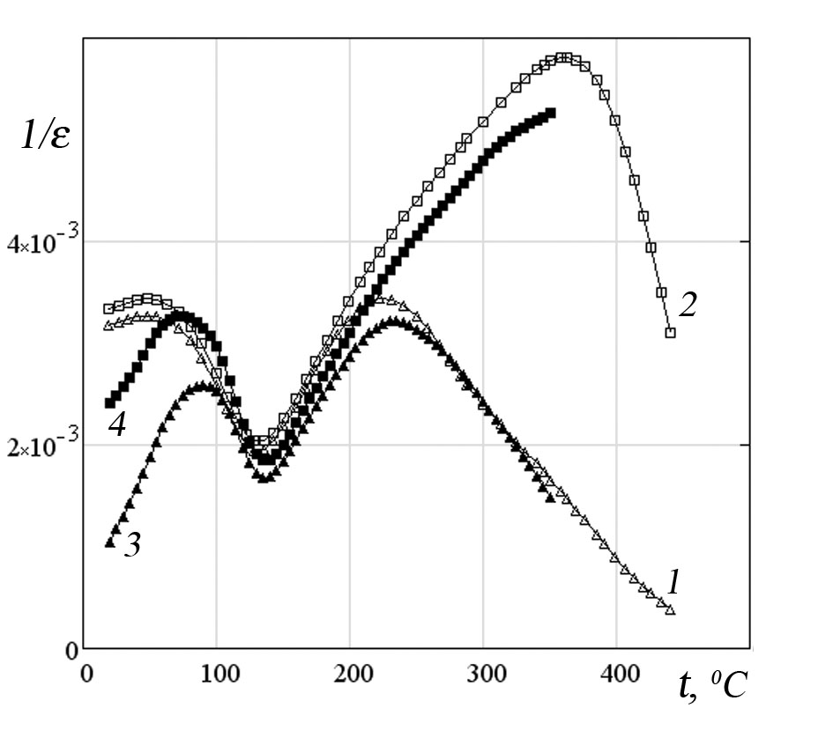
Несмотря на то, что керамика на основе титаната бария уже в течение нескольких десятилетий находит широкое практическое применение, физика электрических процессов на границах кристаллитов с учетом дефектов структуры до сих пор не вполне понятна, что сдерживает прогресс в поиске новых областей использования данных материалов. Одним из классических методов изучения влияния дефектов на свойства материалов является закалка исследуемого образца. В данной работе для выяснения влияния термодинамически неравновесных точечных дефектов на процессы диэлектрической релаксации и переноса заряда как в объеме зерен, так и на их границах, было изучено поведение закаленных образцов перовскитовой керамики.
Рис.1. Температурная зависимость 1/ε для BaTiO₃ с добавкой 4.8 ат.% Al₂O₃; 1, 3 – до и после закалки на частоте 1кГц; 2, 4 – то же на частоте 100 кГц

В качестве примера на рис.1 показана температурная зависимость обратной величины диэлектрической проницаемости до и после закалки для одного из образцов. Закалка осуществлялась резким охлаждением от 600 °С до комнатной температуры на воздухе. Здесь можно выделить три области: I – сегнетоэлектрическая фаза, II – параэлектрическая фаза, где выполняется закон Кюри-Вейсса, III – параэлектрическая фаза, где наблюдается рост ε. Видно, что в области I для исходного состояния дисперсия слабая, в области II она, практически, отсутствует, а в области III – сильная. После закалки в области I появляется сильная дисперсия, а значения ɛ заметно возрастают, особенно на низкой частоте. В то же время, в области III на низкой частоте влияние закалки не наблюдается, а для сигнала высокой частоты различия усиливаются с ростом температуры. Такое поведение следует связывать с увеличением роли объемного заряда в общем импедансе образца, который локализуется вблизи границ раздела фаз. Для последнего случая традиционно используется теория барьера Шоттки. Это дает линейную зависимость в координатах 1/С² – V, где С – емкость, V – напряжение. Однако в нашем случае имело место немонотонное поведение функции, что указывает на сложный характер процессов, формирующих области объемного заряда с участием дефектов структуры. Была также установлена энергия активации релаксационного процесса, значение которой коррелирует с литературными данными для кислородных вакансий.
Применялся также вариант закалки образцов с помощью мощного лазерного импульса. Результаты экспериментов обсуждаются.

Session 7
Miscellaneous

Poster Presentation

surface acoustic wave properties in Sr₃NbGa₃Si₂O₁₄ single Crystal

R.M. Taziev and B.I. Kidyarov

A.V. Rzhanov Institute of Semiconductor Physics, Novosibirsk, 630090, Russia
e-mail: kidyarov@isp.nsc.ru

Recently, considerable efforts were applied in growing of new materials of langasite family (LGS, La₃Ga₅SiO₁₄), (LGT, La₃Ga_{5.5}Nb_{0.5}O₁₄). They exhibit the surface acoustic waves temperature properties are similar to the SAW properties in ST-cut of alpha-quartz single crystal. In the present work we numerically investigated the properties of SAW in Sr₃NbGa₃Si₂O₁₄ single crystal, which has symmetry of alpha-quartz (32). For computation of SAW parameters such as, phase velocity V, electromechanical coupling factor (K²/2), a power flow angle Ψ and temperature coefficient of delay (TCD) of SAW we used the orientation of cut of a crystal is defined by two Euler’s angles (, ), and the propagation direction of SAW in this plane is determined by the third Euler’s angle . It is enough for the given symmetry of a crystal to vary the angle  in the range from 0⁰ to 30⁰ with step 5⁰, angle  in the range from 0⁰ to 180⁰ with step 5⁰, angle  - in the range from 0⁰ to 180⁰ with step 5⁰.
Numerical investigations show, that SNGS has the following extreme values of SAW parameters:
- SAW velocity V varies in the range from 2836 m/s to 3150 m/s.
- SAW temperature coefficient of delay varies in the range from +70x 10⁻⁶/C⁰ to +140x 10⁻⁶/C⁰.
- SAW electromechanical coupling factor K²/2 varies in the range from 0 to 0.57 %.
- SAW power flow angle Ψ varies in the range from -8⁰ to 9⁰.
In the crystal Sr₃NbGa₃Si₂O₁₄ there are no orientations with zero value of SAW TCD. The region, defined by ellipsoidal curve in Fig.1, is the optimal cut orientaions of SNGS for SAW temperature sensor application. It should be noted, that the cut orientations in SNGS crystal with extremely large SAW TCD are in the regions (see Fig.1a), where SAW has extremely small value of electromechanical coupling coefficent (see Fig.1b). This region is the compromise, which contains both a large value of SAW TCD and large value of SAW electromechanical coefficient for SAW sensor applications.
Fig.1. a) SAW K²/2 (%); b) SAW TCD (10⁻⁶/C⁰) for orientations in Sr₃NbGa₃Si₂O₁₄ single crystal with Euler’s angle α=0⁰.

Atomic Structure Of Hf-W Non-crystalline Alloys

A.I. Bocharov, V.V. Ozherelyev, A.V. Bondarev and Yu.V. Barmin

Voronezh State Technical University, Voronezh, 394026, Russia
e-mail: ozher@mail.ru

For better understanding the unique phisico-chemical properties of amorphous alloys based on transition metals it is necessary to study their atomic structure. However, some open questions exist in this field of investigations. In particular, the concentration dependence of the short-range order patameters of amorphous alloys is studied insufficiently.
In this work, using the X-ray diffraction method, we studied the dependence of atomic structure of amorphous alloys of the Hf-W system on concentration of the constituent elements.
Using the method of three-electrode ion-sputtering of a composite target, the samples of the Hf_{100-x}W_{x} (x = 16 – 68 at. %) amorphous alloys were obtained.
From the results of the X-ray diffraction experiment, the structure factors (fig. 1) and radial distribution functions (fig. 2) were calculated. The basic parameters of the topological short-range order were calculated (relative radii of coordination spheres R_{i}/R₁, mean-square deviation of the atomic positions in the first sphere (R₁), and coordination number of the first sphere Z₁).
Fig. 1. Structure factors S(k) of Hf_{100-x}W_{x} amorphous alloys | Fig. 2. Reduced radial distribution functions G(r) of Hf_{100-x}W_{x} amorphous alloys

It was established that all these parameters do not depend on the composition of the alloy. Thus, the topological short-range order in the Hf-W amorphous alloys is constant in the studied compositional region.

Влияние Фазового Состава Керамических Висмутовых ВТСП
на их Критические Параметры

В.Е. Милошенко, О.В. Калядин и М.А. Авдеев

Воронежский государственный технический университет, Воронеж, 394026, Россия
e-mail: miguel14@mail.ru

В металлооксидных ВТСП, помещенных во внешнее магнитное поле, зарождениию вихрей Абрикосова предшествует образование вихрей Джозефсона [1] и гипервихрей [2,3]. Слоистые сверхпроводники системы (Bi,Pb)-Sr-Ca-Cu-O, кроме того, являются многофазными и характеризуются набором критических параметров. Гранулярная структура и многофазность таких материалов обуславливают нетривиальность их электрофизических и магнитных свойств и осложняют определение критических параметров.
В настоящей работе исследованы три партии образцов (№№1-3) висмутовой ВТСП-керамики состава Bi_{1,8}Pb_{0,33}Sr_{1,87}Ca_{1,99}Cu₃O_{z}, полученные по керамической технологии [4] и различающиеся продолжительностью заключительного отжига (60, 75 и 100 часов).
Исследования электрофизических параметров проводились четырехзондовым методом. Фазовый состав определялся с помощью дифрактометра ДРОН-4 (λCuK_{α}). Проникновение магнитного поля в ВТСП изучалось индуктивным методом [3], измерения проводились при температуре кипения азота.
После отжига в течение 60 часов образцы содержали 60 % высокотемпературной (T_{c} ~ 105 K) фазы Bi-2223 (партия №1), 75 – 70 % (№2), 100 – 95 % (№3). Результаты исследований электрофизических параметров и процесса проникновения магнитного поля в ВТСП показаны на рис. 1 и 2 соответственно. Плотность критического тока j_{c} равна: для партии №1 – 9,4, №2 – 11,7, №3 – 14,2 А/см².

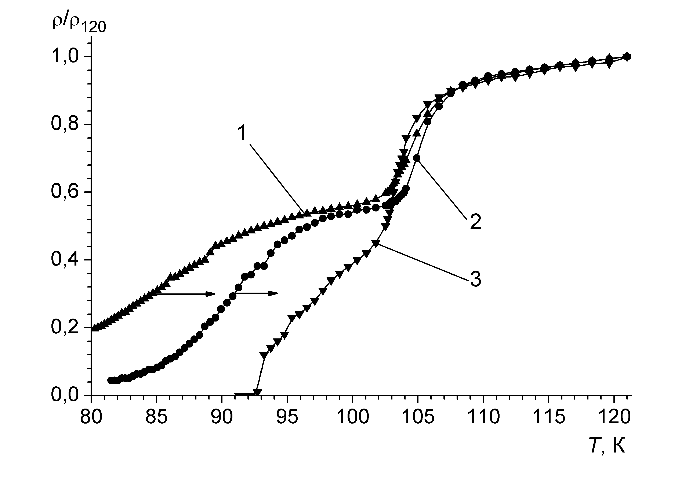 | 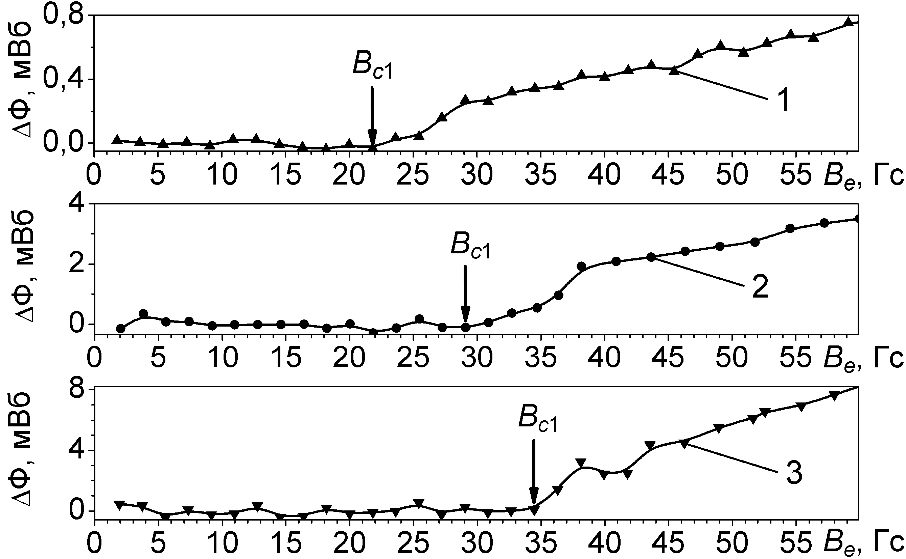
Рис.1. Зависимость приведенного удельного электросопротивления Bi-ВТСП от температуры: кривая 1 – партия №1; 2 – №2; 3 – №3. | Рис. 2. Зарождение вихрей Абрикосова в Bi-ВТСП: кривая 1 – партия №1; 2 – №2; 3 – №3

Из рис. 2 видно, что с увеличением длительности заключительного отжига (т.е. с увеличением содержания фазы Bi-2223) первое критическое поле B_{c1} увеличивается и составляет: для образцов партии №1 – 21,8, №2 – 29,1, №3 – 34,5 Гс.
Таким образом, в Bi-ВТСП продолжительность влияет на величины критических параметров j_{c} и B_{c1}. Увеличение продолжительности заключительного отжига с 60 до 100 часов приводит к возрастанию как критической плотности тока, так и величины первого критического поля более чем в полтора раза, что объясняется ростом в фазовом составе материала доли высокотемпературной сверхпроводящей фазы Bi-2223, а значит – ростом запаса устойчивости сверхпроводящего состояния.

Литература
1. Е.З.Мейлихов. СФХТ. 2, 9, 5 (1989)
2. Э.Б. Сонин. Письма в ЖЭТФ. 47, 8. 415 (1988)
3. В.Е. Милошенко, И.М. Шушлебин, О.В. Калядин. ФТТ. 48, 3, 403 (2006)
4. А.П. Можаев, В.И. Першин, В.П. Шабатин. Журн. всесоюзн. химич. общества им. Д.И. Менделеева. 34, 4, 501 (1990)
Динамика Абрикосовских Вихрей Вблизи Первого Критического
Поля Текстурированных Сверхпроводников на Основе Иттрия

В.Е. Милошенко, И.М. Шушлебин, М.А. Авдеев

Воронежский государственный технический университет, 394026, Россия
e-mail: shushlebin@mail.ru

Проникновение магнитного поля в текстурированные ВТСП происходит в условиях, схожих с известными явлениями в классических сверхпроводниках. В этой связи возникает вопрос о действии в таких материалах потенциального барьера входу вихрей, обусловленного дефектами структуры приповерхностного слоя.
Измерения магнитного потока Ф(В_{е}) проводились с помощью электронного микровеберметра, как и в работе [1]. Магнитное поле создавалось соленоидом, и ориентировалось вдоль большей грани сверхпроводника. Исследовались пять партий текстурированных керамик на основе иттрия. Они различались содержанием нормальной фазы: 1 – 32 %, 2 – 28 %, 3 – 20 %, 4 – 12 %, 5 – 8 %. Все измерения проводились при 78 К.
Как показали результаты исследований (см. рис.) изменение ∆Ф(B_{e}) носит неоднозначный характер, проявляющийся в том, что рост величины проникшего потока (а значит и количества зародившихся в приповерхностном слое вихрей Абрикосова) происходит ступенчато. На каждой кривой насчитывается до пяти ступенек.
В керамических иттриевых ВТСП ранее было подтверждено наличие потенциального барьера входу вихрей [2]. Тогда можно предположить, что в исследованных в данной работе образцах вихри также проникают в объем не по отдельности, а связками, которые задерживаются и накапливаются в приповерхностном слое, удерживаемые барьером (в классических сверхпроводниках он распространяется на глубину большую чем λ), как это рассматривалось в работе в отношении классических сверхпроводников [3]. Этому процессу на графике соответствует ступенька. При достижении связками некоторой количественной величины (в этом приповерхностном слое), давление внешнего поля становится достаточным для преодоления этого барьера, т.е. вихри проникают в объем, кривая зависимости ∆Ф(B_{e}) испытывает резкий скачок. В дальнейшем процесс повторяется.
Оценка числа вихрей в связке проводилась по высоте ступенек и составила порядка 10⁵—10⁶ вихревых нитей. Отметим, что с дальнейшим увеличением поля наблюдались эффекты, аналогичные аномальному эффекту выдавливания, характерного для некоторых ВТСП [4].

Ссылки
1. В.Е. Милошенко, И.М. Шушлебин, О.В. Калядин, М.А. Авдеев. Конденсированные среды и межфазные границы. 13, 4, 425 (2011).
2. И.М, Шушлебин, В.Е. Милошенко. СФХТ. 2, 12, 79 (1989).
3. В.Е. Милошенко, Б.В. Воронин. ФТТ. 27, 12, 3701 (1985)
4. В.Е. Милошенко, И.М. Шушлебин, А.И. Акимов, А.П. Чернякова. СФХТ. 3, 9, 2042 (1990).

Frequency Dependence of Polarization Hysteresis Loops in
Pb(Fe_{1/2}Nb_{1/2})O₃ –PbTiO₃ Ceramics

A.N. Pavlov¹, I.P. Raevski², T.A. Minasyan², A.A. Bokov ³, Z.-G. Ye ³

¹ Rostov State University of Civil Engineering, 344022, Rostov on Don, Russia
² Research Institute of Physics and Physics Department, Southern Federal University, 344090, Rostov on Don, Russia
³ Department of Chemistry, Simon Fraser University, Burnaby, BC, V5A 1S6, Canada
igorraevsky@gmail.com

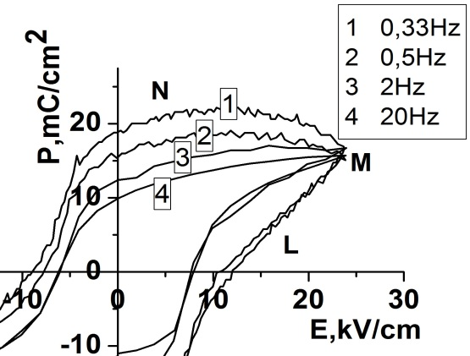
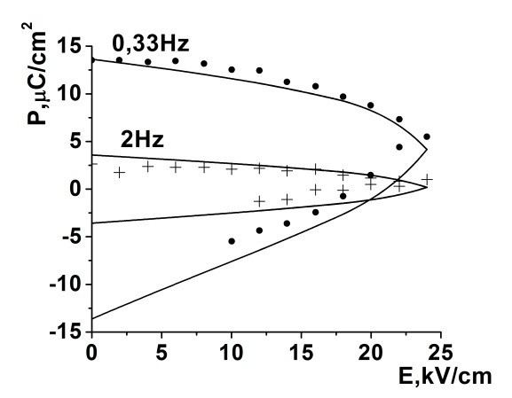
For lead iron niobate- lead titanate solid solution ceramics (1-x)PbFe_{1/2}Nb_{1/2}O₃ – xPbTiO₃ (PFN-xPT) , it is experimentally observed that the shape of the polarization P hysteresis loops depends on the frequency of the external electric field (Fig. 1a).With decreasing of the field frequency the value of the remnant polarization increases.
(a)
(b)

Fig. 1. a). Polarization hysteresis loops of PFN-0.15PTceramics measured at different frequencies. b). Experimental (points) and theoretical (lines) differences between P(E) dependences measured at low ( 0.33 Hz and 2 Hz) and high (20 Hz) frequencies. Theoretical curves were obtained in the frame of the proposed model using the same relaxation time value ф ~ 1,2 s.

We propose a model explaining this phenomenon by the relaxation of the charge localized at the grain-boundary surface states. For high enough values of the external field frequency (х ~ 20Hz) this charge has not enough time to relax and spontaneous polarization in the part of the grain adjacent to the grain –boundary does not manage to switch. An attempt was made to estimate the contribution of this polarization to the LMN part of the loop (Fig.1.a.) by subtracting the values of polarization obtained at 20Hz from the values obtained at low frequencies of the external field.. The model gives good agreement with experiment for different frequencies of the external field (Fig.1.b) at the same value of the relaxation time ф ~ 1,2 s.

Acknowledgment. This work was supported by Russian Foundation for Basic Research (Grant No.
12-08-00887_a)

Piezoelectric Resonance in Rochelle Salt: the Contribution of Diagonal Strains

A.P. Moina

Institute for Condensed Matter Physics, 1 Svientsitskii Street, Lviv, 79011, Ukraine
e-mail: alla@icmp.lviv.ua

Within the framework of the previously proposed [1] modification of the two-sublattice Mitsui model that includes the shear strain ε₄ and the diagonal strains ε₁, ε₂, ε₃ a dynamic dielectric response of Rochelle salt rectangular X-cuts is considered. To describe the coupled dynamics of the pseudospin subsystem and lattice strains, the Glauber-like dynamics of the pseudospins is combined with the classical equations of motion of elementary crystal volume. The problem is reduced to a system of second-order partial differential equations, which is solved numerically by the finite element method. A simplified but explicitly solvable system of equations for the lattice strains is obtained as well, yielding the explicit expressions for the resonant frequencies of crystal vibrations of the ε₄ shear mode and in-plane extensional modes associated with the strains ε₂ and ε₃.
The experimentally observed phenomena of crystal clamping by high frequency electric field, piezoelectric resonance, and microwave dispersion are described. The temperature variation of different vibration modes is explored. It is shown that the lowest resonant frequency is always associated with the ε₄ shear mode.

References
1. A.P. Moina, R.R. Levitskii, I.R. Zachek, Condens. Matter Phys. 14, 43602 (2011)

Bending Vibrations of the Screw Dislocation in the Vicinity
of a Structural Phase Transition Point

V.N. Nechaev and V.V. Dezhin

Voronezh State Technical University, Voronezh, 394026, Russia
e-mail: vmfmm@mail.ru

In the parer [1] is obtained complete system of equations describing the vibrations of the ferroelastic crystal with a dislocation, and considered vibrations edge dislocation. In the present report considered the vibrations of the screw dislocation, lying along the axis with the unit vector tangent to dislocation line , the Burgers vector of the dislocation and the unit vector of the normal to the dislocation slip plane . The description confined to the case of small-amplitude dislocation vibrations near of equilibrium state. Then, considering the fact that in linear approximation of the dislocation displacement and the two-dimensional delta function , where – is the two-dimensional radius-vector counted from the dislocation axis within the plane normal to vector at a given point to the dislocation line, set of equations, describing the vibrations of the ferroelastic crystal with a screw dislocation can be written as
, (1)
, (2)
. (3)
Here – is the deviation of the order parameter from equilibrium value within the crystal devoid of dislocations, – function of the order parameter response to the hydrostatic pressure , – constant striction coefficient, – sound velocity of transverse waves, – density of the crystal, – shear modulus, – Poisson’s ratio, – projection of Peach-Koehler force onto the slip plane. Solving the set of equations (1)–(3) in Fourier representation with the boundary condition (equal to zero of Peach-Koehler force at any instant of time at any dislocation point) we find – is the inverse generalized susceptibility of a screw dislocation. From this expression is determined eigenfrequencies of the screw dislocation in a variety of limits, a change of the effective mass and the effective rigidity of the dislocation, change of speed of bending waves along the dislocation, additional contribution to the attenuation of the vibrations caused by the interaction of the order parameter.

References
1. V.V. Dezhin, V.N. Nechaev and A.M. Roshchupkin. Zeitschrift für Kristallographie. 193, 175 (1990)

The Temperature Dependences of Acoustic Waves Velocities and Elastic Constants in Ferroelastics KPb₂Br₅ and RbPb₂Br₅

P.P.Turchin^{1,2}, A.E.Nesterov^{1,2}, A.A.Parfenov¹, I.M.Rychkov¹, L.I.Isaenko³, A.Yu.Tarasova³, V.M.Pashkov³

¹Siberian Federal University, Russia, 660041 Krasnoyarsk, Svobodny av. 79
² Kirensky Institute of Physics, Russia, 660036 Krasnoyarsk, Akademgorodok 50
³V.S. Sobolev Institute of Geology and Mineralogy, Russia, 630090 Novosibirsk, Koptyug av. 3
e-mail: pturchin@sfu-kras.ru

Ferroelastics monocrystals KPb₂Br₅ and RbPb₂Br₅ related to the set of solid solutions APb₂X₅ (A=K, Rb; X=Cl, Br) also are perspective for laser generation on the average IR-range [1]. Possible optical-acoustic applications of these crystals induce interest and to temperature dependences of elastic waves velocities and elastic constants which were not explored till now.
Tetragonal (I4/mcm) RbPb₂Br₅ and monoclinic (P2₁/c) KPb₂Br₅ monocrystals were grown up from stoichiometric compositions by Bridgman-Stokbarger method. In experiments samples in the square-topped parallelepipeds form of necessary crystallographic orientation with linear dimensions of 5-8 mm are used.
For measuring of velocities temperature dependences of shift and longitudinal bulk acoustic waves (BАW) the automated pulsing ultrasonic installation on the basis of oscillograph DPO 72004 [2] with gas thermostate ensuring a noncontact heating of the sample has been used.
Monocrystals elastic moduluses were found on measured velocities BАW $υ$ values by the Christoffel equations solution
$\left(Γ_{\text{il}}−{\text{λδ}}_{\text{il}}\right)U_{l}=0$, (1)
where $Γ_{\text{il}}=C_{\text{ijkl}}^{E}n_{j}n_{k}$- Christoffel tensor , $C_{\text{ijkl}}^{E}$ - elastic moduluses tensor, $n_{i}$ - unit vector of wave normal, $λ={\text{ρυ}}^{2}$ - eigenvalues, $U_{l}$ - eigenvectors $Γ_{\text{il}}$.
In the investigated temperatures range from 170⁰К to 370⁰К temperature dependences of BAW velocities and elastic constants of monocrystals KPb₂Br₅ and RbPb₂Br₅ are linear. Temperature coefficients of BAW velocities have values within (200-350) ∙10⁻⁶ degree⁻¹.

Acknowledgment. The work is supported by Russian Federation the President’s grant «Leading sciense schools» NSH-4828.2012.2 and the interdisciplinary project of the Siberian Branch of the Russian Academy of Science №28.

References
1. L.I. Isaenko, S.V. Melnikova, A.A. Merkulov, V.M. Pashkov, A.Yu. Tarasova, FTT. 3, 554 (2009)
2. P.P.Turchin, A.A. Parfenov, N.A. Tokarev, A.E. Nesterov, A.Yu. Tarasova, K.S. Aleksandrov, Journal of I.I. Polzunov Altai State Technical University. 3/1, 143 (2011)

Intelligent System For Decision-Making Processes in the Investigation of the Parameters of Ferroelectrics and Semiconductors

E.A. Pecherskaya

Penza State University, Penza, Russia
e-mail: pea1@list.ru

The work is devoted to the intellectualization of information-measuring systems for measuring electrical parameters of active dielectrics and semiconductors. Its operation is based on the developed targeted approach, which is based on an interpretation of the research process in the form of the information - logical model. This model is a set of subsystems (subsystem of parameters of materials and structures based on them, subsystems of the experimental and theoretical studies, subsystem of elements of functional electronics on the basis of these materials), allocated according to the conversion and processing information about the properties of the investigated materials.
The information content consists of the knowledge base of properties of the materials and models of materials; the methods of theoretical study and simulation parameters; methods and means for measuring the parameters of materials; the database of components of nano-and microsystems technique, based on these materials.
Software of the intelligent system is based on algorithms that implement following: methods of decision making in selecting the optimal set of functional dependencies that satisfies to the criteria of most informative of the properties of the material with a minimum of components; the choice of the optimal method and means of measurement, based on the technical - economic demands; estimating errors of measurement and adequacy of modeling of functional dependencies; estimating the probabilities of erroneous decisions of the classification parameters [1]. This system allows to make decisions in the process of research materials related to the presence of fuzzy information at various stages of research.

Acknowledgment. This work was supported by Council for Grants of President of the Russian Federation for state support of young doctors (Grant № МD-2654.2011.8).

References
Pecherskaya Е. А. Journal of nano and microsystem technique. – 2009. - № 6. – P. 16 - 19
Models of the Dielectric Parameters of Ferroelectrics:
Metrological Aspects

E.A. Pecherskaya

Penza State University, Penza, Russia
e-mail: pea1@list.ru

The system to support research of the dielectric parameters of ferroelectric among other features allows to evaluate the area of uncertainty of measurement results of the functional relationships between the parameters of materials. The uncertainty caused by instrumental and methodological errors of the components. In [1] derived formulas for estimating errors caused by influence impedance contacts. The following methodological errors are analyzed:
- the error, caused by the influence of the depolarization field NP. In the relative form of the measurement of the dielectric susceptibility η, this error is described by $\text{δη}η=\frac{η}{1+\frac{1}{N}}$, where N - the depolarization factor;
- the relative error ${\text{δη}}_{A}$ that occurs under adiabatic conditions with alternating measuring signal expressed by the formula: $\text{δη}=\frac{\text{16}π^{2}T_{c}}{C^{2}C_{P}ε_{0}χ}P^{2}$, where $C_{P}$ - the heat capacity per unit volume at constant polarization P; $T_{c}$ - the Curie temperature, C - Curie constant.
- the dynamic error occurs in the measurement of any functional dependencies, for example $η\left(E\right)$, on a harmonic signal such as$E\left(t\right)=E_{m}\text{sin}2π\text{ft}$, where f - frequency. In absolute form, it is defined as, $Δ_{\text{dini}}=E_{\text{mi}}\left(1−\text{cos}2π{\text{ft}}_{у}\right)\frac{dη\left(E\right)}{\text{dt}}|_{E_{i,}η_{i}}$where $E_{\text{mi}}$- the amplitude of the electric field - $\frac{dη\left(E\right)}{\text{dE}}|_{E_{i,}η_{i}}$- the derivative at a particular point $\left(E_{i};η_{i}\right)$;
- the absolute error of discretization $Δ_{\text{disi}}=2E_{\text{mo}}\frac{dη\left(E\right)}{\text{dE}}|_{E_{i},η_{i}}$occurs on DC signal and harmonic signal with amplitude $E_{m0}$.
Accounting of methodological errors improves the reliability of measurements of dielectric parameters of ferroelectric.

Acknowledgment. This work was supported by Council for Grants of President of the Russian Federation for state support of young doctors (Grant № МD-2654.2011.8).

References
Pecherskaya Е. А. Journal of nano and microsystem technique. – 2007. - № 7. – P. 41 - 45.
Temperature Hysteresis and Frequency Dispersion
of Dielectric Permittivity in Рb₂МоО₅ Crystal

I.P. Volnyanskaya¹, M.P. Trubitsyn²

¹Prydniprovs’ka State Academy of Civil Engineering and Architecture, Dnipropetrovsk 49600, Ukraine;
²Oles’ Honchar Dnipropetrovsk National University, Dnipropetrovsk 49050, Ukraine
e-mail: trubitsyn_m@ua.fm

Monoclinic double lead molibdate Рb₂МоО₅ crystal attracts attention due to high anisotropy of the acousto-optic parameters. Nevertheless photo- chromic effect sufficiently lowers an optical transmission and prevents application of Рb₂МоО₅ in the acousto-optic devices. Studying of the light induced defects responsible for photochromism is important to improve optical quality of double lead molibdate crystal.
In the present work we study temperature and frequency dependencies of dielectric permittivity ε of Рb₂МоО₅ single crystals grown from the melts by Czhokhralskii method. Measurements were performed by a bridge method in the temperature interval 290÷700 K and in the frequency range of measuring field f=10²÷10⁴ Hz. Dielectric measurements show two unusual features, namely: i) temperature hysteresis of ε(T) behavior; and ii) non- Debye frequency dispersion of permittivity. On heating of virgin samples the maximum of ε(T) has been detected at 540 K. After heating up to 700 K and on subsequent cooling run the mentioned anomaly disappears (Fig.a). The peak of ε(T), registered on the first heating run, can be restored by holding of the sample at room temperature during two - three months or by illumination of the sample. Thus, ε(T) behavior strongly depends on the prehistory of the sample. On increasing of measuring field frequency, the maximum of ε(T) does not shift on temperature, but its amplitude essentially decreases (Fig.b).

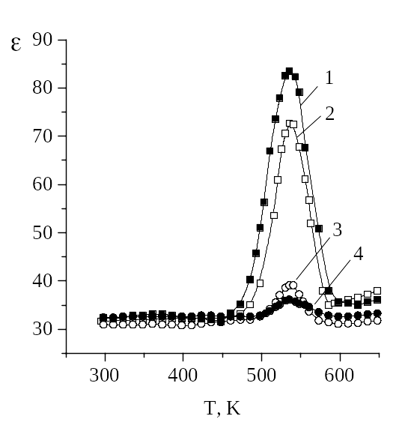  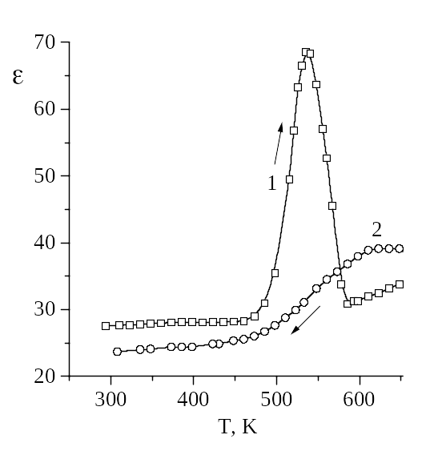  a b | Fig. ε(T) curves in Pb₂MoO₅, measured:  a) on the first heating run (1) and on the first cooling run (2), f=1 kHz;  b) on the first heating run at various frequencies f: 1 - 0.5; 2 - 1; 3 - 3, 4 - 5 kHz

Temperature hysteresis and specific frequency dispersion of ε(T) are explained by contribution of associated dipolar complexes induced by illumination and decomposing on heating. It is assumed that observed ε(T) anomalies are caused by polaron complexes (МоО₄)³⁺, which are typical for РbО-МоО₃ compounds. EPR spectra measurements of illuminated and heat treated Рb₂МоО₅ crystals could confirm this assumption directly.

Features of the Dielectric Spectra of Solid Solutions Based on Alkali Metal Niobates

I.A. Verbenko, K.P. Andrushin, S.I. Dudkina, A.I. Miller, L.A. Reznitchenko

Research Institute of Physics of Southern Federal University
e-mail: ilich001@yandex.ru

In [1] dependences of the relative permittivity (ε/ε₀) on temperature for the solid solutions (SS) of Na_{1-x}Li_{x}NbO₃ (of Na_{0.875}Li_{0.125}NbO₃) were studied. Dependences had the characteristic shape of ferroelectrics with a distinct maximum near the Curie temperature (Т_{c}). However, the curves were found particularly: in the low-frequency region, after a sharp decline above Т_{c} ε/ε₀ is growing rapidly, and the temperature began to rise (T_{i}) increases with frequency (f); in the same frequency range on the tgδ (T) curves exhibits a maximum, gradually "blur" with increasing f; below, above and at Т_{c} ε/ε₀ and tgδ markedly decrease with increasing f; peak values (ε/ε₀)_{m} and tgδ_{m} decreases inversely proportional to the lgf. Low-frequency dispersion of the investigated SS ε/ε₀ characterized for the substances in which ε/ε₀ (f) is not related to the orientation polarization and is due to the influence increasing of ε/ε₀ and tgδ, due to the presence of impurities or defects. It is commonly seen in SS containing volatile elements or ions of variable valence. In niobates of alkali metals are presents volatile elements (alkali ions) and ions of variable valence (niobium). This leads to increased electrical conductivity at high temperatures. In order to detect such effects in more complex SS we studied the dependence of the dielectric constant of ceramics on the basis of (Na, Li) NbO₃, modified MnO₂.
A detailed analysis of dielectric spectra above T_{c} has identified a number of differences from the one described in [1] behavior of ε/ε₀ in the paraelectric (PE) region. Additional low-temperature anomaly are showed. It is situated near the phase transition (PhT). Second, a high-temperature anomaly ε/ε₀ coincides with that described in [1] and corresponds to the temperatures at which changes the valence of Nb (~ 450 ºC). It is remarkable to different rate of change of temperature (T_{i1}) and (T_{i2}) with increasing f (above the rate of change of T_{i1} almost 3 times). The maximum values of T_{i1} growth rate near the PhT, in analogy with the effect of Hedvala (increased reactivity of solids during or as a result of polymorphic transformations), due, apparently, the intensification of diffusion processes, including movement defects initiated by high mobility components lattice in its restructuring. The fact that the rate of change of T_{i}(f) decreases with distance from the PhT, apparently indicates a decline in the role due to their structural changes in the processes of motion of defects and dislocations are formed at different stages of the permanent restoration of the oxidation-Nb.

This work was financially supported by the Ministry of Education and Science of Russian Federation, state contract № 16.513.11.3032.

References
1. O. Yu. Kravchenko, L. A. Reznichenko, G. G. Gadzhiev, et al. Inorg. Mat. 44, 10 (2008)

Cтруктура и Электрические Свойства Новых Гетерогенных
Систем Cu-Pd-In-Y-O

К.С. Габриельс, И.В. Бабкина, О.В. Жилова, А.В. Ситников

Воронежский Государственный Технический Университет, Воронеж, 394026, Россия
e-mail: ivbabkina@mail.ru

Использующиеся в настоящее время газочувствительные пленки имеют существенный недостаток, связанный с достаточно высокой рабочей температурой элемента, поэтому разработка новых соединений, имеющих пониженную температуру максимальной газовой чувствительности, чрезвычайно востребована в настоящее время.
В работе были исследованы образцы гетерофазной системы Pd₉(Cu_{X}(In₃₁Y₄O₆₅)_{100-X})₉₁, полученные методом ионно-лучевого распыления керамической мишени In₃₁Y₄O₆₅, на поверхности которой равномерно были размещены 9 навесок палладия и неравномерно - 7 навесок меди. Изменение концентрации меди в образцах составляло 25 - 65 ат. %. В данном концентрационном интервале происходит уменьшение удельного электрического сопротивления полученного соединения от
2⋅10⁻⁴ Ом⋅м до 6⋅10⁻⁶ Ом⋅м.
Рентгенодифракционные исследования полученной пленки показали, что она является рентгеноаморфным композитом. В зависимости от соотношения концентраций Cu и Pd металлическая фаза состоит из соединения CuPd или Cu₃Pd, а диэлектрическая - из In₂O₃.
Для выявления структурных и фазовых превращений в гетерогенной системе Pd₉(Cu_{X}(In₃₁Y₄O₆₅)_{100-X})₉₁ были проведены измерения температурных зависимостей сопротивления образцов различного состава в вакууме и в воздушной среде. Обнаружено, что при повышении температуры до 200 ⁰С во всех исследуемых составах наблюдается положительный температурный коэффициент сопротивления (ТКС). После нагрева в вакууме до 650 ⁰C для составов с высоким содержанием меди ТКС остается положительным, тогда как при x<42 ат. % ТКС стал отрицательным. Нагрев в воздушной среде повышает сопротивление пленок на два порядка в температурном диапазоне 400-650⁰C, и при остывании все исследованные композиты имеют отрицательный ТКС. Можно предположить, что термообработка в воздушной среде приводит к окислению структуры гетерогенной системы Pd₉(Cu_{X}(In₃₁Y₄O₆₅)_{100-X})₉₁.
Для подтверждения этого предположения был проведен рентгенофазовый анализ соединения после термической обработки. Анализ дифрактограмм показал, что при нагреве в воздушной атмосфере выше 400 ⁰С образуются окислы In₂O₃, Cu₂O, CuO и фаза Cu₃Pd. Интересной особенностью данной гетерогенной системы после термической обработки является возможность образования трех оксидных фаз.
Исследования газовой чувствительности копмозитов Pd₉(Cu_{X}(In₃₁Y₄O₆₅)_{100-X})₉₁ проводились после термической обработки при 550 ⁰C в воздушной среде. Обнаружено, что при малых концентрациях меди (до 37 ат.%) водород понижает сопротивление пленок при 230 ⁰С и 300 ⁰С, а при концентрации Cu больше 37 ат. % при температуре 300 ⁰С сопротивление возрастает. Полученный результат был объяснен возможным перераспределением вкладов полупроводниковой фазы в электроперенос от оксида индия к оксиду меди при повышении температуры испытания на газовую чувствительность.

Зависимость Электрического Сопротивления Компактированных
Нанодисперсных Углеродных Материалов от Магнитного Поля

И. М. Голев, А. В. Усков, М.С. Калиенко, Л. И. Янченко

Воронежский государственный технический университет, Воронеж, Россия

Изучалось магнитосопротивление образцов, полученных компактированием наночастиц углерода в аморфном состоянии (распыление графита в потоке гелия, размер частиц 30–80 нм), деструктированного графита (деструктция графита соединениями внедрения, слои толщиной 30–100 нм и длиной 10⁴ нм), углеродных нановолокон (каталитическое разложение углеродсодержащего газа, диаметр 40–110 нм, длина 500–2000 нм), микрочастиц углерода в аморфном состоянии (разложение метана в электрической дуге, размер частиц 80–120 нм). Используя линейную аппроксимацию кривой logK_{S}(logT) и формулу (1), можно определить величину радиуса локализации. Для этого была построена зависимость logK_{S} (logT). Параметр K_{S} был предварительно определён из зависимостей сопротивления от магнитного поля, построенных в масштабе ln[ρ(B)/ρ(0)] = K_{S}B². Параметр B найден по углу наклона прямой lnσ(T^{1/4}).
$K_{S}=\frac{e^{2}a^{4}}{C_{1}ℏ^{2}}{\left[\frac{T_{\text{ES}}}{T}\right]}^{p}$, (1)
Полученная зависимость для деструктированного графита имеет параболический вид, что хорошо согласуется с сопротивлением в полупроводниках со сферически симметричной зонной структурой, при воздействии слабых магнитных полей. Вид зависимости ln[ρ(B)/ρ(0)] = K_{S}B² подтверждает предположение, что в исследуемых материалах, кроме деструктированного графита, в области комнатных температур реализуется прыжковая проводимость с переменной длиной прыжка. Зависимость относительного удельного электросопротивления от магнитного поля спрямляется в координатах Δρ(B)/ρ(0) = B², что является признаком термически активированной электропроводности. Величина радиуса локализации была составила 6,2 нм для микрочастиц углерода в аморфном состоянии, 7,9 нм для углеродных нановолокон и 23 нм в случае наночастиц углерода в аморфном состоянии. Магнитосопротивление деструктированного графита достигает 3 % в поле 1 Тл, что сопоставимо со значениями для наногранулированных структур типа CoSiO₂ [1].
Проведённый выше анализ результатов, полученных при исследовании магнитосопротивления показал, что в образцах, полученных компактированием аморфных нано- и микрочастиц углерода, а также углеродных нановолокон доминируют механизмы электрической проводимости: прыжковый по локализованным состояниям вблизи уровня Ферми с переменной длиной прыжка и прыжками между ближайшими локализованными состояниями. Это подтверждается тем, что функциональная зависимость величины магнитосопротивления имеет вид ln[ρ(B)/ρ(0)] ∼ B².
В структурах, полученных компактированием углеродных частиц размером 30-120 нм, в которых реализуется прыжковая электропроводность, длина прыжка носителей заряда приблизительно одинакова и составляет 19-25 нм. Изучаемые материалы имеют разные размеры частиц и электрофизические свойства, т.к. они получены по различным технологиям, но механизм электропроводности у исследуемых образцов одинаков. Таким образом, можно сделать вывод, что прыжковая электрическая проводимость в основном обусловлена свойствами контактов между частицами.

Литература
1. O.V. Stognei, Yu. E. Kalinin, I.V. Zolotukhin et al. J. Phys.: Condens. Matter. 15, 4267 (2003)

Эффект Зеебека в Компактированных Нанодисперсных Углеродных Материалах

И. М. Голев, А. В. Усков, Л. И. Янченко

Воронежский государственный технический университет, г. Воронеж, Россия

Представлены результаты исследования термоэлектрических свойств образцов, полученных компактированием наночастиц углерода в аморфном состоянии (распыление графита в потоке гелия, размер частиц 30–80 нм), деструктированного графита (деструктция графита соединениями внедрения, слои толщиной 30–100 нм и длиной 10⁴ нм), углеродных нановолокон (каталитическое разложение углеродсодержащего газа, диаметр 40–110 нм, длина 500–2000 нм), микрочастиц углерода в аморфном состоянии (разложение метана в электрической дуге, размер частиц 80–120 нм). При стандартных условиях термоэдс равна: -7 мкВ/К для образцов из микрочастиц углерода в аморфном состоянии, -7,5 мкВ/К для образцов из углеродных нановолокон, -11,1 мкВ/К для образцов из деструктированного графита и -16,8 мкВ/К для образцов из наночастиц углерода в аморфном состоянии.
Для анализа полученных результатов были построены зависимости $S(T^{1/2})$. В области комнатных температур, где реализуется прыжковый механизм проводимости с переменной длиной прыжка, термоэдс имеет корневую температурную зависимость. Температуры, при которых происходит отклонение от корневой зависимости составляют, 345 К для образцов из нановолокон, 360 К для образцов из микрочастиц углерода в аморфном состоянии, 335 К в случае образцов из наночастиц углерода в аморфном состоянии. Они несколько отличаются от температур, при которых происходит смена механизма электрической проводимости, что отмечается и в других исследованиях [1]. При повышении температуры характерна линейная асимптотика S ~ Т, как и в работе [2], которую можно связать с формулой Мотта для термоэдс [3]:
$S(T)=\frac{π^{2}}{3}\frac{k_{B}}{e}k_{B}T\frac{∂(\text{ln}g(E_{F}))}{∂E}$ (4)
Для образцов из деструктированного графита термо-э.д.с пропорциональна 1/Т во всём температурном участке исследования. Проводимость деструктированного графита что во всем диапазоне исследованных температур σ (Т) можно представить как сумму прыжкового и активационного вкладов, она превышает значения для других материалов в 6 – 10 раз, т.е. активационный вклад существенно превышает вклад, обусловленный прыжковой проводимостью, а температурная зависимость термоэдс пропорциональна 1/Т.
Для исследуемых материалов при температурах доминирует прыжковый механизм электропроводности с переменной длиной прыжка. Таким образом, изменяя структурное состояние графита, можно создавать компактированные структуры с различной величиной электропроводности и термо-ЭДС, что представляет интерес для использования в композиционных материалах.

Литература
1. А.А. Пронин, В.В. Глушков, М.В. Кондрин, А.Г. Ляпин, В.В. Бражкин, Н.А. Самарин, С.В. Демишев Физика твёрдого тела. 49, 1336 (2007)
2. С.В. Демишев, М.В. Кондрин, А.А. Пронин, Н.Е. Случанко, Н.А. Самарин, А.Г. Ляпин, Дж. Бискупски Письма в ЖТФ. 68, 801 (1998)
3. И.П. Звягин. Кинетические явления в неупорядоченных полупроводниках. МГУ. 189 (1984)

Диэлектрические Свойства Пленочных Структур «Желатин-Триглицинсульфат»

О.М.Голицына, С.Н.Дрождин

394006, Воронеж, Воронежский государственный университет

Активное использование тонких сегнетоэлектрических пленок в качестве элементов микроэлектроники и сенсорной техники требует поиска новых пленочных материалов с расширением их функциональных возможностей. В качестве возможного решения растущих практических потребностей предлагается новый пленочный материал «желатин + триглицинсульфат».
Процедура приготовления пленочных материалов на основе желатина с триглицинсульфатом (ТГС) включала следующие операции:
1) растворение желатина в небольшом количестве дистиллированной воды; 2) химическое созревание; 3) введение мелкодисперсного ТГС с размером кристаллитов ~130 мкм.
Готовую эмульсию с равномерно распределенными по всему объему кристаллитами ТГС выливали на разогретую подложку и быстро остужали. Синтезированные пленки в соотношении компонент: 2:1:2 (желатин + вода + ТГС, соответственно) на сутки помещались в вакуум ~ р = 10⁻⁴ mm Hg при комнатной температуре.
Проводились измерения диэлектрической проницаемости и проводимости в поле ~3 V/cm на частоте 1,592 kHz в интервале температур 20-70°С. При комнатной температуре наблюдались петли диэлектрического гистерезиса по методу Сойера- Тауэра.
На температурных зависимостях диэлектрической проницаемости и проводимости обнаружены широкие максимумы, приходящиеся на температуру фазового перехода Т_{С} объемного ТГС.

Релаксационное Поведение Кристаллов ТГС в Окрестности Фазового Перехода

С.Н.Дрождин, О.М.Голицына

Воронежский государственный университет, Воронеж, Россия

В научной литературе до сих пор представлен очень широкий спектр законов, описывающих релаксацию поляризации линейных и нелинейных диэлектриков и нет единого представления о механизмах релаксации. Не менее дискуссионным остается вопрос о температурном и временном поведении внутреннего поля, созданного дефектами в сегнетоэлектрических материалах. В настоящей работе проведены исследования релаксационных процессов деполяризации кристаллов ТГС в параэлектрической фазе. Для кристаллов ТГС с радиационными дефектами (рентгеновское облучение) исследованы температурное и временное поведение четных гармоник тока переполяризации, существование которых определяется присутствием внутреннего поля смещения, ответственного за асимметрию процесса переключения поляризации. Установлены следующие закономерности:
1. релаксация тока деполяризации кристалла ТГС в парафазе, где он является линейным диэлектриком, проходит по степенному закону Кюри – фон Швайдлера. Показатель степени уменьшается с ростом поля от –1.15 до –0.9 при значениях поля от 100 до 300 В, что согласуется с литературными данными для линейных диэлектриков;
2. амплитуды четных гармоник тока переполяризации после перевода облученного кристалла ТГС из параэлектрической фазы в сегнетоэлектрическую и при постоянной температуре в интервале от Т_{с} – 0,2° до Т_{с} – 1° меняются со временем: растут и выходят на насыщение примерно через 90 мин после перевода кристалла через Т_{с}; предполагается, что аналогично ведет себя внутреннее поле малой величины (~ 20 V/cm);
3. временные зависимости амплитуд четных гармоник подчиняются экспоненциальной зависимости A_{2n}(t)=A_{2n}^{max}+(A_{2n}⁰ – A_{2n}^{max})exp(–t/τ), что позволило получить температурную зависимость времени релаксации: время релаксации экспоненциально возрастает, при T → T_{c};
4. в температурных зависимостях амплитуд гармоник наблюдается гистерезис: при нагревании из сегнетоэлектрической фазы в параэлектрическую их значения оказываются ниже чем при обратном ходе, что обусловлено увеличением числа доменных стенок и скорости их движения при охлаждении; эффект сильнее выражен у четных гармоник спектра;
5. исчезновение из спектра четных гармоник и асимметрии переключения происходит в точке Кюри, а существование нечетных гармоник, и, следовательно, нелинейности переключения поляризации затягивается в парафазу на 2 – 3 ⁰.

Диэлектрические Свойства Кристалла ТГС, Выращенного
с Переводом Через Точку Кюри

С.Н.Дрождин, О.М.Голицына, В.О.Чулакова

394006, Воронеж, Воронежский государственный университет

Физические свойства сегнетоэлектрических кристаллов ТГС существенно зависят от условий выращивания, что было продемонстрировано в работах М.С.Цедрика и обобщено в его монографии - единственной в своем роде. Однако, ни в этой работе, ни в других, не исследовались кристаллы, претерпевшие фазовый переход в процессе роста. Результаты исследования диэлектрических свойств такого кристалла представлены в настоящей работе.
Кристалл массой 1100 гр., оптически чистый, был выращен из трижды перекристаллизованной соли методом понижения температуры в интервале от 66 ^{о}С до 39 ^{о}С. 34 образца для исследований были выбраны из пирамиды роста (110) и изготавливались скалыванием по плоскости спайности. Электродами служило напыленное в вакууме серебро.
Проводились измерения диэлектрической проницаемости и тангенса угла диэлектрических потерь в поле ~3 V/cm на частоте 1,592 kHz, как при нагревании с переводом через точку Кюри, так и при охлаждении. Кроме того, при комнатной температуре проводились наблюдения петель гистерезиса и измерения эффективной диэлектрической проницаемости в зависимости от напряженности переполяризующего поля.
Обнаружено, что зависимость максимального значения диэлектрической проницаемости ε_{max} от номера образца, по мере удаления от затравки демонстрирует отчетливый максимум, который соответствует зоне кристалла, выросшей в температурной области фазового перехода. На эту зону приходится, также, наибольшая эффективная нелинейность, и в ней же наблюдается изменение механических свойств кристалла.

Влияние Электронного Облучения на Диэлектрические Свойства
Монокристаллов TlInS₂, TlInSe₂, TlGaS₂ и TlGaTe₂

А.У. Шелег¹, В.Г. Гуртовой¹, В.В. Шевцова¹, С.Н. Мустафеева², Э.М. Керимова²

¹ГНПО «Научно-практический центр национальной академии наук Беларуси по материаловедению». 220072, г. Минск, ул. П. Бровки, 19, Беларусь
²Институт физики НАН Азербайджана. АЗ1143, г.Баку, пр. Г.Джавида, 33, Азербайджан
e-mail: hurtavy@physics.by

Кристаллы TlInS₂, TlInSe₂, TlGaS₂ и TlGaTe₂ относятся к группе таллиевых халькогенидных соединений типа A^{III}B^{III}C^{VI}₂ с ярко выраженной слоистой структурой. Характерной особенностью кристаллов этого семейства является проявление ими как полупроводниковых, так и сегнетоэлектрических свойств. Поскольку кристаллическая структура соединений этого типа является слоистой, то, как правило, это приводит к образованию политипных модификаций этих кристаллов, что очень значительно сказывается на их физических свойствах. Кроме того, многие представители кристаллов этого семейства обладают последовательностью фазовых переходов (ФП), обусловленной наличием в них длиннопериодических соизмеримых и несоизмеримых модулированных сверхструктур и их преобразованием с изменением температуры. Кроме своих интересных физических свойств, кристаллы этих соединений привлекательны с точки зрения практического применения. Это широкозонные полупроводники, которые являются перспективными материалами для изготовления на их основе фотоэлектрических преобразователей, анализаторов спектров и детекторов рентгеновского и нейтронного излучений. Данная работа посвящена исследованию закономерностей изменения диэлектрической проницаемости и электропроводности монокристаллов TlInS₂, TlInSe₂, TlGaS₂ и TlGaTe₂ под действием температуры и электронного излучения.
Измерения диэлектрической проницаемости (ε) и электропроводности (σ) проводили методом плоского конденсатора на монокристаллических пластинках толщиной ~ 0.7 – 1.5 mm вдоль кристаллографического направления [001] с помощью цифрового измерителя Е7-20 на частотах измерительного поля 10³ - 10⁶ Hz в температурном диапазоне 80 - 300 K. Проводились измерения как необлученных, так и облучённых электронами c энергией 4 MeV дозами 10¹⁵ и 10¹⁶ cm⁻².
В результате исследования диэлектрических свойств слоисто-цепочечных монокристаллов TlInS₂, TlInSe₂, TlGaS₂ и TlGaTe₂ установлено, что с увеличением температуры электропроводность и диэлектрическая проницаемость исследованных кристаллов растет. Обнаружена дисперсия диэлектрических характеристик, связанная с релаксационными процессами. Установлено, что облучение электронами с ростом дозы приводит к значительному увеличению значений удельной электропроводности σ и уменьшению диэлектрической проницаемости ε во всей исследованной области температур (80 – 320 К). Обнаружено, что в исследованных монокристаллах имеет место характерная для этого типа соединений последовательность фазовых переходов, проявляющаяся на температурных зависимостях σ = f(T) и ε = f(T) в виде аномалий. Облучение кристаллов электронами дозой 10¹⁵ и 10¹⁶ cm⁻² приводит к частичному сглаживанию пиков, соответствующих фазовым переходам, но не влияет на их температуры.

Dielectric Relaxation in SBN and BaTiO₃ Monocrystals

B. B. Pedko, V. V. Ivanov

Tver state university, Tver, Russia,
E-mail: Vladimir.Ivanov@tversu.ru

Investigation polarization processes are a fundamental problem and has practical interest. Barkhauzen effect is a sensitive method researches the domain structure, allowing to investigate processes not only on a sample surface, but also in crystal volume [1].
A great influence render defects on physical properties of a ferroelectric material, in particular on domain structure. Results of the theoretical analysis of influence of defects are given in work [2] on properties of a ferroelectric material near phase transition.
In this work the temporary dependences quantity Barkhauzen jumps in SBN and BaTiO₃ monocrystals are investigated. The phenomenological theory of the viscosity phenomena and concept of dielectric viscosity allow to describe transition a ferroelectric crystal to an equilibrium state with polarization Р₀ under electric field

P(t) = P₀ [1-exp (-t/ι)],

where ι=β/E - relaxation time, β – dielectric viscosity coefficient.
As establishment time full part polarization equals establishment time of its nonreversible part caused by Barkhauzen jumps. Course time of complete polarization equals spasmodic part similar character, also function of distribution relaxation times we will use experimental curves quantity Barkhauzen jumps N(t) in time distribution.
Being displaced in an external field, domain walls carry out switching process ferroelectric material. Change in time of absolute size of polarization is connected with shift of U (t) of a domain wall by a ratio:
ΔP(t) = 2P₀/d (U(t)),

where P₀ -equilibrium value of polarization, d-thickness of a crystal.
The polarization curve ΔP(t) coincides with a temporary course of U(t) to within a constant 2P₀/d. At step change of external electric field temporary dependences and also polarization, are well approximated by Kolraush's empirical law

U(t)≈1-exp(-(t/ι)^{α}).

Calculations of curves of distribution quantity Barkhauzen jumps in time by the regularizations of Tikhonov’s method, and also in the assumption that the domain structure, relax to an equilibrium condition, represents set of relaxator with various relaxation times ι (as a relaxator the domain wall acts) showed that distribution relaxation times function for these crystals is asymmetrical.

References
1. Rudyak V. M. Switching processes in nonlinear crystals. - M: Science, 248, (1986).
2. Strukov B. A., Levanyuk A.P. Physical bases of the ferroelectric phenomena in crystals. - M: Science, 304, (1995).

Фон Внутреннего Трения в Нанокомпозиционном Материале
Металл-Диэлектрик и его Связь с Диффузионными Характеристиками Вакансий

В.Г. Кульков¹, Л.Н. Коротков², Д.П. Тарасов³, В.В. Дешевых¹

¹Филиал национального исследовательского университета «МЭИ», Волжский, ²Воронежский государственный технический университет, Воронеж, ³Военный авиационный инженерный университет, Воронеж

Среди многообразия наноструктурных материалов определенный интерес вызывают нанокомпозитные материалы. Причиной этого являются их уникальные свойства, которые обусловлены их структурными особенностями. Так например, в таких материалов повышаются демпфирующие свойства.
Рассмотрим нанокомпозитный материал, армированный включениями кубической формы. Под действием внешнего периодического напряжения $σ\left(t\right)=σ_{0}\text{exp}\left(iωt−ϕ\right)$ на гранях включений возникают нормальные и касательные напряжения. Вследствие периодического растяжения и сжатия, границы раздела фаз становятся попеременно источниками и стоками вакансий. Уравнение диффузии вакансий в данном случае будет иметь вид: $\frac{∂C\left(x,y,t\right)}{∂t}=D∇^{2}С\left(x,y,t\right)+A\text{exp}\left(iωt\right)$, где D – коэффициент межфазной диффузии вакансий, $∇^{2}$ – двумерный оператор Лапласа, А – периодический источник вакансий, $C\left(x,y,t\right)$ - равновесная концентрация вакансий.
Скорость деформации материала получим, зная скорость его смещения к границе: $υ_{n}\left(t\right)=2ΩδA\text{exp}\left(iωt\right)−i\frac{2ωΩδ}{L^{2}}\int_{S}{C\left(x,y,t\right)\text{dS}}$, где L – ребро куба, Ω – атомный объем.
Величина внутреннего трения в материале будет найдена из стандартного уравнения: $Q_{0^{−1}}=ΔW2πW$, где W –максимальная упругая энергия в объеме зерна, ΔW – энергия, рассеянная за цикл колебаний на всем сегменте. Тогда:
$\begin{aligned}Q_{0^{−1}}=\frac{π^{4}{\text{ϑβ}}^{2}C_{0b}Ω^{2}δG}{\text{32}\text{kTL}}F\left(Z\right), \\ F\left(Z\right)=\frac{1}{{ZΣ}_{0}}\sum_{m,l}{\frac{m^{2}+l^{2}}{m^{2}l^{2}\left({\left(m^{2}+l^{2}\right)}^{2}+Z^{2}\right)}},\end{aligned}$ $Z=\frac{{ωL}^{2}}{π^{2}D}$,
где G – упругий модуль. Полученное выражение описывает выскотемпературный фон внутреннего трения в нанокомпозитном материале.
График зависимости $\text{ln}F\left(Z\right)$ от $\text{ln}Z$ демонстрируют зависимость $\text{ln}\left(Q^{−1}⋅T\right)$ от логарифма частоты или обратной температуры. Он состоит из двух участков, каждый из которых имеет линейный характер и различные тангенсы угла наклона к горизонтальной оси координат. Последние характеризуют энергии активации диффузионного процесса, которые в данном случае относятся друг к другу приблизительно как 1 к 2. Экспериментальные данные, полученные при исследовании нанокомпозита типа металл-диэлектрик, показали адекватность представленной модели.
Различный характер зависимости от частоты связан с соотношением между глубиной диффузии вакансий вдоль межфазной границы и ее геометрической протяженностью. Полученные результаты позволяют судить о диффузионных характеристиках межфазных границ в объектах наномасштабного уровня.

Dielectric Properties of Monoclinic RbD₂PO₄ the Effect of Hydrostatic Pressure

I.R. Zachek¹, A.S. Vdovych² and R.R. Levitskii ²

¹ Lviv Polytechnic National University, Lviv, 79013, Ukraine
² Institute for Condensed Matter Physics of the National Academy of Sciences of Ukraine, Lviv, 79011, Ukraine
e-mail: levyt@icmp.lviv.ua

We proposed modified proton ordering model for quasi-one-dimensional monoclinic RbD₂PO₄, that takes into account linear over strains ε_{i} and ε₅ contributions to the proton subsystem energy. Within the framework of the model, using the two-particle cluster approximation, with taking into account the short-range and long-range interactions, longitudinal electric field, and hydrostatic pressure p=-σ_{i} we calculate the thermodynamic potential. From the condition of the thermodynamic potential minimum, we obtain a system of equations for the strains ε_{i} and for the order parameter. Using these equations we calculate the static dielectric permittivity of the crystal. Molar heat capacity of the proton subsystem is calculated by direct differentiation of the thermodynamic potential over temperature. The dynamic dielectric permittivity of the crystal is calculated within the D.N.Zubarev nonequilibrium statistical operator method.
A thorough numerical analysis of dependences of the obtained physical characteristics of monoclinic RbD₂PO₄ on the theory parameters is performed. A set of these parameters, which allows us to properly describe the available experimental data for static and dynamic permittivities, is found.
The effect of hydrostatic pressure on the physical characteristics of the crystal is explored. We obtained a proper description of the pressure dependence of phase transition temperature and the temperature dependences of static and dynamic permittivities at different frequencies.

Термополяризационный Эффект в Полостных Структурах
Гетерогенных Систем

В.И. Лисицын, Н.С. Камалова, Н.А.Саврасова,
И.П. Бирюкова, Б.М. Кумицкий, В.В. Саушкин

Воронежская государственная лесотехническая академия
394087, Россия, г. Воронеж, ул. Тимирязева, д. 8, rc@icmail.ru

В последнее время для исследования таких гетерогенных систем, как древесина, используется модель полимерного композита, основными составляющими которого являются частично кристаллическая целлюлоза и аморфный лигнин, представляющий из себя субстанцию, исследуемую методами моделирования. Установлено, что в неоднородном температурном поле за счет различий в тепловом расширении составляющих системы, пьезо- и пироэлектрических свойств целлюлозы и поляризации свободных боковых групп молекул последней возникает электрическое поле. Этот факт подтверждается экспериментально [1]: разность потенциалов в поперечном слое составляет 35 – 50 мВ при неоднородности температуры порядка 2 К на 100 мкм. Получается, что в гетерогенной системе за счет ее сложнокомпонентности возникает разность потенциалов: $U=α_{p}ΔT$, где α_{p} - некий коэффициент пропорциональности, характеризующий (подобно коэффициенту Зеебека в полупроводниках) взаимовлияние компонент. Древесина является пористым материалом. На рис.1 приведена электронная фотография поперечного среза березы. Учитывая этот факт, а также то, что в древесине поры заполнены растворами солей (электролитом), в последних возникнет ток, а его мощность $P_{i}=σα_{p}^{2}{ΔT}^{2}S/l$, где σ - электропроводность раствора солей, l, S-длина и площадь сечения поры соответственно.
Одновременно с этим потоком будет протекать процесс разрушения неоднородности температуры за счет теплопроводности системы мощностью $P_{Q}=−λSΔT/l$, здесь λ - коэффициент теплопроводности. Условие равновесия позволяет оценить величину $Z=P_{i}/P_{Q}={\text{σα}}_{p}^{2}ΔT/λ$, называемую термоэлектрической добротностью материала. Это выражение, прежде всего, показывает, что природные пористые гетерогенные системы можно использовать как материал для создания термоэлектрических преобразователей, а так же разрабатывать электрические устройства, позволяющие определять влажность древесины.
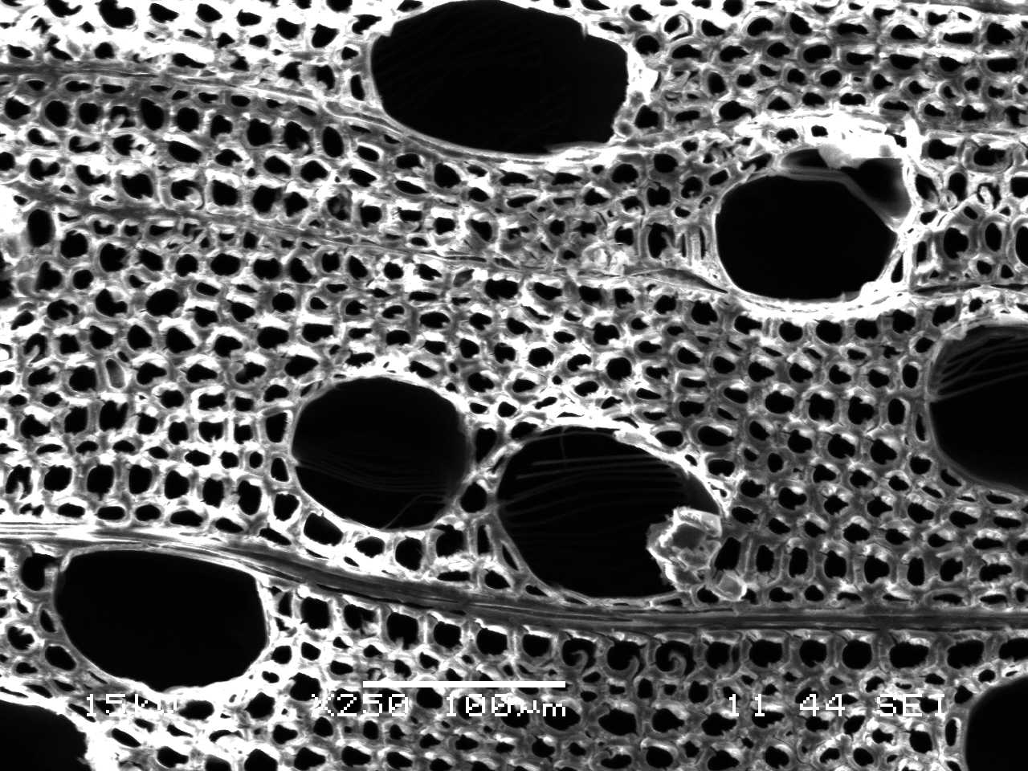
Рис.1. Электронная фотография поперечного среза березы.

Список литературы
1. Евсикова Н.Ю., Камалова Н.С., Матвеев Н.Н., Постников В.В. Новый подход к определению степени кристалличности целлюлозы в древесине // Известия РАН. Серия физическая. – 2010. – Т. 74, № 9. – С. 1373–1374.

Электрическая Проводимость и Плотность Спиртовых Суспензий Углеролных Нановолокон

Ю.В. Панин, В.А. Макагонов

Воронежский государственный технический университет, 394026, Россия, Воронеж, Московский проспект, 14
e-mail: vlad_makagonov@mail.ru

Многие оксиды металлов обладают высокими значениями термоэдс и могут служить основой для создания термоэлектрических материалов нового поколения при условии повышения их электропроводности. Повысить электропроводность оксидов можно путём наполнения их углеродными наноматериалами. Так в работе [1] показано, что при наполнении диэлектрической матрицы углеродными нанотрубками с концентрацией до 0,5% электропроводность получаемого композита возрастает на 7 порядков, в то время как теплопроводность возрастает не более чем на 3%, а при наполнении одностенными углеродными нанотрубками теплопроводность даже понижается. Объясняется данное явление термическим сопротивлением межфазной границы. В связи с этим при получении термоэлектрических материалов по жидкофазной технологии возникает необходимость получения высокодисперсных и стабильных суспензий как углеродного наполнителя, так и оксида металла.
Одним из способов достижения высокой степени дисперсности углеродных наполнителей является их обработка в высокоэнергетичной планетарной мельнице. В работе изучена возможность измельчения углеродных волокон в высокоэнергетичной планетарной мельнице АГО-3 в стальных барабанах стальными шарами диаметром 7 мм. Исследовалась эффективность измельчения углеродных волокон в этиловом спирте объемом 150 мл в зависимости от концентрации углеродных волокон и времени обработки. Концентрация углеродных волокон в этиловом спирте составляла 2,3 об. %, 3,78 об. % и 5,2 об. %. Масса стальных шаров 200 г. Время обработки 300 мин. Исходный средний размер углеродных волокон 344 нм. Путём измерения электрической проводимости получаемых суспензий оценивали эффективность измельчения.
Результаты исследований показали, что при увеличении концентрации нановолокон в суспензии и времени измельчения наблюдается рост электрической проводимости и плотности. При этом порог электрической перколяции для концентраций волокон 2,3 об. % и 3,78 об. % наблюдался через 100 мин обработки. Для суспензии с концентрацией углеродных волокон 5,2 об. % проводимость суспензии после 100 мин обработки несколько снижалась, а затем начинала расти. Электрический порог перколяции наблюдался через 275 мин обработки. Причиной снижения электрической проводимости после 100 мин обработки является разрыхление приповерхностного слоя углеродных волокон и ухудшения условий контактирования. При этом плотность суспензии оставалась постоянной. Таким образом, степень дисперсности углеродных волокон зависит от их концентрации в этиловом спирте.

Работа выполнена при финансовой поддержке РФФИ (проект № 11-08-00855-а)

Литература
1. F H.Gojny, M.H.G.Wichmann, B.Fiedler, I.A.Kinloch, W. Bauhofer, A.H.Windle, K. Schulte. Polymer. 47. 2036 (2006)

Роль Кристаллитов Целлюлозы в Поляризации Биополимерного
Композита - Древесины в Неоднородном Температурном Поле

Н. Н. Матвеев, Н. Ю. Евсикова, Н. С. Камалова, Н.И. Коротких

ФГБОУ ВПО «Воронежская государственная лесотехническая академия», 394087, Россия, г. Воронеж, ул.Тимирязева, д. 8, rc@icmail.ru

Целью настоящей работы является применение теории поляризационных явлений в кристаллах для описания поляризационных эффектов, обусловленных наличием градиентов температуры, в биополимерном композите - древесине. В работе [1] показано, что неоднородное температурное поле вызывает изменение поляризованности P в сложной композиционной системе: «кристаллическая волокнообразующая целлюлоза – аморфный лигнин», которой моделируется древесина, за счет пироэлектрического эффекта в кристаллитах целлюлозы и пьезоэлектрического эффекта, обусловленного избыточным давлением на кристаллическую целлюлозу со стороны лигнина, испытывающего тепловое расширение в направлении неоднородности температуры. Однако, суммарная поляризованность P целлюлозы должна также включать ориентационную составляющую P_{ор} , связанную в с поворотом боковых полярных групп макромолекул целлюлозы: ${\text{dP}}_{i}=−d_{\text{ijk}}c_{\text{kjml}}μ_{\text{ml}}α\text{dT}+γ_{i}\text{dT}+{\text{dP}}_{\text{ор}}$ ,
где d_{ijk} – тензор пьезоэлектрических модулей, с_{jkml} - константы упругой жесткости, μ_{ml} – отношение модуля Юнга лигнина к модулю Юнга целлюлозы, α - коэффициент теплового расширения лигнина, γ_{i} - пироэлектрический коэффициент целлюлозы. Очевидно, что последнее слагаемое будет прямо пропорционально относительному изменению числа частично свободных боковых групп некристаллической части микрофибрилл целлюлозы N. Предположим, что вероятность поляризации пропорциональна доле относительно свободных боковых групп W~ ΔN/N , тогда $\text{ln}(ΔN/N)=−ΔS/R$ , где ΔS - флуктуации комформационной энтропии макромолекул целлюлозы в 1 моле вещества древесины. В работе [2] эта величина оценивалась через относительное изменение времени релаксации. Полученное выражение для изменения поляризованности в слое древесины толщиной l₀ в температурном поле с градиентом $∇T$ имеет вид: ${δP}_{i}=(γ_{i}−d_{\text{ijk}}c_{\text{jkml}}μ_{\text{ml}}α(1+{Nαc}_{л}{Vλ}_{i}/{\text{RT}}_{0}))∇{\text{Tl}}_{0}$, где
λ - ориентационная восприимчивость. Из всего перечисленного можно сделать вывод, что кристаллиты целлюлозы являются как-бы «центрами» поляризации в волокнообразующей части биокомпозита - древесины.

Список литературы:
1. Новый подход к определению степени кристалличности целлюлозы в древесине / Н. Ю. Евсикова, Н. С. Камалова, Н. Н. Матвеев, В. В. Постников // Известия РАН. Серия физическая. - 2010. - Т. 74, № 9. - С. 1373-1374.
2. Степень кристалличности целлюлозы и время релаксации сегментальной подвижности ее макромолекул в неоднородном температурном поле / Н. Ю. Евсикова, Н. Н. Матвеев, Н. С. Камалова // Вестник Воронежского государственного технического университета. - 2011. - Т. 7, № 8. - С. 180-182.

Properties of TGS Crystals Grown From Aqueous Solution
with Isopropanol

S.D. Milovidova, O.V. Rogazinskaya, A.S. Sidorkin, A.N. Popov, N.G. Popravko, M.A.Onishchenko

Voronezh State University
e-mail: sidorkin@phys.vsu.ru

One of the problems restraining the practical use of triglycine sulfate crystals (TGS) aresignificant changes in the domain structure due to thermal and electrical effects. To fix a domain structure and, consequently, to stabilize properties various types of defects (such as chromium ions or molecules of L, α-alanine) are introduced in the crystals during the growth process.
Present work represents studying the properties of TGS crystals grown at 23 ° C by evaporation of an aqueous solution with 20% of isopropyl alcohol (IPA) from the point uncontrolled primers (hereinafter TGS + IPA).
Dielectric research has shown a decrease of the phase transition temperature (T_{c}) for the TGS + IPA crystal samples at 0.8 K compared with a conventional undoped TGS crystal grown at temperatures of 48 ÷ 43 °C. Characteristically, a smearing of the phase transition usual for impurity crystals is not observed. The values of dielectric permittivity at the maximum for the TGS + IPA are the same order as that for normal TGS (~ 10⁴), it is also saved the second type phase transition: the “Two-low” and the Curie-Weiss law are satisfied.
The decrease of the phase transition temperature is consistent with the results of X-ray analysis, which indicate a decrease in the parameter «b» of the crystal lattice.
Studies of the dielectric nonlinearity and dielectric hysteresis loops of TGS crystal samples have shown the presence of internal bias field ~ 100 V/cm. The presence of an internal field in TGS + IPA crystals is confirmed by pyroelectric measurements, which showed higher values of the pyroelectric coefficient for TGS + PSI crystal compared to a conventional TGS over the entire temperature range from room temperature to the Curie point.
Similarly TGS crystals irradiated with X-rays, the domain structure in TGS + IPA takes the form of a chain of small domains with the same sign passing through the entire surface of the sample, against the background of the matrix is much greater in size and domains of opposite sign. However, as already noted, typical for irradiated TGS crystals smearing of the phase transition and a significant decrease in the values of dielectric permittivity were not observed in TGS + IPA samples.

Низкочастотные Акустические Исследования Монокристалла
Na_{0,5} Bi_{0,5}TiO₃

С.А. Гриднев, Д.В. Полухин, Т.В. Крузина*

Воронежский государственный технический университет, Воронеж, Россия
e-mail: karapusha.89@mail.ru
*Днепропетровский национальный университет, Украина

Целью данной работы было проведение измерений, которые привели бы к разрешению противоречий, касающихся количества и последовательности фазовых переходов (ФП) в натрий висмутовом титанате Na_{0,5} Bi_{0,5}TiO₃ (НВТ). Известно, что в области 520-540⁰С осуществляется кубическо-тетрагональный переход. Неполярная тетрагональная фаза существует в температурном интервале 350⁰С -520⁰С. Ниже 200⁰С реализуется ромбоэдрическая сегнетоэлектрическая фаза. Природа области 200-350⁰С не ясна. Предполагается, что это промежуточная антисегнетоэлектрическая фаза [1]. В соответствии с работой [2] в области температур 200 – 350 ⁰С сосуществуют ромбоэдрическая и тетрагональная фазы, и не обнаружено антисегнетоэлектрическое состояние при температурах выше 200 ⁰С. Интересно, что проведенные в [2] акустические измерения при изгибных колебаниях образца не обнаружили даже следов ФП при 200 ⁰С. В настоящей работе проведены исследования упругих и неупругих свойств монокристалла НВТ на низкочастотном крутильном маятнике, обладающим высокой чувствительностью к изменениям кристаллической структуры. Результаты приведены на рис. 1.
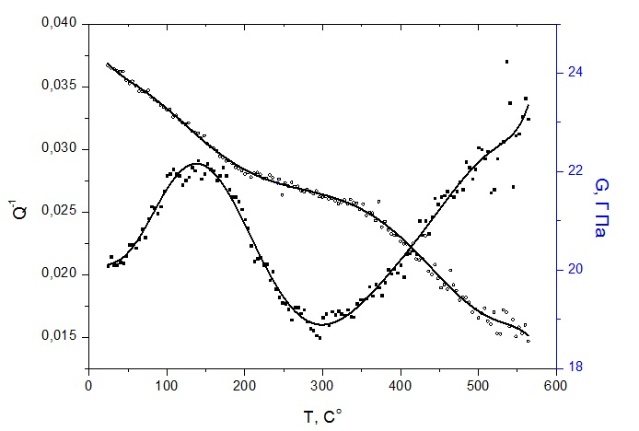

Рис.1. Температурные зависимости внутреннего трения Q⁻¹ и модуля сдвига G для образца Х-ориентации монокристалла НВТ

Наличие широкого пика Q⁻¹ и характерного изменения G свидетельствуют о размытом ФП вблизи 200 ⁰С, связанным с одной из скалывающих компонент х₅ или х₆ тензора деформаций, возникающих при кручении образца. Отсутствие пика Q⁻¹ вблизи 520 ⁰С обусловлено тем, что внешнее крутильное напряжение не сопряжено с параметром сегнетоэластического ФП. Однако его существование подтверждается измерениями ДТА. Таким образом, из наших измерений следует, что в НВТ имеют место два ФП: сегнетоэлектрический при 200 ⁰С и сегнетоэластический при 520 ⁰С.

Литература
- Sakata K., Masuda Y. Ferroelectrics, 1974 ,v.7, N1-4, p.347-349.
- Суханич Я., Птак В.С. // Известия РАН, 1991. Т.55, №3, стр. 555-558.

Поглощение Ультразвука в Биополимерах

В.В. Постников, Н.С. Камалова

Воронежская государственная лесотехническая академия, 394087, Россия
e-mail: vvpost@icmail.ru

Типичным представителем биополимерных систем является натуральная древесина. В модифицированном виде этот биокомпозит широко используется в промышленности в качестве заменителя целого ряда конструкционных материалов [1]. В упрощенном виде древесину можно моделировать как пористую структуру, стенки которой состоят из частично кристаллической целлюлозы и аморфного лигнина. Для успешного уплотнения древесины необходимо лигнин перевести из стеклообразного в вязкотекучее состояние. Как показали последние исследования, для этой цели можно использовать обработку образцов ультразвуком [2].
При обработке древесины ультразвуком возможны два механизма его поглощения. Во-первых, этот процесс может происходить за счет возникновения механического трения на границе ультразвукового датчика (наконечника) и поверхности образца: Если обозначить через F_{N} среднюю силу нормального давления ультразвукового наконечника на стенку ($F_{N}=p_{\text{max}}S/2$, где p_{max} - амплитуда давления ультразвука, S - площадь контакта), то мощность поглощенной энергии q₁ можно представить в виде [3]:
$q_{1}=2\text{πμ}{\text{fF}}_{N}δ=2\text{πμ}{\text{fp}}_{\text{max}}Sδ/2={μP}_{у}δ/ξ_{0}$. (1)
Здесь P_{у} – мощность ультразвука, δ - величина проскальзывания наконечника по поверхности образца, μ – коэффициент трения, f – частота, ξ₀ - амплитуда колебаний ультразвука. Логично предположить, что вся эта мощность (в силу диссипативности силы трения) идет на нагревание приконтактной области образца. Для оценки величины изменения его температуры (обозначим ее через Θ) можно воспользоваться уравнением теплового баланса: $CΘ=q_{1}t$ (здесь С – теплоемкость древесины), из которого следует
$Θ=q_{1}t/C$. (2)
Вторым механизмом поглощения является вязкое трение в средней части клеточной стенки (которая, как известно [1], состоит, в основном, из лигнина), мощность которого можно оценить как [3]:
$q_{2}=\left\langle ε∂F_{\text{вяз}}/∂t\right\rangle =πfηS2πfξ_{0}ε/2l=πfηP_{у}ε/p_{\text{max}}l$, (3)
а изменение температуры внутри стенки при обработке образца ультразвуком будет определяться выражением:
$Θ=q_{2}t/C_{л}$. (4)
Здесь С_{л} – теплоемкость лигнина, ε - относительная деформация, η – коэффициент вязкости лигнина, l – толщина стенки.
Эти соотношения показывают неоднородность распределения температуры внутри образца при обработке последнего ультразвуком. Дальнейшие исследования позволят прогнозировать оптимальные технологические параметры режимов ультразвуковой обработки для успешного пластифицирования образцов древесины перед модифицированием.

Список литературы.
- Шамаев В.А. Химико-механическое модифицирование древесины. Воронеж: ВГЛТА. – 2003. – 260 с.
- Постников В.В., Камалова Н.С., Кальченко С.В. Ультразвуковая пластификация лигнина в модифицированной древесине / Известия РАН. – Серия физическая. – 2010. – Том 74. – №9. – С. 1375-1376.
Физические основы ультразвуковой технологии / Сб. под ред. Розенберга Л.Д. – М: Наука. – 1970. – 688с

Dielectric Properties of SrTiO₃ Doped with Pr

I.A. Sluchinskaya, A.I. Lebedev

Physics Dept., Moscow State University, Moscow, 119991, Russia
e-mail: irinasluch@nm.ru

Recently, a dielectric anomaly in Pr-doped SrTiO₃ ceramics was revealed at ~500 K and was attributed to the ferroelectric phase transition in this material [1]. Subsequent investigations led to contradictory results both on the structure of the solid solution and the nature of the dielectric anomaly [2]. The x-ray diffraction studies [3,4] showed that the temperature of the structural phase transition to the I4/mcm phase increases with increasing Pr concentration, and at x ≥ 0.05 the structure is tetragonal at 300 K. X-ray absorption fine structure (XAFS) studies [4] revealed that Pr ions are predominantly in the 3+ oxidation state and occupy the Sr sites. No evidences of the off-centering of Pr atoms and of the oxygen octahedra distortion were revealed, and therefore no structural signs of the ferroelectric phase transition was found in this material. Therefore, the nature of the dielectric anomaly requires further studies.
In this work, the dielectric properties of an incipient ferroelectric SrTiO₃ doped with Pr were studied. Samples of a nominal composition of (Sr_{1–x}Pr_{x})TiO₃ with x = 0.025–0.30 and different deviation from stoichiometry were prepared by the solid-phase synthesis and annealed at temperatures of 1100–1500 °C. The complex dielectric constant was measured using an impedance analyzer E7-2 at a frequency of 1 kHz in the temperature range 77–620 K.
In all investigated samples, the dielectric anomaly was observed at a temperature of ~550 K and its maximum was nearly independent of the Pr concentration. The measurements at temperatures below 300 K revealed that the dielectric constant increases as the temperature is lowered. The temperature dependence of the inverse dielectric constant approximately followed the Curie-Weiss law. The extrapolated Curie temperature varied from ≈+40 K in pure SrTiO₃ to ≈ –500 K in the sample with x ≈ 0.15. Thus, the doping SrTiO₃ with Pr does not result in the appearance of the ferroelectric phase. On the contrary, the Pr doping suppresses the ferroelectric instability in SrTiO₃. This conclusion is consistent with results of [5], which found the hardening of the soft mode with increasing the impurity concentration in Pr-doped SrTiO₃. In our opinion, the appearance of the dielectric anomaly above 300 K can be explained by the conductivity associated either with the ionization of the Pr donor levels (Pr³⁺ → Pr⁴⁺ + e–) or with a thermally-assisted hopping of electrons between Pr atoms which can exist in two different oxidation states (Pr³ ⁺ and Pr⁴ ⁺).

References
1. A. Durán, E. Martínez, J. A. Díaz, J. M. Siqueiros. J. Appl. Phys., 97, 104109 (2005).
2. A. Duran, F.Morales, L.Fuentes, J. M. Siqueiros. J. Phys.: Condens. Matter, 20 085219 (2008).
3. R. Ranjan, R. Hackl, A. Chandra. Phys. Rev. В 79, 144122 (2009).
4. I.A. Sluchinskaya, A.I. Lebedev, A. Erko. Phys. Solid State, 54, 975 (2012) [Fizika Tverdogo Tela 54, 917 (2012)].
5.R. Ranjan, R. Hackl, A. Chandra, E. Schmidbauer, D. Trots, H. Boysen. Phys. Rev. B 76, 224109 (2007).

Трансформация Геликоидальной Спиновой Структуры в Многослойной Системе Ho/Y

В. Тарнавич¹, С.Григорьев¹, D. Lott², S. Mattauch³
¹ Петербургский институт ядерной физики, 188300 Гатчина, Россия
²Helmholtz Zentrum Geesthacht, 21502 Geesthacht, Germany
³Jülich Centre for Neutron Science (JCNS), 85747 Garching, Germany

Известно, что киральность геликоидальных магнитных структур кристаллов, не имеющих кристаллографического центра инверсии, определяется знаком антисимметричного обменного взаимодействия Дзялошинского-Мориа [1,2]. В тоже время в материалах с наличием кристаллографического центра инверсии право и левосторонние спирали энергетически эквивалентны. Подобное вырождение может быть снято приложением внешней силы, такой как электрическое поле, деформация кручения и т.д. Так в суперструктуре Dy/Y (где Dy является планарным магнетиком со спиральной структурой) была обнаружена невырожденная киральность, наведённая магнитным полем. Как было показано, магнитное поле, приложенное в плоскости образца ниже T_{N} способно изменить относительное соотношение между левыми и правыми спиралями [3].
В данной работе проводилось исследование магнитной спиральной структуры Ho/Y с помощью рассеяния поляризованных нейтронов. В данном случае Y можно рассматривать как структурно идентичный немагнитный аналог Ho. Эксперименты проводились на рефлектометре MARIA (реактор FRM-2, JCNS) с использованием поляризованных нейтронов. Для формирования магнитной спиральной структуры с неодинаковой заселенностью левых и правых спиральных доменов образец охлаждался в поле до температур T ниже T_{N}. Среднее значение киральности, пропорциональное разности числа левых и правых спиралей, измеряли как поляризационно-зависимую часть магнитного рассеяния нейтронов. Полученные результаты демонстрируют яркую зависимость параметра киральности как от температурной и магнитно-полевой предысторий, так в значительной степени и от толщины слоёв магнитного и немагнитного слоёв. Изменение средних значений спиновой киральности интерпретировали в рамках гипотезы взаимодействия Д-М, которое появляется на магнитно-немагнитных интерфейсах многослойных систем.

References
[1] I. E. Dzyaloshinskii, Zh. Exp. Teor. Fiz. 46, 1420 (1964) [Sov. Phys. JETP 19 , 960 (1964)]
[2] P. Bak and M. Jensen, J. Phys. C 13 , L881 (1980)
[3] S. V. Grigoriev et al., Phys.Rev. B 82, 195432 (2010)

Электрические Свойства Керамики Сa_{2.3}Bi_{0.7}Co₄O₉

Л.Н. Коротков, И.П. Чебанная. В.А. Макагонов

Воронежский государственный технический университет, Воронеж, Россия
e-mail: irasoln1989@yandex.ru

Поиск и разработка новых термоэлектрических материалов, эффективных при повышенных температурах, наряду с усовершенствованием и модификацией уже известных, является весьма важной технической и научной задачей. Больший практический интерес представляют слоистые кобальтиты натрия и кальция, характеризующиеся наибольшими значениями фактора мощности и термоэлектрической добротности при высоких температурах. Целью данной работы явилось получение и изучение электрофизических и термоэлектрических свойств твердых растворов кобальтитов кальция-висмута.
Образцы получали методом твердофазного синтеза по стандартной двухстадийной керамической технологии [1]. Были синтезированы следующие составы: Сa_{2.3}Bi_{0.7}Co₄O₉. Сa_{2,9}Bi_{0.1}Co₄O_{9,} Сa_{2,7}Bi_{0.3}Co₄O₉. Образцы были приготовлены путем спекания смеси оксидных порошков СaCO₃ , Bi₂O₃ , Co₃O₄, взятых в стехиометрическом соотношение. Синтез проводился при температуре 910 ºС в течение 5 часов в воздушной среде, а спекание при 1000 ºС в течение 4 часов, с последующим охлаждением в режиме выключенной печи.
В ходе эксперимента были проведены измерения электрической проводимости (σ) и коэффициента термоЭДС (S) в диапазоне температур 100-300 K.
Эксперимент выявил коррелированное поведение кривых σ(Т) и S(Т). Причем обе зависимости проходят через минимум в окрестностях комнатной температуры T_{r} (рис.). Анариз полученных результатов показал, что ниже T_{r} электропроводность преимущественно обусловлена прыжковым механизмом переноса заряда. Выше T_{r} наблюдается уменьшение σ с температурой. Полученные результаты обсуждаются.

Рис. Зависимости термоЭДС и удельной проводимости (σ) от обратной температуры для материала Сa_{2.3}Bi_{0.7}Co₄O₉.

Литература
1. Глозман И.А. Пьезокерамика. М: Энергия, 1972.288 с.

Internal friction in single-crystal Rb₃H(SO₄)₂

S.A. Gridnev, A.A. Kamynin. and V.A. Leonov
Voronezh State Technical University, Voronezh, 394026, Russia

The great interest to the study of crystals with hydrogen bonds is related with the problem of structural phase transitions and transitions between phases with ordered and disordered hydrogen bonds, due to symmetry change [1]. Although attention to these objects was paid a long time but there are some discrepancy in the obtained results ($\text{С2/с}→$cubic [1] or $\text{A2/a}→R\overset{}{3}m$ [2] symmetry point group change for Rb₃H(SO₄)₂). Thus, the purpose of this work was to study different physical properties of ferroelastic-superionic single crystal Rb₃H(SO₄)₂. For measurements the rectangular 3х2х0.5 mm samples were cut, which further were subjected to grinding and application of silver electrodes. Acoustic properties were studied using a composite bar technique. As a resonator part PZT plate (9x5x2 mm) was used, which long edge glued to Rb₃H(SO₄)₂ plate by epoxy. Figure 1 and figure 2 show data of dielectric and electrical measurements. One can see that features in the temperature dependences of dielectric loss tangent, capacitance and resistance occur at the same temperature. In the capacity maximum region the activation energy of resistivity varies from 0.6 eV to 1.3 eV. Figure 3 represents the temperature dependence of the internal friction, which maximum coincides with that of the capacity and the fracture of the dielectric loss tangent. A smearing the internal friction peak, apparently, is explained by that it represents a superposition of two peaks at 375 K and at 420 K. It is seen in temperature dependences of capacity and a loss tangent (fig. 1), and also of resistance (fig. 2) more obviously. The obtained data allow considering that near 425 K the structural phase transition takes place. This is in a good agreement with the known literature data.
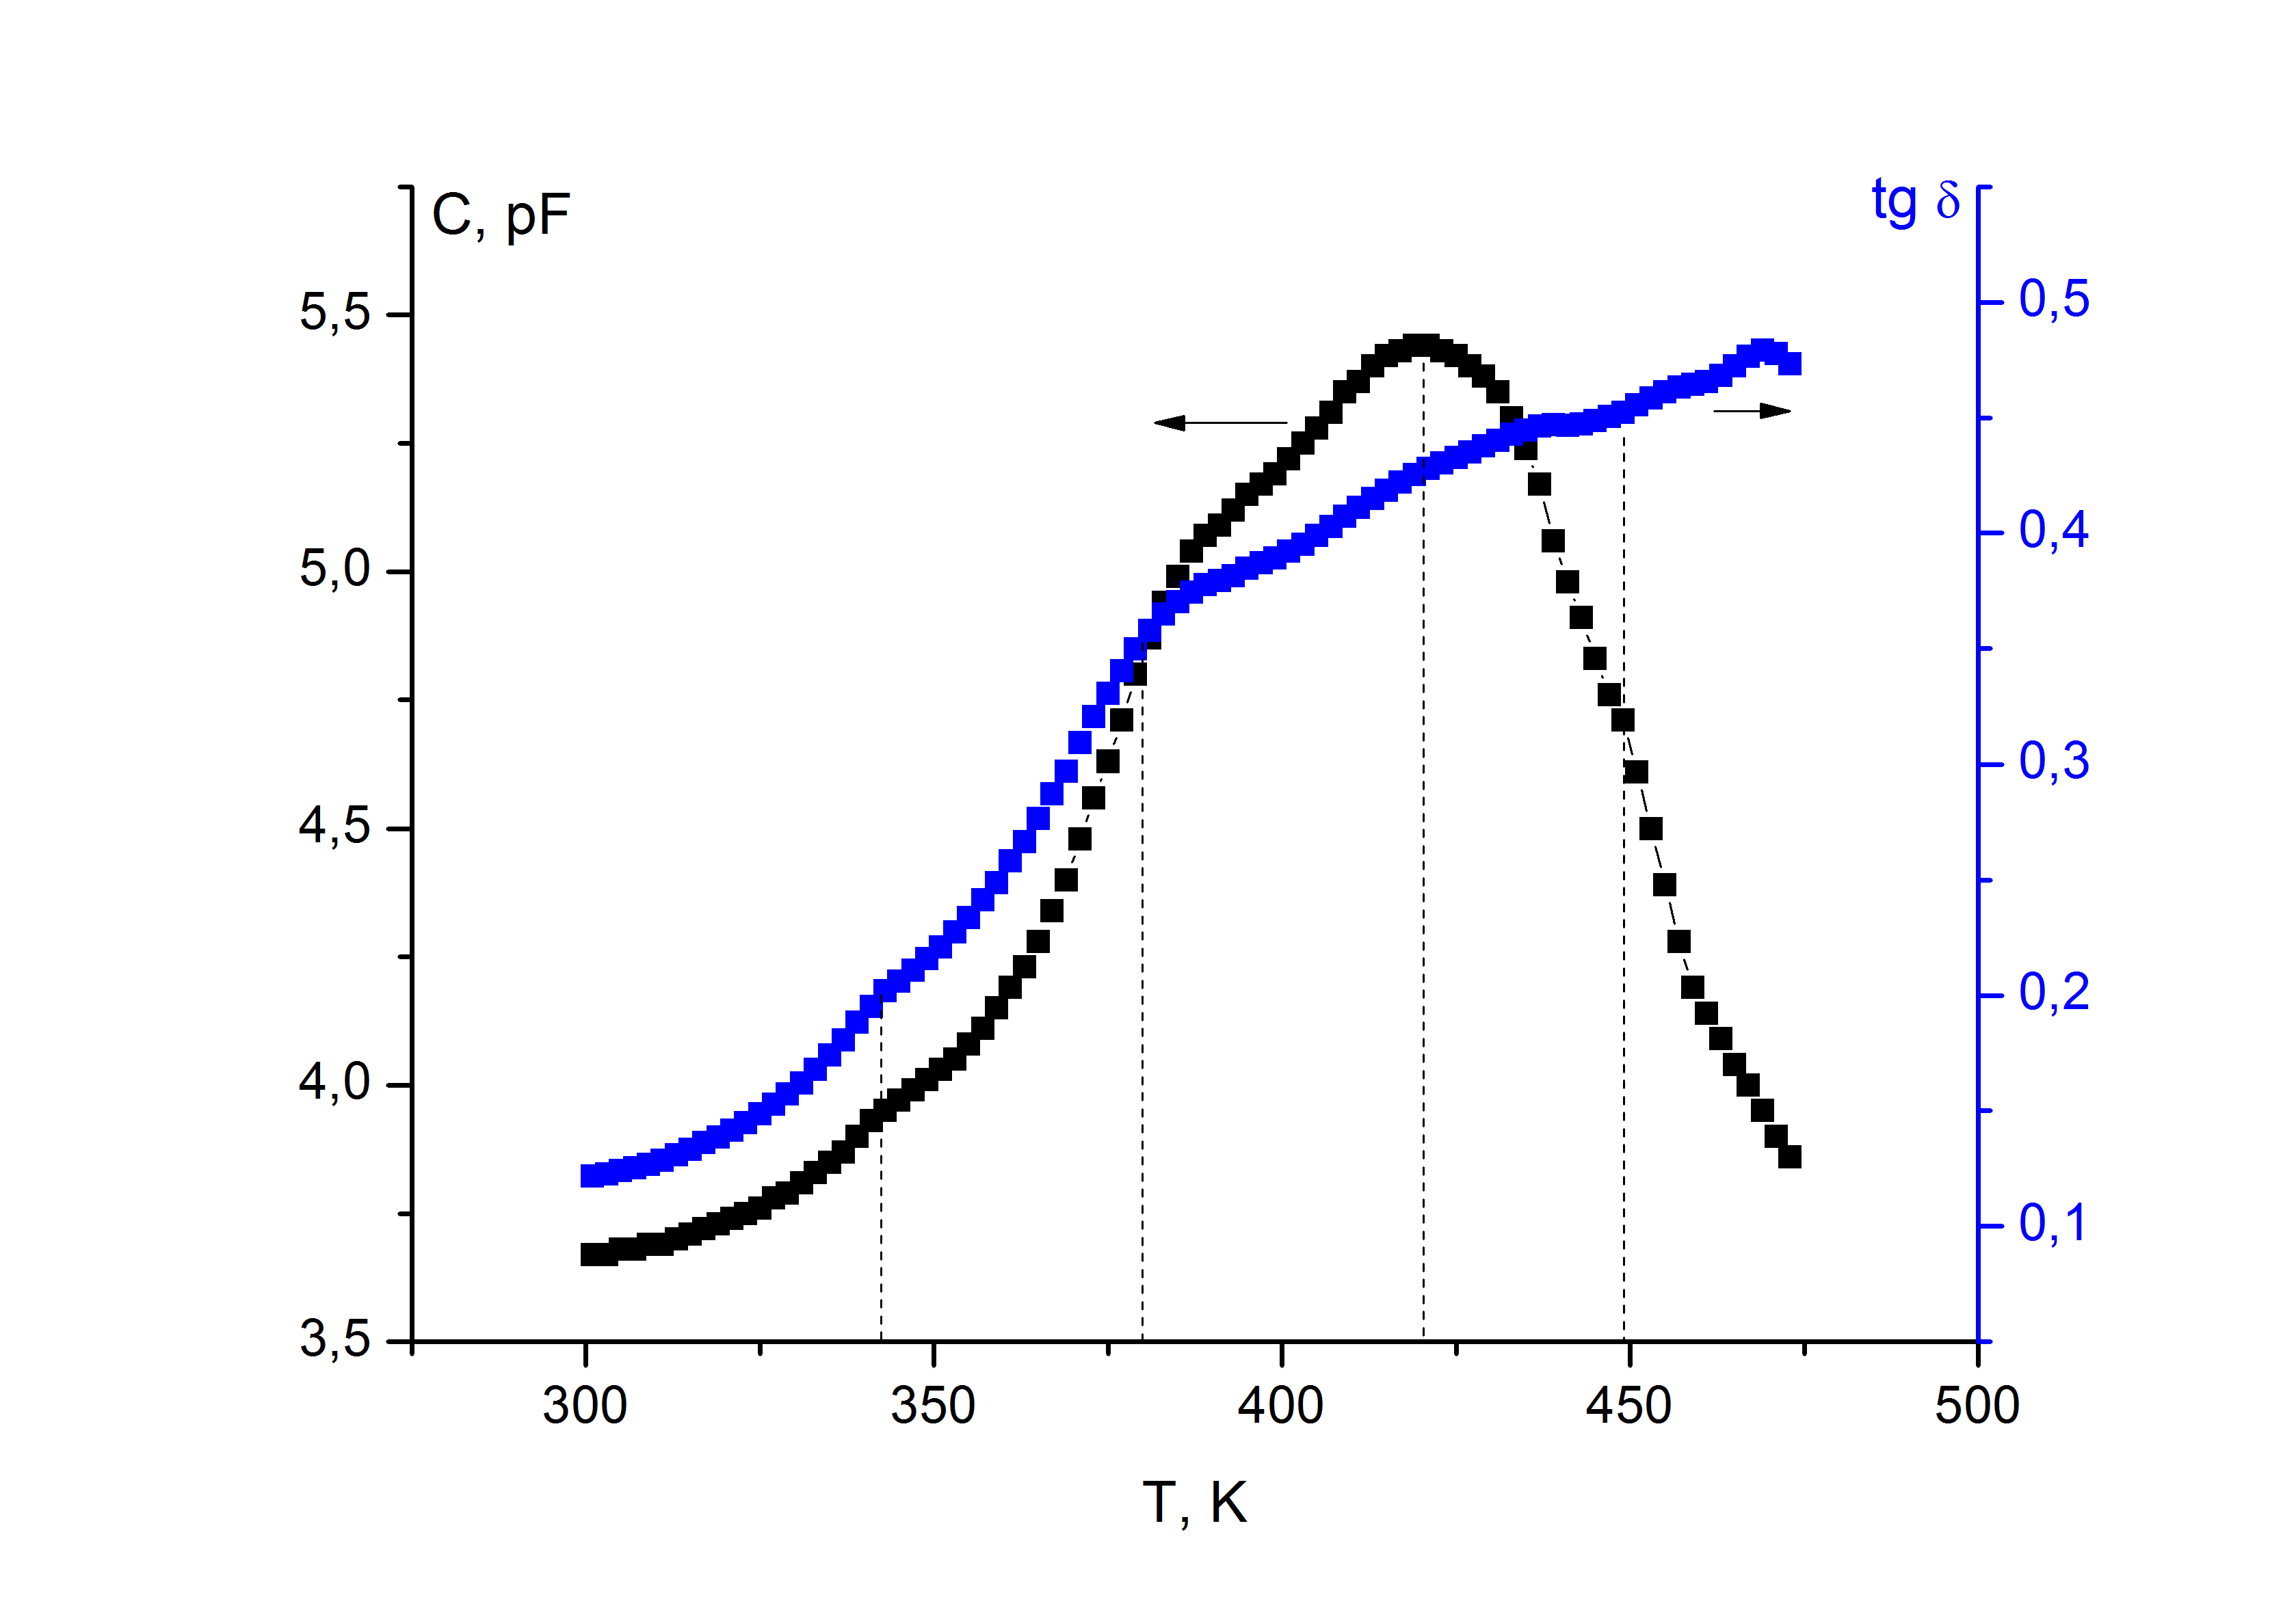
Рис. 1. Temperature dependences of capacity and dielectric tangent loss at the frequency 1 MHz.
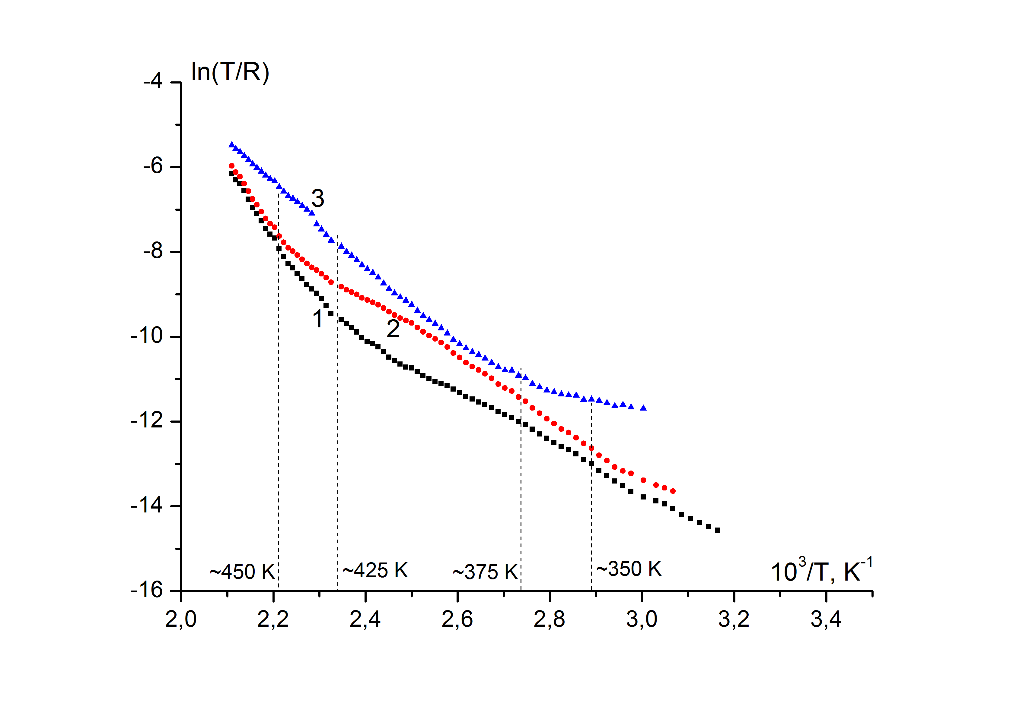
Рис. 2. Resistance temperature dependences at the frequencies: 1-25 Hz, 2-2 kHz, 3-100 kHz.
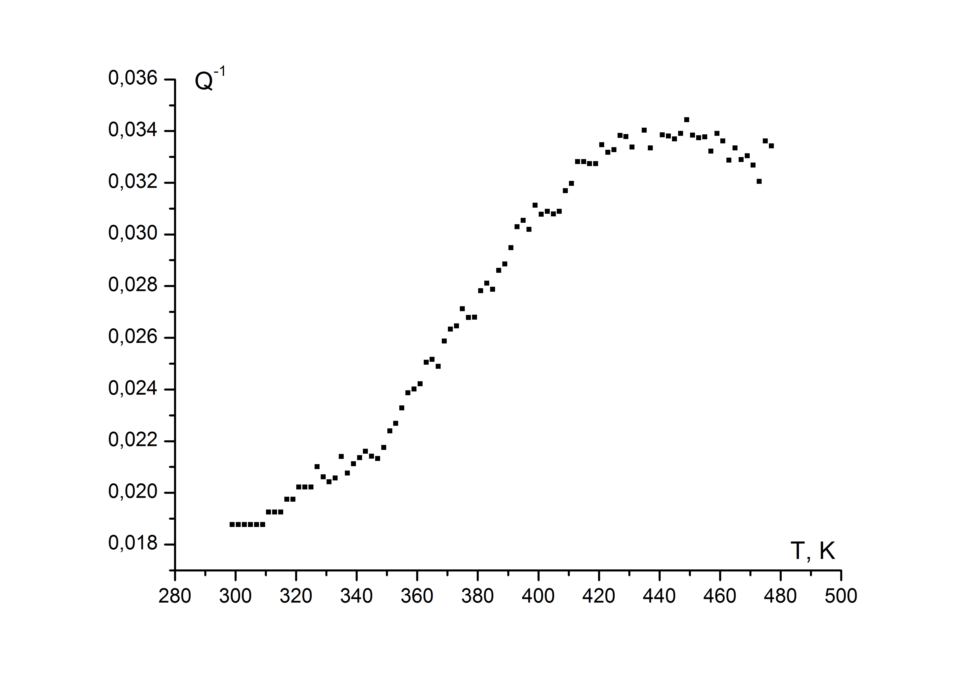
Fig. 3. Temperature dependence of internal friction
at the frequency ~207 kHz.

References
[1] A. I. Baranov // Crystallography reports. 2003. V.48. N 6. P. 1012.
[2] M. Fukai, A. Inaba, T. Matsuo, H. Suga // Solid State Communications. 1993. V. 87. N 10. P. 939.

Оптические Спектры Поглощения Монокристаллов
(1-x)PbMg_{1/3}Nb_{2/3}O₃ – xPbTiO₃ (0 ≤ x ≤ 0.3)

Т.П. Мясникова, И.П. Раевский, С.И. Раевская

Южный федеральный университет,
344090 Ростов-на-Дону, Россия

В работе Вихнина и др. [1] предложена модель полярных кластеров в сегнетоэлектрических релаксорах типа PMN, основанная на образовании состояний с переносом заряда и появлении электронных и дырочных поляронов в химически флуктуирующих кластерах, обусловленных компенсацией зарядов.
В настоящей работе в спектрах поглощения монокристаллов $(1−x)\text{PbMg}$${}_{1/3}{\text{Nb}}_{2/3}O_{3}−\text{xPbTiO}$${}_{3}(0≤x≤0\text{.}3)$ в видимой области спектра обнаружены полосы с максимумами 400-410 нм (3.1 эВ), относящиеся к вибронному экситону с переносом заряда, так как край поглощения лежит в ультрафиолетовой области (3.4 эВ), наблюдалась сильная температурная зависимость этих полос и зелёная люминесценция. Обнаружены изменения параметров правила Урбаха оптических спектров поглощения исследованных монокристаллов в области 40-70 и 100-120${}^{о}С$, соответствующих фазовым переходам.
В ближней ИК-области наблюдались полосы поглощения в области 10300 см${}^{−1}$(1.3 эВ) предположительно обусловленные поляронами. Температурное поведение этих полос и проводимости позволяет предположить, что происходит переход от состояния поляронов малого радиуса для PMN (x=0) к поляронам большого радиуса для ${\text{PbTiO}}_{3}(x=1)$.
Таким образом, настоящая работа является подтверждением модели полярных кластеров.

References
1.V.S.Vikhnin, R. Blink, R. Pirc, S.E. Kapphan, I.L. Kislova, P.A. Markovin, Ferroelectrics, 268, 257 (2002).

Сопоставление Оптических Спектров Скандониобата
и Скандотанталата Свинца

Т.П. Мясникова, К.Г. Абдулвахидов, А.Э. Мясникова

Южный федеральный университет
344090 Ростов-на-Дону, Россия

Среди большого класса релаксорных материалов особое место занимают соединения скандотанталата свинца - ${\text{PbSc}}_{0\text{.}5}{\text{Ta}}_{0\text{.}5}O_{3}$ (PST) и скандониобата свинца - ${\text{PbSc}}_{0\text{.}5}{\text{Nb}}_{0\text{.}5}O_{3}$ (PSN). В отличие от классического релаксора магнониобата свинца – PMN и ему подобных сегнетоэлектрических релаксоров, которые не обнаруживают сегнетоэлектрического поведения в отсутствии электрического поля, эти соединения даже в отсутствие поля, помимо возникновения в некотором интервале температур релаксорных свойств, обнаруживают спонтанный фазовый переход (ФП) в сегнетоэлектрическую фазу.
Несмотря на присутствие ряда общих черт в поведении соединений PST и PSN, имеется существенная разница между ними. Температура сегнетоэлектрического ФП упорядоченных кристаллов PST ($Т≈{\text{40}}^{о}С$) выше, чем разупорядоченных PST ($Т≈0^{о}С$), в то время как в кристаллах PSN наблюдается противоположная ситуация.
В видимой области спектра поглощения PSN и PST наблюдались похожие по форме полосы с длиной волны в максимуме 405-410 нм, положение которых сильно зависит от температуры. Эти полосы могут быть отнесены к вибронному экситону с переносом заряда, так как край поглощения PSN и PST лежит в ультрафиолетовой области, положение этих полос сильно зависит от температуры и для обоих веществ наблюдалась зелёная люминесценция. Сила экситон-фононного взаимодействия, определённая по спектрам поглощения, у PST примерно в пять раз больше, чем у PSN. Наличие минимумов параметра правила Урбаха у PSN при температурах 70, 90 и 120${}^{о}$С и у PST при 30 и 120${}^{о}$С показывает возможное существование ФП при этих температурах.
Спектры люминесценции PSN и PST имеют полосы с близкими значениями длин волн максимумов (506 нм и 491 нм соответственно). Сила экситон-фононного взаимодействия, рассчитанная по спектрам люминесценции, оказывается примерно одинаковой для двух веществ: 1.39 ${\text{эВ}}/{\overset{o}{A}}$ у PSN и 1.31 ${\text{эВ}}/{\overset{o}{A}}$ у PST при комнатной температуре. Минимумы степени поляризации полос люминесценции соответствуют температурам ФП веществ (у PSN – 90 и 120${}^{о}$С, а у PST – 30 ${}^{о}$C).
В ближней ИК-области у PSN наблюдалась полоса поглощения с частотой максимума 9700 см${}^{−1}$ (1.2 эВ) и полушириной 1.4 эВ, возможно обусловленная наличием поляронов малого радиуса с энергией активации 0.6 эВ. В спектре поглощения PSTнаблюдалась полоса с частотой максимума 13400 см${}^{−1}$(1.66 эВ) и полушириной 0.62 эВ, обусловленная поляроном большого радиуса с энергией связи 0.395 эВ.

Диэлектрическая Релаксация В Кристалле Несобственного Сегнетоэлектрика–Сегнетоэластика Молибдата Тербия

С.А. Гриднев, С. Е. Трухачев, В.А. Леонов

Воронежский государственный технический университет, Воронеж, Россия
e-mail: serge.truhachev@gmail.com

В настоящей работе исследована температурная зависимость tgδ в молибдате тербия Tb₂(MoO₄)₃ ниже точки Кюри при различных частотах. Измерения tgδ проводились мостовым методом на частотах 1 и 2 кГц при амплитуде измерительного напряжения 1 В. Температура в измерительной ячейке в азотном криостате с изменялась со скоростью 2 К/с. Образец представлял собой прямоугольный брусок размером 4х3х2 мм³ с серебряными электродами, нанесенными перпендикулярно полярной оси Z.
Результаты эксперимента представлены на рис. 1. В интервале температур 200-380 К на зависимости tgδ(T) обнаружен пик, который смещается вверх по шкале температур при увеличении частоты, т.е. пик диэлектрических потерь имеет релаксационный характер.
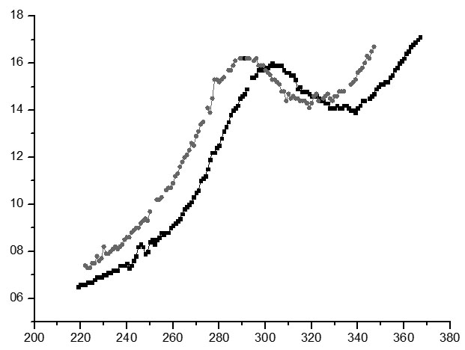
tgδ, 10⁻⁴
1
2
T, K

Рис. 1. Температурные зависимости tgδ кристалла молибдата тербия при разных частотах измерительного поля: 1 – 1, 2 – 2 кГц.

В предположении о дебаевском характере релаксационного процесса найдены значения энергии активации E_{a} и предэкспоненциального множителя τ₀, которые составили ~0.4 эВ и 2.5⋅10 ^{–11} с соответственно.
Для объяснения природы пика была использована модель электростатического взаимодействия доменных стенок с адсорбированными точечными дефектами [1,2].

Литература
1. Gridnev S.A. // Ferroelectrics. 2002. V. 266. P. 171.
2. Гриднев С.А., Дрождин К.С., Шмыков В.В. // Кристаллография, 1997, том 42, № 6, с. 1135-1136.

Author Index

A
Abalmassov V.A. 14
Abubakarov A.G. 62
Akhmedov I.R. 22
Akimov S.V. 46
Aliev A.R. 22
Amira Y. 71
Amirov A.A. 43
Andryushina I.N. 23, 62
Andryushin K.P. 23, 62, 137
Antonova M. 86
Atuchin V.V. 50, 63, 64, 65

B
Balashova E.V. 90
Barmin Yu.V. 127
Blazhevich A.V. 39, 40
Bocharov A. 77
Bocharov A.I. 127
Bogomolov A.A. 100
Bokov A.A. 130
Bondarev A.V. 127
Borisenko S.A. 112
Bormanis K. 86
Bowen C. R. 117
Budai J. D. 10
Bunina O.A. 81

C
Chernaya T.S. 56
Chernobabov A.I. 34
Chezganov D.S. 113
Choukri E. 71

D
Danshina E.P. 47, 74
Dec J. 115
J-L. Dellis 81
Dezhin V.V. 132
Dmitricheva E.V. 24
Dolbinina V.V. 56, 120
Dudkina S.I. 137
Dudnik E.F. 46
Dvornikov V. 103
Dyadkina E.A. 40

E
Egorova A.E. 54
Elamraoui Y. 71
Eremkin V.V. 58
Erko A. 55, 59, 60

F
Fedoseev A.I. 120
Filipič C. 5

G
Gerashchenko N. V. 75
Gagou Y. 71
Gomes M. J. M 100
Gorbatenko S.A. 76
Gorbatenko V.V. 76
Goreshnik E. 5
Gorshkov A.G. 100
Grebenev V.V. 56
Gribe Z.H. 42
Gridnev S.A. 36, 42 , 75,79,
98,157
Grigorjev E.S. 36
Guranych P.P. 121
Gushcin A.V. 24

H
Hoffman J.-U. 40

I
Isaenko L.I. 63, 65, 133
Ivanov I. N. 10
Ivanov O.N. 47, 74
Ivanov V.A. 24
Ivanov V.V. 112, 145
Ievlev A.V. 115
Ivleva L.I. 115

K
Kakagasanov M.G. 22
Kalgin A.V. 36, 42
Kalinin S. V. 10
Kalinin Yu.E. 36
Kamenshchikov M.V. 99
Kamilov I.K. 43
Kamynin A. A. 75, 79,157
Kesler V.G. 65
Khmara A. 77, 78
Khodorov A. 100
Kidyarov B.I. 48, 50, 63, 64, 65,
126
Kolmakov A. 10
Korotkov L. 11, 77, 78, 103
Korotkova T. 103
Kosobokov M.S. 114
Kovalevskii V.I. 38
Kozin R.V. 115
Krichevtsov B.B. 90
Krivoruchko V. 117
Krylov A.S. 18, 25
Krylova S.N. 18, 25
Kvasov A.A. 28
Kubrin S.P. 39, 40
Kudrjash V.I. 76
Kupriyanov M.F. 88
Kuznetsov D.K. 114, 115

L
Labutina, M.L. 55
Lebedev A.I. 8, 19, 59, 60, 154
Lemanov V.V. 90
Leonov V.A. 79,157
Levitskii R. 11, 121, 147
Levstik A. 5
Likhovaya D. 77, 78
Lin Z.S. 65
Liu Hsiang-Lin 49
Lobov A.I. 114
Lott D. 155
Luk’yanchuk I. A. 10, 71
Lushnikov S.G. 120

M
Makarova I.P. 56
Maksimov A. V. 51, 69, 70
Maksimov E.G. 15
Maksimova O.G. 51, 69, 70
Malitskaya M.A. 38, 39, 58, 81
Markov Yu.F. 26, 28
Marychev M.O. 55
Matsko N.L. 15
Marssi M. E. 71
Mastropas Z.P. 16, 122
Mattauch S. 155
Mezzane D. 71
Miller A.I. 62, 137
Milovidova S.D. 151
Minasyan T.A. 130
Mingaliev E.A. 114, 115
Misyul S.V. 20
Moina A.P. 93, 131
Molokeev M.S. 20, 63, 65
Myasnikov E.N. 16, 122

N
Naberezhnov A.A. 40, 103
Nazarenko A.V. 88
Nebogatikov M.S. 113
Nechaev V.N. 31, 132
Nepochatenko V.A. 17
Neradovskiy M.M. 113
Nesterov A.E. 133

O
Olekhnovich N.M. 39
Onishchenko M.A. 151
Ozherelyev V.V. 127

P
Panchenko E.M. 81
Pankova G.A. 90
Parfenov A.A. 133
Pashkov V.M. 133
Pavelko A.A. 57, 80
Pavlenko A.V. 57, 80
Pavlov A.N. 130
Pavlov S.V. 27
Pecherskaya E.A. 134, 135
Pedko B.B. 145
Pelegov D.V. 115
Petrova T. O. 70
Pereira M. 100
Pilyuk E. 77, 78
Popov A.N. 151
Popravko N.G. 151
Portnov V.N. 54
Poushkarev A.V. 39
Pozdeev V.G. 17
Prasolov B.N. 77
Pronin I.P. 99
Prosandeev S.A. 38
Proutorov E.V. 51
Pugachev A. M. 38, 81

R
Raevski I.P. 38, 39, 40, 58, 81, 130
Raevskaya S.I. 38, 39, 40, 58, 81
Razumovskaya O.N. 43
Razumnaya A.G. 88
Reznichenko L.A. 23, 43, 57, 62, 80, 137
Rogazinskaya O.V. 151
Roginskii E.M. 26, 28
Rychkov I.M. 133
Rysiakiewicz-Pasek E. 103

S
Sadykov H.A. 62
Safonov I.N. 20
Salak A.N. 39
Semenchev A. F. 58
Seregin M.S. 40
Shevtsova S.I. 57, 58
Shikhova V.A. 115
Shilkina L.A. 23, 57, 80
Shur V.Ya. 6, 113, 114, 115
Sidorkin A.S. 151
Silva J. P. B. 100
Sitalo E. 77
Slivka A.G. 121
Sluchinskaya I.A. 8, 59, 60 Д.В. 154
Smirnov M.B. 8
Smotrakov V.G. 58
Solnyshkin A.V. 99
Somov N.V. 24, 55
Sorokov S. 11, 77, 78, 83
Strelcov E. 10
Stukova E.V. 102
Suzdalev D.V. 81

T
Taifi E. 71
Talanov M.V. 82, 84
Tarasova A.Yu. 133
Tavčar G. 5
R.M. Taziev 126
Tischler J. Z. 10
Titov V.V. 38, 81
Topolov V. Yu. 12, 117
Troitskaia I.B. 64
Trubitsyn M.P. 136
Trybula Z. 11
Tselev A. 10
Turchin P.P. 133
Turik A.V. 7, 34, 35
Tyurnina A.E. 115

V
Val’kova T. A. 51
Vdovych A. 11, 121, 147
Verbenko I.A. 43, 62, 137
Verin I.A. 56
Viskovatyh A.V. 31
Vlasenko M. 103
I.P. Volnyanskaya 136
Voronov V.N. 18, 25
Vtyurin A.N. 18. 25
Vyshatko N.P. 39

Z
Zadorin D.A. 59
Zachek I.R. 121, 147
Zakharchenko I.N. 38, 39, 58
Zakhvalinskii V. 77, 78
Žemva B. 5
Zhurkov S.A. 63, 65

Y
Ye Z.-G. 130
Yelisseyev A.P. 63, 65
Yurkov A.S. 116, 123
Yuzyuk Yu.I. 4

А
Абдулвахидов К.Г. 159
Авдеев М.А. 128, 129
Ан Фам Май 105
Андреев Е.В. 96, 97
Антропова Т. 106
Ахматов Х.С-Х. 29

Б
Бабкина И.В. 138
Бирюкова И.П. 148
Борманис К. 87
Богомолов А.А. 91, 94, 101
Богатин А.С. 96, 97
Богатина В.Н. 96, 97
Бурханов А.И. 85, 86, 87, 105

В
Воскобойник М.Ю. 41

Г
Габриельс К.С. 138
Голицына О.М. 92, 109, 141, 142, 143
Голосовский И. 106
Григорьев С. 155,
Григорян Г.С. 124
Гриднев С.А. 41, 61, 152,160
Голев И.М. 139, 140
Гриднев А.Е. 92
Гужаковская К.П. 85
Гуртовой В.Г. 144

Д
Даринский Б.М. 108
Дрождин С.Н. 92, 109, 141, 142, 143
Дешевых В.В. 146

Ж
Жилова О.В. 138

Е
Евсикова Н. Ю. 150

И
Ивлева Л.И. 85
Игнатова Ю.А. 96, 97

К
Калване А. 87
Калиенко М.С. 61, 139
Калинин Ю.Е. 104
Калядин О.В. 128
Камалова Н.С. 148, 150, 153
Карпенков Д.Ю. 91
Кашкаров В.М. 92
Квятковский О.Е. 9
Керимова Э.М. 144
Кибалин Ю. 106
Кислова И.Л. 91, 101
Ковригина С.А. 96, 97
Королева Е. 106
Коротких Н.И. 150
Коротков Л.Н. 68, 104, 146, 156
Короткова Т.Н. 68
Крузина Т.В. 152
Кульков В.Г. 146
Кумицкий Б.М. 148

Л
А.П.Лазарев 108
Леонов В.А 160
Лисицын В.И. 148

М
Р.М. Магомадов 29
В.А. Макагонов 149, 156
В.В. Макарова 61
Матвеев Н. Н. 150
Медников С.В. 86, 105
Милошенко В.Е. 128, 129
Морсаков И.М. 94, 101
Мустафеева С.Н. 144
Мясникова Т.П. 158,159
Мясникова А.Э. 159

Н
Нечаев В.Н. 30
Ньян Лыу Тхи 86

П
Панин Ю.В. 149
Плясцов С. 106
Полухин Д.В. 152
Поречная Н. 106
Постников В.В. 153
Пшенко О. 106

Р
Раевский И.П. 158
Раевская С.И. 158

C
Саврасова Н.А. 148
Саушкин В.В. 148
Сигов А.С. 108
Ситников А.В. 104, 138
Сливка А.Г. 82
Солнышкин А.В. 91, 94, 101
Солодуха А.М. 124

Т
Тарасов Д.П. 104, 146
Тарнавич В. 155
Толстых Н.А. 61
Толстых Н.А. 61
Трухачев С.Е. 160
Туманов И.Е. 87
Турик А.В. 96, 97
Тхыонг Н. Х. 105

У
Усков А. В. 139, 140

Х
Хаустов Р.В. 104

Ч
Чебанная И.П. 156
Чулакова В.О. 143

Ш
Шелег А.У. 144
Шевцова В.В. 144
Шуба А.В. 30
Шуста В.С. 82
Шуста О.В. 82
Шушлебин И.М. 129

Я
Янченко Л. И. 139, 140

Contents

Plenary Lectures 3
Session 1. Phase transitions, lattice dynamics and soft modes.
Oral presentation 13
Poster presentation 21
Session 2. Multiferroics.
Oral presentation 33
Poster presentation 37
Session 3. Structure, crystal growth and optical properties
Oral presentation 45
Poster presentation 53
Session 4. Disordered ferroelastics and related materials.
Oral presentation 67
Poster presentation 73
Session 5. Heterogenous systems and thin films.
Oral presentation 89
Poster Presentation 95
Session 6. Domains and domain boundaries and their dynamics.
Oral presentation 107
Poster Presentation 111
Session 7. Miscellaneous.
Oral presentation 119
Poster presentation 125

Author Index 161

