SUPPLEMENTARY MATERIAL TO THE PAPER

MgCo₂-D₂ and MgCoNi-D₂ systems synthesized at high pressures
and interaction mechanism during the HDDR processing

by

Chubin Wan ^{1, 2}, V.E. Antonov³, R.V. Denys ^{2,4}, V.I. Kulakov³ and V.A. Yartys ^{2, 5}

¹ University of Science and Technology Beijing, 100083, China

² Institute for Energy Technology, P.O. Box 40, Kjeller NO-2027, Norway

³ Institute of Solid State Physics, Russian Academy of Sciences,
Chernogolovka 142432, Russia

⁴ HYSTORSYS AS, P.O. Box 45, Kjeller NO-2027, Norway

⁵ Norwegian University of Science and Technology, Trondheim, Norway

Crystal structure data for compounds participating in the phase-structural transformations

Table S1
Crystal structure data for Co
T = 27 °C | Atoms | Sites | x/a | y/b | z/c | occ.
LT hcp Co  Space group | Co | 2c | 1/3 | 2/3 | 1/4 | 1
P6₃/mmc (No. 194)
a =0.2507 nm
c =0.4076 nm
T = 500 °C
HT fcc Co  Space group | Co | 4a | 0 | 0 | 0 | 1
Fm$\overline{3}$m (No. 225)
a=0.3560 nm

Table S2
Crystal structure data for Mg₂CoD₅
T = 27 °C | Atoms | Sites | x/a | y/b | z/c | occ.
LT β-Mg₂CoD₅  Space group | Mg1  Mg2 | 2a  2b | ¾  ¾ | ¼  ¼ | ½  0 | 1  1
P4/nmm (No. 129) | Co | 2c | ¼ | ¼ | 0.2470 | 1
a =0.4468 nm | D1 | 2c | ¼ | ¼ | 0.0028 | 1
c =0.6577 nm | D2 | 8j | 0.0121 | 0.0121 | 0.2743 | 1
HT γ-Mg₂CoD₅  T = 250 °C | Mg  Co | 8c  4a | ¼  0 | ¼  0 | ¼  0 | 1  1
Space group | D | 24e | 0.2368 | 0 | 0 | 0.83
Fm$\overline{3}$m (No. 225)
a =0.646 nm

Table S3
Crystal structure data for MgCo₂
T = 500 °C | Atoms | Sites | x/a | y/b | z/c | occ.
Space group | Mg | 4f | 1/3 | 2/3 | 0.5629 | 1
P6₃/mmc (No. 194) | Co1 | 2a | 0.1697 | 0.3394 | 1/4 | 1
a =0.4895 nm | Co2 | 6h | 0 | 0 | 0 | 1
c =0.7998 nm

Table S4
Crystal structure data for MgCo
T = 500 °C | Atoms | Sites | x/a | y/b | z/c | occ.
Space group | Mg | 48f | 0.4209 | 1/8 | 1/8 | 1
Fd$\overline{3}$m (No. 227) | Co1 | 16c | 0 | 0 | 0 | 1
a =1.1555 nm | Co2 | 32e | 0.2020 | 0.2020 | 0.2020 | 1

Table S5
Crystal structure data for Mg
T = 300 °C | Atoms | Sites | x/a | y/b | z/c | occ.
Space group | Mg | 2c | 1/3 | 2/3 | 1/4 | 1
P6₃/mmc (No. 194)
a =0.3233 nm
c =0.5252 nm

Table S6
Crystal structure data for MgO
T = 27°C | Atoms | Sites | x/a | y/b | z/c | occ.
Space group | Mg | 4a | 0 | 0 | 0 | 1
Fm$\overline{3}$m (No. 225) | O | 4b | 1/2 | 1/2 | 1/2 | 1
a =0.4212 nm

Rietveld refinements data for the MgCo₂D_{2.5} system at 27°C - 500°C

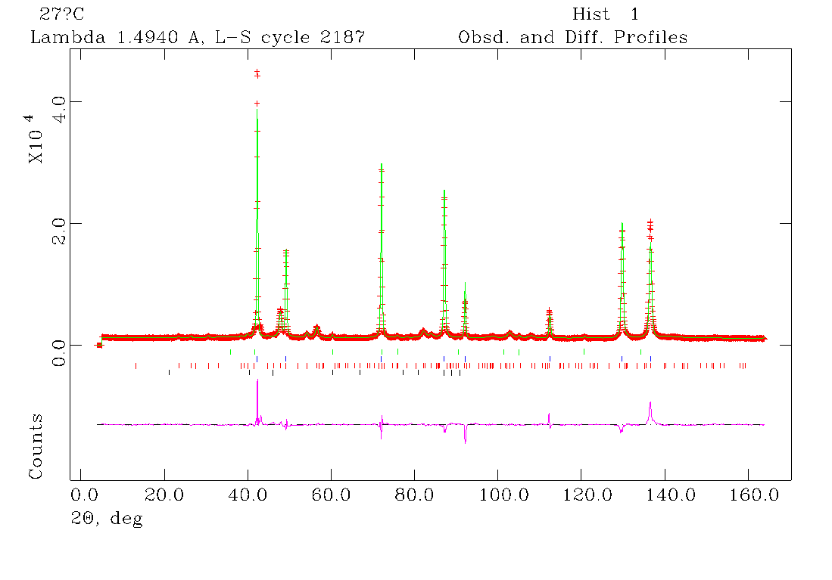
R_{wp}=7.0%, R_{p}=4.8%, χ²=9.1
Fig. S1. NPD pattern of the MgCo₂D_{2.5} system at 27°C.

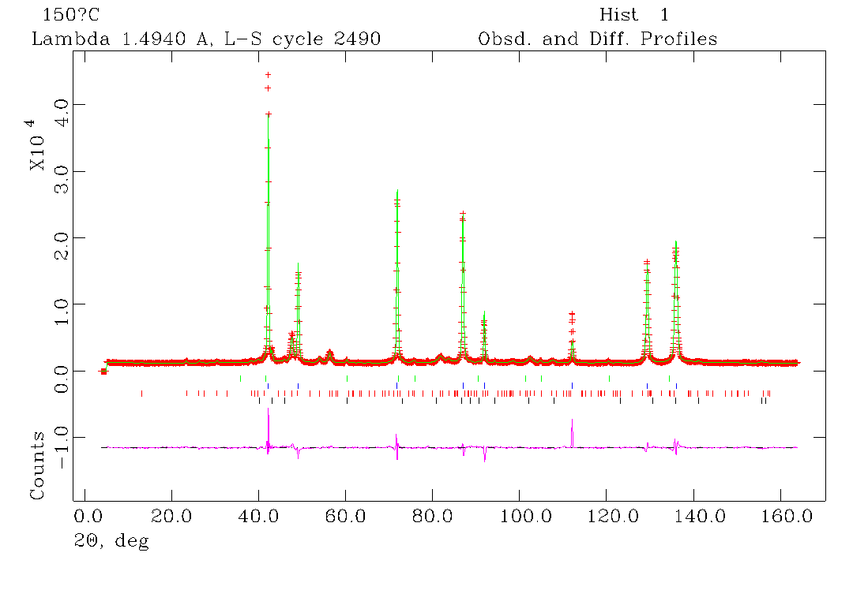
R_{wp}=7.5%, R_{p}=5.0%, χ²=8.6
Fig. S2. NPD pattern of the MgCo₂D_{2.5} system at 150°C.

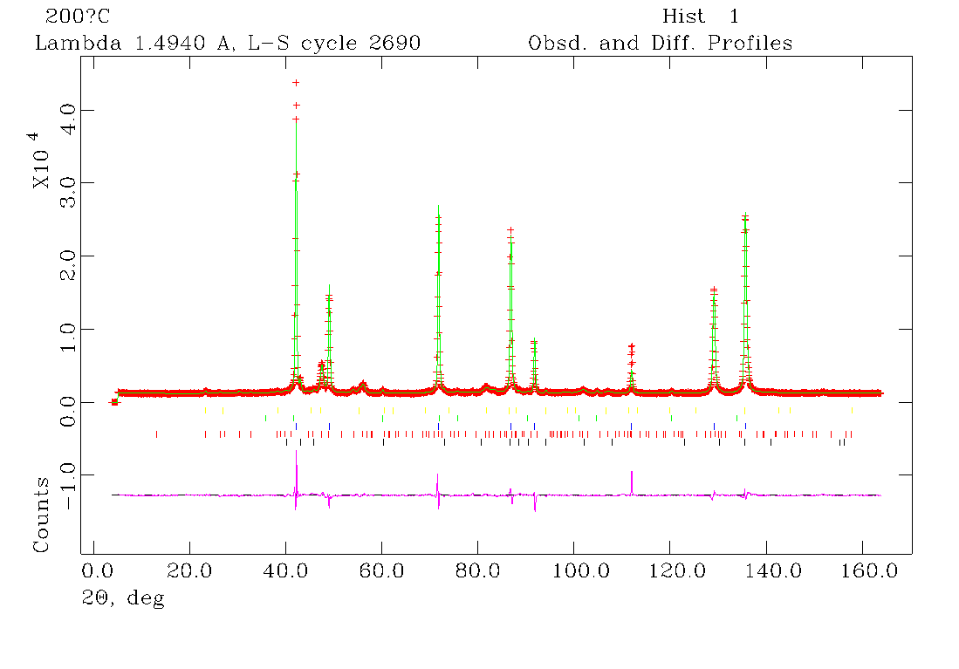
R_{wp}=6.9%, R_{p}=4.7%, χ²=7.6
Fig. S3. NPD pattern of the MgCo₂D_{2.5} system at 200°C.
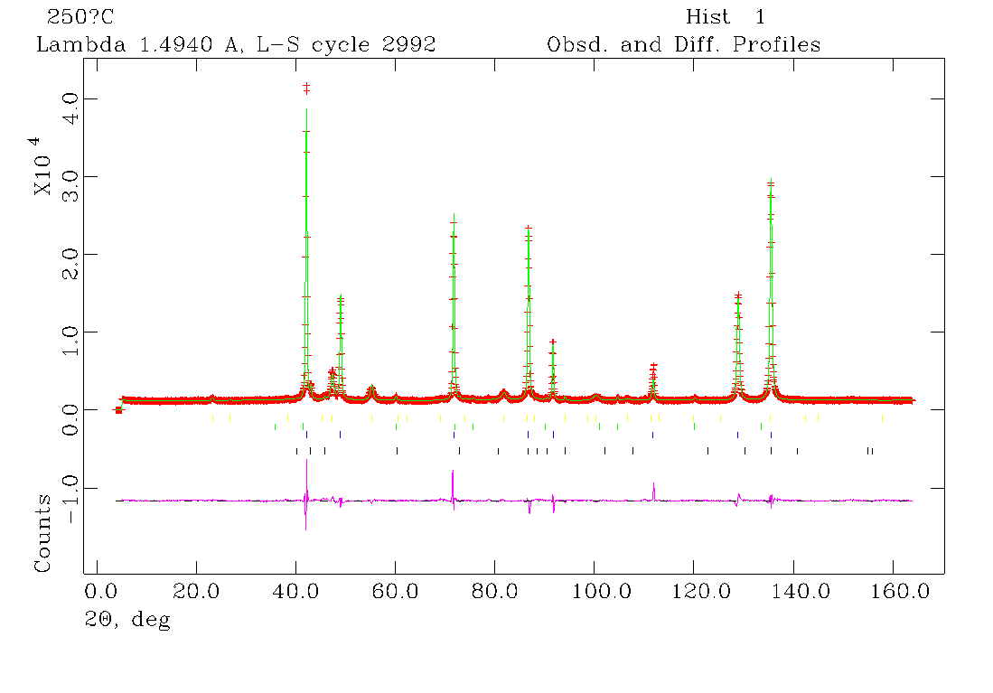
R_{wp}=6.7%, R_{p}=4.6%, χ²=6.8
Fig. S4. NPD pattern of the MgCo₂D_{2.5} system at 250°C.

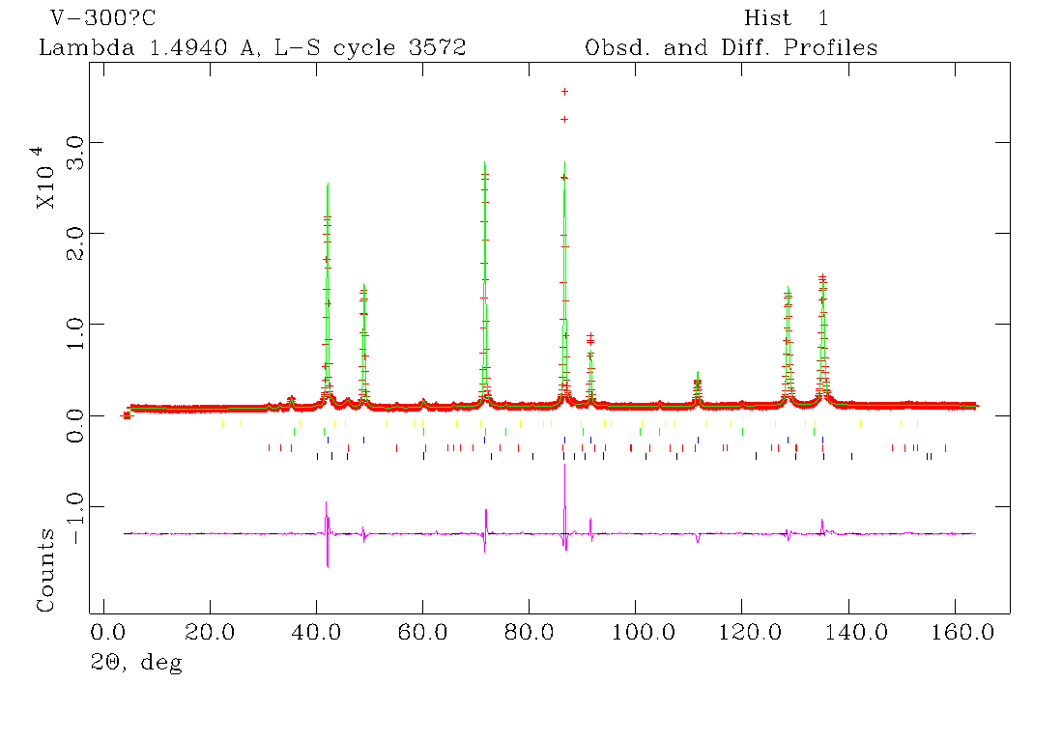
R_{wp}=8.0%, R_{p}=5.6%, χ²=12.2
Fig. S5. NPD pattern of the MgCo₂D_{2.5} system at 300°C.
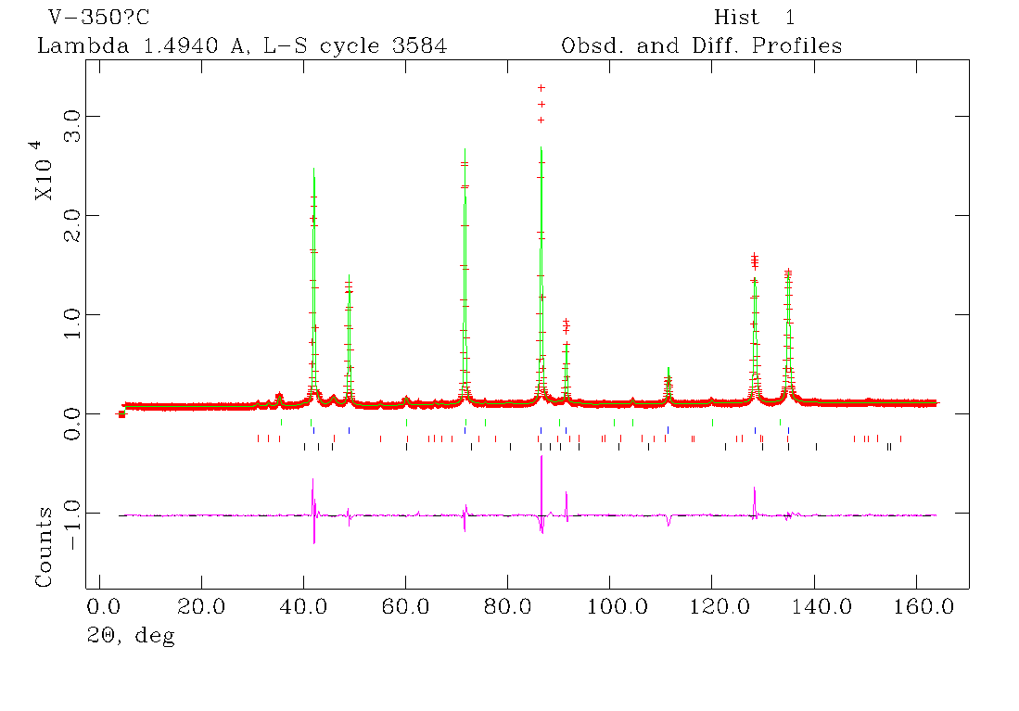
R_{wp}=8.0%, R_{p}=5.5%, χ²=10.2
Fig. S6. NPD pattern of the MgCo₂D_{2.5} system at 350°C in vacuum.
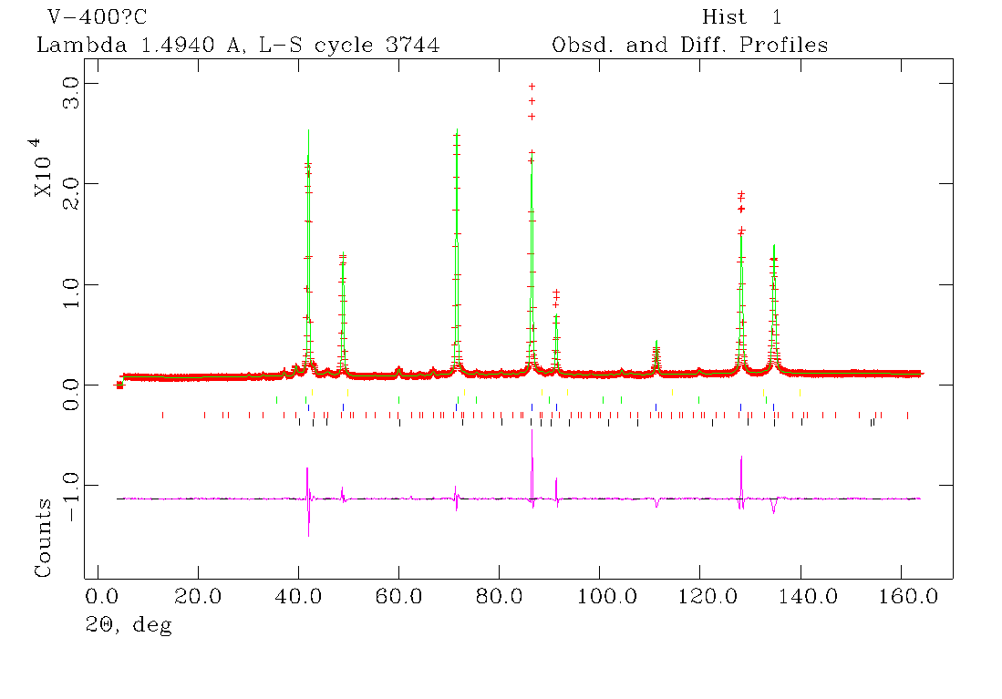
R_{wp}=8.1%, R_{p}=5.5%, χ²=10.3
Fig. S7. NPD pattern of the MgCo₂D_{2.5} system at 400°C in vacuum.

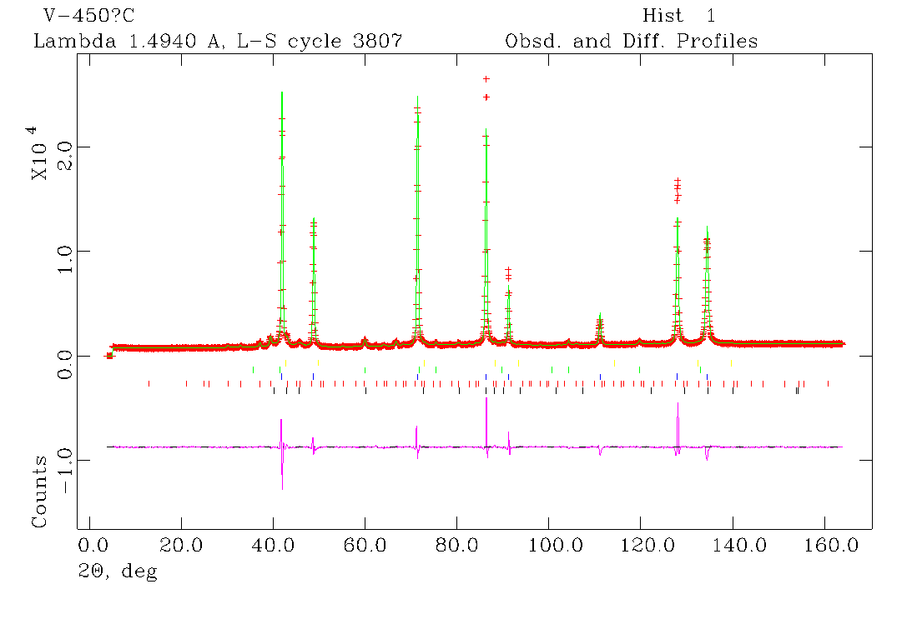
R_{wp}=7.4%, R_{p}=5.1%, χ²=8.8
Fig. S8. NPD pattern of the MgCo₂D_{2.5} system at 450°C in vacuum.

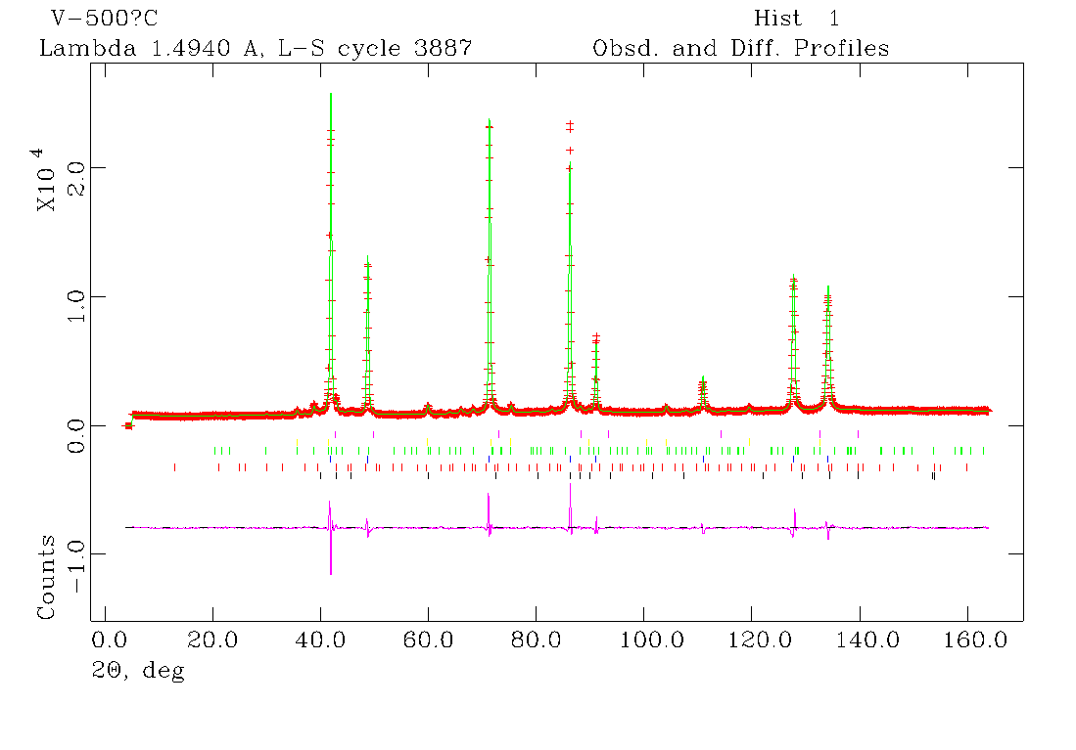
R_{wp}=5.9%, R_{p}=4.3%, χ²=5.5
Fig. S9. NPD pattern of the MgCo₂D_{2.5} system at 500°C in vacuum.

