SUPPLEMENTARY INFORMATION
HYDROGEN INDUCED STRUCTURAL PHASE TRANSFORMATION IN ScNiSn-BASED INTERMETALLIC HYDRIDE CHARACTERIZED

BY EXPERIMENTAL AND COMPUTATIONAL STUDIES

by
Volodymyr A. Yartys, Vasyl V. Berezovets, Ponniah Vajeeston, Lev G. Akselrud, Vladimir Antonov, Vladimir Fedotov, Steffen Klenner, Rainer Pöttgen, Dmitry Chernyshov, Michael Heere, Anatoliy Senyshyn, Roman V. Denys, Ladislav Havela

Synthesis of ScNiSn-based hydride

A compact sample of intermetallic precursor has been activated by heating it in high vacuum (10⁻⁵ mbar) at 673 K for 1 hour. After its cooling to room temperature, the autoclave with the sample has been filled with hydrogen up to a pressure of 10 bar H2. The sample was not reacting with hydrogen at such conditions. Then the autoclave with the precursor sample was heated to 673 K under the hydrogen pressure of 10 bar and the sample was dwelled at these conditions for 24 hours. After that the sample was furnace cooled to ambient temperature. This synthesis procedure resulted in the hydrogenation process and formation of the hydride. The sample after the hydrogenation did not lose its compactness but became brittle and was easily powdered using a mortar.

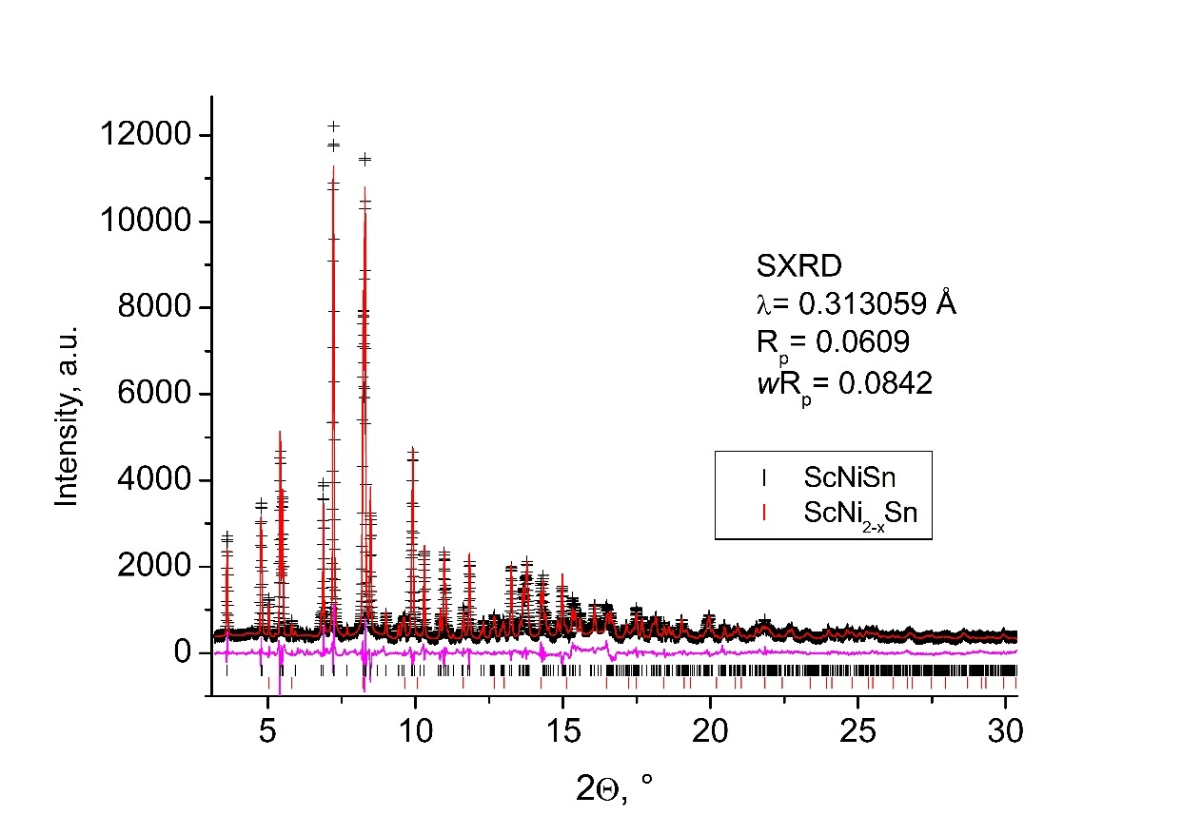
Fig. S1. Rietveld refinement of the synchrotron X-ray powder diffraction pattern of ScNiSn collected at 295 K. 2 theta angle range 3.205-30.385°; Step size 0.005°; λ= 0.313059 Å. Rp= 0.0842. Experimental data: points; calculated data: line; residual plot: bottom line. Positions of the peaks are shown by ticks; ScNiSn – top; ScNi2–xSn – bottom.

Table S1.
Crystal structure data for the intermetallic compound ScNiSn. a= 6.6276(2), b= 4.3581(2), c= 7.4879(3) Å, V= 216.28(2) (Å³). Space group Pnma (No. 62). TiNiSi type of structure. Z= 4.

Atoms | Sites | x/a | y/b | z/c | Biso (Å²) | Occ.
Sc | 4с | 0.5080(9) | 1/4 | 0.2907(5) | 0.43(7) | 1.0
Ni | 4с | 0.7929(5) | 1/4 | 0.5831(7) | 0.82(5) | 1.0
Sn | 4с | 0.2032(3) | 1/4 | 0.5866(4) | 0.58(2) | 1.0

Table S2.
Refined crystal structure data for the intermetallic compound
ScNi2–xSn (x= 0.42).
a= 6.1821(3) Å, V= 236.27(4) Å³, Z= 4. Space group Fm$\overline{3}$m (No. 225). Cu2MnAl type of
structure.

Atom | Site | x/a | y/b | z/c | Biso, (Å²) | Occupancy
Sc | 4b | 1/2 | 1/2 | 1/2 | 0.61 | 1.0
Ni | 8с | 1/4 | 1/4 | 1/4 | 0.61 | 0.79(2)
Sn | 4a | 0 | 0 | 0 | 0.61 | 1.0
Reference data on the structure of ScNi2–xSn are given in [32].

Table S3.
Crystal structure data for the ScNiSnH0.5 deuteride from the refinements of the synchrotron powder XRD data. a= 7.0555(2), c= 3.7414(2) Å, V= 161.29(2) Å³. Sp.gr. P$\overline{6}$2m (No. 189).
ZrNiAl type of structure.

Atoms | Sites | x/a | y/b | z/c | Biso (Å²) | Occ.
Sc | 3g | 0.6004(4) | 0 | 1/2 | 0.45(5) | 1.0
Ni1 | 1b | 0 | 0 | 1/2 | 0.50(7) | 1.0
Ni2 | 2c | 1/3 | 2/3 | 0 | 0.60(5) | 1.0
Sn | 3f | 0.2647(1) | 0 | 0 | 0.44(1) | 1.0

Table S4.
Interatomic distances (Å) in the crystal structure of ScNiSnD0.5.

Atom 1 | Atom 2 | Distances, Å
Sc | Ni1 | 2.819(1)
 | Ni2 | 2.855(1)
 | Sn | 3.018(1)
 | Sn | 3.110(1)
 | Sc | 3.735(2)
 | Sc | 3.7414(2)
Ni1 | Sn | 2.6436(3)
Ni2 | Sn | 2.6275(5)
Sn | Sn | 3.2353(6)
 | Sn | 3.7414(2)

Table S5.
Crystal structure data for ScNiSnD0.5 (Sp.gr. P$\overline{6}$2m) from the refinements of the neutron powder diffraction pattern collected using the neutron powder diffractometer SPODI at 295.0 K at a wavelength of λ=1.487 Å. a= 7.0368(5), c= 3.7307(3) Å, V= 159.98(4) Å³, RBragg= 0.0236.
Atom | Site | x/a | y/b | z/c | Biso (Å²) | Occupancy
Sc | 3g | 0.6014(2) | 0 | 1/2 | 0.44(2) | 1.0
Ni1 | 1b | 0 | 0 | 1/2 | 0.40(6) | 1.0
Ni2 | 2c | 1/3 | 2/3 | 0 | 0.60(4) | 1.0
Sn | 3f | 0.2647(1) | 0 | 0 | 0.39(5) | 1.0
D | 2d | 1/3 | 2/3 | 1/2 | 1.01(8) | 0.686(5)
D2 | 1a | 0 | 0 | 0 | 1.00(5) | 0.041(7)

Table S6.
Interatomic distances (Å) in the crystal structure of ScNiSnD0.5.
Atom 1 | Atom 2 | Distances, Å
Sc | D | 2.1531(6)
 | Ni1 | 2.8048(6)
 | Ni2 | 2.8487(5)
 | Sn | 3.0129(9)
 | Sn | 3.098(1)
 | Sc | 3.7292(8)
 | Sc | 3.7307(4)
Ni1 | D2 | 1.8654(2)
Ni1 | Sn | 2.6384(8)
Ni2 | D | 1.8654(2)
Ni2 | Sn | 2.619(1)
Sn | D2 | 1.866(1)
 | Sn | 3.232(1)
 | Sn | 3.7307(4)

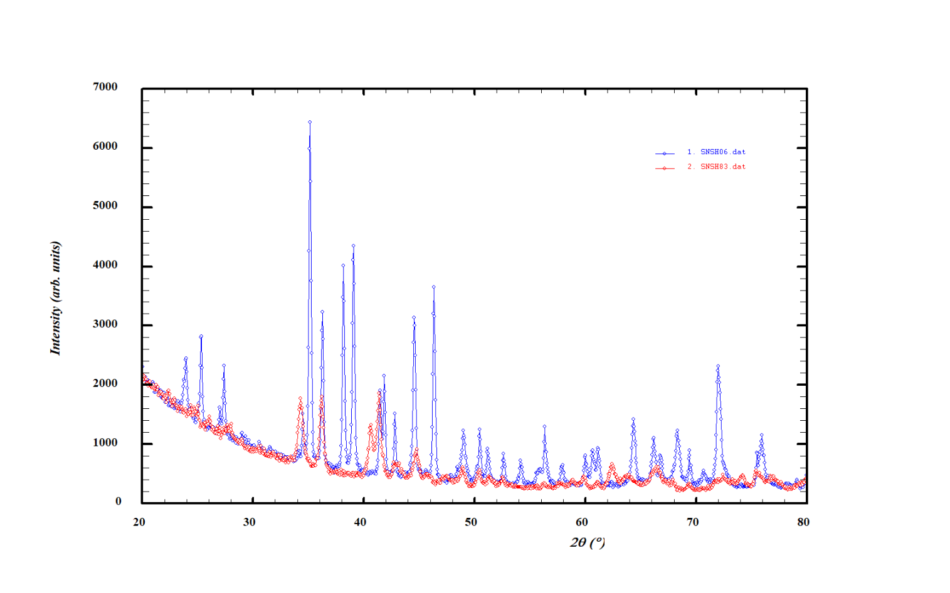
Fig. S2. XRD pattern of ScNiSnH0.83 (Cu Kα) (red) synthesized at H2 pressure of 2 GPa when heating the sample to 373 K as compared to the ScNiSnH0.62 synthesized at ISSPh at 2 GPa by attempting to further hydrogenate the ScNiSnH0.5-0.6 sample obtained at IFE at 10 bar H2.

Table S7.
Crystallographic data for the high pressure hydride ScNiSnH0.83.

a = 6.830(2), b = 4.056(2), c = 7.967(3) Å, V = 220.7(1) A³, Z = 4.
Space group Pnma (No. 62). TiNiSi type of structure.

Atoms | Sites | x/a | y/b | z/c | Biso, Å² | Occupancy
Sc | 4с | 0.514(3) | 1/4 | 0.326(2) | 0.74(9) | 1.0
Ni | 4с | 0.772(2) | 1/4 | 0.619(2) | 0.74(9) | 1.0
Sn | 4с | 0.157(1) | 1/4 | 0.566(1) | 0.74(9) | 1.0

Tetrahedron Sc3Ni.

Site | x/a | y/b | z/c | radius, Å
4с | 0.519 | 1/4 | 0.594 | 0.50
Distances in [Sc3Ni] tetrahedron: Sc–Ni = 2×2.85 and 2.92 Å; Sc–Sc = 2×3.44 and 4.06 Å Distances from the centre of interstice to the surrounding atoms:
i–Sc = 3×2.14 Å; i–Ni = 1.74 Å; i–i = 2.53 Å

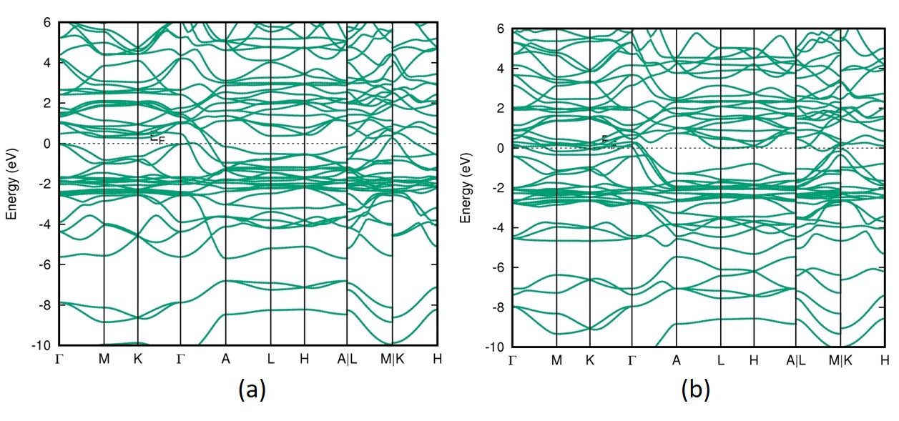
Fig. S3. Calculated electronic band structures in the Sp.gr. P$\overline{6}$2m along with the high symmetric points in the Brillouin Zone for ScNiSn and its hydride ScNiSnH0.667.

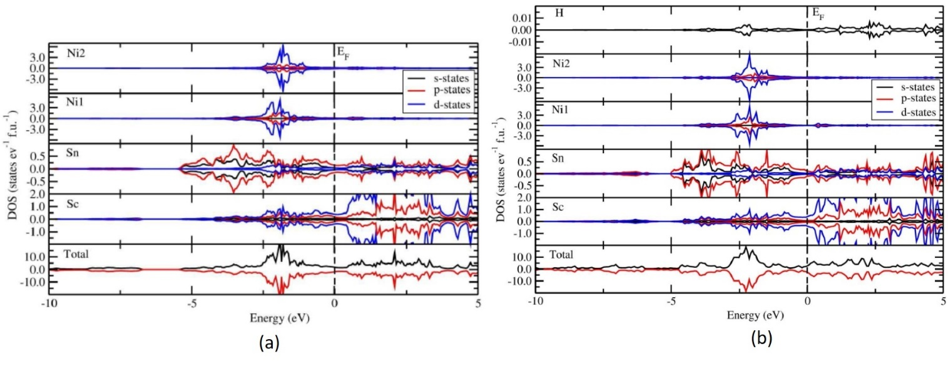

Fig. S4. The total density and partial density of states for ScNiSn (a) and its hydride ScNiSnH0.667 (b).

