Table 1 of Samples
(*Deuterium experiments marked with grey background)
Sample | Stoichiometry of superconducting phase | Synthesis conditions | Photo before and after heating |  | Electrical measurements | X-ray diffraction
 |  |  | Before | After
1 | LaH₁₀  (expected from the value of T_{c}) | La + H₂  145 GPa laser heated  Mixture of La and excess of H₂ was compressed to 145 GPa.  After the laser heating, H₂ vibron is seen around the sample |  | 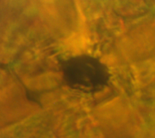 | P = 145 GPa, T_{c} ∼ 244 K  P = 151 GPa, T_{c} ∼ 249 K  Resistance dropped to 0 Ω.  Red and orange curves; and orange points, Fig. 1; Fig. ED 5 | -----
2 | LaH₁₀ | La + H₂  137 GPa laser heated  Mixture of La and great excess of H₂ was pressurized to 137 GPa and then heated by laser | 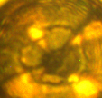 | 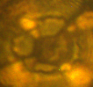 | P = 137 GPa, T_{c} ∼ 243 K  Sharp superconductive transition to 0 Ω.  Dark yellow curve and points in Fig. 1 | Fm-3m, dominant phase,  a=5.1578(5) Å, V=137.21(4) Å³;  with impurity of hcp (II):  P6₃/mmc (LaH₁₀)  a=3.7525(7) Å, c=5.561(2) Å,  V=67.81(2) Å³;  and minor impurity of hcp (I):  P6₃/mmc (LaH₁₀)  a=3.66 Å, c=5.95 Å, V=69.0 Å³. Fig. 3a,b,d
3 | LaH₁₀ | La + H₂  150 GPa laser heated  La was pressurized in H₂ to 150 GPa and then heated by laser. All H₂ was absorbed by La | 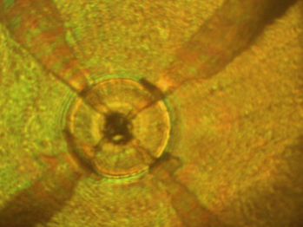 | 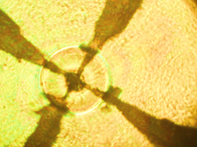 | P = 150 GPa, T_{c} ∼ 249K  Blue curve and points in Fig. 1 | Fm-3m, dominant phase,  a=5.1019(5) Å, V=132.80(4) Å³;  with minor impurities of hcp (I):  P6₃/mmc (LaH₁₀)  a=3.6226(8) Å, c=5.895(2) Å,  V=66.99(3) Å³; and  Pm-3m (LaH_{∼12})  a=3.2929(8) Å, V=35.70(3) Å³.  Fig. 3a,b,d

4 | LaH₁₀  (expected from the value of T_{c}) | La + H₂  150 GPa laser heated  Mixture of La and excess of H₂ was pressurized to 150 GPa and then heated by laser. After the chemical reaction H₂ is still present around the sample. | 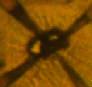 | 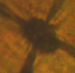 | P = 150 GPa, T_{c} ~ 246 K  Several pronounced superconductive steps with the highest T_{c}∼246 K. The residual resistance is ∼80 Ω at ∼80 K.  Green points in Fig. 1 (inset) | ------
5 | LaH₁₀  (expected from the value of T_{c}) | La + H₂  145 GPa laser heated  Mixture of La and excess of H₂ was pressurized to 145 GPa and then heated by laser. |  |  | P = 145 GPa, T_{c} ∼ 251 K  Almost no pressure dependence of T_{c} in 145 – 172 GPa pressure range.  Red points in Fig. 1(inset) | ------
6 | LaH₁₀  (expected from the value of T_{c}) | La + H₂  145 GPa laser heated  Mixture of La and excess of H₂ was pressurized to 145 GPa and then heated by laser. | 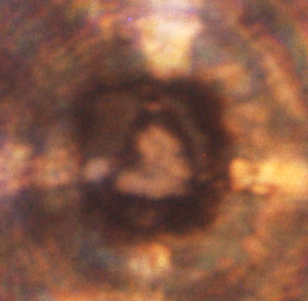 | 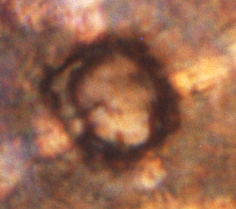 | P = 168 GPa, T_{c} ∼ 249 K  T_{c} was measured in the 150-218 GPa pressure range  Magenta points in Fig. 1 (inset). | ------
7 | LaH₁₀  (expected from the value of T_{c}) | LaH₃ + H₂(deficiency)  141 GPa - no laser heating  LaH₃ was compressed in H₂ atmosphere at 141 GPa. No laser heating was used. H₂ was in deficiency. | 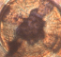 |  | P = 141 GPa, T_{c} ∼ 245 K  2 weeks after the synthesis, superconductivity was measured with T_{c} ∼245K. The superconductive step is broad, with R(200K)/R(245K) = 10%.  R(300K)=1 Ω, R(75K) < 10⁻⁴ Ω.  Black point in Fig. 1 (inset) | ------
8 | LaD₁₁ | La + D₂  142 GPa laser heated  Mixture of La and excess of D₂ was compressed to 142 GPa. After the laser heating D₂ vibron is detected around the sample. |  | 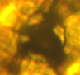 | P = 142 GPa, T_{c} ∼ 140 K  Resistance dropped to nearly zero at ∼126 K.  Red point in the inset in Fig. ED 4b; Fig. ED 5 | P4/nmm, dominant phase,  a=3.7258(6) Å, c=5.0953(12) Å,  V=70.73(2) Å³;  and impurity of hcp (I):  P6₃/mmc (LaD₁₀)  a=3.6389(11) Å, c=5.942(3) Å,  V=68.14(4) Å³. Fig. 3c,e
9 | LaH_{x}, x ≥ 3  (mostly LaH₃) | La + H₂(deficiency)  152 GPa laser heated  La in H₂ deficiency was pressurized to 152 GPa and then heated by laser. | 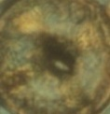 | 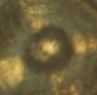 | P = 152 GPa, T_{c} ∼ 108 K | Mostly LaH₃ phase Fm-3m:  a=4.3646(5) Å, V=83.14(3) Å³  and unidentified impurities.  Black point in Fig. ED 1c
10 | LaH_{x1}, x₁≥ 3 | La + H₂(deficiency)  178 GPa, before laser heating  La in H₂ deficiency was pressurized to 178 GPa at room temperature. No thermal treatment was applied. | 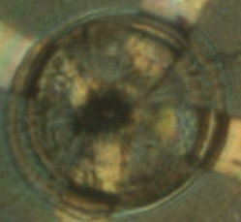 | 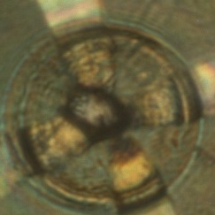 | P = 178 GPa, T_{c} ∼ 70 K  Several steps in R(T) with T_{c} of the first step at ∼70 K. Under magnetic field of 5 T, all steps shifted to lower temperatures, including the onset of superconductivity which shifted to ∼49 K.  Black and red points in Fig. ED 2 | ------
 | LaH_{x2}, x₂> x₁  (traces of LaH₃) | 178 GPa, after laser heating  The same mixture (pressurized to 178 GPa) but with subsequent laser heatings. At every heating, the sample expanded by absorbing H₂ and got metallic luster of the final product. |  |  | P = 178 GPa, T_{c} ∼ 112 K  After the first laser heating, a new superconductive step at ∼112 K was detected. Each succeeding laser heating led to gradual disappearance of the ∼70 K step and growth of the ∼112 K step. Blue and green points in Fig. ED 2; Fig. ED 5 | Complex powder pattern with traces of Fm-3m LaH₃ phase  a=4.313(2) Å, V=80.2(1) Å³  Blue point in Fig. ED 1c; Fig. ED 1d,e
 | LaH_{x}, x ≥ 3  (no traces of LaH₃) | La + H₂(deficiency)  150 GPa laser heated  Mixture of La in great deficiency of H₂ was pressurized to 150 GPa and then heated by laser. |  | 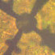 | P = 150 GPa, T_{c} ∼ 70 K  Sharp and narrow superconductive step with T_{c}∼70 K.  Magenta points in Fig. ED 2; Fig. ED 5 | Unknown phase(s) with complex powder diffraction pattern.  Green point in Fig. ED 1c
11
12 | LaH_{x} | La + H₂  160 GPa laser heated  Mixture of La and excess of H₂ was pressurized to ∼160 GPa and then heated by laser. | 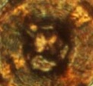 | 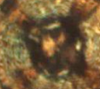 | P = 160 GPa, T_{c} ∼ 210 K  P = 150 GPa, T_{c} ∼ 215 K  A sharp superconductive step with T_{c}∼210 K at 160 GPa.  By decreasing the pressure to 150 GPa T_{c} increased to 215K.  Fig. ED 3; Fig. ED 5 | ------
13 | LaD_{x} | La + D₂  139 GPa laser heated  Mixture of La and excess of D₂ was pressurized to 139 GPa at room temperature and then heated by laser. | 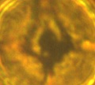 | 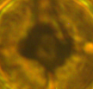 | P = 139 GPa, T_{c} ∼ 150 K  P = 152 GPa, T_{c} ∼ 165 K  One channel (resistance of ∼1 kΩ) showed wide transition with T_{c} ∼150 K at 139 GPa. T_{c} increases to ∼165 K at increasing pressure to 152 GPa.  Black, red and blue points in Fig. ED 4b, and black points in the inset; Fig. ED 5 | ------
14 | LaD_{x} | LaD₃ + D₂  130 GPa, before laser heating  LaD₃ was compressed in excess D₂ atmosphere to 130 GPa. | 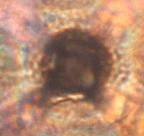 | 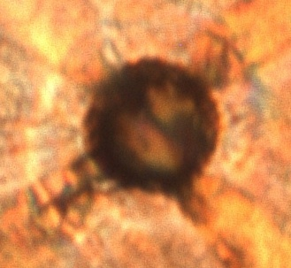 | P = 130 GPa, T_{c} ∼ 80 K  The onset of superconductivity is at ∼80 K. R(300K)=0.2 Ω. R(60K) < 10⁻⁴ Ω.  Fig. ED 5 | ------
 | LaD₁₀ | 131 GPa, after laser heating  D₂ was in deficiency |  |  | The sample became semitransparent, and its R(300K) increased to 6 Ω. R(T) demonstrated an anomaly at T_{c} ∼113 K, which can be attributed to superconductivity. | almost pure hcp (II)  P6₃/mmc (LaD₁₀)  a=3.7460(5) Å,  c=5.5849(17) Å,  V=67.87(2) Å³
15 | LaD₁₁ | La + D₂  154 GPa laser heated  Mixture of La and excess of D₂ was pressurized to 154 GPa at room temperature and then heated by laser. | 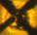 | 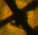 | P = 163 GPa, T_{c} ∼ 168 K  Green point in the insert of Fig. ED 4b | P4/nmm (LaD_{∼11}),  a=3.6767(9) Å, c=5.0327(19) Å, V=68.03(3) Å³; with minor impurities (possibly hcps)
16 | LaD₁₀₋₁₁ | La + D₂  146 GPa laser heated  Mixture of La and excess of D₂ was pressurized to 146 GPa at room temperature and then heated by laser. |  | 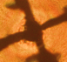 | P = 161 GPa, T_{c} ∼ 168 K  Blue point in the insert of Fig. ED 4b | A mixture of hcp (II):  P6₃/mmc (LaD_{∼10})  a=3.6920(9) Å, c=5.459(4) Å,  V=64.44(4) Å³; and  P4/nmm (LaD_{∼11}):  a=3.6969(5) Å, c=5.040(1) Å,  V=68.88(2) Å³;  with minor impurity of hcp (I)  P6₃/mmc (LaD_{∼10})  a=3.622(2) Å, c=5.825(5) Å,  V=66.20(6) Å³.
17 | LaD₁₀ | La + D₂  120 GPa laser heated  Mixture of La and D₂ was pressurized to 120 GPa at room temperature and then heated by laser. No conductivity after laser heating. Pressure was increased to 152 GPa, and SC with T_{c}∼180 K was measured. | 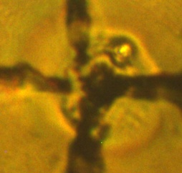 | 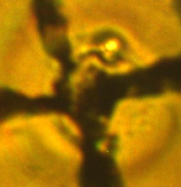 | Before heating at 152 GPa:  P = 152 GPa, T_{c} ∼ 180 K  After heating at 152 GPa in two steps:  P = 147 GPa, T_{c} ∼ 187 K  P = 147 GPa, T_{c} ∼ 160 K | Before heating at 152GPa:  a mixture of Fm-3m (LaD₁₀)  a=5.136(5) Å, V=135.4(4) Å³;  hcp (I): P6₃/mmc (LaD₁₀)  a=3.639(4) Å, c=5.886(6) Å,  V=67.5(1) Å³; and hcp (II):  P6₃/mmc (LaD₁₀)  a=3.761(3) Å, c=5.483(8) Å,  V=67.2(1) Å³;  and unidentified impurities.  After heating at 152 GPa:  a mixture of P4/nmm (LaD₁₁), a=3.750(2) Å,  c=4.971(5) Å, V=69.88(8) Å³;  hcp (I): P6₃/mmc (LaD₁₀)  a=3.6519(13) Å, c=5.927(2) Å, V=68.46(4) Å³;  and hcp (II) P6₃/mmc (LaD₁₀)  a=3.772(2) Å, c=5.496(5) Å,  V=67.71(7) Å³ and the same unidentified impurities.

18 | LaD_{∼10} | La + D₂  147 GPa laser heated  Mixture of La and excess of D₂ was pressurized to 147 GPa at room temperature and then heated by laser at low power (no glowing). |  |  |  | P = 147 GPa : T_{c} ∼ 160 K  After 1 month:  P = 153 GPa : T_{c} ∼ 180 K  . | A mixture of hcp (II):  P6₃/mmc (LaD_{∼10})  a=3.708(3) Å, c=5.484(6) Å, V=65.32(9) Å³; and  Fm-3m (LaD₁₀)  a=5.06 Å, V=129.6 Å³;  and minor unidentified impurity
19 | LaD₁₀₋₁₁ | La + D₂  109 GPa laser heated  127GPa laser heated  140 GPa laser heated  154 GPa laser heated  La+D₂ was compressed to 109 GPa. After laser heating a new Raman peak appeared at 3110 cm⁻¹. After pressurizing to 127 GPa, X-ray diffraction was measured. After laser heating at 140 GPa some parts of the sample became transparent. The new Raman peak from the sample persists up to 154 GPa (although its frequency decreased to 3104 cm⁻¹). | 140 GPa, before heating  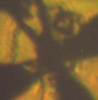 |  | 140 GPa, after heating  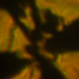 | The 4th electrode was not in contact with the sample. Resistance between other electrodes was R∼1.5 – 2.5 kΩ | At 127 GPa dominant phase is Fm-3m (LaD₁₁)  a=5.2671(8) Å, V=146.12(6) Å³;  impurity of hcp (II):  P6₃/mmc (LaD₁₀)  a=3.7549(11) Å, c=5.598(2) Å, V=68.35(4) Å³;  and traces of hcp (I):  P6₃/mmc (LaD₁₀)  a=3.66 Å, c=6.04 Å,  V=70.3 Å³; and unidentified phase(s)
20 | LaD₃ | LaD₃ + D₂  111-123 GPa no laser heating  LaD₃ was compressed in D₂ atmosphere to 111-123 GPa. D₂ was in deficiency. |  |  |  | P ∼ 111-123 GPa:  T_{c} ∼ 68 K  R(300K)=1Ω, R(55K) < 10⁻⁴ Ω. | Nearly pure Cmcm-LaD₃, a=2.90 Å b=6.77 Å c=4.67 Å, V=91.7 Å³
21 | LaH₁₂ | LaH₃ + H₂  153 GPa laser heated  LaH₃ was compressed in H₂ atmosphere to 153 GPa and then heated by laser. H₂ was in a great excess. | 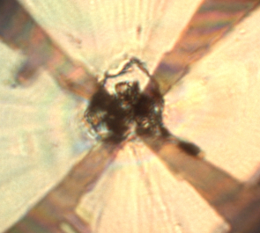 | 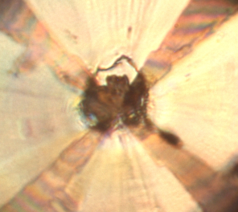 |  | After heating the sample became semi-transparent,  R > 1 MΩ | After heating at 159 GPa: mostly distorted primitive simple cubic Pm-3m-LaH₁₂ with a=3.30 Å, V=35,9 Å³ and minor impurity of Fm-3m-LaH₁₀ with a=5.10 Å, V=132,6 Å³

