Type of the Paper Article
The enrichment of (Cu,Sn) solid solution driven by the high pressure torsion
Boris Straumal^{1-3*}, Askar Kilmametov³, Anna Korneva⁴, Pawel Zięba ⁴, Yuri Zavorotnev⁵, Leonid Metlov^{5,6} , Olga Popova⁷, Brigitte Baretzky²
¹ Ossipyan Institute of Solid State Physics of the Russian Academy of Sciences, Chernogolovka, Russia
² Institute of Nanotechnology, Karlsruhe Institute of Technology, Eggenstein-Leopoldshafen, Germany
³ Chernogolovka Scientific Center of the Russian Academy of Sciences, Chernogolovka, Russia
⁴ Institute of Metallurgy and Materials Science, Polish Academy of Sciences, Krakow, Poland
⁵ Donetsk Institute for Physics and Engineering named after A.A. Galkin, Donetsk, Ukraine
⁶ Donetsk National University, Donetsk, Ukraine
⁷ Donetsk National Technical University, Pokrovsk, Ukraine

* Correspondence: straumal@issp.ac.ru, Ossipyan Institute of Solid State Physics a of the Russian Academy of Sciences, Ac. Ossipyan str., 2, 142432 Chernogolovka, Russia
Received: date; Accepted: date; Published: date
Abstract: The Cu–14 wt.% Sn alloy was annealed at temperatures 320 and 500°C. The concentration of tin c_{init} in the copper-based matrix increased with annealing temperature. The annealed samples were subjected to the high pressure torsion (HPT) at 6 GPa, 5 turns, 1 rpa. HPT led to the refinement of Cu grains. The shape of the colonies of α+ε phases changes only slightly. The HPT-driven enrichment of Cu-based solid solution with Sn atoms c_{HPT} – c_{init} decreased with increasing c_{init}. The performed theoretical analysis explains this behavior of the HPT-driven enrichment.
Keywords: high pressure torsion; phase transformations; transmission electron microscopy; scanning electron microscopy; Cu-based alloys; high-pressure torsion; solubility; dissolution

1. Introduction
The high pressure torsion (HPT) is one of the important variants of severe plastic deformation (SPD) [1]. During HPT the sample is located under high pressure of 4 to 12 GPa between rotating anvils of HPT machine. The sample cannot "escape" from this confined space and, therefore, cannot break. If the plungers of HPT machine (typically made of cemented carbides) are harder than a sample (like for example copper- or aluminum-based alloys), the number of anvil rotations can be practically infinite as well as formally calculated strain [2–6]. Such values of strain appear quite non-physical and, indeed, the relaxation process starts during HPT, and after certain rotations number a certain steady state is reached [7–11]. In the steady state mode, mass transfer processes continue to occur in the sample volume, what is determined by the rheology of the material [12, 13]. In the case when the sample is a composition of different metals, these processes lead to the intensification of chemical reactions, the formation of various patterns, homogenization of the chemical composition, etc. [14–16]. Thus, such process is quite unusual in comparison with conventional deformation schemes where the sample indeed changes its shape (i.e. actually deforms). Therefore, SPD and particularly HPT have numerous structural aspects which remain not deeply investigated. In particular, when HPT is applied to the two-phase alloys with a solid solution in the matrix containing the precipitates of a second phase, the competition of dissolution of second phase and decomposition of a solid solution can take place [10, 17–19]. To study certain structural peculiarities of enrichment of solid solution in a two-phase alloy during HPT is the goal of this work. We chose for this purpose the Cu–Sn system where a lot of preliminary work has been done [17, 11–14]. We also propose the theoretical approach for the description of solid solution enrichment.

2. Materials and Methods
The cylindrical ingot of Cu–14 wt. % Sn alloy was manuractured by the vacuum induction melting from the high-purity 99.9998 wt. % copper and 99.999 wt. % tin. The as-cast ingots were cut into the 0.6 mm thick disks for further HPT processing. The discs were then mechanically ground and chemically etched. The discs were then sealed at the room temperature into silica ampoules with a residual pressure of ~4×10^{–4} Pa. The ampoules were annealed at 320°C for 1200 h and at 500°C for 894 h. After annealing the ampoules were quenched into cold water. Then the samples were processed by HPT at pressure of 6 GPa and room temperature for 5 anvil rotations at a constant rotation speed of 1 rpm using a computer controlled HPT device custom built by W. Klement GmbH, Lang, Austria. The sample thickness after HPT was 0.35 mm.
Torsion straining of a disc sample of diameter 2R and thickness t produces a shear strain γ = 2π n r / t (where n is the number of plunger rotations and r is the distance from the sample centre). γ changes from zero at r = 0 to a maximum of γ_{max} on the external surface at r = R. In order to compare the shear strain with a tensile deformation, the equivalent strain value is frequently used [23, 24]. All samples for further studies were cut from the deformed samples at a distance of r = 3 mm from the middle of the disk. For r = 3 mm and 5 plunger rotations one gets, respectively, γ = 270 and e_{eq} = 156. This strain value was used for the manufacturing of nanograined materials in numerous previous studies [23, 24].
For the metallographic investigations the samples were ground with SiC grinding paper, and sequentially polished with 6, 3, and 1 μm diamond pastes. The structure examination of the samples was carried out using an FEI E-SEM XL30 scanning electron microscope (SEM) (FEI, Hillsborough, OR, USA) equipped with EDAX Genesis EDS spectrometer (AMETEK, Inc., Berwyn, PA, USA). The SEM images were taken using backscattered electron signal (BSE mode) in order to obtain the composition contrast between different phases. The thin foils for transmission electron microscopy (TEM) examination were manufactured by a twin-jet polishing technique using a D2 electrolyte manufactured by Struers company. TEM studies were carried out using a TECNAI G2 FEG super TWIN (200 kV) (FEI, Hillsborough, OR, USA) with an energy dispersive X-ray (EDS) spectrometer manufactured by EDAX (AMETEK, Inc., Berwyn, PA, USA). The focused ion beam (FIB) technique was applied by means of FIB Quanta 3 D, TECNAI FEG microscopy (30 kV) (FEI, Hillsborough, OR, USA) for the preparation of thin foils of deformed material, in order to obtain the interface between the second phase and α-matrix. The X-ray diffraction (XRD) patterns were obtained in the Bragg–Brentano geometry in a Siemens D-500 X-ray diffractometer (Malvern Panalytical, Malvern WR14 1XZ UK) with Cu-Kα radiation. The Pseudo-Voigt function was used for fitting of XRD peak profiles.

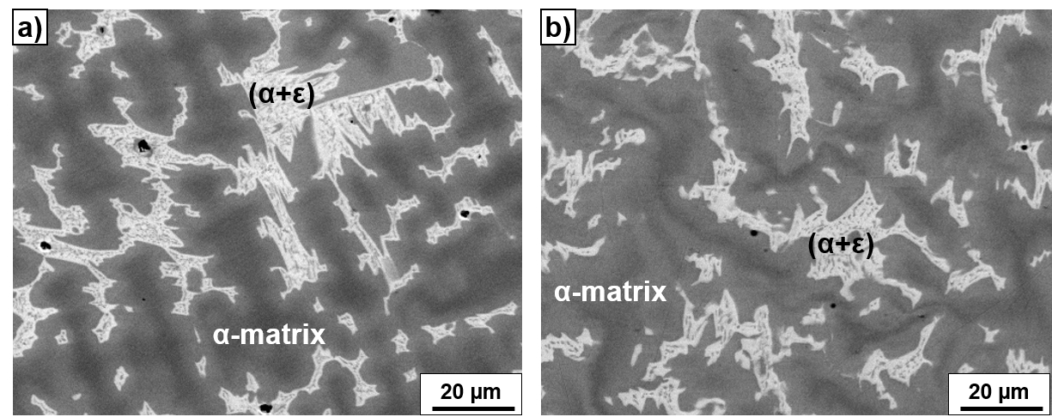
Figure 1. SEM images of the Cu–14wt.%Sn alloy after annealing at 320°C, 1200 h (a) and following HPT deformation (b).

3. Results
SEM micrographs of the Cu–14 wt.% Sn alloy are shown in Fig. 1. Fig. 1a shows the microstructure of the Cu–8 wt.% Sn alloy annealed at 320°C for 1200 h. This state was the initial one before HPT. The (Cu) solid solution matrix (or α-phase) appear dark and the α+ε eutectoid colonies appear bright. The grain size in (Cu) matrix is ~10-30 μm. The colonies of α+ε phase have complicated shape. Figure 1b shows the same sample as in Fig. 1a but additionally deformed by HPT. After HPT, the shape of the colonies of α+ε phases does not change much. They are only slightly curved in the comparison with straight colonies before HPT.
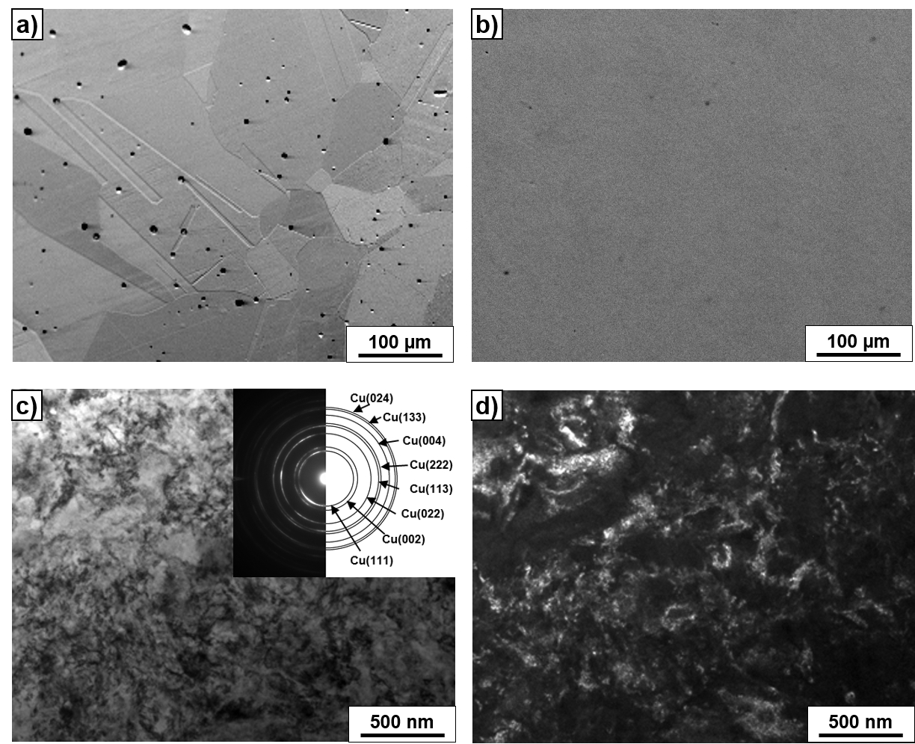

Figure 2. SEM images of the Cu–14wt.%Sn alloy after annealing at 500°C, 894 h (a) and following HPT deformation (b). Bright field (c) and dark field (d) TEM images of the microstructure of the HPT-deformed Cu–14 wt.% Sn alloy, pre-annealed at 500°C, 894 h. The selected area electron diffraction (SAED) pattern is shown as the insert in (c).

Fig. 2a shows the microstructure of the Cu–8 wt.% Sn alloy annealed at 500°C, 894 h. This state was also the initial one before HPT. The (Cu) solid solution matrix (or α-phase) appear bright and small particles of δ-phase appear dark. The grain size of (Cu) solid solution matrix is about 200-300 μm. Figure 2b shows the same sample as in Fig. 1a but additionally deformed by HPT. The SEM image looks uniformly grey since the sample contains only the ultrafine grained (Cu) solid solution. The bright field (Fig. 2c) and dark field (Fig. 2d) TEM images demonstrate that the grain size in (Cu) phase after HPT is about 150-200 nm which is similar to other Cu-based alloys after HPT [18]. The SAED pattern in Fig. 2c shows that the sample contains only (Cu) phase. Thus, HPT leads to the strong grain refinement in (Cu).
Fig. 3 contains the TEM images of the microstructure of the HPT-deformed Cu–14 wt.% Sn alloy, pre-annealed at 320°C, 1200 h. Bright field (Fig. 3a) and dark field (Fig. 3b, d) images of the α-matrix of (Cu) solid solution show that the grain size in (Cu) phase after HPT is also about 150-200 nm like in Fig. 2. The (Cu) grains are also not elongated. The Fig. 3d image shows the contact area between α and ε phases. The SAED patterns for these α and ε phases are shown in Fig. 3e and Fig. 3f, respectively.
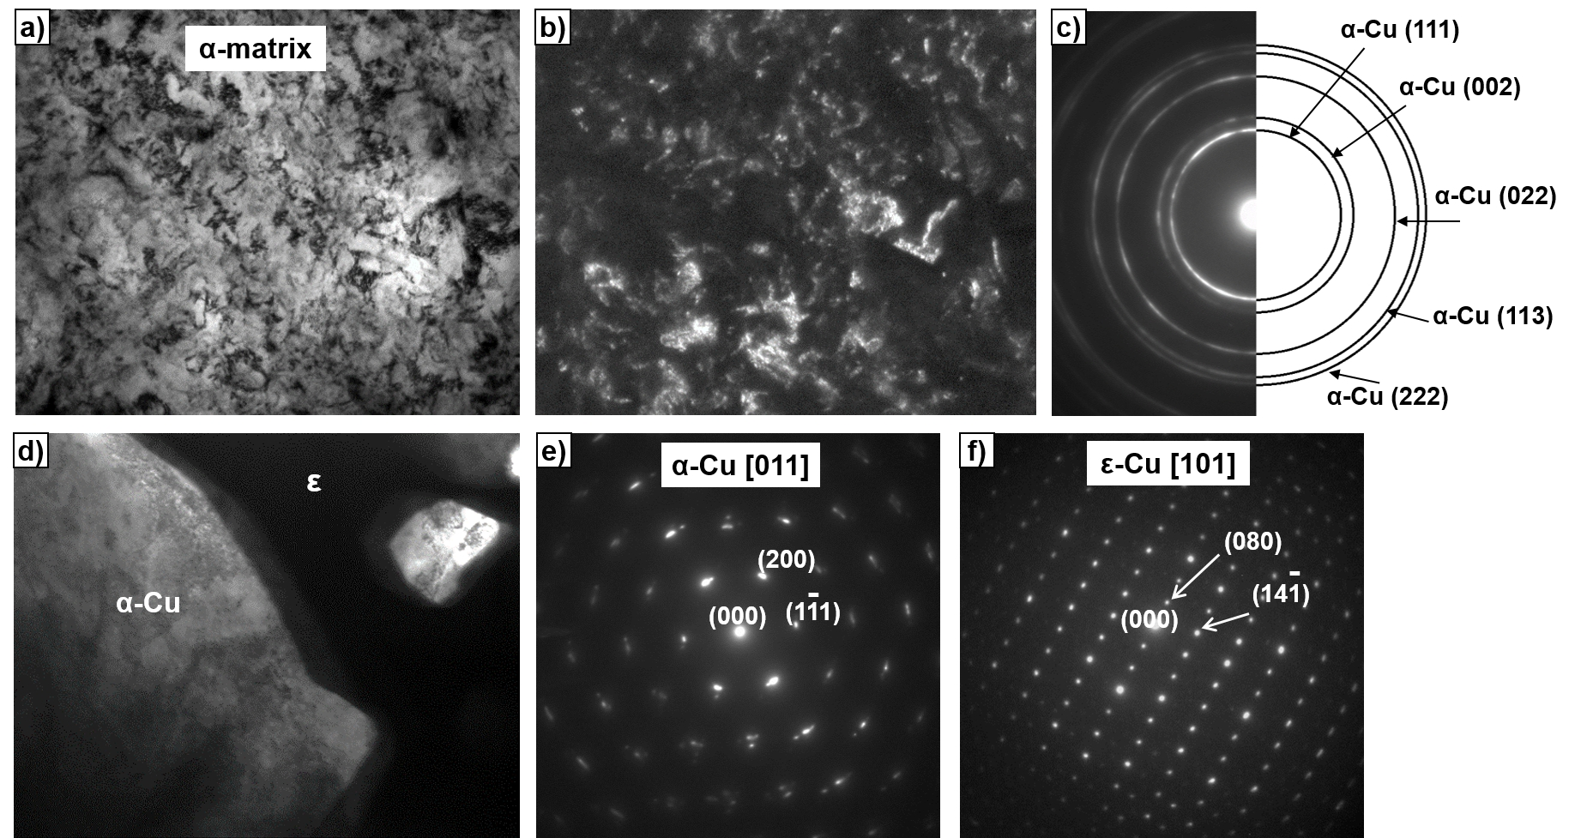
Figure 3. TEM images of the microstructure of the HPT-deformed Cu–14wt.% Sn alloy, pre-annealed at 320°C, 1200 h. Bright field (a), dark field (b, d) images, as well as the selected area electron diffraction (SAED) patterns (c,e,f) are shown. The (a,b,c) images correspond to the α-matrix of (Cu) solid solution. The (d) image shows the contact area between α and ε phases. SAED patterns for the α and ε phases are shown in (e) and (f) panels, respectively.

In Fig. 4 the X-ray diffraction patterns are given for Cu–14wt.% Sn alloy annealed at 320°C (red curves) before HPT (top red curve) and after HPT (bottom red curve) as well as annealed at 500°C (black curves) before HPT (bottom black curve) and after HPT(top black curve). The XRD pattern of Cu–14wt.% Sn alloy annealed at 320°C (top red curve) contains peaks for the (Cu) phase and intermetallic phase ε. The peaks are narrow since the copper and ε grains are quite large (see microstructure in Fig. 1a). After HPT the copper grains strongly refined (see Fig. 3). As a result, the peaks in Fig. 3b (bottom red curve) broadened. Moreover, the ε peaks, become weaker in comparison with copper peaks and almost disappeared. It cannot be attributed only to the grain refinenement. Indeed, the copper peaks after HPT are shifted towards the lower diffraction angles. In other words, the lattice parameter of Cu-based solid solution increased. We know, that the increase of Sn content in the Cu-based solid solution increases the (Cu) lattice parameter [17]. It means that the certain part of ε precipitates diluted in the copper matrix. As a result, the intensity of ε X-rays peaks strongly decreased after HPT.
Figure 4. X-ray diffraction patterns of the Cu–14wt.% Sn alloy annealed at 320°C (red curves) before HPT (top red curve) and after HPT (bottom red curve) as well as annealed at 500°C (black curves) before HPT (bottom black curve) and after HPT(top black curve). Vertical dotted lines and arrows show the peak shift after HPT.

The XRD pattern of Cu–14wt.% Sn alloy annealed at 500°C (bottom black curve) contains only peaks for the (Cu) phase. As we saw from Fig. 2 the amount of ε precipitates is very low and, therefore, the ε peaks are not visible. The Cu peaks in Fig. 4 (bottom black curve) are narrow since copper grains are quite large (see micrographs in Fig. 2a). After HPT the grains strongly refined (see Fig. 2c,d). As a result, the Cu peaks in Fig. 4 (top black curve) broadened. The ε peaks are not visible after HPT, as before HPT. However, the copper peaks very slightly shifted to the right after HPT. It means that the lattice spacing decreased due to the dissolution of tin in the Cu-based solid solution. The peak shift in the sample pre-annealed at 500°C is much lower than in the sample pre-annealed at 320°C. It means that the amount of tin dissolved in the copper matrix during HPT decreases and even changes the sign with increasing temperature of pre-annealing.

4. Discussion
In our previous works the HPT of various copper-based alloys with silver, tin, cobalt, etc. dissolved in (Cu) was studied [18]. The main result of these works is the fact that at any annealing temperature during the subsequent HPT processing, the alloy always reaches the same state with a certain content of the dissolved component. It is only at a certain annealing temperature that the content of the dissolved component does not change, and the authors called this temperature the effective temperature of severe plastic deformation T_{eff}.
A theoretical approach of non-equilibrium evolutionary thermodynamics (NET) was proposed earlier to describe the processes occurring during metal processing by SPD methods [25–28]. An important feature of this approach is the existence of a steady-state, which is reached by any system subjected to SPD. Such steady-state is reached for all characteristics of the system, for example for the density of structural defects like dislocations and grain boundaries. The concentration of dissolved component should also reach a steady-state value.
An important condition for the use of NEET approach is the presence of plastic flow, which is the reason for the generation and annihilation of structural defects. The termination of plastic flow, that is, the transition to the elastic region or even to the absence of external stress, terminates the powers of NEET and the usual classical, perhaps, nonequilibrium thermodynamics comes into force. The ultimate transition between them is absent in the very essence of the question.
Therefore, some of the phase diagrams in works [17, 18], associated with annealing, should be constructed within the framework of the classical theory of diffusion phase transitions, and to construct the other part of the phase diagrams associated with SPD, it is necessary to use the NEET approach. In this paper, the calculations of the concentration of the dissolved component are carried out within the framework of the classical theory of phase transitions, which is the initial value for calculating their density in the framework of NEET.
The alloy under study can be described by the formula Cu_{1-x}Sn_{x}, where x is the concentration of Sn atoms. The elements Cu and Sn are in different groups and periods of the periodic table and have different numbers of valence electrons. This circumstance explains the presence of many phases in the Cu-Sn phase diagram [29]. In particular, the phases can form like: α, α+ε, α+δ etc. where α is a solid solution of Sn in Cu, ε is a solid solution based on the electronic compound Cu₃Sn, δ is a solid solution based on the electronic compound Cu₃₁Sn₈. The ε-phase has a hexagonal lattice and the δ-phase has a complex cubic lattice. At the point (11%, 320°C) there is a triple point (bifurcation). It has to be underlined that the border between α and α+ε areas is convex, and the border between α and α+δ areas is convex. It indicates a significant difference in the nature of interactions in the alloy. There is an inflection at the bifurcation point. As indicated above, a first-order phase transition (PT) occurs in the region of the bifurcation point, i.e. the symmetry, lattice parameters and constants of various kinds of interactions change. On the equlibrium phase diagram, such changes are almost invisible. However, the superposition of external severe deformation by HPT made it possible to see this transition. It can be seen in Fig. 15 of [17]. In the dependence of lattice parameter befroe abd after HPT on the temperature of pre-annealing the S-shaped section exists. It is located in the region of the bifurcation point. Here we will propose a mathematical description of the effects that appear upon imposition of HPT in the Cu-Sn system.
In the theoretical consideration in this work, we used the virtual crystal model [30]. In this case, the potential of the alloy is a "weighted" average potential of the alloy components. With this approximation, the potential is periodic. Consequently, it is possible to introduce a generalized vector order parameter (OP), which characterizes the change in the linear dimensions and shape of the elementary cell of the virtual lattice under certain influences. Usually, a linear combination of the displacements of the atoms of the unit cell is taken as the OP. According to Landau's phenomenological theory, the nonequilibrium thermodynamic potential can be represented as
(1)
where are the phenomenological parameters, M is the torsion torque applied along the OZ axis, is the density of defects, are the components of the OP vector. The terms with derivatives describe the structure inhomogeneities. As shown in [31], the difference in the values of the exponents is . Therefore, in what follows we everywhere assume that . Since in the plasticity region the value of the torsion torque does not depend on the number of revolutions, we will assume that the value of the torsion torque in the experiment of [17] does not depend on the number of revolutions.
In accordance with the NEET, the torsion torque M should increase first witt increasing strain due to the hardening of the material. Later M reaches a constant steady-state value. Here, to simplify the calculations, we immediately set it equal to some constant (steady-state) value. This circumstance will be taken into account later in more accurate versions of the theory, which will also consider the generation and annihilation of structural defects such as dislocations and grain boundaries.
The system of Euler equations for potential (1) has the form
(2)
We will seek a solution to this system in the form of a spiral structure
(3)
In the approximation of constancy of the OP modulus, we obtain
(4)
Since the process is equilibrium, it follows from (4) that
(5)
The equation (4) is biquadratic with respect to the OP modulus. Substituting (5) into (4), we obtain a quadratic equation for the OP modulus and a physical solution in the form
(6)
Further, it is necessary to estimate what parameters change during the transition from one phase to another, as well as within each phase. Obviously, change when the phases are changing. The change of α₁ is due to the different value of the phase transition temperature. The change of α₂ is due to the different values of the lattice parameter of both phases. The change of δ is due to the differences in the interaction between the OP and defects. In addition, it is necessary to take into account the different temperature dependence of the defect density. It turned out that in order to achieve the best qualitative agreement between theoretical and experimental data, it is sufficient to take into account the quantitative change in the coefficients, the change in magnitude and sign of δ, as well as the temperature dependence of the density of defects in the form , where is a phenomenological coefficient. The exponent n depends on the difference between the temperatures of annealing and phase transition. Satisfactory results were obtained with the dependence shown in Fig. 5. This graph indicates that, up to the phase transition temperature, the constant of interaction of the OP with defects first increases and then decreases. The solid line in Fig. 6 shows the dependence in the absence of HPT. When the annealing temperature and phase transition temperature are equal, an S-shaped anomaly appears, which is absent in the experimental curve. This difference is apparently due to the large temperature step between corresponding experimental measurements.

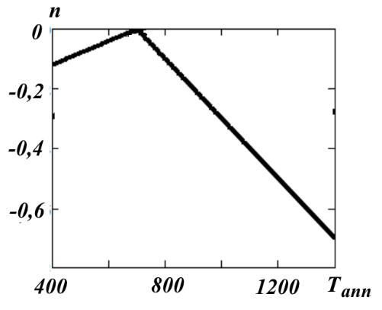

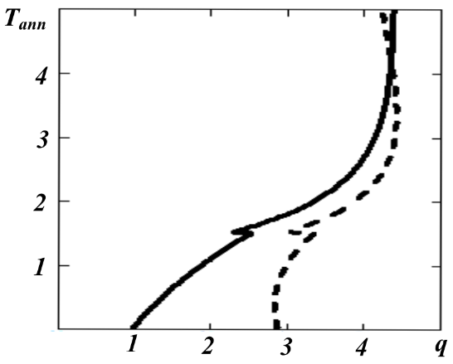
Figure 5. Dependence of exponent n on the annealing temperature .)

Figure 6. Dependence before HPT (solid line) and after HPT (dotted line).

It follows from the experimental data that there is a certain critical temperature point at which the graphs for and intersect. This is possible only in the case when the coefficient depends on the annealing temperature and turns to infinity at, and also changes sign when passing through the critical point . The graph of the function should be similar to the graph of a function with a breakpoint of the second kind. The plot of the dependence under HPT is shown in Fig. 2 with dotted line under the assumption that the sought dependence has the form
, (7)
where γ₃ is a phenomenological parameter. From a comparison of Fig. 6 and Figure 15 of work [17], it can be seen that there is a qualitative agreement between the experimental and theoretical results. The sign of the propagation vector (5) also depends on the sign of . Hence it follows that when passing through the critical temperature point, the propagation vector changes its sign and the spatial rotation of the spiral will be reversed.
The critical temperature point mentioned above where the graphs for and intersect, corresponds to a steady-state according to the concepts of the NET theory. From Fig. 6, it can be assumed that the steady-state, characterized by a certain value of the tin concentration, should depend on the annealing temperature.
Based on the results obtained above, let us consider the behavior of the concentration of tin in copper matrix when the HPT is applied as a function of the annealing temperature . According to the phase diagram given in [17], at the lowest annealing temperature, the percentage of Sn is zero. Consequently, in this case, the OP value will correspond to the Cu lattice. With increasing , an impurity Sn appears in the Cu-based solid solution and the value of the generalized OP will change.
Since the sum of Cu and Sn concentrations is equal to unity, knowing the expression for the value of the generalized OP as a function of the OP for copper and OP for silver, we can find the dependence of the percentage of Sn on the annealing temperature. In the literature, the formula of the weighted arithmetic mean is mainly used. However, its use does not give a result that coincides with the conclusions of the experimental work [17]. The best approximation turned out to be a dependence of the form
(8)
where are the OPs of Cu and Sn lattices, respectively. According to the above, we will assume that and, since the lattice parameters of copper and silver are not very different, where, β > 0 and is small. The solid line in Fig. 7 shows the result of a numerical calculation in the absence of torsion. This line is convex up to the bifurcation point, and after this point it is concave. Thus, it and qualitatively coincides with the corresponding line on the phase diagram [17]. The dashed line in Fig. 7 shows the result of the numerical calculation of the dependence upon the imposition of the HPT. It is seen that both lines, in accordance with the results of [17], have vertical asymptotes, which corresponds to steady-state states.
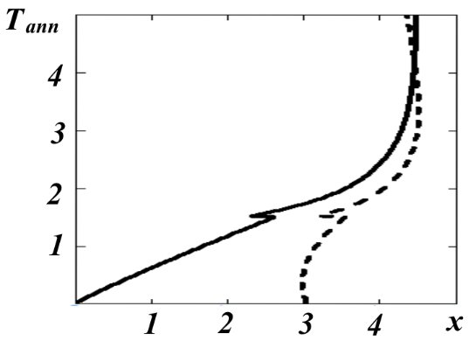
Figure 7. Dependence before HPT (solid line) and after HPT (dotted line).

It should be noted that all the results presented above are based on a potential containing Lifshitz invariants. It is of interest to consider the behavior of the OP in crystals where these invariants are absent. In this case, the potential density for the two-component order parameter has the form
(9)
The last term describes the interaction between the OP distortions along different axes. The extremum of a functional of the form (9) is found using the system of Euler-Poisson equations. As a result, we get
(10)
Consider the behavior of the system at . We will seek a solution in the form (3). We have
(11)
It follows from here that
(12)
After substituting (12) into (11), we obtain an equation similar to (4). Consequently, most of the conclusions drawn using a potential with Lifshitz invariants are also valid in this case. However, in this case, the intersection of the curves before and after the imposition of the HPT is impossible, since, according to (12), the sign changing of is impossible due to the nonnegativity of the square of the propagation vector.
Taking into account the coefficient for determining the modulus of the propagation vector, a transcendental equation is obtained, in which the OP modulus is explicitly included. Hence it follows that the terms at describe the appearance of multiple harmonics in the process of torsion.

5. Conclusions
We studied the HPT of two Cu–Sn samples with low and high concentration of tin in the (Cu) solid solution and remaining Sn-rich phases. These samples were produced by the preliminary anneal at low and high temperature. We observed that HPT leads to the enrichment of (Cu) solid solution with tin atoms. This enrichment is high for the low starting Sn concentration (and also low pre-annealing temperature) and low for the high starting Sn concentration (and high pre-annealing temperature). The proposed therretical model qualitatively explains such behaviour.

Acknowledgments
This work is supported by National Science Centre of Poland (grant OPUS 2014/13/B/ST8/04247), Volkswagen Stiftung (grant 97751), as well as state tasks of ISSP RAS and CSC RAS. SEM and TEM investigations were performed within the Accredited Testing Laboratories possessing the certificate No. AB 120 issued by the Polish Centre of Accreditation according to European standard PN-ISO/IEC 17025:2005 and the EA-2/15.
Author Contributions: Conceptualization, B.S., Y.Z. and L.M.; Methodology, A.Ka., A.Ki., O.P., L.M. and Y.Z.; Software, O.P., L.M. and Y.Z.; Validation, B.S. and B.B.; Formal Analysis, Y.Z., O.P. and L.M.; Investigation, A.Ka., A.Ki., O.P. and Y.Z.; Resources, B.S., P.Z. and B.B.; Data Curation, B.S. , P.Z. and B.B.; Writing-Original Draft Preparation, B.B., Y.Z., and O.P.; Writing-Review & Editing, B.B., Y.Z., O.P. and L.M.; Visualization, B.S.; Supervision, P.Z.; Project Administration, B.S. and B.B.; Funding Acquisition, B.S., P.Z. and B.B.
Funding: This research was funded through National Science Centre of Poland (grant OPUS 2014/13/B/ST8/04247) and Volkswagen Stiftung (grant 97751).
Conflicts of Interest: The authors declare no conflict of interest.

References
- Valiev R.Z.; Islamgaliev R.K.; Alexandrov I.V. Bulk nanostructured materials from severe plastic deformation. Progr. Mater. Sci. 2000, 45, 103–189, doi: /10.1016/S0079-6425(99)00007-9
- Borchers C.; Garve C.; Tiegel M.; Deutges M.; Herz A.; Edalati K.; Pippan R.; Horita Z.; Kirchheim R. Nanocrystalline steel obtained by mechanical alloying of iron and graphite subsequently compacted by high-pressure torsion. Acta Mater. 2015, 97, 207–215, doi: 10.1016/j.actamat.2015.06.049
- Lee S.; Horita Z. High-pressure torsion for pure chromium and niobium. Mater. Trans. 2012, 53, 38–45, doi: 10.2320/matertrans.MD201131
- Edalati K.; Toh S.; Watanabe M.; Horita Z. In situ production of bulk intermetallic-based nanocomposites and nanostructured intermetallics by high-pressure torsion. Scr. Mater. 2012, 66, 386–389, doi: 10.1016/j.scriptamat.2011.11.039
- Cubero-Sesin J.M.; Horita Z. Strengthening via microstructure refinement in bulk Al4 mass. % Fe alloy using high-pressure torsion. Mater. Trans. 2012, 53, 46–55, doi: 10.2320/matertrans.MD201127
- Bryła K.; Morgiel J.; Faryna M.; Edalati K.; Horita Z. Effect of high-pressure torsion on grain refinement, strength enhancement and uniform ductility of EZ magnesium alloy. Mater. Lett. 2018, 212, 323–326, doi: 10.1016/j.matlet.2017.10.113
- Straumal B.B.; Kilmametov A.R.; Ivanisenko Yu.; Mazilkin A.A.; Kogtenkova O.A.; Kurmanaeva L.; Korneva A.; Zięba P.; Baretzky B. Phase transitions induced by severe plastic deformation: steady-state and equifinality. Int. J. Mater. Res. 2015, 106, 657–664, doi: 10.3139/146.111215
- Edalati K.; Lee D.J.; Nagaoka T.; Arita M.; Kim H.S.; Horita Z.; Pippan R. Real hydrostatic pressure in high-pressure torsion measured by bismuth phase transformations and FEM simulations. Mater. Trans. 2016, 57, 533–538, doi: 10.2320/matertrans.M2015374
- Edalati K.; Horita Z. High-pressure torsion of pure metals: Influence of atomic bond parameters and stacking fault energy on grain size and correlation with hardness, Acta Mater. 2011, 59, 6831–6836, doi: 10.1016/j.actamat.2011.07.046
- Straumal B.B.; Kilmametov A.R.; Kucheev Yu.O.; Kurmanaeva L.; Ivanisenko Yu.; Baretzky B.; Korneva A.; Zięba P.; Molodov D.A. Phase transitions during high pressure torsion of Cu–Co alloys. Mater. Lett. 2014, 118, 111–114, doi: 10.1016/j.matlet.2013.12.042
- Edalati K.; Horita Z.; Furuta T.; Kuramoto S. Dynamic recrystallization and recovery during high-pressure torsion: Experimental evidence by torque measurement using ring specimens. Mater. Sci. Eng. A 2013, 559, 506–509, doi: 10.1016/j.msea.2012.08.132
- Beygelzimer Y.; Kulagin R.; Toth L.S.; Ivanisenko Yu. The self-similarity theory of high pressure torsion. Beilstein J. Nanotechnol. 2016, 7, 1267–1277, doi: 10.3762/bjnano.7.117
- Kulagin R.; Beygelzimer Y.; Ivanisenko Y.; Mazilkin A.; Hahn H. High pressure torsion: from laminar flow to turbulence. IOP Conf. Ser.: Mater. Sci. Eng. 2017, 194, 012045, doi: 10.1088/1757-899X/194/1/012045
- Kulagin R.; Mazilkin A.; Beygelzimer Y.; Savvakin D.; Zverkova I.; Oryshych D.; Hahn H. Influence of high pressure torsion on structure and properties of Zr-Ti-Nb alloy synthesized from TiH₂, ZrH₂ and Nb powders. Mater. Lett. 2018, 233, 31–34, doi: 10.1016/j.matlet.2018.08.139
- Kulagin R.; Beygelzimer Y.; Bachmaier A.; Pippan R.; Estrin Y. Benefits of pattern formation by severe plastic deformation. Appl. Mater. Today 2019, 15, 236–241, doi: 10.1016/j.apmt.2019.02.007
- Kulagin R.; Beygelzimer Y.; Ivanisenko Y.; Mazilkin A.; Straumal B.; Hahn H. Instabilities of interfaces between dissimilar metals induced by high pressure torsion, Mater. Lett. 2018, 222, 172–175, doi: 10.1016/j.matlet.2018.03.200
- Straumal B.B.; Kilmametov A.R.; Baretzky B.; Kogtenkova O.A.; Straumal P.B.; Lityńska-Dobrzyńska L.; Chulist R.; Korneva A.; Zięba P. High pressure torsion of Cu–Ag and Cu–Sn alloys: limits for solubility and dissolution. Acta Mater. 2020, 195, 184–198, doi: 10.1016/j.actamat.2020.05.055
- Straumal B.B.; Kilmametov A.R.; Korneva A.; Mazilkin A.A.; Straumal P.B.; Zięba P.; Baretzky B. Phase transitions in Cu-based alloys under high pressure torsion. J. Alloys Comp. 2017, 707, 20–26, doi: 10.1016/j.jallcom.2016.12.057
- Straumal B.B.; Pontikis V.; Kilmametov A.R.; Mazilkin A.A.; Dobatkin S.V.; Baretzky B. Competition between precipitation and dissolution in Cu–Ag alloys under high pressure torsion. Acta Mater. 2017, 122, 60–71, doi: 10.1016/j.actamat.2016.09.024
- Korneva A.; Straumal B.; Chulist R.; Kilmametov A.; Bała P.; Cios G.; Schell N.; Zięba P. Grain refinement of intermetallic compounds in the Cu–Sn system under high pressure torsion. Mater. Lett. 2016, 179, 12–15, doi: 10.1016/j.matlet.2016.05.059
- Korneva A.; Straumal B.; Kilmametov A.; Cios G.; Bała P.; Zięba P. Effect of high pressure torsion on microstructure of Cu – Sn alloys with different content of Hume Rothery phase. Mater. Charact. 2016, 118, 411–416, doi: 10.1016/j.matchar.2016.06.019
- Straumal B.B.; Kilmametov A.R.; Mazilkin I.A.; Korneva A.; Zięba P.; Baretzky B. Phase transformations in copper–tin solid solutions at high-pressure torsion. JETP Lett. 2019, 110, 624–628, doi: 10.1134/S0021364019210112
- Valiev R.Z.; Ivanisenko Yu.V.; Rauch E.F.; Baudelet B. Structure and deformation behaviour of armco iron subjected to severe plastic deformation. Acta Mater. 1996, 44, 4705–4712, doi: 10.1016/S1359-6454(96)00156-5
- Korznikov A.V., Tram G., Dimitrov O., Korznikova G.F., Idrisova S.R., Pakiela, Z. The mechanism of nanocrystalline structure formation in Ni₃Al during severe plastic deformation. Acta Mater. 2001, 49, 663–671, doi: 10.1016/S1359-6454(00)00345-1
- Gleser A.M.; Metlov L.S. Physics of megaplastic (severe) deformation in solids. Phys. Sol. State 2010, 52, 1162–1169, doi: 10.1134/S1063783410060089
- Metlov L.S. Formation of the internal structure of solids under severe load. Phys. Rev. E 2010, 81, 051121, doi: 10.1103/PhysRevE.81.051121
- Metlov L.S. Nonequilibrium evolution thermodynamics of vacancies. Phys. Rev. Lett. 2011, 106, 165506, doi: 10.1103/PhysRevLett.106.165506
- Metlov L.S. Nonequilibrium dynamics of a two-defect system under severe load. Phys. Rev. E 2014, 90, 022124, doi: 10.1103/PhysRevE.90.022124
- Fürtauer S.; Li D.; Cupid D.; Flandorfer H. The Cu–Sn phase diagram, Part I: New experimental results. Intermetallics 2013, 34, 142–147, doi: 10.1016/j.intermet.2012.10.004
- Ehrenreich H.; Schwartz L. The Electronic structure of alloys. Solid State Physics, 1976, 31, 149-286.
- Zavorotnev Yu.D.; Pashinskaya E.H.; Varyukhin V.N.; Popova O.Yu. Distribution of ferromagnetic moments in crystals under external twisting. JMMM 2014, 349, 244–248, doi: 10.1016/j.jmmm.2013.08.061.
 | © 2021 by the authors. Submitted for possible open access publication under the terms and conditions of the Creative Commons Attribution (CC BY) license (http://creativecommons.org/licenses/by/4.0/).

